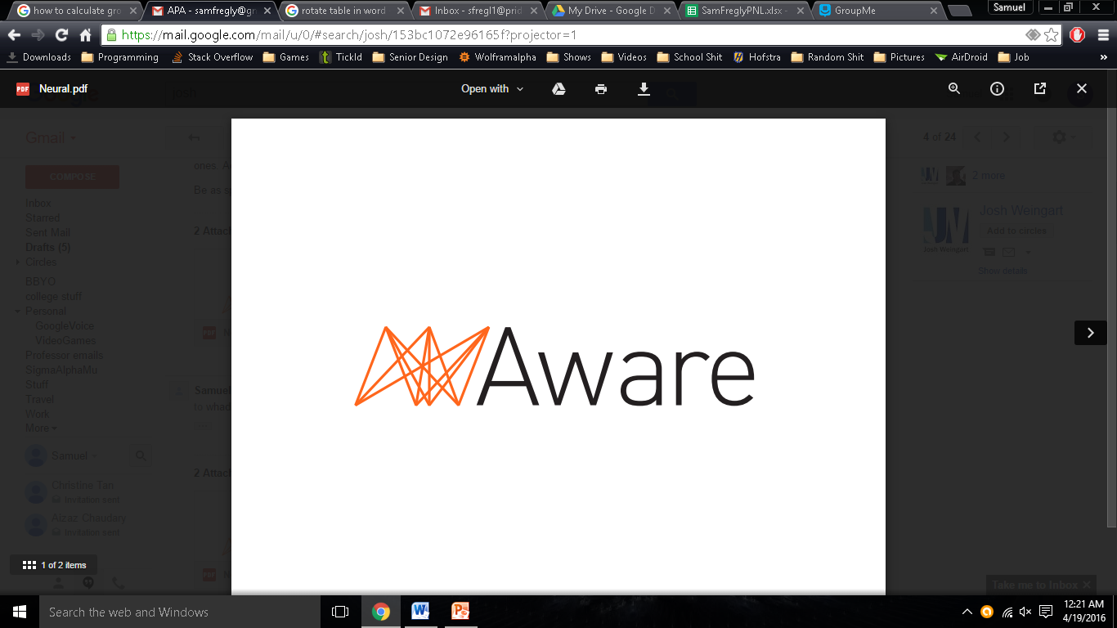

Sam Fregly

CEO and Founder

Wahid Hadi

Co-Founder

**Aware Predictive Analytics Executive Summary**

Big data is an ever growing field in all industries. Analysis of big data is important for making intelligent business decisions. Aware has figured out to take advantage of this vast information from a wide variety of sources and apply them to an equally diverse set of industries. The goal is to be a reliable and frequently used tool when it comes to making decisions based off of consumer sentiment. Aware is capable of collecting any type of text data from potential consumers, analyzing it using advanced supervised learning algorithms, and outputting predictions relevant to a specific company. Aware is capable of providing analysis of online sentiment dozens of times faster and more frequent than online surveys or polls.

People love to complain. A single disgruntled customer can dramatically affect the reputation of a company. As any experienced business owner knows the loudest clients are the unhappy ones. Getting reliable information about customer experiences can make or break a company. Especially for large entities, collecting this information and analyzing its meaning appropriately is extremely difficult.

Online polling is extremely unreliable; Google, Amazon, Target, Macy’s and many more companies offer some type of a rewards program for customers in exchange for answering market research questions online. To get 500 responses from online surveys can cox st as much as $5000 and there is no promise that participants answered honestly. At the same time people constantly voice their opinions online.

Aware currently focuses on predicting the polling numbers of all of the presidential candidates based on tweets pulled from twitter. Aware just left its beta stages and is capable of updating the polling numbers every hour. No other available product or service is capable of making hourly predictions. National polls take days to properly do are only done two or three times a week. Aware easily tracks daily fluctuations in the polls that are directly tied to the candidate’s daily actions. During high traffic times such as during a debate Aware can make predictions every few minutes. It is extremely powerful to see how people respond to a candidates responses to individual questions.

This is just one example of the many things that Aware can do. The accuracy and frequency of our predictions outperform other analytic software. Aware does not stop at analyzing the consumer sentiment, Aware tells clients exactly how it is going to influence their business. With the amount of available information growing every day it is important for business to use this information to make intelligent economic decisions.

**Problem**

National surveys and polling can get very pricey and very unreliable. A typical national survey can cost between $20-25,000 for only 800 respondents, keep in mind that companies are required to pay for non-responses as well. Online surveys are significantly cheaper, costing around $5,000-10,000, however the quality of responses can be very unreliable. It is very often that the surveyed are compensated and many respondents give random responses just to receive the compensation. Companies and public figures today have to put up with relying on these outdated means of gathering polling numbers, surveys, or other types of analytics. There is no option out there that offers real time analytics that guarantees accurate responses for the money.

**Solution**

At Aware, there is an option. Aware uses raw data which is currently being collected from Twitter. Social media platforms such as Twitter run today’s world with over 500 million tweets sent per day. That is 500 million opinions from the general public tweeted every day that can be used to answer national surveys and polls or any other type of analytics. Using a complex search algorithm, this data is then filtered according to the client’s need. The search algorithm takes in queries that is specifically tailored to the client to process the data. Once processed, the data is then used in conjunction with a supervised learning algorithm to make hourly predictions. These results could be for stock market fluctuations, candidate polling, customer satisfaction, market research, etc. Aware is not limited to Twitter. It is capable of connecting to any source feed that can give data in a text format. Whether it is connecting to other social media platforms such as Facebook, Google+, or connecting to internal emails, Aware™ is compatible with all.

**Why Now**

Today, big data analytics are on the minds of many companies and enterprises. More data has been created in the past two years than in the entire previous history of the human race. The digital world today accumulates to 4.4 zettabytes, or 44 trillion gigabytes, of data. With all of this data, a powerful tool can be created. Along with the fact that over 80% of enterprises and companies have deployed or have plans to deploy some sort of big data project. Over a third of the budget allocated to marketing is spent on analytics. The trend is only increasing. There will be an estimated 73% increase on spending over the next 3 years. Not only is this a viable option for companies and enterprises to increase profit and gain an edge over competitors, but also for politicians to analyze their campaigns. Whether it’s the presidential election, state elections, or others, polling is a necessity all candidates need. Given that social media is so large today, a lot of support for a candidate can be shown through social media and not just by phone polls.

**Market Size**

Aware™ caters to the needs of companies and enterprises looking to analyze big data to see market trends, product trends, or internal trends. Companies can see how well they’re performing, or what is needed to be done to gain that competitive edge. They can also analyze internal emails to see if there is any correlation between employee satisfaction and production. Aware™ is not limited to just companies and enterprises, but also to individuals and e-commerce. Individuals such as politicians looking to see how well they’re performing in a state, with a certain gender/age, or how they are performing in a race can benefit from Aware™. As for e-commerce, Aware™ can help investors see the trend in stocks, giving them some support on their decision as to who to invest with. Currently over a third of all major companies marketing budget is spent on some form of analysis. Finding an exact market size is difficult, the estimates range anywhere from 2 billion to over 150 billion. A conservative estimate is about 40 billion for 2016.

**Competition**

Aware has multiple competitors. Predictive analytics and Big Data analytics is not a brand new field. Google Analytics, Adaptive Insights, Exago, MicroStrategy, and Microsoft are some of them.

Some of our competitive advantages are technical ones. Many of these other analytic services use an Unsupervised learning algorithm artificial intelligence(AI) vs our primarily Supervised learning algorithm AI. The difference being, Unsupervised AI categorize data without knowing anything about it and does not make predictions Aware primarily use a Supervised AI which focuses on making predictions. The AI is trained with Aware’s historical database. By using a historical database Aware can ensure high accuracy in its validation data. It is easy to track that when X people said this and Y people felt this way on this date company Z’s stocks rose by 5%. Another competitive advantage is that Aware can analyze any type of text data in real time. Twitter, yelp, customer forums, emails; It is all the same thing to Aware. On top of all of this Aware will be consistently update with new features and performance updates. Aware will have multiple predictive models, competitor analysis, analysis based on demographics, and a growing historical database.

**Product**

Aware was started in September 2015. As of April 12, 2016 the beta was completed. Right now the AI is being trained and it is collecting more data to improve the accuracy of it’s predictions. We (Wahid and Samuel) are both graduating but plan to work full time on Aware over the summer. Working full time we are more than capable of launching a completed Website, front and back end, by September 2016.

We are currently using an open source Ai which does not need any legal protection. We utilize a custom search algorithm (Seekit) which we are licensing from Andrew Fregly, Samuel’s uncle. He owns the copyrights to Seekit but has given full written permission for us to use, modify and profit from it as we please. Legal written permission provided upon request. All of the data we collect is public so we don’t have to protect it.

The features of our product are currently hourly predictions using a supervised artificial intelligence, Storage of historical database, support multiple data sources.

**Go-To-Market**

Our market strategy is primarily word of mouth and presentations. We will directly contact companies and universities telling them how they can benefit from Aware. For every client we acquire we will put in their contract that they may be asked questions from prospective clients about their experience with Aware. Starting off Wahid and Samuel will personally talk to every prospective client. After a certain point a dedicated sales team would need to be hired.

Aware is easily scaled since a majority of the work for any individual client is at the beginning and setting the service up to best fit the client’s needs, specific feature packages, specific predictive models ect. One employee could easily handle communication with a dozen or more clients. The number of programmers required is relatively static and should remain small. Aware would only need a couple of d

eveloper teams of 2-5 people to constantly roll out new features and add specialized features upon request from clients.

The main cost to scaling is buying more storage space, but the cost of memory is constantly dropping in price. A terabyte ssd/hard drive costs as little as $100. If we store 6 months of data per client at a high estimate of 2 terabytes a month. It will costs us about $1200 per client to store their data. When we are charging a minimum of $3,000 per month. Storage is a minor cost.

**Business Model/Revenue Model**

Packages will start at $3000. The contents of which are detailed below. These are just the three standard packages based on our current features. Few clients will perfectly fit into any of these packages, but it gives a general idea about how much Aware will cost. Packages are fully customizable. Maybe they want us to make predictions from a larger historical database but only need them once a day. Aware offers completely customizable packages. Costs will be based upon prediction frequency, how well the AI is trained (how much historical data is used), how many and which predictive models they want, how many and which data sources are predictions being made from, and use of any additional features that may be added such as twitter demographic partitioning. Of course for a feature such as prediction frequency we will not charge per prediction, but for a max number of predictions. Part of the sales process will be working with the client to get them what works best for them.

|  |  |  |
| --- | --- | --- |
| Jester | Knight | King |
| **$3000+ / m** | **$5000+ / m** | **$7000+ / m** |
| 1 data source | 2 data sources | Unlimited data sources |
| 1 predictive model | 2 predictive models | All predictive models |
| 2 months data storage, max 2TB | 4 months data storage, max 6TB | 8 months data analysis, max 12TB |
| 100 predictions/m | 250 predictions/m | 680 predictions/m |
| + Per additional feature | + Per additional feature | + Per additional feature |

**Team**

Founders are Wahid Hadi and Samuel Fregly. The company is currently split 60-40 ownership with Samuel Fregly owning 60% of the company. Profits are split 50-50. This was done to prevent gridlock when it comes to making company decisions but still fairly rewarding each founder for their contributions. We currently have no other investors. The entire company right now is just Wahid and Samuel. If someone owns at least a 5% stake in the company they are eligible to be on the board of directors if the current board votes them in. A 5% investment does not guarantee a spot.