

STUDENT user manual

BSCCS FINAL-YEAR PROJECT



Department of computer science

City University of Hong Kong

Contents

[Function 1. Add Proposal 2](#_Toc505594242)

[Step 1: Fill in General 2](#_Toc505594243)

[Step 2: Fill in Outcome 3](#_Toc505594244)

[Step 3: Fill in Environment 3](#_Toc505594245)

[Step 4: Fill in Relationship 4](#_Toc505594246)

[Step 5: Fill in Remark 5](#_Toc505594247)

[Step 6: Fill in Supervisor 5](#_Toc505594248)

[Step 7: Save and Submit 5](#_Toc505594249)

[Function 2. Edit Proposal 6](#_Toc505594250)

[Function 3. Revise Proposal 6](#_Toc505594251)

[Function 4. Equipment Request 7](#_Toc505594252)

[Function 5. Message 8](#_Toc505594253)

[Function 6. Past Projects 9](#_Toc505594254)

[Function 7. Submissions 9](#_Toc505594255)

[Project Plan 9](#_Toc505594256)

[Interim Report 11](#_Toc505594257)

[Final Report 12](#_Toc505594258)

# Add Proposal

Click on the  button.

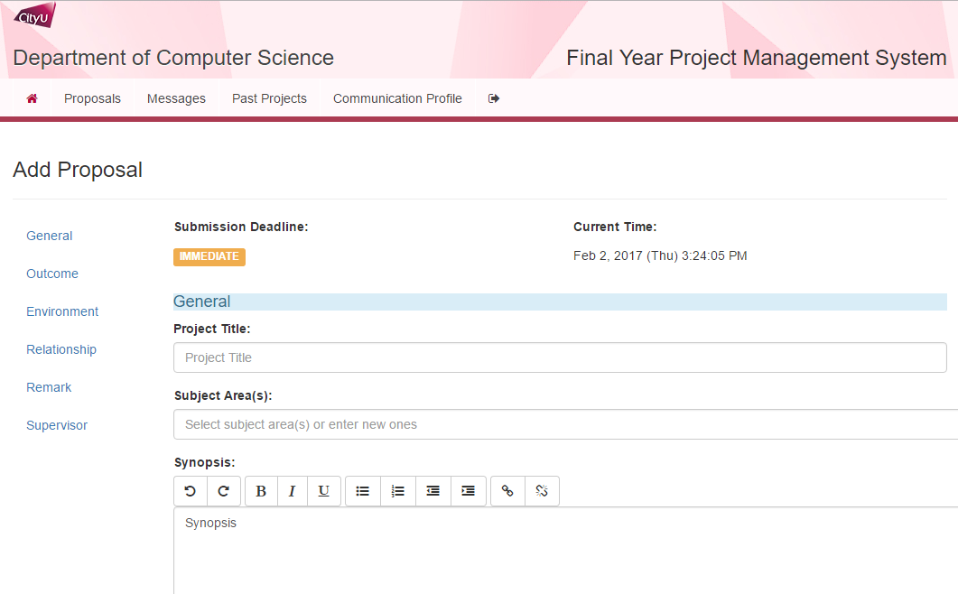

## Step 1: Fill in General

|  |
| --- |
| C:\Users\kfwong\AppData\Local\Microsoft\Windows\INetCacheContent.Word\screencapture-fypms4-dev-cs-cityu-edu-hk-student-proposal-index-do-1485328761212_02.png |
| |  |  | | --- | --- | | General | | | Project Title | Required; <= 255 characters | | Subject Area(s) |  | | Synopsis | <= 8000 characters | |

## Step 2: Fill in Outcome

|  |
| --- |
| screencapture-fypms4-dev-cs-cityu-edu-hk-student-proposal-index-do-1485328761212_03 |
| |  |  | | --- | --- | | Outcome | | | Objectives | <= 8000 characters | | Deliverables | <= 8000 characters | |

## Step 3: Fill in Environment

|  |
| --- |
| screencapture-fypms4-dev-cs-cityu-edu-hk-student-proposal-index-do-1485328761212_04 |
| |  |  | | --- | --- | | Environment | | | Hardware(s) |  | | Software(s) |  | |

## Step 4: Fill in Relationship

|  |
| --- |
| screencapture-fypms4-dev-cs-cityu-edu-hk-student-proposal-index-do-1485328761212_05 |
| |  |  | | --- | --- | | Relationship | | | Past Project(s) | Select any related past projects that below the Past Project(s) field | | Liaison with Industry | <= 8000 characters | | End Users | <= 8000 characters | |

## Step 5: Fill in Remark

|  |
| --- |
| screencapture-fypms4-dev-cs-cityu-edu-hk-student-proposal-index-do-1485328761212_06 |
| |  |  | | --- | --- | | Remark | | | Remark | <= 8000 characters | |

## Step 6: Fill in Supervisor

|  |
| --- |
| screencapture-fypms4-dev-cs-cityu-edu-hk-student-proposal-index-do-1485328761212_07 |
| |  |  | | --- | --- | | Supervisor | | | Selected Supervisor | Select the supervisor below the Selected Supervisor field; Required | |

## Step 7: Save and Submit

|  |
| --- |
| screencapture-fypms4-dev-cs-cityu-edu-hk-student-proposal-index-do-1485328761212_08 |
| |  |  | | --- | --- | | Save and Submit | | | Save for Later | The form will be saved in the system AND will not be submitted for acceptance. You may come back and edit later. | | Submit for Acceptance | Once submitted, you are not able to edit it. The Supervisor will see if to approve your project | |

# Edit Proposal

If you have save a proposal rather than submit for acceptance on a proposal, you probably need to edit it.

Just click the edit button to edit the proposal.

# Revise Proposal

You may need to make some revision and submit again if the supervisor would like you to make some changes to the proposal and submit again.

There are 2 statuses you can submit proposals again.

1. **Revision Required**, the supervisor requires students to make some changes and submit again;
2. **Rejected**, the supervisor does not think the proposal is good enough for acceptance neither for revision.



Just click into the project title to revise a proposal.

You are not going to edit the previous proposal directly but duplicate a proposal to edit and submit again.

You need to click on the duplicate button to generate a new copy of previous proposal.

You may also click on the  add button to create a new proposal to submit again.

Edit as what have been told by your supervisor and submit again.

# Equipment Request

After your proposal is being Accepted, you are going to make Equipment Request. Click on Screen Clipping button and select Hardware(s) and Software(s) with Justification. You may refer to what you have selected in your proposal and make adjustment here to submit. Your supervisor will then Endorse or Reject your Pending request(s).

|  |
| --- |
| Screen Clipping |
| |  |  | | --- | --- | | Equipment Request | | | Hardware | Select hardware(s) for your project. | | Software | Select software(s) for your project. | | Justification | Provide reasons on why you need those resources for your project. | |

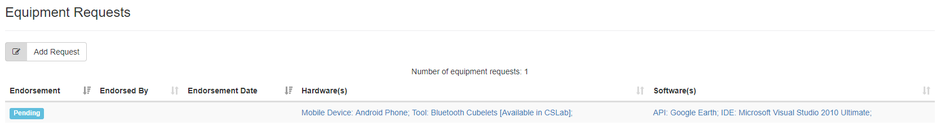

You may see a list of requests as you may initiate many equipment requests.

# Message

You can initiate communication with staff by the New Message function. Click the Screen Clipping button.

|  |
| --- |
| Screen Clipping |
| |  |  | | --- | --- | | Message | | | Recipient | Select target staff to communicate. | | E-mail copy | You may get email copies by specifying which email(s) to save the copy. (You can receive a copy in your e-mail address and alternate e-mail address by default.) | | Content | The message content. | |

# Past Projects

You can search past projects for your reference. Click the Screen Clipping button. Then you can search by Year, Supervisor and Subject Area.

|  |
| --- |
| Screen Clipping |
| |  |  | | --- | --- | | Past Projects | | | Year | The academic year of projects. | | Supervisor | Teacher who supervise those project(s). | | Subject Area | Type in subject area to filter. | |

# Submissions

## Project Plan

You can submit project plan once your proposal is accepted and project code has been generated. Click into 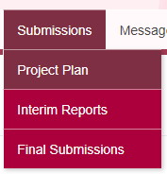 and you can upload the project plan.

|  |
| --- |
| Screen Clipping |
| |  |  | | --- | --- | | Project Plan | | | Document File | Just upload a project plan PDF or Word file. | | E-mail…. | Just check it to notify your supervisor for the submission of project plan. | |

## Interim Report

You can submit interim report once your project plan was done. Click into 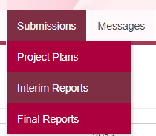 and you can upload the interim report#1 and interim report#2 by the Submit button and download the cover by clicking Download Cover.

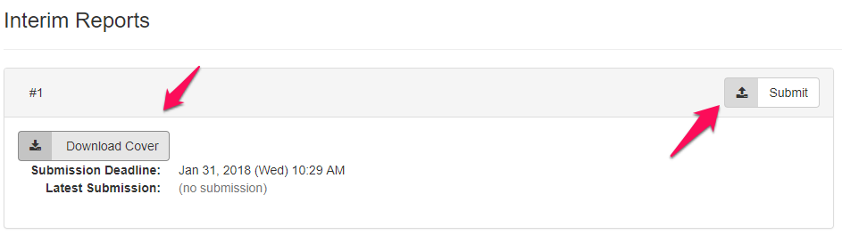

|  |
| --- |
|  |
| |  |  | | --- | --- | | Final Report | | | Document File | Just upload the final report PDF or Word file. | | E-mail…. | Just check it to notify your supervisor for the submission of interim report#1. | |

|  |
| --- |
|  |
| |  |  | | --- | --- | | Final Report | | | Document File | Just upload the final report PDF or Word file. | | Creativity | Just write down the creative part of your interim report#2. | | E-mail…. | Just check it to notify your supervisor for the submission of interim report#2. | |

## Final Report

You can submit final report once your interim report was done. Click into 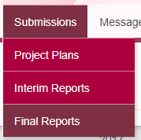 and you can upload the final report.

|  |
| --- |
|  |
| |  |  | | --- | --- | | Final Report | | | Document File | Just upload the final report PDF or Word file. | | Creativity | Just write down the creative part of your final report. | | E-mail…. | Just check it to notify your supervisor for the submission of final report. | |