MeV Scripting XML schema and DTD
2.23.2004

Purpose: This document describes a proposed XML schema and DTD to support scripting activities within TMeV. The nodes for midas and dbi_controller are not populated in this
version but are placeholders for further development of a common DTD for tm4 applications
if such a common DTD should be developed.

The node hierarchies and attributes are developed specifically to support mev script creation, loading, and execution. Note that the node hierarchy and attributes are the main focus of this document and further discussions can determine if element names should be standardized and what those names should be for structures common to various scripting environments.

Three sections follow which describe the script definition. Basic Terminology provides descriptions of some of the key node types found in the DTD. This can be used as a reference when reading the formal DTD. The second section is the UML representation of the schema. This provides a clear view of the hierarch found in the last section which is the actual DTD.

1.) Basic Terminology (Definitions)

This is an partial list of some terms used within the document. Some of these terms correspond to tags which are described in the DTD and the corresponding UML hierarchical diagram.

Analysis (analysis)- A process defined by the execution of an Algorithm Set or sets.

Algorithm Set (alg_set)- a set containing one or more Algorithms performed on
a particular data reference. Branching of analysis processing occurs by having a separte
Algorithm Set operating on a different data reference.

Algorithm (algorithm)- A procedure which takes in data and produces output according to the rules defined by the specific algorithm. An Algorithm has four attributes, an alg_id unique to a particular algorithm instance, an alg_name which specifies the algorithm to be applied, an alg_type (clustering, data adjustment, filtering, etc.), an input_data_ref which is a quick reference to the input data set.

Parameter Set (plist) - A set of parameters required or optional for the execution of a particular algorithm.

Parameter (param)- An input variable to an algorithm other than the primary data set. Parameters have key and value attributes.

Matrices (mlist) - Algorithms often require input arrays and input matrices. The matrix list if present contains a list of matrices that can possibly be a single vector to represent an array.
The matrix element type is identified by a name and includes a type attribute to assist in reconstruction to a Java object of appropriate type. An xdim attribute corresponds to number of rows while for each row the number of columns can vary in this structure.
(May want to rename to array2D or some other name to reflect this special case and the case where a matrix is really an array or simply have an array element type.)

Data Representation - data references are used to connect algorithm sets (and algorithms) to input data. These references refer to either the primary data source or to an output data node from an algorithm. This permits creation of new algorithm sets (branching) which perform algorithms on data subsets in the case of clustering or filtering output, or on transformed data in the case of other data adjustments.

2.) XML Schema
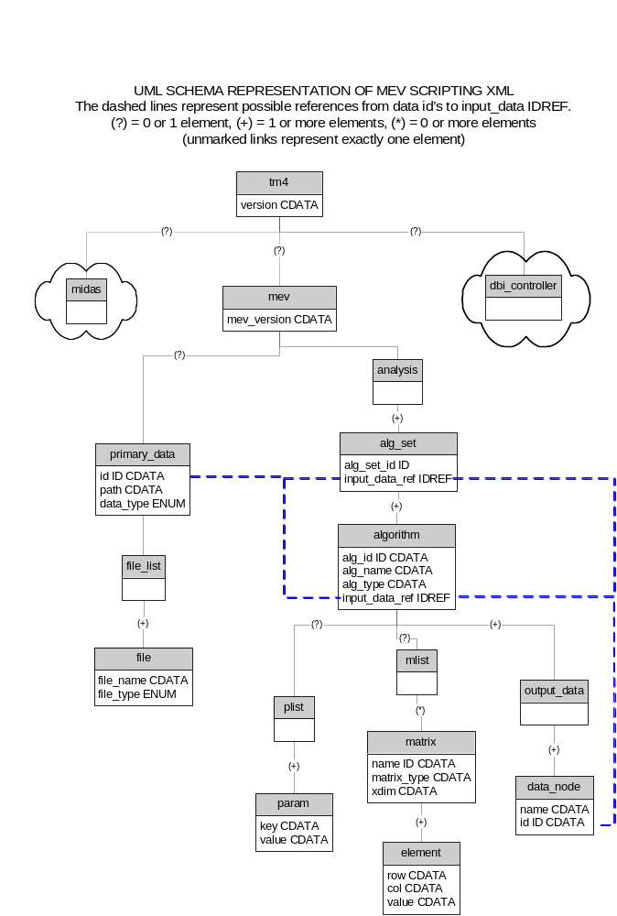

3.) Document Type Definition

<!ELEMENT tm4 (midas?, dbi_controller?, mev?)>
<!ATTLIST tm4 version CDATA #REQUIRED>

<!-- midas and dbi_controller place holders -->
<!ELEMENT midas EMPTY>
<!ELEMENT dbi_controller EMPTY>

<!ELEMENT mev (analysis, primary_data)>
<!ATTLIST mev version CDATA #REQUIRED>

<!ELEMENT analysis (alg_set+)>

<!ELEMENT alg_set (algorithm+)>
<!ATTLIST alg_set set_id ID #REQUIRED
input_data_ref IDREF #REQUIRED>

<!ELEMENT algorithm (plist, mlist, output_data)>
<!ATTLIST algorithm ser_number_id ID #REQUIRED
input_data_ref IDREF #REQUIRED
alg_name CDATA #REQUIRED
alg_type CDATA #REQUIRED>

<!ELEMENT plist (param*)>

<!ELEMENT param (key, value)>
<!ATTLIST param key CDATA #REQUIRED
value CDATA #REQUIRED>

<!ELEMENT mlist (matrix*)>
<!ELEMENT matrix (element+)>
<!ATTLIST matrix name ID #REQUIRED
matrix_type CDATA #REQUIRED
xDim CDATA #REQUIRED>

<!ELEMENT element EMPTY>
<!ATTLIST element x CDATA #REQUIRED
y CDATA #REQUIRED
value CDATA #REQUIRED>

<!ELEMENT output_data (data_node+)>

<!ELEMENT data_node EMPTY>
<!ATTLIST data_node data_node_id ID #REQUIRED
name CDATA #REQUIRED>

<!ELEMENT primary_data (file_list)>
<!ATTLIST primary_data id ID #REQUIRED
data_type CDATA #REQUIRED>
<!-- want an enumeration of data types (mev|tav|stanford|affy|gpr) -->
<!ELEMENT file_list (file+)>
<!ELEMENT file EMPTY>
<!ATTLIST file file_path CDATA #REQUIRED
file_type CDATA #REQUIRED>
<!-- want an enumeration of file types (‘data’|’annot’|’preference’|’ref’) -->

