Probability of an F1 overtake under the 2026 Boost and Overtake Mode rules
MMA3001 Numerical Methods and Machine Learning: individual project report Sam Gazzola · Repository https://github.com/SamGazz10/Gazzola3001 · October 2026
Every number in this report is produced by code in the repository from fixed random seeds; Appendix D lists the command that regenerates each result. Code documentation (generated from the docstrings) is in docs/api/.

Summary
From 2026 a Formula 1 car within 1 s of the car ahead gets Overtake Mode (0.5 MJ of extra battery energy and electrical power to a higher speed) instead of DRS, and either driver can use Boost, the maximum engine plus battery power. This project estimates the probability that an attempt succeeds, P(overtake), from 19 inputs. A physics simulator integrates both cars’ equations of motion with fourth-order Runge-Kutta (RK4) and gives the exact probability by Gauss-Legendre quadrature; a neural network trained only on simulated 0/1 outcomes predicts it 20 times faster, with a mean error of 2.0 percentage points on 30,000 held-out attempts (gradient boosting 3.8, logistic regression 15.7). Against 17 real 2026 races the physics holds up, but the simulator makes passes from 0.5-1 s behind too easy, because real drivers ration battery energy across the lap.

1. Engineering problem
Context. The 2026 power unit pairs a 400 kW engine with a 350 kW electric motor-generator (MGU-K) on the rear axle and a battery of about 4 MJ usable energy [1, 2, 5, 6], which full electrical power empties in about 11 s, less than one long straight. Electrical power also tapers from 290 km/h to zero at 355 km/h; Overtake Mode, earned within 1 s of the car ahead at a detection point, adds 0.5 MJ and full power to 337 km/h [1-4]. Overtaking has become a mechanical-engineering problem of longitudinal vehicle dynamics and hybrid-powertrain energy management: traction, drag, slipstream and how much energy each car can deploy over the remaining distance.
Problem. Given the situation as the attacker leaves the corner before a straight, estimate the probability that the attacker is ahead at the braking point at the end of the straight and the move sticks.
Why it matters. Teams decide every lap whether to attack or recharge, and drivers when to use Boost. A fast, calibrated probability lets a strategist compare options (“attack now with 60 % charge, or next lap with 90 %?”) and shows rule makers which Overtake Mode parameter changes overtaking, and for whom (Section 5.4).
Intended use. Decision support and what-if analysis, where many situations must be evaluated quickly, and a training pipeline that can be retrained on real labelled attempts (python -m overtake.train --data) once they exist.
Scope and its limits. One attempt on one straight, without energy strategy across the lap; safety cars and damage are out of scope. Battery and Boost use are not in public data, so training data are simulated and the network is only as right as the simulator; in return the ground truth is exact.

2. Inputs, outputs and data
Inputs. A scenario is one row (a Python dict, pandas row or CSV row) with the 19 fields of Table 1. Omitted fields take the defaults, which together form the default scenario used throughout this report.
Table 1. Inputs (accepted range, with the training range in brackets where narrower).
Input | Meaning and units | Accepted (trained) | Default
gap_s | gap at the corner exit, s | 0-3 (0.05-2.0) | 1.0
run_length_m | corner exit to braking point, m | 10-2000 (250-1300 straights, 50-300 corners) | 800 (150 into a corner)
attacker_battery, defender_battery | state of charge, % of 4 MJ | 0-100 | 100, 60
attacker_boost, defender_boost | Boost used, flag | true/false or 1/0 | true, true
overtake_mode | within 1 s at the detection point, flag | true/false or 1/0 | gap_s ≤ 1
attacker_tyre, defender_tyre | soft, medium, hard, intermediate, wet | listed | soft, medium
attacker_tyre_age, defender_tyre_age | laps | 0-80 (0-40) | 5, 15
track_condition, track_temp_c | dry, damp or wet; °C | listed; 0-70 (10-55) | dry, 35 (20 damp or wet)
segment | where the move completes: straight, slow, medium or fast corner | listed | straight
circuit | one of 24 circuits, or generic | listed | generic
attacker_skill, defender_skill | racecraft rating (grid about 60-100) | 0-100 (60-100) | 85, 85
top_speed_delta_kph, pace_delta_s | attacker car’s advantage: straight-line speed, km/h; lap time, s/lap | ±30 (±15); ±3 (±1.5) | 0, 0
Output. P(overtake), the probability between 0 and 1 that this attempt succeeds. It is calibrated against the simulator (Section 5.2): among situations predicted at 30 %, about 30 % succeed in simulation, so options can be compared directly. Real pass rates are lower at 0.5-1 s (Section 5.3).
Invalid, missing and unsupported inputs. An unknown category or field name, a value outside the accepted range, text, NaN, a non-boolean flag or a missing column raises a ValueError naming the field and the allowed values (the command line exits with status 2). Omitted or None fields take their defaults. Values outside the training range, or Overtake Mode inconsistent with the gap, are predicted with a warning (Section 5.2 measures the cost); a missing model file raises an error explaining how to train one. Function-level inputs, outputs and exceptions are in NumPy-style docstrings (docs/api/).
Data. 300,000 simulated attempts (inputs sampled across the training ranges; 15 % of batteries start full; 27 % succeed), split 80/10/10 into training, validation and test sets and regenerated from fixed seeds. Real timing data from 17 races of the 2026 season (OpenF1 [15]) are used for validation only.

3. Computational approach
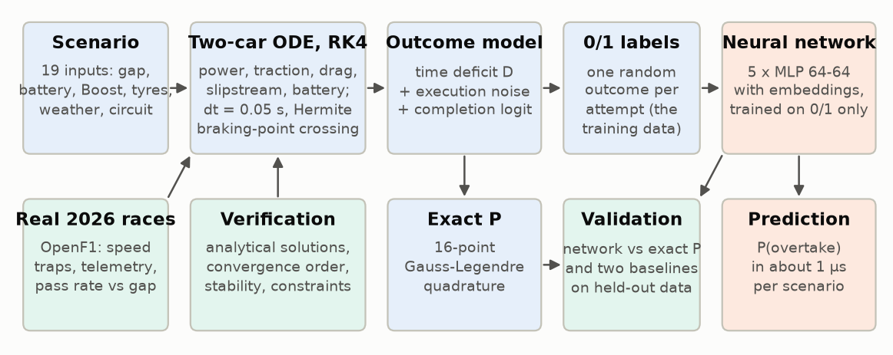
Figure 1. Workflow. Top: the simulator generates 0/1 outcomes on which the network is trained. Bottom: what checks each part.

3.1 Physical model (overtake/physics.py)
Each car is a point mass moving along the straight, with position $x$, speed $v$ and battery energy used $e$:
$$\dot{x}=v, m \dot{v}=min(F_{P},F_{T})−F_{D}−F_{R}, \dot{e}=P_{E}.$$
- Drive force $F_{P}=η (P_{ICE}+P_{E})/v$, with electrical power $P_{E}=s P_{K}(v) min\left(1,(E−e)/S\right)$: $P_{K}$ is 350 kW to 290 km/h, falling to zero at 355 km/h (full power to 337 km/h with Overtake Mode); the deployment share $s$ is 1 with Boost and 0.55 on the standard map; $E$ is the energy available; over the last $S=20$ kJ the power fades out, keeping the equations continuous.
- Traction limit $F_{T}=μ w_{r} (mg+1/2ρC_{L}A v^{2})$ of the driven rear tyres; it limits acceleration below about 200 km/h with Boost and carries tyre compound, age, temperature and wetness through the grip $μ$.
- Drag $F_{D}=1/2ρ C_{D}A k v^{2}$, where the follower’s slipstream factor $k=1−0.25 e^{−Δx/20 m}$ fades to 1 over one car length as it draws alongside. Rolling resistance $F_{R}=c_{rr}(mg+1/2ρC_{L}A v^{2})$.
The slipstream couples the cars, so all six states are integrated together until the defender reaches the braking point, giving the attacker’s remaining time deficit $D$. Assumed: a flat straight without wind; constant mass and low-drag aero coefficients; full throttle from the same corner-exit speed on every straight; one deployment level per driver, no reaction to the other car; the whole charge available for this straight.
Table 2. Main parameters (all constants in Appendix E).
Parameter | Value | Source
MGU-K power; taper; Overtake Mode | 350 kW; 290 → 355 km/h; full power to 337 km/h and +0.5 MJ | regulations [1, 2, 4, 7]
Engine power; usable battery energy | 400 kW; 4 MJ | [5]; estimate [6]
Mass; $C_{D}A$, $C_{L}A$ | 800 kg; 1.0 m², 3.0 m² | estimates (768 kg minimum plus fuel)
$μ$ (new soft, dry), $c_{rr}$, $η$; slipstream | 1.7, 0.012, 0.95; 25 % less drag, 20 m decay | estimates
Corner-exit speed | 33 m/s × √(relative grip); up to 6 % grip lost in dirty air | estimate, the most influential (Section 5.4)
A car on a full battery reaches about 345 km/h after 800 m with Boost and Overtake Mode, 330 with Boost alone, 319 on the standard map and 288 with no electrical power (top speed 303 km/h), consistent with real speed traps (Section 5.3; Figure A2).

3.2 Numerical methods
Time integration: RK4 with a fixed step of 0.05 s. RK4 is fourth-order accurate for four right-hand-side evaluations per step (forward Euler: first order; Section 4). Being explicit, it is stable only while $λ Δt$ stays within about 2.785 on the negative real axis, $λ$ being the fastest decay rate in the system. That is not the car’s speed (at most about 1 s⁻¹) but the battery ramp, where $\dot{e}∝(E−e)$ decays at $λ=sP_{K}/S=17.5$ s⁻¹ with Boost: linear theory puts the limit at 0.16 s, and the battery is first overdrawn at 0.125 s (Figure A4). The 0.05 s step, set by the accuracy study (Section 6), leaves a margin of 2.5.
Braking-point crossing. Straight-line interpolation within the crossing step is second-order accurate (0.20 ms worst deficit error at 0.05 s, against 0.059 ms), so the crossing time is found by four Newton iterations, converged to round-off, on the step’s cubic Hermite interpolant (fourth order). Scenarios are vectorised: integrated together as NumPy arrays in chunks of 20,000, each leaving the active set at its braking point.

3.3 Outcome model and exact probability (overtake/simulator.py)
Execution varies between attempts: the attacker’s effective deficit is $D−ε$ with $ε∼N(0,σ)$, $σ=0.20$ s in the dry (0.24 damp, 0.28 wet, more for lower-rated drivers); $D$ also includes caution on a wet track and a strong defender’s positioning. Within $L=0.15$ s the attacker can lunge; with margin $u=ε−(D−L)$ the move sticks with probability $logistic(z_{0}+5min(u,0.5))$, where $z_{0}$ combines driver ratings, braking grip, corner type, weather, circuit passability and the defender’s remaining Boost energy (estimated constants, Appendix E). The exact probability is a one-dimensional integral,
$$P=\int_{0}^{∞}{ϕ_{σ}}(u+D−L) logistic\left(z_{0}+5min(u,0.5)\right) du,$$
with $ϕ_{σ}$ the normal density of $ε$. The integral is split at the kink $u=0.5$ s: the tail has a closed form, and the smooth part is evaluated with 16-point Gauss-Legendre quadrature, exact for polynomials up to degree 31. Training labels are random draws of $ε$ and of success; the exact $P$ is used only to validate.

3.4 Neural network (overtake/model.py, overtake/train.py)
Categorical inputs pass through learned embeddings (circuit 6 numbers, tyre 4, weather 2, segment 3); numeric inputs are standardised with training-set statistics. The resulting 33 numbers feed a multilayer perceptron with two hidden layers of 64 SiLU units, dropout 0.1 and a sigmoid output: 6,589 parameters. It is trained on 0/1 outcomes with binary cross-entropy, AdamW [10] (learning rate 2×10⁻³, halved after three epochs without improvement; weight decay 10⁻⁴), batches of 1,024, and early stopping on the validation loss (patience 5 epochs, at most 100); these are common defaults, while the layer sizes and the ensemble of five networks (seeds 0-4) were chosen on validation data (Section 6). A network was chosen because it learns from 0/1 outcomes alone, as it would from recorded attempts, and captures interactions simpler models cannot (battery charge matters far more on a long straight than into a corner).

3.5 Implementation and reproducibility
The package overtake has one module per stage; 88 pytest tests cover the numerics, pipeline and notebooks; python -m overtake.train and python -m overtake.experiments all regenerate every result; work was done on Git feature branches merged into main.

4. Alternative solutions
Table 3. Numerical methods.
Choice | Alternative | Evidence | Decision
RK4 | Forward Euler | Worst deficit error at 0.05 s: 13 ms against 0.059 ms; Euler needs 4.6 times RK4’s run time to meet 1 ms, 46 times to match it; overdraws the battery from 0.075 s (RK4: 0.125 s) | RK4
Fixed-step RK4, vectorised | Adaptive RK45 with events (SciPy [17]), one scenario at a time | At tolerance 10⁻⁶: 0.45 ms worst error (RK4: 0.024 ms, same 100 scenarios) at about 570 times the cost; adaptive steps cannot be shared across a batch | RK4
16-point Gauss-Legendre | Simpson, trapezoid, Monte Carlo | 12 nodes reach 2×10⁻¹⁵; Simpson needs 257 points for 3×10⁻¹¹; Monte Carlo (1,600 replays) 0.7 points RMS, 167 times slower | Gauss-Legendre
Table 4. Learned models (same inputs and training data) against direct simulation on 30,000 test attempts; 95 % bootstrap interval in brackets; by region in Figure A1.
 | Neural network (5) | Gradient boosting | Logistic regression | Direct simulation
Mean error against exact P (points) | 2.0 (2.0-2.1) | 3.8 (3.7-3.8) | 15.7 (15.5-15.8) | 0 (it is the truth)
Worst error (points) | 58.7 | 70.0 | 98.9 | 0
Error, unsuited tyres / 1,300-2,000 m straights (points) | 2.6 / 4.4 | 5.7 / 9.7 | 27.5 / 26.9 | 0 / 0
Log loss / ROC AUC | 0.257 / 0.948 | 0.267 / 0.944 | 0.411 / 0.853 | 0.252 / 0.949
Calibration error | 0.005 | 0.014 | 0.004 | 0.004
Training time | 208 s | 9 s | 3 s | none
Prediction (µs per scenario, incl. input checks) | 12 | 17 | 9 | 246
Model size | 132 kB | 1,139 kB | 4 kB | -
Interpretability | low (needs sensitivity analysis) | medium | high | high (physics)
Logistic regression cannot represent interactions, so its error is largest where they dominate (straights, wet tracks, unsuited tyres). Gradient boosting trains 24 times faster but is 1.9 times less accurate, worse in every region and less well calibrated: piecewise-constant trees approximate smooth physics poorly. Neither baseline was handicapped by its settings (Appendix A). Direct simulation is exact but 20 times slower, and can use real data only by fitting its few outcome constants to aggregate pass rates; the network needs attempts with all 19 inputs. The network is the most accurate fast surrogate, and its 208 s of training pays for itself after about 0.9 million predictions.

5. Validation
Three questions were asked, each against a reference able to answer it: are the equations solved correctly (5.1, exact solutions and theory), does the network reproduce the simulator (5.2, withheld data), and is the simulator realistic (5.3, real races)?

5.1 Verification of the numerical methods
Table 5. Verification checks, each with its acceptance criterion.
Check | Method | Acceptance | Result
Right-hand side, integrators, crossing | Exact solutions: constant power, $v^{2}=v_{0}^{2}+2Pt/m$; drag only, $v=v_{0}/(1+kv_{0}t/m)$ | relative error < 10⁻⁸ at 0.05 s | met
Order of accuracy | Slope of log error against log step (Figure A3) | Euler 1, RK4 4, each ± 0.15 | Euler 0.95, 1.00; RK4 4.05, 4.00
Step size, full model | Deficit against a 0.001 s reference, 2,000 scenarios | worst error < 1 ms (0.5 % of $σ$) | 0.059 ms; order 2.0 (kinks in the right-hand side)
Stability | Battery-depletion ramp, steps 0.025-0.3 s | energy used ≤ available | met at 0.05 s; broken from 0.125 s
Physical constraints | Energy budget, speed bounds; direction of 10 input effects | always | met
Quadrature; crossing | SciPy’s adaptive quad; Newton residual | < 10⁻¹⁰; < 10⁻⁹ m | met
Outcome sampling | 20,000 Monte Carlo replays, 50 scenarios | within 4.5 standard errors | met
Error budget. Time stepping dominates: at most 0.059 ms in the deficit, which moves $P$ by at most 0.012 points since $|dP/dD|≤1/(σ\sqrt{2π})=2.0$ s⁻¹; quadrature (10⁻¹⁵) is negligible and the modelling error of Section 5.3 far larger. The part most vulnerable to numerical failure is the battery ramp: from 0.125 s RK4 spends energy the car does not have. The fixed step (margin 2.5) and an energy-budget test guard against it; integrating the energy equation exponentially would remove the limit.

5.2 Validation of the network against the exact probability
Design. The network learns from 0/1 outcomes and never sees the exact probability. The validation set served early stopping and every modelling choice; the test set only final comparisons. The main metric is the mean absolute error against the exact probability, in percentage points; outcome-only metrics that real data would also allow (log loss, calibration error, ROC AUC) are reported alongside, with the exact probability’s own log loss (0.252) as the floor no model can beat.
Results. The mean error is 2.0 points (median 0.7, 90th percentile 5.6, 99th 15.6), lower than gradient boosting in every region, with a log loss 0.004 above the floor. For the comparisons a strategist makes, the change in probability is right to 2.1 points when Boost is switched (true change 10.0 on average) and 1.3 points for 20 points less charge (true 4.0); gradient boosting 3.5 and 1.8. The network follows the main what-if curves (Figure 2), including the drop when Overtake Mode is lost above 1 s.
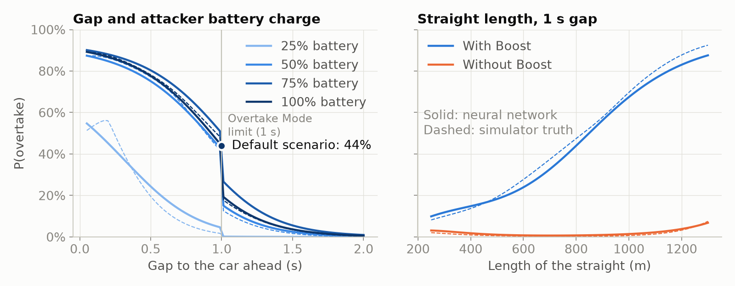
Figure 2. Network (solid) against the exact probability (dashed) for the default scenario, varying the gap and battery (left) and the straight’s length (right).
Failure modes. (i) Rare combinations: with tyres unsuited to the surface (slicks when wet, treaded tyres when dry) the error is 2.6 points against 1.9; such attempts are 18 % of the test set but half of the worst 1 %. (ii) Along the battery axis: 3.5 points low at a full battery in the default scenario (44 % against 47 %), 10.5 low in the wet, and 7.4 high at 37.5 %, where the exact curve is steepest; ensembling cannot remove this and a physics-informed input only moved it (Appendix B). (iii) Extrapolation: on straights longer than any in training the error rises to 4.4 points, hence the out-of-range warning.

5.3 Validation of the simulator against real 2026 races
The simulator was compared with 17 races of 2026 in OpenF1 [15] (overtake/realdata.py). No public source records battery charge or Boost use, so the comparison is indirect. Of 4,289 recorded position changes, removing lap 1 (962), safety-car, red-flag and Overtake-Mode-disabled periods (852) and pit stops (1,253) leaves 1,222 on-track passes, checked by tracing passes back to the raw data (Appendix C).
- Speed limit. In 19,588 race laps the fastest speed-trap reading exceeds 355 km/h on only 2 (358 km/h), supporting the power taper.
- Acceleration. On 135 full-throttle stretches of one car at Monza, the car model fits best with the standard energy map (115 stretches; median RMS error 9.9 km/h, 21.2 with Boost). On the longest straight the real car peaks at 317 km/h and slows to 302 km/h before braking; the model does not.
- Pass rate against gap (Figure 3). The real chance falls much faster with the gap: at 0.75-1 s it is a fifth of its 0.25-0.5 s value, against two thirds in the simulator, then levels off at 2-5 % per lap beyond 1 s.
- Circuits. The simulator’s circuit passability ranks real passes per lap with Spearman correlation 0.65 (p = 0.006, 16 circuits; 0.58 without Monaco).
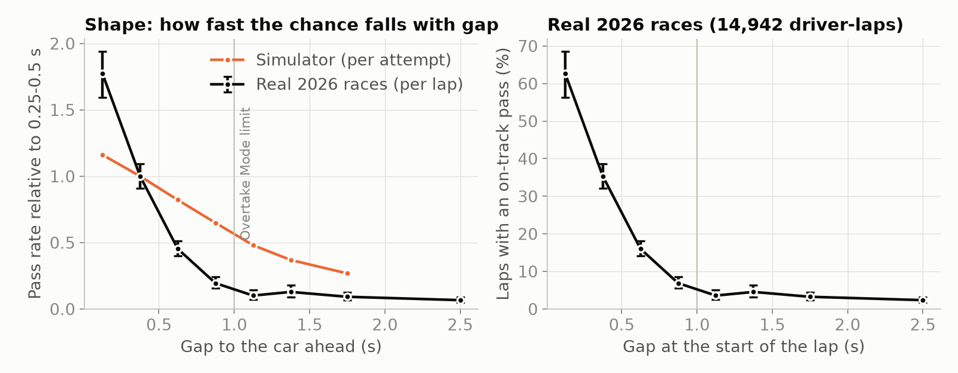
Figure 3. Pass rate against the gap at the start of the lap: shape compared with the simulator (left, both relative to 0.25-0.5 s) and real rates with 95 % Wilson intervals (right).
The physics is plausible, but the outcome model is too optimistic at 0.5-1 s: it gives the attacker more energy for one straight than real drivers spend.

5.4 Sensitivity and engineering interpretation
The network moves the same way as the simulator for every input (Figure A6); gap, straight length, batteries and Boost matter most. Of the estimated constants (Figure A7), the corner-exit speed matters most: 10 % slower or faster moves the default scenario from 47 % to 55 % or 40 %, because it sets how long both cars are traction-limited. The two Overtake Mode levers help different attackers (Figure A8): the extra energy matters only when the battery cannot cover the straight (at 30 % charge, 0 to 1 MJ takes P from 0.1 % to 27 %; at 100 % it changes nothing), while the later taper start helps whenever energy is plentiful (18 % if power tapered from 290 km/h, 47 % at 337 km/h).

5.5 Influence on model selection, and what validation cannot establish
Validation set the step (convergence and stability studies), the network size (one-standard-error rule [14]) and the ensemble and inputs (five seeds); real data was kept out of tuning. Validation cannot establish that the estimated constants are right for real cars, or the network’s accuracy on real attempts; it is calibrated against the simulator, on test data from the same sampler as its training data.

6. Optimisation and performance
The aim was the cheapest step and implementation accurate by a wide margin, and the smallest network that accuracy allows (Table 6). Times are wall-clock (time.perf_counter, best of three) on a 16-thread Intel laptop CPU on battery, PyTorch using 12 threads; training was timed on a 4-core cloud machine. Absolute laptop times vary between runs; the ratios carry over.
Table 6. Baseline against selected solution.
Change | Baseline | Selected | Effect
Slipstream: instant switch-off, then fading over a car length | RK4 first order; 1.1 ms worst error at 0.05 s | 0.043 ms, same scenarios | 25 times more accurate
Time step (2,000 scenarios; Figures A4, A5) | 0.1 s: 0.58 s, 0.27 ms; only 1.25 times inside the battery overdraw | 0.05 s: 1.11 s, 0.059 ms | twice the cost buys a stability margin of 2.5
Loop over scenarios, then vectorised (200 scenarios) | 24.6 s | 0.54 s | 45 times faster; with chunking 1,160 times (123 ms to 106 µs per scenario)
Chunk size (40,000 scenarios) | 1,000: 22.2 s | 20,000: 4.2 s | 5.2 times faster; 40,000 is slower and needs twice the memory
Exact $P$: Monte Carlo (1,600 replays), then Gauss-Legendre | 205 µs, 0.7-point error | 1.2 µs, exact | 167 times faster
Single network, then ensemble of five | 2.24 ± 0.06 points | 2.02 points | 10 % lower error, 5 times the cost
Network size: lowest loss (128-128-64), then one-standard-error rule (64-64) | 59,649 FLOPs | 13,313 FLOPs | 4.5 times cheaper, loss within one standard error
Profiling (cProfile, generating 20,000 attempts) puts 97 % of the run time in the ODE integration: force evaluation 22 %, NumPy’s clipping 12 %, the integration loop 12 %, RK4 step 11 %, slipstream 10 %; sampling, outcome model and quadrature take 3 %. Training dominates the whole pipeline: one epoch of one network takes 6.8 s (the first network ran 53), against 33 s to simulate all 300,000 attempts.
FLOPs and arithmetic intensity. An ensemble prediction costs 66,565 FLOPs and a simulation about 68,600 (153 RK4 steps of about 444 hand-counted FLOPs, plus quadrature), yet the network’s forward pass is about 58 times faster (2.2 against 130 µs; 20 times with input checks). Dense matrix products reuse each weight across a batch, so intensity rises from 0.5 FLOP/byte for one prediction (memory-bound) to 446 at 10,000, where the ensemble runs at 30 GFLOP/s; the simulator’s float64 element-wise operations move about 24 bytes per FLOP, so its 0.5 GFLOP/s is memory-bound, and NumPy uses one thread where PyTorch uses all. Memory: 132 kB ensemble, 12 MB peak per 20,000-scenario chunk (tracemalloc), 115 MB dataset; chunking caps the simulator’s memory.
Data requirements. The error falls from 6.8 points with 10,000 training attempts to 2.2 with 240,000 and is still falling, while a larger network does not help (Table A1): data, not size, limits accuracy.

7. Limitations and lessons learned
Limitations. The model is only as realistic as the simulator (estimated constants, one straight, a simple driver model), and real races show it too optimistic from 0.5-1 s behind; the network is weakest for rare combinations, beyond its training range and along the battery axis.
Lessons.
- Convergence studies find modelling errors: RK4 converging at first order exposed a discontinuity in the slipstream model.
- Stability is set by the fastest process: speed changes over seconds, but the battery ramp decays in 0.06 s and sets the step limit.
- One training run is not evidence: the seed alone moves a single network’s prediction by several points, so comparisons used five seeds.
- Hypotheses must be tested: the obvious cause of the full-battery bias was wrong, and a fix that worked in one run moved the error in five.
- Verification is not validation: every numerical check passed, yet real races showed one assumption (a full battery per attack) to be wrong.
Improvements. Model energy management across the lap; fit the execution noise and circuit factors to real pass rates; fine-tune a network pre-trained on simulation if energy data appear (untested).

8. AI use and reflection

Disclosure
Claude Code (Anthropic) was used throughout, first in a cloud session and then a local one. It summarised the 2026 rules; wrote the code, figures and 88 tests; researched the current-season sources I named (Kaggle, OpenF1) and built the OpenF1 comparison; audited the project against the brief; and drafted this report. Its work was checked by the tests, the exact-solution, convergence and stability studies, regenerating every number from code, tracing real passes back to the raw data, and a second agent re-checking each audit finding. Other AI errors caught: a first simulator too crude for the unit, a stability argument that missed the battery ramp, two wrong diagnoses of the full-battery bias, a filter counting safety-car position changes, and an unsourced speed.

Reflection
Claude Code was the only AI tool I used. The problem was my idea, as was the decision to use a neural network. My role was to check that the information was correct and within the scope of the project, to fine-tune the AI’s output and to suggest improvements. The AI wrote all of the code, generated the simulated data and formatted everything so it was presentable. I asked it to research data from the current F1 season, from sources such as Kaggle and OpenF1, and it used OpenF1 to cross-check the simulations against real 2026 races.
I used AI to bridge the gap between my idea and the final product: my coding knowledge is nowhere near advanced enough to build a neural network on my own. The checks I cared about most were model accuracy and code quality. I trusted the output because I had the AI audit its own work, with multiple agents scanning everything for problems, but it still made mistakes. One was in the slipstream, which switched off instantly when the cars drew level: the jump in drag made RK4 converge at only first order. The time-step study exposed it; fading the slipstream over one car length fixed it.
I had to relearn methods such as RK4, and I researched what F1 drivers weigh up when planning an overtake, so I could judge whether each input’s weighting was acceptable.
Without AI I could not have reached this standard; I would probably have built a basic logistic regression instead of a neural network. The project still deepened my understanding of how prediction models work and what makes them efficient and accurate. Next time I would choose a problem with real, complete data: Boost and Overtake Mode only arrived in 2026, so there was no data with battery and Boost information to train on, and the simulated data may contain inaccuracies.

References
- Formula 1, “Explained: the key terms for Formula 1’s new-for-2026 rules”. https://www.formula1.com/en/latest/article/explained-the-new-key-terms-for-formula-1s-new-for-2026-rules.3T5BU6TC9quGcIpGzoWkY0
- Formula 1, “Explained: 2026 power unit regulations”. https://www.formula1.com/en/latest/article/explained-2026-power-unit-regulations-fia.68izKQ2tn1voQPWvgLVMXN
- ESPN, “Formula 1’s new terminology explained: Overtake Mode, Boost, and how it affects 2026 racing”. https://www.espn.com/f1/story/_/id/47333501/
- Crash.net, “‘Manual Override Mode’: F1’s new overtaking aid - and DRS replacement - explained”. https://www.crash.net/f1/news/1050188/1/manuel-override-mode-f1s-new-overtaking-aid-and-drs-replacement-explained
- PMW Magazine, “FIA signs off 2026 F1 PU rules with MGU-H dropped and tight constraints on ICE design”. https://pmw-magazine.com/news/race-series-news/fia-signs-off-2026-f1-pu-rules-with-mgu-h-dropped-and-tight-constraints-on-ice-design.html
- Honda, “2026 Formula 1 Regulations Overview”. https://global.honda/en/F1/features/2026_Commentary/regulations/
- FIA, 2026 Formula 1 Technical Regulations, Section C (Power Unit), Issue 4, 2023. https://FIA.com/sites/default/files/fia_2026_formula_1_technical_regulations_pu_-_issue_4_-_2023-10-25.pdf
- The Race, “Boost, overtake mode, active aero: key 2026 F1 terms explained”. https://www.the-race.com/formula-1/boost-overtake-mode-active-aero-recharge-key-2026-terms-explained
- S. C. Chapra and R. P. Canale, Numerical Methods for Engineers, McGraw-Hill (Runge-Kutta methods, stability, Gauss quadrature).
- I. Loshchilov and F. Hutter, “Decoupled weight decay regularization”, ICLR 2019 (AdamW).
- C. Guo, G. Pleiss, Y. Sun and K. Q. Weinberger, “On calibration of modern neural networks”, ICML 2017 (calibration error).
- F. Pedregosa et al., “Scikit-learn: machine learning in Python”, JMLR 12, 2011.
- A. Paszke et al., “PyTorch: an imperative style, high-performance deep learning library”, NeurIPS 2019.
- T. Hastie, R. Tibshirani and J. Friedman, The Elements of Statistical Learning, 2nd ed., Springer, 2009, Section 7.10 (one-standard-error rule).
- OpenF1, free API of Formula 1 timing data. https://openf1.org (2026 races, accessed October 2026).
- E. B. Wilson, “Probable inference, the law of succession, and statistical inference”, Journal of the American Statistical Association 22, 1927 (score interval).
- P. Virtanen et al., “SciPy 1.0: fundamental algorithms for scientific computing in Python”, Nature Methods 17, 2020 (solve_ivp, quad).

Appendix A. Supplementary figures
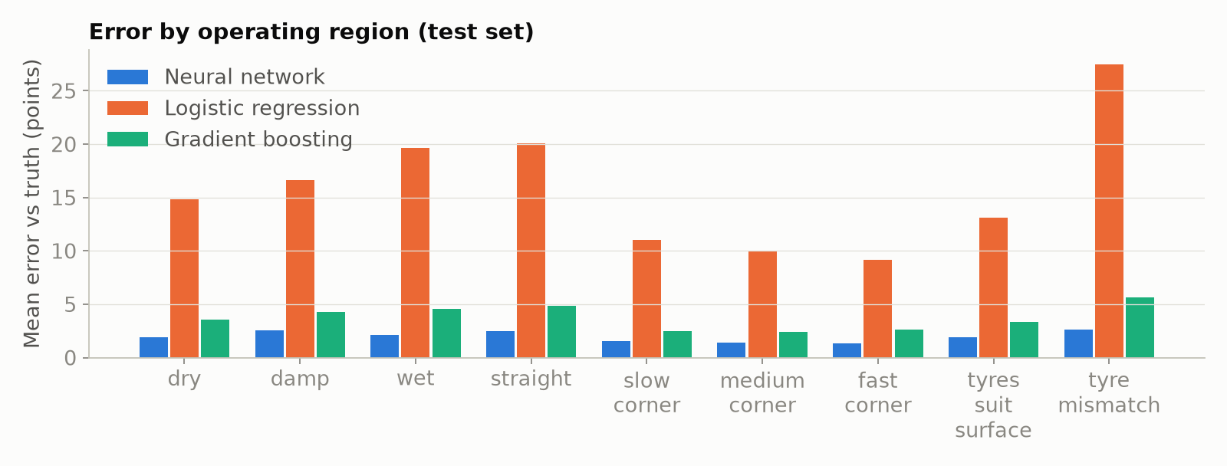
Figure A1. Mean error against the exact probability by operating region (test set).
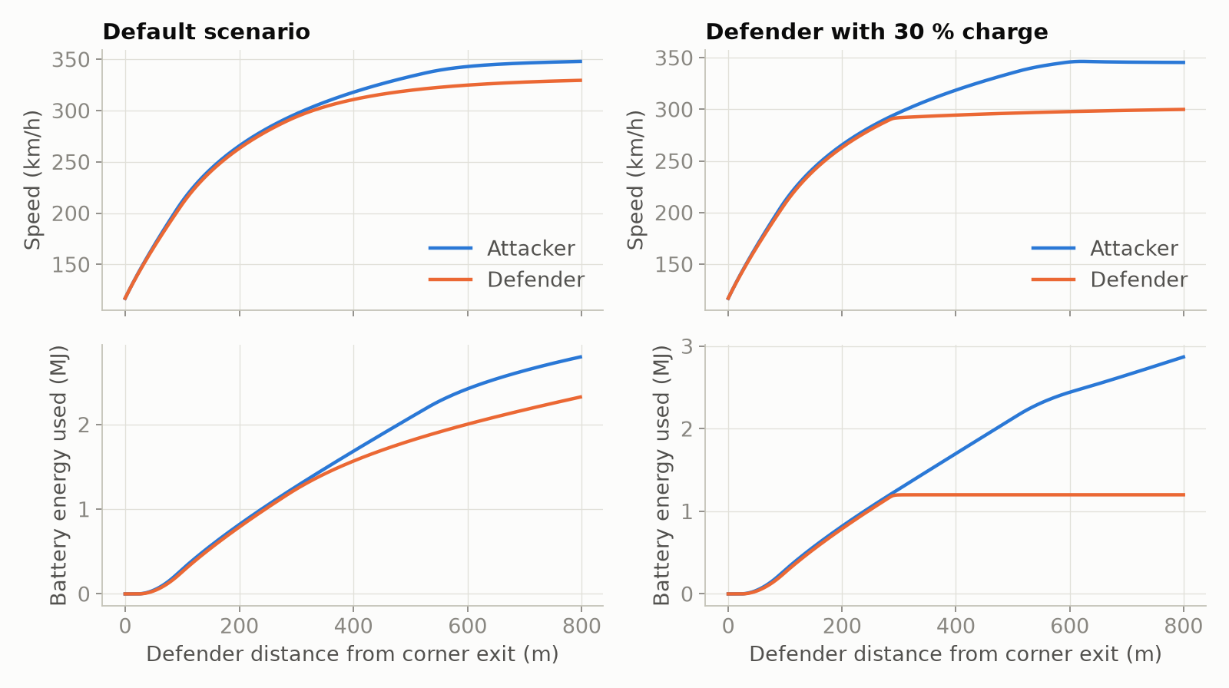
Figure A2. Simulated speed and battery energy along an 800 m straight: default scenario (left) and a defender with only 30 % charge, who runs out of energy mid-straight (right).
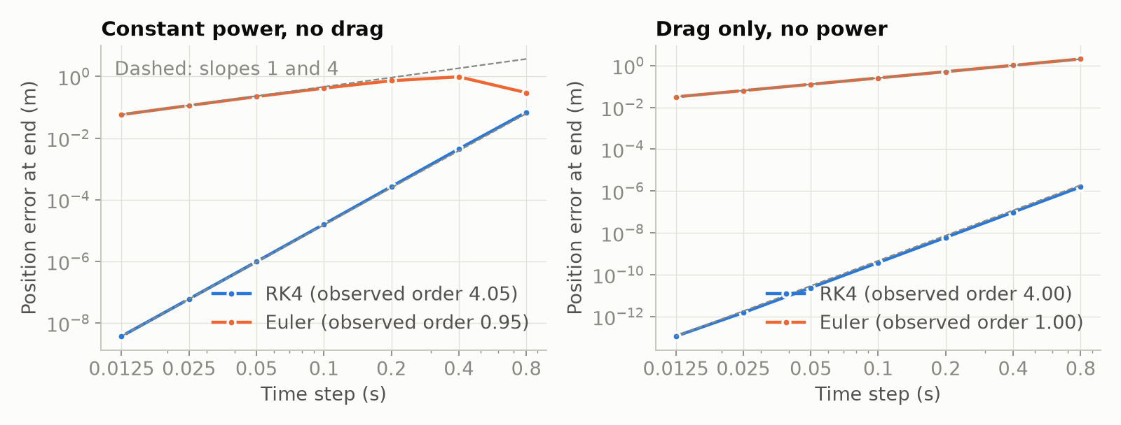
Figure A3. Convergence of Euler and RK4 against two exact solutions of the car model: dashed lines have slopes 1 and 4.
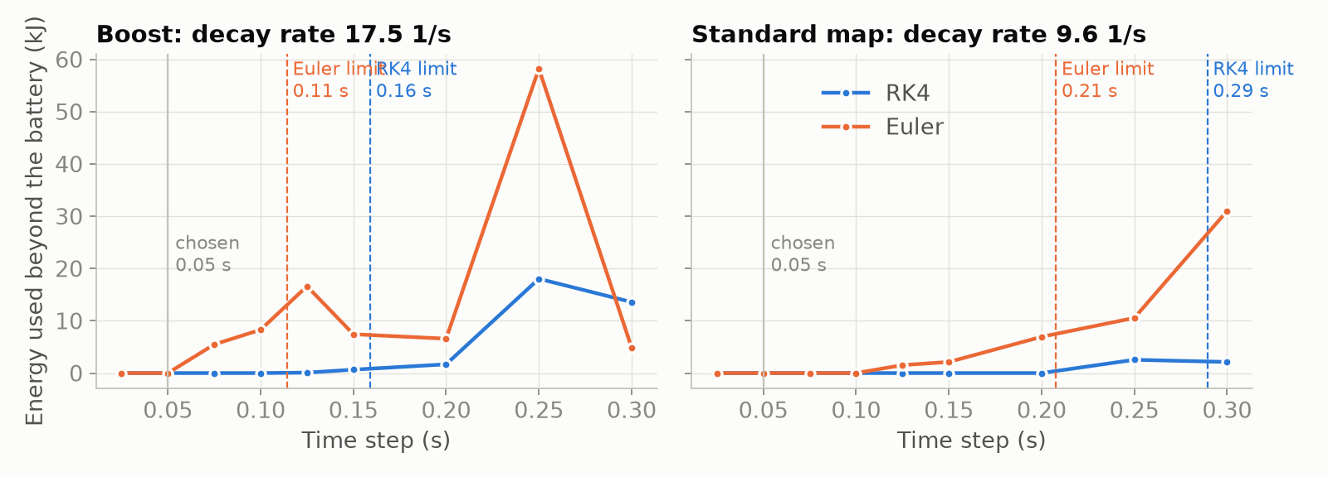
Figure A4. Energy used beyond the battery against time step on the battery-depletion ramp, with the stability limits predicted from each method’s stability region (experiments stability). Euler overdraws once $λΔt>1$, where its amplification factor turns negative, before its stability limit.
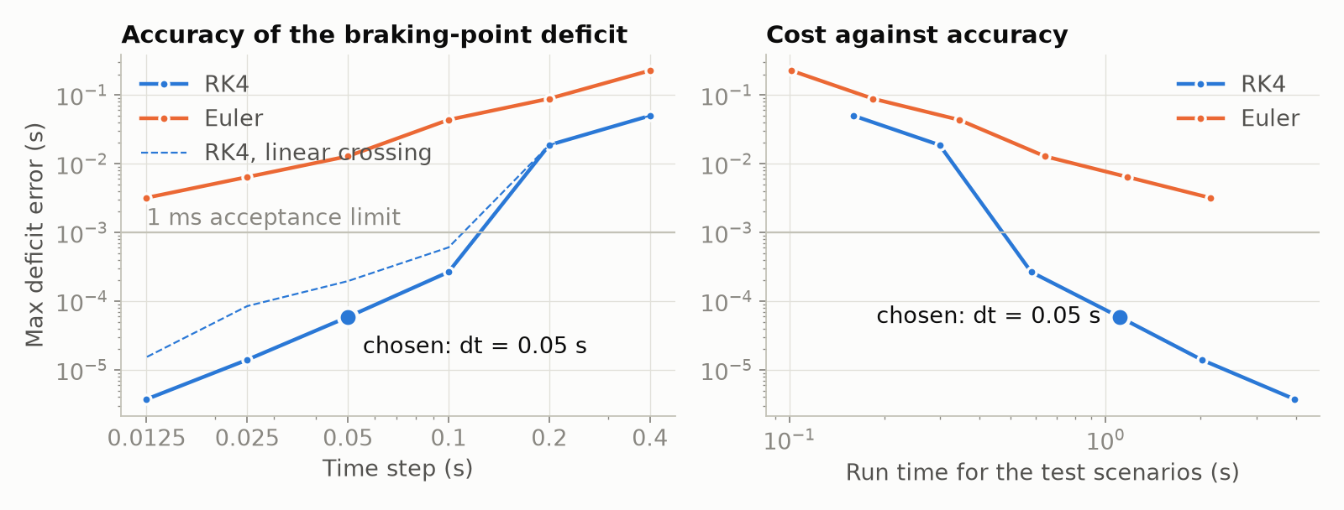
Figure A5. Worst deficit error against time step (left) and run time (right), full two-car model, with RK4 using straight-line crossing interpolation dashed; the chosen step is marked.
Table A1. Network sizes (validation set).
Hidden layers | Parameters | FLOPs per prediction | Validation log loss ± standard error | Error against exact P (points)
32 | 1,309 | 2,369 | 0.2671 ± 0.0029 | 3.4
64-64 (selected) | 6,589 | 13,313 | 0.2594 ± 0.0029 | 2.2
128-128-64 | 29,373 | 59,649 | 0.2591 ± 0.0029 | 2.3
256-256-128 | 107,709 | 217,601 | 0.2606 ± 0.0030 | 2.6
Baselines. Of nine gradient-boosting settings, the one used (learning rate 0.1, 31 leaves) was best on validation data (3.7 points, others up to 4.2); logistic regression gives 15.5 points for any penalty (experiments baselines).
The one-standard-error rule was adopted after two runs on different data ranked 64-64 and 128-128-64 in opposite orders by less than 0.001: choosing the raw minimum would have chosen on noise.
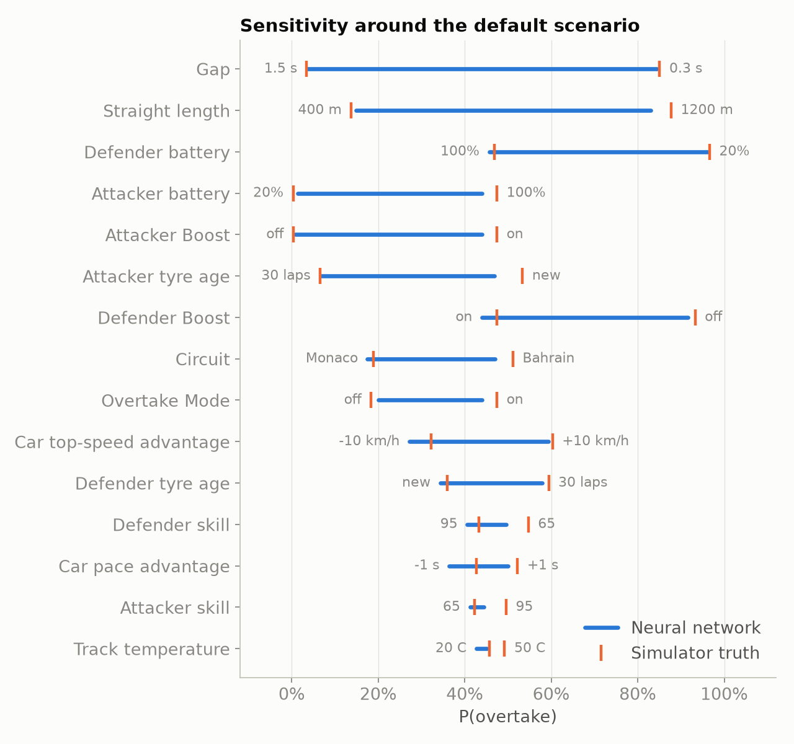
Figure A6. One-at-a-time sensitivity around the default scenario: network (bars) against the exact probability (ticks). Gap, straight length and the two batteries matter most; driver ratings and track temperature least.
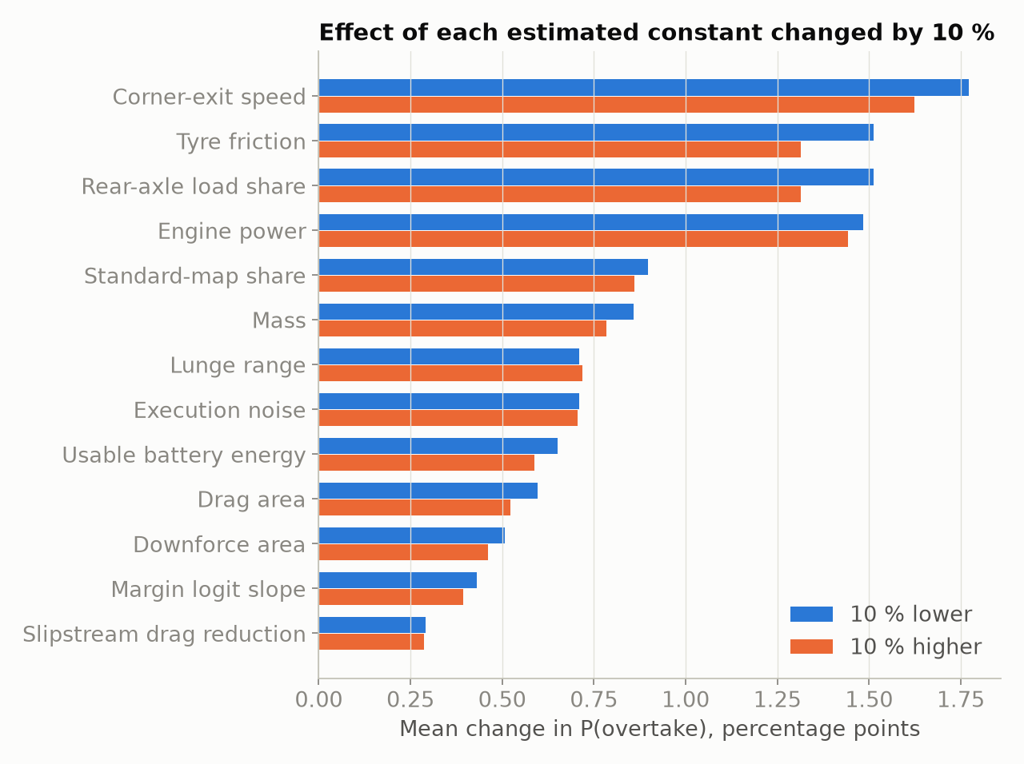
Figure A7. Mean change in the exact probability over 2,000 random scenarios when each estimated constant is 10 % lower or higher (experiments constants). Tyre friction and the rear-axle load share act only through their product, so their effects are equal.
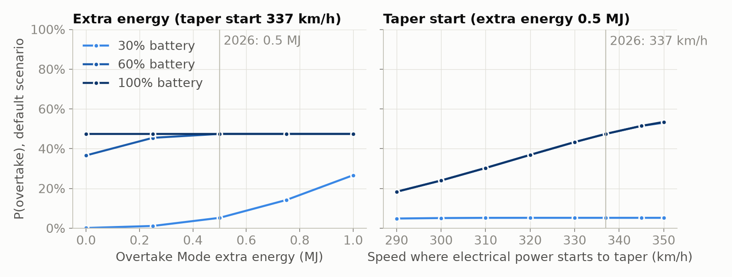
Figure A8. Exact probability in the default scenario against the Overtake Mode extra energy (left) and the speed where electrical power starts to taper (right), at three attacker charge levels (experiments rules).

Appendix B. The full-battery bias
Sensitivity analysis showed the first single network 6 points low at the default scenario. Three explanations were tested in turn. (1) Too little training data at a full battery, the edge of a uniform 0-100 % distribution: making 15 % of training attempts start full (realistic, so kept) did not reduce the error. (2) The network smooths a sharp corner: along the battery axis the exact probability rises steeply and stops abruptly near 60 %, where the battery first covers the straight; two physics-informed inputs (each car’s battery energy divided by the energy needed for full power along the straight, capped at 1) were added to hand the network that corner. (3) Run-to-run variation between training seeds. Explanations 2 and 3 were tested together over five seeds (experiments ablation, validation set):
 | Mean error (points) | Log loss | Error at default scenario (points) | Worst error along battery axis (points)
Raw inputs, single network (mean ± sd) | 2.24 ± 0.06 | 0.2595 ± 0.0004 | -3.5 ± 2.5 | 7.8 ± 2.0
Raw inputs, ensemble of 5 | 2.02 | 0.2585 | -3.5 | 7.4
Energy-cover inputs, single network (mean ± sd) | 2.18 ± 0.04 | 0.2589 ± 0.0004 | +0.3 ± 2.5 | 12.6 ± 4.3
Energy-cover inputs, ensemble of 5 | 1.97 | 0.2580 | +0.3 | 12.6
The seed alone moves the default-scenario error by about ±2.5 points, so the first network’s -6 points was partly bad luck. Ensembling cut the mean error by about 10 % with either input set, but cannot remove a bias that all runs share. The energy-cover inputs removed the bias at the default scenario and lowered the log loss slightly but consistently (by 0.0005, in all five seeds), yet made the worst error along the battery axis larger (12.6 against 7.4 points), because their energy estimate ignores the power taper above 290 km/h and puts the corner at about 75 % instead of 60 %. A model that is better on average but wrong in the place a strategist most needs was not adopted: raw inputs, ensemble of five. On a wet track with intermediates the remaining bias grows to 10.5 points at a full battery (20 % against 30 %), although across the 1,569 wet straights in the test set on which both cars use intermediates or wets the error averages 2.8 points with no overall bias.

Appendix C. Real-data comparison details
python -m overtake.experiments real; results in reports/results/real_data.json. Position changes are classified by the first rule that applies: start (lap 1, 962); neutralised (852): during a safety car, virtual safety car or red flag, or while race control had disabled Overtake Mode, taken from race-control messages; pit stop (1,253): either car pitted on that lap or the lap before, or is on its pit-out lap; on track (1,222, 28 %). Checking individual passes against the raw rows exposed the need for the neutralised rule: at Monza a “pass” on lap 6 was made behind the safety car after a red flag, on a 148 s lap against a normal 88 s. Filtering mattered as much as modelling: 72 % of recorded position changes were not on-track passes.
Table C1. Pass rate per lap against the gap at the start of the lap (7,501 driver-laps with a gap under 3 s, of 14,942 after removing lap 1, pit and neutralised laps; 95 % Wilson intervals [16]).
Gap | Driver-laps | Real pass rate | Relative to 0.25-0.5 s | Simulator, relative
0-0.25 s | 233 | 63 % (56-69) | 1.77 | 1.16
0.25-0.5 s | 801 | 35 % (32-39) | 1.00 | 1.00
0.5-0.75 s | 1,250 | 16 % (14-18) | 0.45 | 0.82
0.75-1 s | 1,061 | 6.9 % (5.5-8.6) | 0.19 | 0.65
1-1.25 s | 841 | 3.6 % (2.5-5.0) | 0.10 | 0.48
1.25-1.5 s | 705 | 4.5 % (3.2-6.3) | 0.13 | 0.37
1.5-2 s | 1,078 | 3.2 % (2.3-4.5) | 0.09 | 0.27
2-3 s | 1,532 | 2.3 % (1.7-3.2) | 0.07 | outside simulated range
The rates are per lap for real races and per attempt for the simulator, over different mixes of situations, so only their shapes are compared. A sharp step at the 1 s threshold would be blurred in the real data, because the gap is measured at the start of the lap rather than at the detection point. The circuit comparison uses 16 of the 17 races: one race’s circuit is not in the simulator’s list.

Appendix D. Reproducing the results
Result | Command | Output
Train the network and baselines | python -m overtake.train | models/overtake_net.pt, reports/results/test_metrics.json
Every experiment and figure | python -m overtake.experiments all | reports/results/*.json, reports/figures/*.png
Workflow (Figure 1) | experiments diagram | workflow.png
Verification (Tables 3, 5; Figures A3-A5) | experiments solver timestep stability adaptive quadrature | solver.json, timestep.json, stability.json, adaptive.json, quadrature.json
Plausibility, constants, rules (Section 3.1, 5.4; Figures A2, A7, A8) | experiments speed_trace constants rules | speed_trace.json, constants.json, rules.json
Model selection (Tables 6, A1; Appendix B) | experiments selection ablation | selection.json, ablation.json
Comparison (Table 4, Section 5.2; Figure A1) | experiments baselines comparison | baselines.json, comparison.json
Performance (Table 6 rows 3-4, Section 6) | experiments performance | performance.json
Sensitivity (Figures 2, A6) | experiments sensitivity | sensitivity.json
Real races (Section 5.3, Figure 3, Appendix C) | experiments real (downloads about 80 MB once) | real_data.json
Earlier runs quoted in Table 6 (slipstream row) and Appendices A-B | not regenerated by the current code | timestep_before_slipstream_fix.json (and figure), timestep_after_slipstream_fix.json, *_before_battery_sampling.json, selection_min_rule.json, ablation_3_seeds.json
Redraw every figure from saved results | experiments figures | reports/figures/*.png
Interactive calculator in the browser | python -m overtake.app | page at http://127.0.0.1:8000
Tests and report | python -m pytest --html=reports/test_report.html --self-contained-html | reports/test_report.html
API documentation | pdoc overtake --docformat numpy -o docs/api | docs/api/

Appendix E. Simulator constants
Rules are fixed by the 2026 regulations; every other value is an engineering estimate (overtake/physics.py, overtake/simulator.py).
Group | Constant | Value
Car | Air density; rear-axle load share; car length | 1.2 kg/m³; 0.55; 5.5 m
Run start | Corner-exit speed; dirty-air grip loss | 33 m/s × √(relative grip); 6 % × e^(−gap/1 s)
Battery | Usable energy; Overtake Mode extra; power ramp-out | 4 MJ × charge; 0.5 MJ; last 20 kJ
Deployment | Share of MGU-K power with Boost; standard map | 1; 0.55
Tyres | Grip relative to a new soft in the dry, by compound, surface, age and track temperature | tables in simulator.GRIP, DEG_PER_LAP, CLIFF_LAP
Outcome | Execution noise $σ$ (dry / damp / wet); extra for a rating below 90 | 0.20 / 0.24 / 0.28 s; up to 0.04 s
Outcome | Caution (dry / damp / wet); defender positioning | 0 / 0.05 / 0.12 s; 0.04 s × (rating − 60)/40
Outcome | Lunge range $L$; margin slope; margin cap | 0.15 s; 5 per s; 0.5 s
Outcome | $z_{0}$ terms | 0.5 + 1.2 × rating difference/40 + 25 × grip difference + segment + weather + circuit − 0.2 × defender Boost × defender charge
Outcome | Segment (straight, slow, medium, fast corner); weather (dry, damp, wet) | 0, +0.2, −0.6, −1.6; 0, −0.5, −0.9
Outcome | Circuit passability | −2.5 (Monaco) to +0.6 (Bahrain, Spa); generic 0
Sampling | Training scenarios: mostly dry straights, Boost for most attackers, 15 % full batteries, Overtake Mode within 1 s | simulator.sample_scenarios

