# Tracing material use to final products in dynamic material flow analysis: a comparative application of methods to the USA and EXIOBASE regions (part II)

Jan Streeck1,*, Hanspeter Wieland1,2, Stefan Pauliuk3, Barbara Plank1, Kenichi Nakajima4, Dominik Wiedenhofer1

1 University of Natural Resources and Life Sciences, Vienna, Department for Economics and Social Sciences, Institute of Social Ecology, Schottenfeldgasse 29, 1070 Vienna, Austria

2 Vienna University of Economics and Business, Institute for Ecological Economics, Vienna, Austria

3Industrial Ecology Freiburg, Albert-Ludwigs University Freiburg, Freiburg (Germany)

4XXXXXXXXXXXXXXX

*Corresponding author: [jan.streeck@boku.ac.at](mailto:jan.streeck@boku.ac.at)

# Abstract (long for now)

Several economy-wide dynamic Material Flow Analysis (dMFA) studies extrapolate fragmented information on material end-use products, i.e. the product stocks as which material consumption accumulates, for single countries and years across longer time periods and global countries. However, correct representation of end-uses is crucial to adequately respresent product lifetimes and material service contributions to human well-being. Therefore, improving the tempo-spatial and material coverage as well as resolution of material end-use products for these ‘top-down’ dMFA techniques is important to provide robust assessment of the contributions materials can make to provide human well-being within planetary boundaries.

In part I of this work we reviewed and systematized five distinct approaches that derive information on end-use products via so-called ‘end-use shares’, i.e. ratios that split total material consumption to different end-uses, by drawing on industry shipment data in physical units and monetary input-output tables (MIOTs). Here, we empirically apply these approaches to the case study USA using national-level data and to the Multi-Regional Input-Output Model EXIOBASE. Additionally, we propose and apply methodological improvements for a closer match of MIOT-dMFA system boundaries (‘Hypothetical Transfer’).

We find mixed results regarding the fit of end-use shares derived from data in physical versus monetary units. For U.S. national data, some materials show rather good fit (e.g. aluminum with a relative median deviation X%), while others deviate stronlg (iron & steel --- Y%). However, in many cases the temporal trajectory of MIOT-based end-use shares approximated that of physical data, if also at different magnitude. Hopes of achieving high end-use product resolution with detailed MIOTs remain inconclusive due to little availability of physical data at that resolution. HT-WIO best results for packaging as ‘intermediate product’….For EXIOBASE, we find good fit for some countries and materials (e.g. steel in China), while substantial deviations for some countries and end-uses bad (e.g. construction in UK). Additionally, for 18 countries very large overestimation of aluminum use in machinery. For materials for which ‘packaging’ is an important end-use, EXIOBASE is ill-suited to to missing this sector.

To apply MIOT-based end-use shares to dMFA, without any idea of physical realities seems risky. However, together with available industry shipments, MIOT-data might add additional information regarding temporal trajectory and variance between countries. Together with use of qualitative data and country characteristics that might help to bringt in more country and temporal resolution. Additionally, hopes are that new developments in MRIOs that are specifically build for material flows such as GLORIA might provide better suited information.

# Introduction

To evaluate system-wide effects of changing consumption patterns, we require methodologies that quantify resource use both comprehensively, i.e. the economy-wide use of multiple materials with global long-term coverage, and detailed, i.e. establishing a connection of element and material cycles to the end-use products that humans demand for their well-being (Haberl et al. 2019). Dynamic Material Flow Analysis (dMFA) is a research field that has longstanding expertise in detailed assessments of production and consumption (Müller et al. 2014; Lanau et al. 2019; Fu et al. 2021), and recently also the less detailed but more comprehensive field of economy-wide Material Flow Accounting (ew-MFA) is moving in this direction (Wiedenhofer et al. 2019; Streeck et al. 2020; Plank et al. 2022).

However, dMFA models and studies are yet often either detailed or comprehensive due to the huge efforts required to achieve both at the same time. Stock-driven ‘bottom-up’ dMFA can be very detailed but requires huge efforts to achieve economy-wide coverage, if at all feasible due to data constaints. The ‘Resource Efficiency – Climate Change’ (RECC) model, for instance, represents material use in buildings and passenger vehicles with high level of detail regarding different material qualities and multiple end-use product archetypes, but requires large efforts to achieve full system coverage (Pauliuk et al. 2020; Pauliuk and Heeren 2020). On the other side of the dMFA method spectrum are inflow-driven ‘top-down’ dMFA approaches which utilize statistics of economy-wide material consumption. These models can cover comprehensive material use but with little detail, i.e. no distinction of product end-uses. An example is the Material Inputs, Stocks and Outputs (MISO) model, which connects economy-wide material consumption with stock-flow modelling (Wiedenhofer et al. 2019).

Although the detail of the ‘bottom-up’ models is hardly achievable via the ‘top-down’ dMFA methodology, studies that introduce mid-level end-use detail to the latter exist (Streeck et al., in preparation): for example, Dahlström et al. (2004) who introduce 6-9 end-use sectors to economy-wide material flows for crude iron, steel and aluminum in the UK, or Cao et al. (2017b) who introduce three end-use sectors for economy-wide cement use in 184 countries.

To introduce end-use detail, many of these studies use ‘***end-use shares’***, i.e. shares to split total material consumption to different end-use products or sectors (see Figure/Table 1 in Streeck et al., in preparation). These end-use shares can be derived from two different data sources: first, data on material shipments to different industries or markets in mass units, as reported by industry associations and statistical bureaus; and second, monetary input-output tables (MIOTs) which can be utilized to derive end-use information from monetary as proxy for physical data. Industry shipment data in mass units are scarce and most of the studies that make use of such data focus on a single material or country, or extrapolate information for few years and countries across the globe (e.g. Müller et al. 2006; Daigo et al. 2007; Pauliuk et al. 2013). MIOTs in contrast are widely available and their economy-wide nature, coverage of multiple sectors of material production, and compilation in global multi-regional input-output models (MRIOs), makes them an attractive data sources for deriving end-use shares for many materials, countries and years (applications in for example Hashimoto et al. 2007; Chen and Graedel 2015; Pauliuk et al. 2017).

If we were able to combine information from these two data sources to derive ‘end-use shares’ for a wide range of materials, countries and years, the application to economy-wide MFA databases, covering up to almost all global countries and a wide range of materials (UNEP 2016), could quantify the material consumption in different end-use products or sectors at novel material and country resolution.

Therefore in Streeck et al. (in preparation) we reviewed the literature that used industry shipments and MIOTs to generate end-use shares and theoretically assessed five different approaches for their similarities, strengths and weaknesses. We concluded that the Waste Input-Output approach to MFA (WIO-MFA; Nakamura et al. 2007) represents the most accurate choice to derive end-use shares from MIOTs, as it closely sticks to the mass-balance principle of dMFA. However, also for WIO-MFA limitations remain regarding the match of MIOT-dMFA system boundaries (see Streeck et al. (in preparation) and section 2.1.1 for details). Furthermore, despite being inferior from a theroretical point of view, some approaches other than WIO-MFA might still be attractive for initial assessments due to their time-efficient application.

Here we apply the five identified approaches to derive end-use shares for empirical data, suggest one particular methodological improvement, and compare derived results between methods, materials and end-uses. We deploy the methods to U.S. national MIOTs in a detailed comparison drawing on official national data with detailed product group resolution. Additionally, we apply an improved version of WIO-MFA (‘Hypothetical Transfer-WIO’) to the regions of the MRIO EXIOBASE (Stadler et al. 2018). We aim to answer the following research questions:

* RQ1: How well do end-use shares derived from industry shipments in physical units and monetary input-output tables agree for the case of the USA and EXIOBASE regions?
  + RQ1.1: How well does the suggested improvement to WIO-MFA (‘Hypothetical Transfer)’ perform?
  + RQ1.2: Which differences across different materials and end-use products/sectors can be observed?
  + RQ1.3: What is the effect of sector and product aggregation on differences in end-use shares?
  + RQ1.4: How well do end-use shares from national data agree with end-uses derived from an MRIO?
* RQ2: What do the outcomes of RQ1 imply for obtaining end-use share information for many materials, years and countries for application to economy-wide Material Flow Accounting / Analysis?

# 2. Methodology

## 2.1 Summary of applied methods

In Streeck et al. (in preparation) we reviewed and systematized five methods to differentiate end-use products for economy-wide material flows based on data on industry shipments in physical units and monetary input-output tables (MIOTs). Additionally, we suggest one methodological improvement (‘Hypothetical Transfer’), overall making six methods that we here comparatively apply. Table 2 lists the key formulas of the methods, which we briefly describe in the following:

Table 1: Formulas and literature sources for deriving end-use shares from industry shipments in physical units (eq. 1) and the five input-output approaches (eqs. 2-12) used in this study. For a detailed description of methods, please refer to Streeck et al. (in preparation).

|  |  |  |  |  |
| --- | --- | --- | --- | --- |
| Data | Approach | Key equations |  | Selected papers |
| Physical industry shipment | Direct use, (dis)aggregation of shipments (S) |  | (1) | Pauliuk et al. 2013; Liu and Müller 2013; Cao et al. 2017b |
| Monetary input-output tables | Waste Input-Output Approach to Material Flow Analysis (WIO-MFA) |  | (2) | Nakamura et al. 2007; Nakamura et al. 2014 |
|  | (3) |
|  | (4) |
| Consumption-based accounting (CBA) |  | (5) | (Hashimoto et al. 2007) |
| Ghosh Input-Output Approach to Absorbing Markov Chains (Ghosh-IO AMC) | , | (6,7) | Duchin and Levine 2010, 2013 |
|  | (8) |
| Partial Ghosh Input-Output (Partial Ghosh-IO) |  | (9) | Cao et al. 2017a; Aryapratama and Pauliuk 2019 |
|  | (10) |
| Hypothetical Transfer applied to WIO-MFA (HT-WIO) |  | (11) | own suggestion; to be combined with WIO-MFA, CBA or Ghosh-IO AMCto derive |
|  | (12) |

^ = matrix is diagonalized, -1 = matrix inverse**,** x = total product output, **L** = Leontief inverse, y = final demand, **D** = end-use share matrix, = material shipment to industry *i*, = technology matrix, = mass filter, = yield filter, index *m*,*p*,*c* = reference to partitioned matrices for materials *m*, intermediate products *p*, products delivered to final consumption *c*, **B** = matrix of allocation coefficients normalized to total output, **B**INTER = matrix of allocation coefficients normalized to intermediate output, = matrix for transferring transactions from **Z** to **Y** (see next subsection).

We use the summary term ‘industry shipments’ for statistics in physical units describing material deliveries to industry sectors or markets from which end-uses can then be inferred and assumed according to industry/market label (e.g. ‘construction’). Industry shipments often only cover parts of total material consumption (see Streeck et al., in preparation for detailed explanation). For that reason, many of the studies identified in Streeck et al. (in preparation) do not use industry shipments as direct input to dMFA models but instead calculate end-use shares by dividing individual by total shipments (eq. 1) and applying these shares to total material consumption, as we do here.

All methods using MIOTs distribute materials according to the monetary transactions from industry to industry (Partial Ghosh-IO) or from industry to final demand (all other MIOT methods), with differences in underlying IO-models and data manipulation between methods (Streeck et al., in preparation). For all models presented here, proportionality between monetary and physical flows is assumed as default.

The Waste Input-Output approach to Material Flow Analysis (WIO-MFA) aims to track mass-balanced material and product flows with help of a Leontief price model. Therefore, the technology matrix representing economy wide transactions between industries is manipulated: filters are introduced to remove non-physical and waste transactions (eq. 2). In addition the technology matrix is partitioned in into two parts (eq. 3): one with coefficients only for transactions from material to product sectors, and the other with coefficients only for transactions from product to product sectors. These features allow WIO-MFA to approximate material and product flows at their actual mass, instead of calculating footprints. The end-use share matrix is calculated by dividing deliveries to final demand per product by total product output (eq. 4).

The Consumption-based Accounting approach (CBA) calculates material footprints following the (environmentally extended) Leontief quantity model and uses supply-chain wide multipliers. That means that the allocation of material flows entails embodied materials over the whole supply chain, not removing transactions that refer to waste or non-physical flows. As for WIO-MFA, is calculated by dividing deliveries to final demand per product by total product output (eq. 5). In equation 5 we only use the monetary data to compute end-use shares, without considering environmental satellite accounts.

The Ghosh-IO approach to Absorbing Markov Chains (AMC) combines a Ghosh quantity model with fixed sales structure with the input-output market balance (shares of final demand on total output as the Markov absorbing state; eq. 6-8). Like WIO-MFA, Ghosh-IO AMC partitions transactions between materials and products (eq. 6).

The Partial Ghosh-IO approach in contrast does not use final demand accounts but only relies on the interindustry matrix, for which the practitioner defines absorbing states as a set of sectors in this matrix (eq. 9).

The basic element of both Ghosh-type approaches is the allocation matrix , with its coefficients representing sector market shares (mind the different definition of between methods in Streeck et al., in preparation). For Partial Ghosh-IO the end-use share matrix is readily obtained as part of a Ghosh-type inverse (eq. 10), while for Ghosh-IO AMC the inverse is multiplied with the absorbing state (final demand shares; eq. 8). For detailed conduct of methods please refer to part I of this publication (Streeck et al., in preparation).

Of all described MIOT-based methods, WIO-MFA adheres most closely to the dMFA logic and can be regarded as most accurate for evaluating end-use shares from a theoretical point of view (Streeck et al., in preparation). However, as discussed in Streeck et al. (in preparation), also WIO-MFA has limitations. Therefore, we additionally introduce a fifth approach to MIOTs, call this method ‘Hypothetical Transfer (HT)’, which we here apply to WIO-MFA (‘HT-WIO’). This suggested method variation and the limitation it addresses is described in section 2.1.1.

### 2.1.1. Methodological suggestion: ‘Hypothetical Transfer’ applied to WIO-MFA (‘HT-WIO’)

All MIOT-based methods that determine the end-use of materials according to the products these are contained in when being delivered to final demand come with a potential limitation: when calculating the supply-chain distribution of materials to products (the inverse), the end-use meaning of products can be lost due to non-matching system boundaries of MIOTs and dMFA (see Streeck et al., in preparation). For instance, products such as ‘packaging’ are end-uses (= final demand) in the sense of dMFA but are classified as intermediate demand in MIOTs, meaning that they have zero or very small final demand themselves, but instead are delivered to other industries. Thus the materials (e.g. ‘plastics’) contained in these intermediate products (e.g. ‘packaging’) are accompanying other products (e.g. ‘motor vehicles’) delivered to final demand. However, when calculating the common supply-chain tracing via Ghosh/Leontief inverse, these specific intermediate products (e.g. ‘plastics in packaging’) delivered to products for final demand (e.g. ‘motor vehicles’) are missclassified according to the end-use of the final product (e.g. as ‘plastic in motor vehicles’). Above issue can apply for MIOT transactions between sectors representing physical products (the ‘packaging’ example), but also between a sector representing a physical product and a service sector. ‘Plastics’ might then for instance end up in the end-use ‘hotels and restaurants’, the physical use of which could only be guessed (might be packaging, but also other end-uses if these are accounted for as intermediate demand).[1]

There are three ways to resolve end-use missclassification as ‘service’, while only one for assignment to the wrong ‘product’: 1) for ‘service’ one can ‘guess’ the end-use by assuming for instance that ‘plastics’ delivered to ‘hotels and restaurants’ end up as food packaging (e.g. similarly done for cement in Cao et al. 2017a), 2) one can simply delete the transactions to ‘service’ sectors which might seem intuitive for WIO-MFA mass filters (to our knowledege, no study reports steps from original to mass-filtered MIOTs so that dealing with ‘services’ in other studies can only be assumed), or 3) one might apply methods similar to production layer decomposition to re-instate the end-use functionality of upstream inputs (works for misclassification as ‘product’ and ‘service’).

Case 1) seems ill-advised as it introduces subjective assumptions. Case 2) biases the distribution of materials to end-use products, as the upstream supply-chain ‘pull effect’ from the ‘service’ sectors’ final demand is neglected. Thus only case 3) seems sensible and at least two methods exist to correct for misclassifications: the Hypothetical Extraction Method as applied by (Yokoi et al. 2018; Dietzenbacher et al. 2019; Hertwich 2021) and production layer decomposition as supposed by (Nakamura et al. 2007). However, all of these approaches imply initial double counting, if MIOTs are not perfectly triangular (directional). This can be corrected for (see Cabernard et al. 2019; Hertwich 2021), which however comes with assumptions and tedious work, which seems hardly applicable to all sectors of detailed MIOTs such as the national U.S. official national MIOTs.

Therefore, we here propose a simple approach that corrects for missclassifications by transferring direct flows of particular transactions to final demand, and term that method ‘Hypothetical Transfer’(HT): the total flow matrix is used to transfer the transactions considered intermediate for MIOTs but end-use for dMFA (e.g. the total output of ‘packaging’ by MIOT sector) to final demand (Figure 1 and Table 1 eqs. 11-12). This way the intermediate products of interest which formerly were endogenous to the interindustry system are exogenized to final demand, thereby keeping their end-use meaning during inverse calculation. One could also express this procedure as cutting off the system boundary of the interindustry system towards downstream.

The proposed operation does not change the MIOT market balance, as values are simply relocated within the balance without chainging total sector output (transactions for rows transferred from to ). The missing input to the industry balance is assumed to be covered by additional value added (transactions for columns from to ).

Hypothetical Transfer can be conducted for any full IO-model (considering both interinudustry and final demand accounts). When using this method in conjecture with WIO-MFA, yield filters should be applied to (instead of ) before Hypothetical Transfer, to avoid the assignment of ‘waste flows’ to final demand (eqs. 11-12). For a simple matrix algebra example please refer to the supplementary information two (SI2).

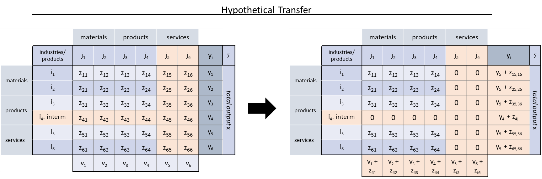

*Figure 1: Example for the Hypothetical Transfer (HT) method applied to an example monetary input-output table (MIOT): during hypothetical transfer, the direct flows of products that are intermediate demand in the logic of MIOTs but end-use (final demand) in dynamic Material Flow Analysis (‘i4 interm’), as well as monetary flows that most probably correspond to a physical counterpart but are input to services sectors (sector output to j5/j6), are transferred from the interindustry flow matrix to final demand . One could say that the interindustry supply chain is cut-off towards downstream by re-classifying intermediate outputs as final demand (end-use).*

## 2.2 Data sources

Table 2 shows the data sources for U.S. industry shipments and MIOTs, as well as their temporal coverage and end-use resolution. The industry shipment data comes with several limitations detailed in Streeck et al. (in preparation). To notice for the U.S. in particular are: for both data sources on Copper, the end-use ‘buildings construction’ contains construction machinery (USGS 2015; CDA 2020); USGS (2015) iron & steel data is only partially useful as 62-73% of total shipments are reported to the end-uses ‘service centers and distributors’, ‘undistributed’, or ‘other’; for iron & steel the American Iron and Steel Institute (AISI 1941-2005) data as reported by Pauliuk et al. (2013) only reports 50% of steel shipped to domestic crude steel production; for iron & steel the YSTAFB data (Myers et al. 2019) leaves unclear which end-use shares rely on AISI reported values; for wood, the data by McKeever (2009) was generated partially drawing on economic data, which cannot deliver a completely independent picture in comparison to input-output generated end-use shares and gives volumetric

Table 2: Material, time and end-use resolution for industry shipment data sources, as well as national level monetary input-output tables (MIOTS) for the USA, and the multi-regional input-output model EXIOBASE.

|  |  |  |  |  |
| --- | --- | --- | --- | --- |
|  | Source | Period | End-uses | Comment |
| Industry shipments | | | | |
| Aluminum | USGS (2015) / AAI (1976–2003) | 1975-2003 | (Building &) construction, Consumer durables, containers and packaging, electrical, machinery and equipment, transportation, other | USGS data based on AAI end-use shipment shares applied to USGS data on apparent consumption; added net trade in final products from Streeck et al. (2021); yield correction applied |
| Liu and Müller (2013) | 1960-2009 | From Global Aluminium Recycling Model; yield correction applied |
| Cement | PCA (2016) | 2011-2015 | Public construction, nonresidential buildings, residential buildings, other (all with 4-7 subcategories) | - |
| Cao et al. (2017b) | 1992-2016 | Civil engineering, nonresidential building, residential building |
| Kapur et al. (2008) / PCA (2005) | 2003 | Residential buildings, public buildings, commercial buildings, water and waste management, streets and highways, farm construction, utilities, others |
| Copper | USGS (2015)/CDA (2020) | 1975-2003 | Building construction, Consumer and general products, Electrical and electronic products, Industrial machinery and equipment, Transportation equipment | CDA shares applied to US primary copper apparent consumption; Added net trade in final products from Streeck et al. (2021) |
| CDA (2020) | 1999-2019 (as available) | tracks gross metal shipments to end use markets (more comprehensive); Added net trade in final products from Streeck et al. (2021) |
| CDA (2022) | 1994-2002, 2008-2010 | Building wire, plumbing & heating, power utilities, automotive electrical, air conditioning & commercial refrigeration, telecommunications, in-plant equipment, business electronic, ordnance, lighting & wiring devices, other (slight changes over years) | - |
| Iron & steel | USGS (2015) / AISI (2003) | 1975-2003 | Construction, Containers, Other, Service centers and distributors, Transportation, Undistributed | Large fraction to service centers and undistributed; Added net trade in final products from Streeck et al. (2021) |
| Pauliuk et al. (2013) / AISI (1941-2005) | 2004 | Aircraft, agriculture, appliances, automotive, construction, containers & shipping materials, electrical equipment, machinery, mining and quarrying, oil and gas industry, ordnance and other military, other domestic and commercial equipment, rail transportation, shipbuilding | Only represents 50% of shipments to domestic crude steel production |
| YSTAFB (Myers et al. 2019) / Müller et al. (2006)/ AISI (1941–1999) | 1941-1999 | Construction, machinery & appliances, other products, transport | Original data not published; unclear for which years primary data was used |
| Plastics | Euromap (2020) | 2009-15 | Automotive, construction industry, electrical electronics and telecom, packaging, other | Unclear whether physical/downloaded; data was downloaded in 2020, now members-only |
| Tin | USGS (2015) | 1975-2003 | Cans & containers, electrical, construction, transportation, other | Data sourced from USGS and U.S. Bureau of Mines; apparent consumption |
| Wood | McKeever (2009) | 1950-2006 | New housing (single family, multi family, manufactured), residential repair & remodeling, new nonresidential (buildings, other), manufacturing (furniture, other), packaging & shipping, other | Data result of estimation process including use of monetary data; yield correction applied for end-use ‘furniture’ |
| U.S. national MIOTS | | | | |
| 12-19material | US BEA (2018,2021) | 1963, 1967-2012 (5-yearly) | sectors for 2012 MIOT (exemplary): 28 construction, 64 machinery, 26 transport, 8 household appliances, 8 furniture, 8 textiles, 5 packaging, 29 food, 19 extraction, 135 services, 75 others | Sector classification changes over time; yield correction for WIO-MFA according to yield filter matrices |
| EXIOBASE (44 countries + 5 rest of world regions) | | | | |
| 15 materials | Stadler et al. (2021) | 1995-2011 | Sectors: 1 construction, 5 machinery & appliances, 2 transport, 1 furniture & others, 3 textiles, 26 agriculture & food, 27 raw materials, 22 energy carriers, 66 services, 48 others | Yield correction for WIO-MFA according to yield filter matrices |

*for remaining materials USGS industry shipments only report intermediate use categories (e.g. for lead, zinc, cement); plastic end-use data in theory available from ‘Resin Review: The Annual Statistical Report of the North American Plastics Industry’ (ACC), but fee-based

not mass end use shares which we converted using factors from FAO (see SI 1.2.5); and where indicated in Table 2, material contained in final goods trade was added from data obtained in Streeck et al. (2021).

Industry shipment data for countries other than the U.S. were available from the sources listed in SI 1.1. In general little long-term data are available on the country level. The data we found distinguished between 5-10 end-use categories. Highest geographical resolution were information for 20 countries and 9 world-regions for aluminum (Liu and Müller 2013; Bertram et al. 2017), 184 countries for cement ca. 1990-2011 (Cao et al. 2017b), North America and EU28 for copper (Spatari et al. 2005; Ciacci et al. 2017), China, India, UK and USA for iron and steel (Dahlström et al. 2004; Pauliuk et al. 2012, 2013), ca. 63 countries for 2009-15 and longer for China and EU for plastics (Euromap 2016; Jiang et al. 2020; Plastics Europe 2006-2021).

Regarding MIOTs, we herein utilize national MIOTs for the USA, as well as the state-of-the-art multi-regional input-output model EXIOBASE. U.S. national MIOTs were derived from the U.S. BEA benchmark supply-use tables/MIOTs (US BEA 2018, 2021), which are available at a very high sectoral resolution (367-537 sectors) for the years 1963 and every five years from 1967 onwards until 2012. For comparison, and considering a globally available source for other countries we used EXIOBASE v3.8.2 as published by Stadler et al. (2021).

## 2.3 Technical implementation and testing sensitivity in scenarios

The detailed preparational steps required to calculate end-use shares with the methods in Table 1 are described in the supplementary information (SI 1.2) and summarized here. The scripts and underlying data for calculation of results from MIOTs are available on GitHub (insert link to repository).

Predominantly, we used industry shipment data without further manipulation. Only for cases in which it was clear that system boundaries required adjustment to calculate domestic end-uses we applied the following operations as indicated in Table 2: 1) when shipments did not include trade in final products we added UN Comtrade data derived from Streeck et al. (2021), and, 2) when we could be certain that shipments referred to crude materials, for which substantial processing losses during manufacturing to final products could be expected, we subtracted processing losses as reported in the WIO-MFA yield matrices (see GitHub repository). The end-use was inferred by the labeled destination of shipments (e.g. ‘construction’).

For MIOTs the practitioner needs to make several choices for calculating end-use shares: 1) which parts of MIOT accounts to use to represent domestic material consumption, 2) how to identify the sectors that distribute materials to end-use, and the end-use meaning from sector labels, and, 3) how to manipulate MIOT data to approximate physical flow behavior for monetary transactions.

1. For both USA national and EXIOBASE MIOTS, we used reported accounts for domestic and imported interindustry flows and final demand (excluding exports and inventory changes).
2. For MIOTs we had to choose the sectors that represent material and end-use from the entire sector list. We selected sectors representing material use according to sector label and description (for the USA in NAICS (2017)) that closest matched the properties of a potential material extension. For example, we designated the sector ‘iron & steel production’ as the sector distributing the domestic use of crude steel material flows to downstream MIOT sectors. For the U.S. tables, several sectors potentially qualified for distributing material flows. Therefore, we calculated end-use shares for two sets of sector selections and evaluate their influence on results (see SI 1.2.2 for sets; default is ‘Base’). Similarly, we identified the end-use of sectors according to their label. USA MIOTs show very high sector resolution and could in theory distinguish hundreds of product groups. For presentation of results, we aggregated end-use sectors (after calculations) to 18 end-use categories and allocated each sector output to these categories according to sector label. For the USA we therefore consulted the description in NAICS (2017) as well as allocation in Chen (2017). Please note that end-use categories are not necessarily entirely exclusive: for instance, products such as ‘prefabricated buildings’ are part of either ‘residential structures’ or ‘non-residential structures’ but could not unambiguously allocated to one of the latter according to their label and were thus classified under the category ‘other buildings’.
3. All MIOT-based approaches to calculate end-use shares require the definition of filter matrices (except for CBA). Filter matrix configurations and scripts to assemble filters are documented on GitHub.

For WIO-MFA, two types of filter matrices need to be designed: the mass filter and the yield filter. The mass filter removes monetary transactions/flows that are believed to have no physical counterpart, such as service flows. The decision on whether to filter, i.e. set to zero, or keep a specific transaction remains subjective to some degree. To capture the ambiguity we designed two filter scenarios: one in which service sector in & outputs were deleted (called ‘WIO-MFA’; default) and one in which only service sector outputs were deleted (called ‘WIO-MFA_filtDif’).

Ghosh-IO AMC filters were designed as described in Duchin and Levine (2010): no mass or yield filters were applied but reverse transactions from products to materials were prohibited and the final demand of sectors selected as ‘materials’ were set to zero.

For the Partial Ghosh-IO filter, products need to be differentiated into intermediate and end-use products. We followed th reasoning of Aryapratama and Pauliuk (2019) who evaluate the differentiation in their case study according to the ratio between the value of product output going to intermediate versus final demand. For details on filter matrices please refer to SI 1.2.3.

# 3. Results

## 3.1 USA

Results in this section refer to USA national MIOTs and shipments in Table 2, if not labeled otherwise. The figures below only show MIOT-based results on the level of sector aggregation that matches the categories of the physical unit industry shipments. We found 115 time series or data points of material end-use industry shipments for comparison to MIOT-based results. Here we compare to 54 of these data series, the remainder depicting either very detailed categories that we aggregated for comparison, or categories such as ‘other’. For additional results please see SI 1.3 and GitHub repository.

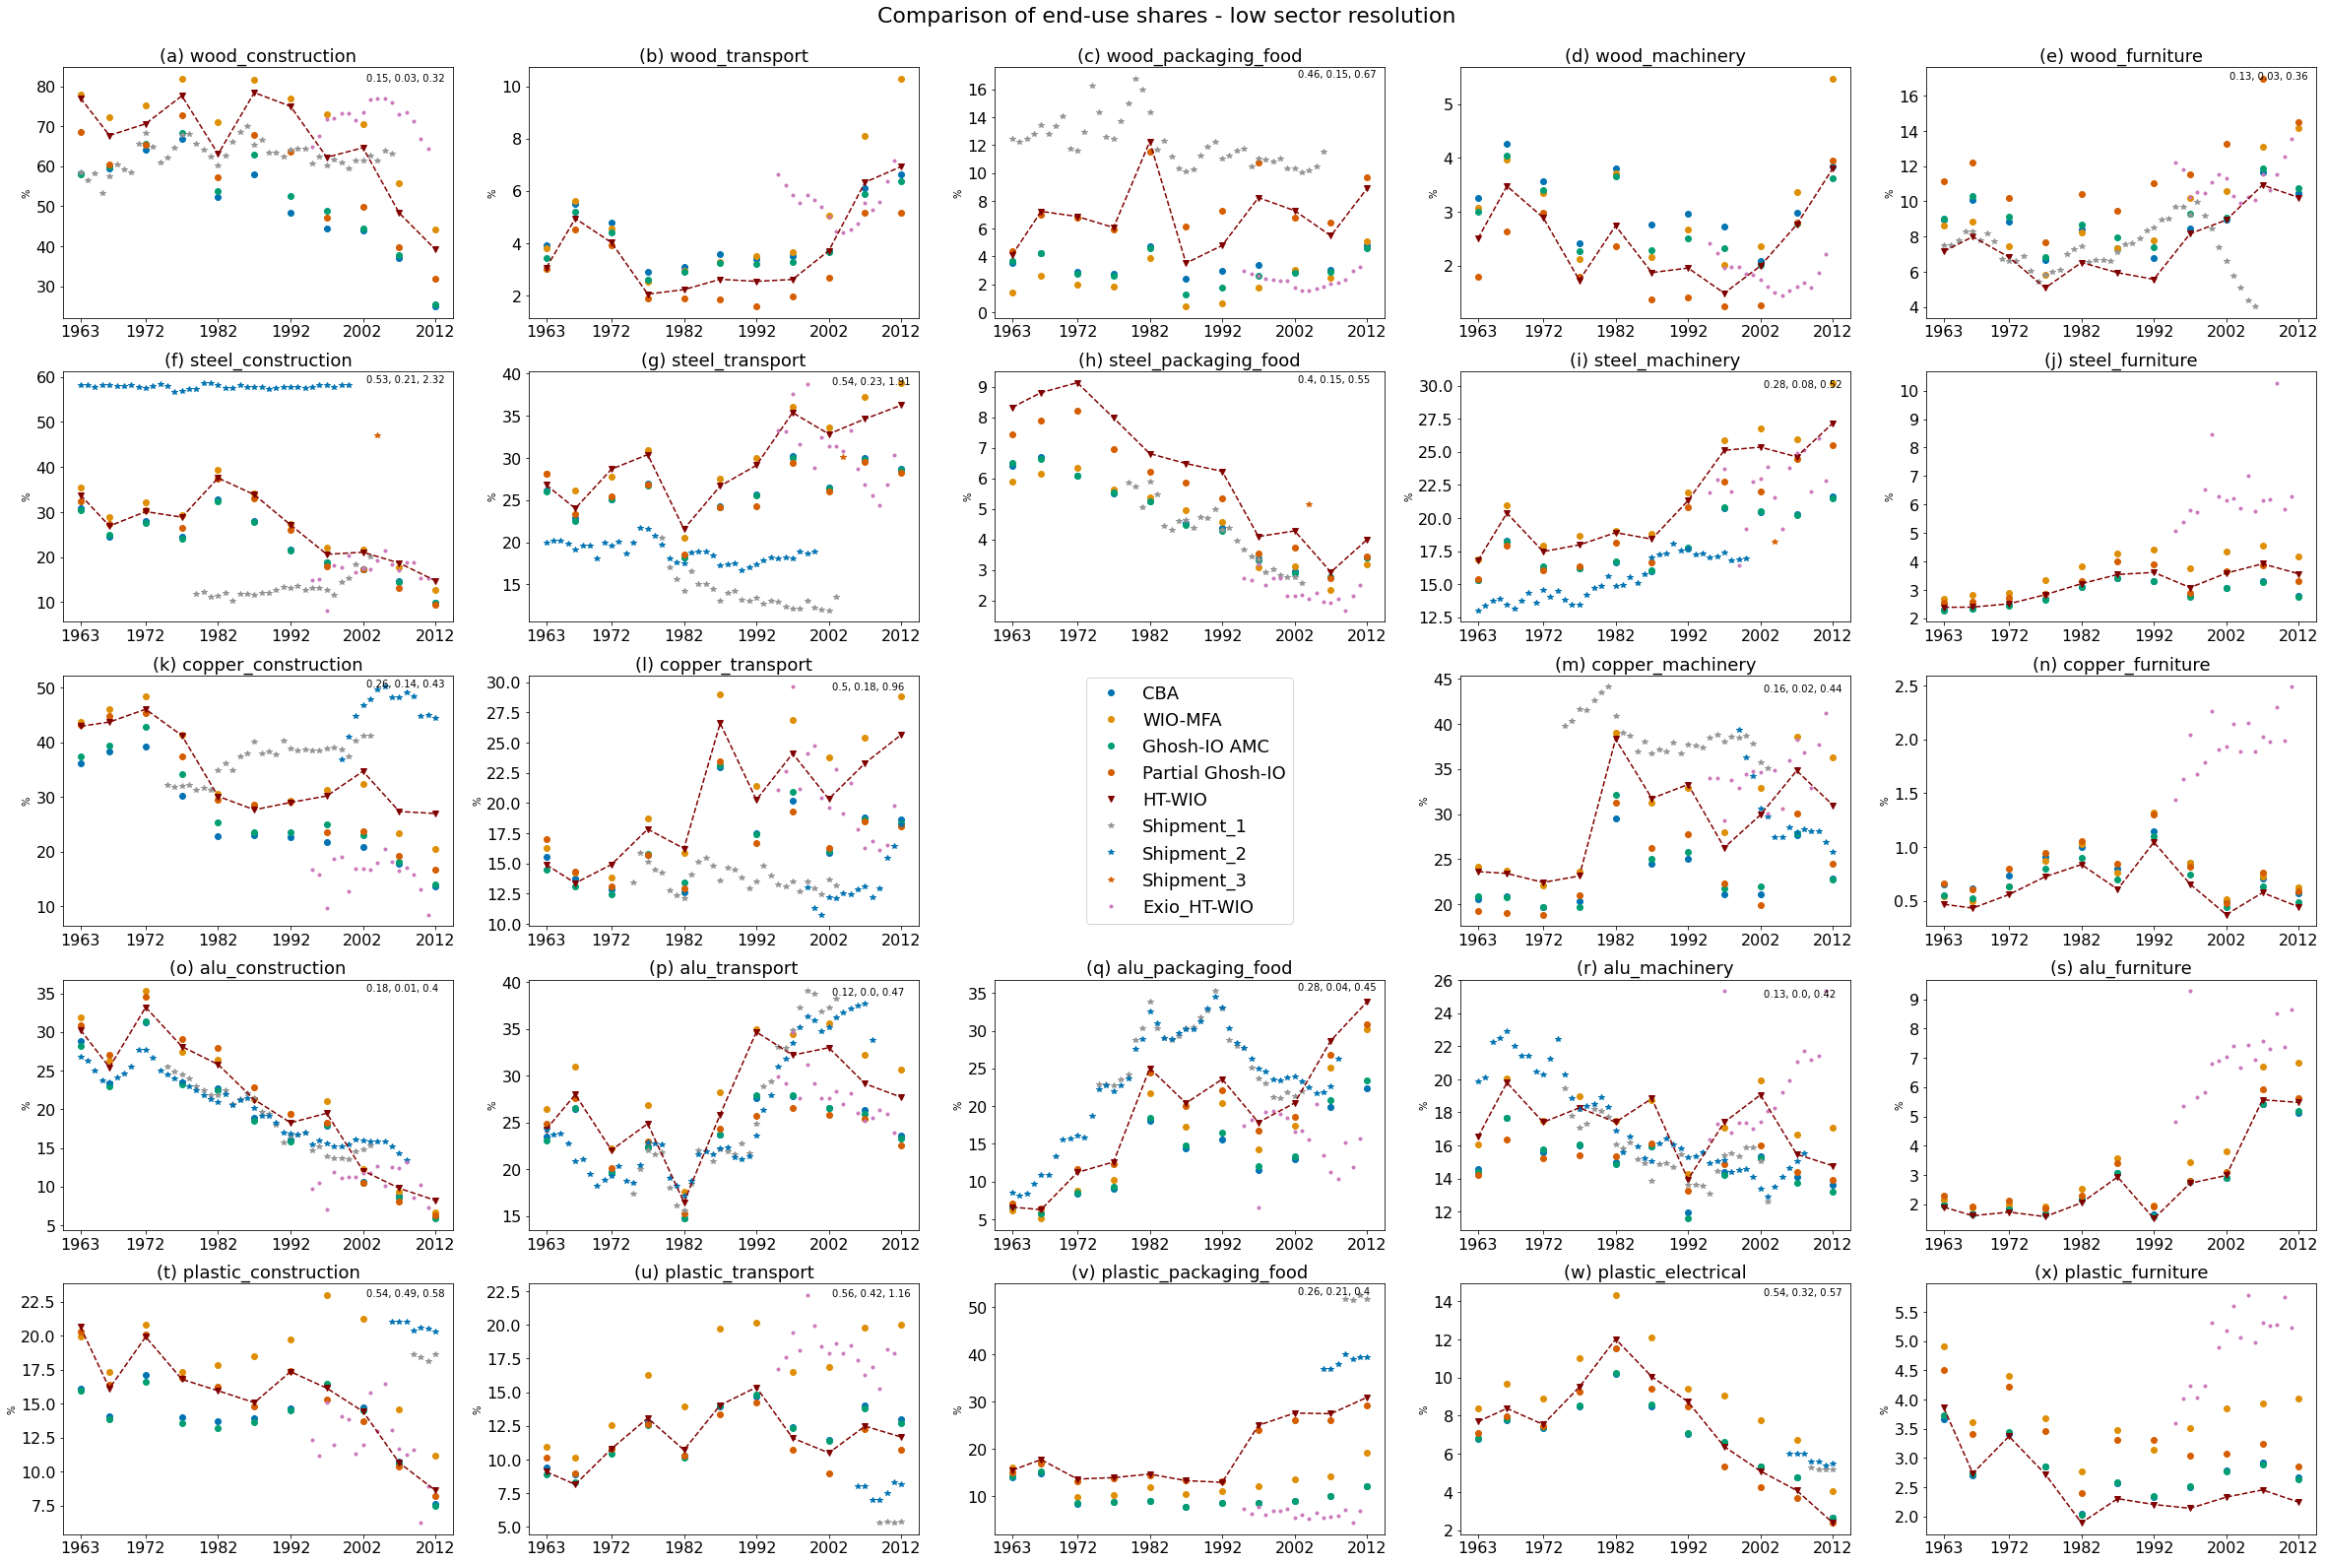

Figure 2: Comparison of end-use shares derived from U.S. monetary input output tables (MIOTs) for 11 data points between 1963-2012 generated with five input-output approaches and industry shipment data in physical units (see section 2) at low sector resolution (results aggregated to 14 sectors after calculations). Values in the upper right corner of subplots refer to the relative deviation of HT-WIO results from shipments (median, minimum, maximum). For the methods to MIOTs, specific sectors were selected to represent material distribution as end-use shares. To see which sectors were considered to correspond to the shown materials ones were for each year, please see the SI 1.2.2 ‘Base’ scenario.X . The shown data sources for industry shipments are (Table 2): wood - all: McKeever 2006; steel – 1: USGS, 2 – YSTAFB, 3 – Pauliuk et al. 2013; aluminum: 1 – USGS, 2 – Liu et al. 2013; copper: 1 – USGS, 2 – CDA; plastic: 1 – Euromap, 2 – Plastics Europe (data for EU not US)

### 3.1.1 Comparison of HT-WIO to industry shipments at low sector resolution (RQ 1, 1.1, 1.2)

In Figure 2, we compare the end-use shares for different materials, end-use categories and the U.S. national MIOTs, as well as EXIOBASE, to available industry shipments. We here highlight ‘HT-WIO’ as the theoretically most accurate MIOT-based approach to trace material flows to end-use products (see section 2.1.1). The values in the upper right corner of subplots refer to the relative deviation of HT-WIO results with U.S. national MIOTs from shipments (median, minimum, maximum). In text, we additionally describe the deviation over more than one subplot as the . Please note that the 5 selected end-uses in Figure 2 represent the lion’s share of material use but might not sum up to 100% due to remainging ‘other’ uses (see Data SI ‘HTWIO_fullResults_USA’ for overview of 100% allocation).

The relative deviation of HT-WIO results in comparison to industry shipments over all materials, end-uses and years was . However, this deviation was biased by the differing availability of industry shipments per material and end-use. Therefore it seems more instructive to look at deviation of individual materials, end-uses or combinations thereof: per material, the HT-WIO results for aluminum showed the the best (relative deviation ,) while steel showed the worst fit to industry shipments (). The poor match for steel was to some degree due to the poor quality of steel industry shipment data, indicated by strongly diverging values for shipment sources (panels f & g). Looking at the comparison between end-use categories, differences were smaller than between materials, with machinery & electrical being closest to shipment data with a relative deviation of , and transport deviating strongest with . For individual subplots, we found rather good fit for, for example, aluminum in construction (panel o) or wood in furniture (panel e) and rather bad fit for, for example, steel in construction (panel f) or wood in packaging (panel c).

Despite large deviations for many material end-uses, the temporal trajectories of 13 MIOT-based end-use shares in subplots approximated those of industry shipments, if also deviating in magnitude and sometimes lagging in time (good fit for aluminum in construction and packaging (panel o & q), and rather good fit for e.g. copper in construction & transport (panel k & l), and aluminum in machinery (panel r)). Exceptions were for instance wood in furniture after 2002 (panel e) and steel in construction (panel f). For 4/18 plots with shipment data we could not judge the temporal fit due to the short time series of shipments. For figure and statistical data please see the Data SI 1.

### 3.1.2 Comparison of different MIOT-based methods

Figure 2 also shows results for the MIOT-based methods CBA, Ghosh-IO AMC and Partial Ghosh. Differences across methods originate from varying underlying system boundaries through (non-)manipulation of MIOT structure and data via differing definitions of absorbing states, mass filters and yield correction (section 2.1 & Streeck et al., in preparation). From the comparison of methods, two prominent observations can be drawn:

First, although the methods of CBA and Partial Ghosh-IO are simple when compared to HT-WIO (no mass and yield filters, little supply-chain flow manipulation), both methods performed surprisingly well, when comparing to HT-WIO results. For many materials and end-uses, these methods were close to HT-WIO results (e.g. panels b, f, o, u). However, this does not imply that these methods are suited from a conceptual point of view with, for example, CBA calculating embodied instead of actual mass, leading to large deviations for some plots (e.g. panels a, m, p, x).

Second, strong deviation between methods could be observerd in particular for the end-use ‘packaging/food’. Here, the MIOT system boundary problem outlined in section 2.1.1 can be observed in action. Packaging is an ‘intermediate product’ in MIOTs, while an ‘end-use product’ in the sense of dMFA. The method ‘HT-WIO’ has been introduced to tackle this issue, while other methods that do not consider this problem performed worse for packaging end-use shares (Figure 2, 3rd panel column). For these methods, materials contained in packaging are effectively incorporated in downstream product mass (e.g. plastics in car packaging accounted for as plastics in car). The described phenomenon could be observed in particular for wood and plastics packaging (panels c&v) but is less pronounced for metals packaging (panels h&q). However, this would change if we did not interprete the use of above materials in ‘food products’ as ‘packaging’ too (indicated by lael [material]_packaging_food; e.g. ‘food products’ for aluminum made up 5-30%-points of aluminum in this category for WIO-MFA over all years). A methodological exception is Partial Ghosh-IO, as in there the ‘absorbing’ end-use state is directly defined by the practitioner from matrix flows, and thus ‘packaging’ can be assigned as end-use, like we did here. The results were very similar to HT-WIO.

Correctly accounting for MIOT ‘intermediate products’ such as packaging does not only influence the end-use shares of these ‘intermediate products’, but also leads to overestimation of shares of all other end-uses, as in neglect, these get assigned higher shares (i.e. if shares of one end-use change that means that shares of all others change too). This gives a rationale for using the proposed HT-WIO method. For additional details and explanations please refer to SI 1.3.1.

### 3.1.3 Comparison of different input-output databases (RQ 1.4)

The difference of MIOT-based end-use shares from official national MIOTS and the MRIO EXIOBASE varied between material end-use combinations (Figure 2). While well aligned for steel in construction and for part of the time series of aluminum and plastic in construction (1st panel column), as well as for steel, aluminum and copper in transport (2nd panel column); rather large deviations occured for certain years or periods of latter panels. Partially, opposite trends and large outliers could be observed (e.g. panel (l): outlier in 1997 and large deviations since 2005). EXIOBASE performance was particularly bad for furniture (5th panel column; except wooden) but also for packaging which EXIOBASE does not distinguish as separate end-use sector (3rd panel column). Metals packaging was an exception as the lacking packaging sectors is compensated by considering deliveries to ‘food products’ as packaging (‘food products’ are a primary application of metal packaging; plastics and wood packaging in contrast used for diverse end-use products). Also for comparison of EXIOBASE-based results to industry shipments a mixed picture emerged. Thus judging from a first comparison to national MIOT data and U.S. shipments, EXIOBASE performs reasonably well for some material end-uses while bad for others, without showing a clear systematic, except for overestimation of ‘furniture’ end-use shares and underestmation of ‘packaging’ other than metallic.

### 3.1.4 Comparison HT-WIO to industry shipments at varying sector resolution (RQ 1.3)

One potential advantage of using the U.S. MIOTs is that we could achieve end-use resolution corresponding to the very high MIOT sector resolution (see Table 2). Here we compare U.S. MIOT-based results at different levels of end-use resolution to available shipment data. Figure 3 depicts the wood and cement use at medium-level detail (‘civil engineering’, ‘residential’ and ‘nonresidential structures’), and high-level detail (which corresponds to individual MIOT sectors; ‘single-family’ and ‘multi-family’ ‘buildings, housing and structures’). At these levels of detail, industry shipment data for comparison is scarce, i.e. we only found data for the U.S. wood and cement.[2] Two things are important when interpreting Figure 3 results:

First, the definitions of each end-use category between the four data sources differ: the Portland Cement Association (PCA) talks about ‘buildings’, McKeever (McK) talks about ‘housing’, Cao et al. (2017) talk about ‘building’, and the MIOTs discern ‘buildings’ for 1963, a mix of ‘housing, apartments & buildings’ for 1967-1977, and a mix of ‘structures, apartments & buildings’ for 1982-2012 (see GitHub for Excels with MIOT and industry shipment end-use category / sector definitions). None of these categories are well defined in original sources, leaving unclear which activities are aggregated under these terms.

However, the MIOT-based end-use shares for asphalt hint towards the system boundaries for MIOT-sectors: large end-use shares of the material sector ‘paving mixtures’ resulted for the construction categories (e.g. ‘single- and multi-family structures’ in 2007/12: 15-35% of ‘paving mixtures’ end-use; ‘new office buildings’ in 1982: 11%), which suggests that the MIOT categories ‘buildings, housing and structures’ include urban streets for which these ‘paving mixtures’ are used. This raises a classification problem, as for dMFA we would like to distinguish material use in buildings versus streets, as these stocks provide very different services.

Second, at the end-use resolution ‘construction’, we assumed categories such as ‘ready-mix concrete manufacturing’ (6-8% of 2012 cement use) or ‘residential alterations and repairs’ (between 4-21% of cement use from 1963-2021, Figure 3) to contribute. However, at higher resolution, we cannot allocate ready-mix concrete to either (non-)residential or civil engineering, or residential repairs to single or multi-family housing. Thus the end-use shares at comparatively high sector resolution (panels b-h in Figure 3) only include material use that is unambiguously associated and might therefore underestimate shares.

For wood, we found good fit of MIOT-based shares for the low-resolution end-use ‘construction’ (median deviation of 15%), with a temporal trajectory similar to shipments. Disaggregating ‘construction’ into the sub-categories ‘residential’ and ‘non-residential’ (panels b-c), we found rather good fit for longer time periods but large single or multiple-year deviations of >50-200%. Further zooming into individual MIOT sectors (panel d), we observe a rather good fit again, with a deviation of 27% (min. 8, max. 45%) for ’new single family*’ and 10% (min 2%, max. 48%) for ’new multifamily*’.

For cement, we do not show the category ‘construction’, as we assume that 100% of cement is delivered to this categoriy (in HT-WIO results: 91-99% among years). When further disaggregating ‘construction’ into the

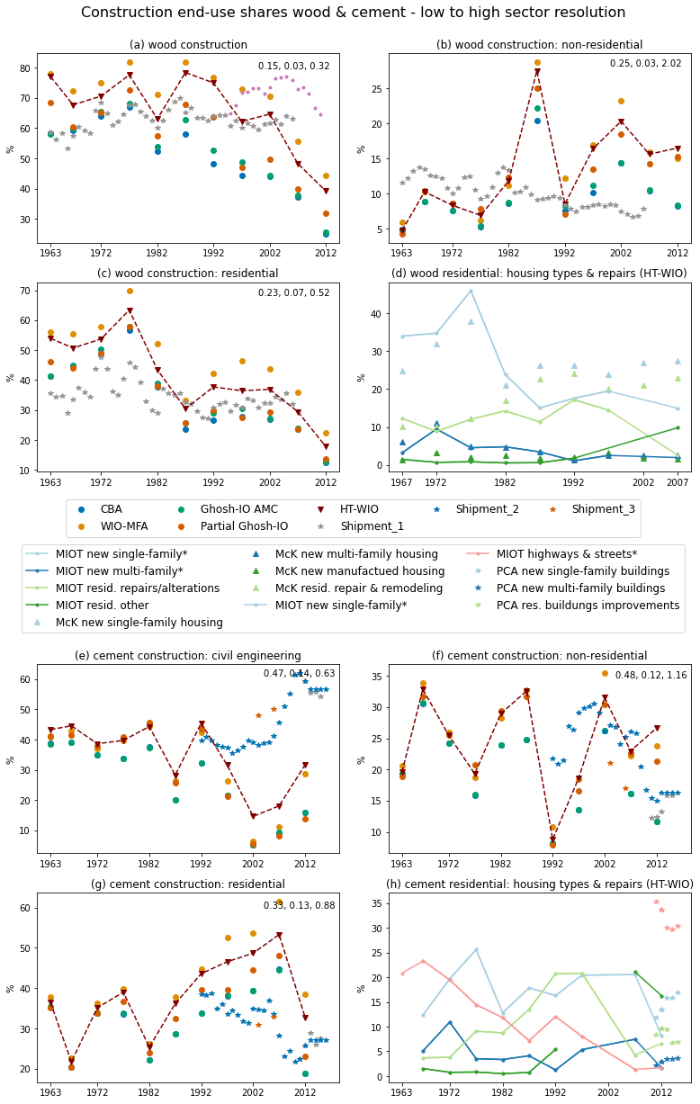

Figure 3: Comparison of end-use shares derived from U.S. monetary input output tables (MIOTs) for 11 data points between 1963-2012 generated with five input-output approaches (see section 2.1), with industry shipment data in physical units (see section 2.3) at medium (1) and low (2) sector aggregation. The shown data sources for industry shipments are (Table 3): wood - all: McKeever 2006 (McK); cement – 1: PCA, 2 – Cao et al. 2017, 3 – Kapur et al. 2008. Please note that the end-use categories of MIOTs do not exactly match those of industry shipments (indicates by the asterisk* in the second legend): PCA – ‘buildings’; McKeever ‘housing’; MIOTs - ‘buildings’ (1963), a mix of ‘housing’, ‘apartments’ & ‘buildings’ (1967-1977); and a mix of ‘structures’, ‘apartments’ & ‘buildings’ (1982-2012). Thus also on the medium-level aggregation (residential, non-residential, civil engineering) these classification mismatch applies. For details please see text below figure.

categories ‘civil engineering’, ‘non-residential’, and ‘residential’, we found rather large relative median deviations between 33-48% (and larger outliers with 63-116%), albeit coarsely similar temporal trajectory. These large deviations were probably due to missclassification of cement in ‘highways & streets’ as ‘residential and urban structures’ in MIOTs as explained for asphalt ‘paving mixtures’ above. This is also visible in panel (h): for 2012 the MIOT sector ‘transportation structures and highways and streets’ is assigned <2% of cement use, which stands in stark contrast to 34% of cement use reported by PCA industry shipments to ‘highways and streets’. In panel (h), the relative median deviation of MIOT and PCA data for 2012 were 95% for ‘highways & streets*’, 39% ’new single family* and 41% for ’new multifamily*’.

### 3.1.5 Sensitivity to choices of supply or use sectors & filter matrix

The choice of supply or use sectors in MIOTs, as well as WIO-MFA mass filter design are two methodological choices expected to effect results rather strongly (Nakamura et al. 2009; Owen et al. 2017; Wieland et al. 2020). Therefore we ran a second set of supply/use sector and mass filter choices for the methods WIO-MFA and HT-WIO (see section 2.3). Results showed that for both items large deviations compared to the base case can occur, underlining the importance of supply/use sector and mass filter choices (see SI 1.3.2 for details).

## EXIOBASE

Figure 4 panels 1a-I compare EXIOBASE-based results (HT-WIO) with available industry shipment data in physical units for China, India and the UK as the countries with many shipment datapoints. Panels 2j-l map results for three selected material end-uses for all 49 EXIOBASE regions and identify countries with minimum and maximum values. For plot data, including the (relative) differences between MIOT-based and shipment results, please see the Data SI.

For panels 1 steel, we found rather good fit of shipments to MIOT-results for China[3], Indian and UK machinery, and Indian transport, while MIOT-results strongly underestimate steel use in construction for India (-48% to -87%) and even stronger for The UK (-73% to -82%). For aluminum we observed okay to good fit for China and India, with exception of Chinese transport (-54% to +20%), and rather bad fit for The UK. Strikingly, aluminum in machinery & appliances[4] was strongly overestimated in MIOT-results for all three countries (with all except 3 data points with deviations >200%). This also applied to 10/11 additional country comparisons with shipment data from Liu and Müller (2013) shown in SI 1.3.3. For plastics, we could observe that the largest end-use according to shipment data (‘packaging’) has no representation in EXIOBASE as it is not distinguished as MIOT sector.

For panels 2, we observed wide ranges of end-use shares among countries for steel use in construction and transport, and aluminum use in construction. Countries with high shares for construction aluminum were Japan and Greece (low shares quite mixed; Russia 2x), for construction steel Indonesia and Taiwan (low shares for UK and Malta), and for transport steel Luxembourg and Brazil (low shares Russia). Data from Liu and Müller (2013) confirm low construction aluminum shares for Russia, and rahter high shares for Japan, although shares for Netherlands and Norway are much higher in shipment than MIOT data (see SI 1.3.3). Unfortunately steel shipment data is very scarce and no comparison except for The UK could be conducted: when comapring with shipments in panel (1c), the low MIOT-based end-use shares for UK construction steel seem to be an artifact. Please note that the box / swarmplots are not weighted by the material consumption volume of respective countries.

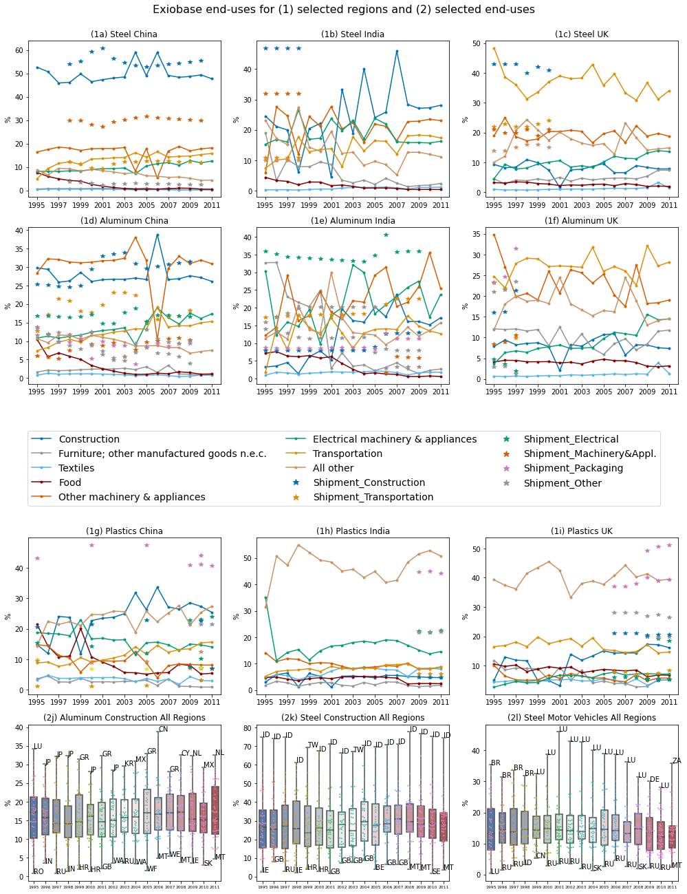

Figure 4: Comparison of end-use shares derived from EXIOBASE with the method of HT-WIO (see section 2), with industry shipment data in physical units (see section 2.3). The shown data sources for industry shipments are (Table 4): steel: China – Pauliuk et al. 2012, India – Pauliuk et al. 2013, UK - Pauliuk et al. 2013 / Dahlström et al. 2004; aluminum: all – Liu and Müller 2013; plastics: China – Jiang et al. 2020, UK - Plastics Europe 2006-2021(shares for whole EU), all - Euromap 2016. BE = Belgium, BR = Brazil, CN = China, CY = Cyprus, DE = Germany, GB = United Kingdom, GR = Greece, HR = Croatia, ID = Indonesia, IE = Ireland, IN = India, JP = Japan, KR = South Korea, LU = Luxembourg, MT = Malta, MX = Mexico, NL = Netherlands, RO = Romania, RU = Russia, SE = Sweden, SK = Slovakia, TW = Taiwan, WA = Rest of World Asia and Pacific, WE = Rest of World Europe, WF = Rest of World Africa, ZA = South Africa

# Discussion of insights from empirical application

* Purpose of this work was to compare the end-use shares derived with different MIOT-based methodologies to industry shipments in physical units and see the fit
* And from this to draw conclusions on the potential to derive end-use share information for many materials, countries and years from MIOTs to complement scarce physical data base

## How well do end-use shares derived from MIOTs versus industry shipments agree?

* HT-WIO as theoretically best MIOT-based method, so we focused analysis of results on this approach
* In practice we saw varying fit of HT-WIO results to industry shipments, ranging from close agreement to large disagreements (see results section 3)
  + differences between materials for U.S. MIOT-results (alu good, wood rather good, steel bad; 3.1.1)
  + however for many material end-uses the temporal trajectory was similar for MIOT-based and industry shipment results (if also at different magnitude)
    - So MIOTs might give information about temporal changes, also if not about exact magnitude
    - Raises the idea to calibrate overlapping periods of MIOT-based results with industry shipments and then use the trajectory
* We ended up using the industry shipment data as a kind of benchmark for MIOT-based results
  + but need to keep in mind that also physical data has its limitation (see diverging shipment sources in Figure 2 and limitations of shipments discussed Streeck et al., in preparation)
    - for instance, for USGS steel shipment data, 62-73% of total shipment mass are reported to categories with unknown end-use, e.g. ‘service centers’
* Difficult to draw overall conclusions, as agreement seems to depend on the specific material end-use combinations for countries and years
* The initial hope of obtaining very high end-use resolution from detailed MIOTs (see potential end-use resolution for U.S. MIOTs in Table 2) remains inconclusive
  + little physical data to compare with
  + we do know however that sector-level comparison prone to error as in more aggregate indicators these errors cance each other out (Abd Rahman et al. 2021; Lutter et al. 2019)
  + however, chen & graedel (2015/2017) show that for aluminum (which we also here found as a particularly good fit for MIOT/shipment results) rather detailed end-use categories derived from U.S. MIOTs partially show okay fit to estimations with other methods (while deviating substantially for some end-uses)
  + for higher resolution of end-uses, potentially up to individual MIOT sectors, the problem occurs that that sectors might not be assignable to preferred dMFA end-use categories due to unclear sector labels (e.g. ‘residential repairs’ unclear if to single- or multifamily housing; see section 3.1.4)
  + anyways usually low sector resolution for MRIOs which are interesting for covering many countries

## Which parameters are crucial for approximating material end-use shares?

* We could identify several parameters that can stronlgy influence MIOT-based results:
* importance of end-use product / sector defintions and system boundaries between data sources
  + these are seldomly defined (in particular for industry shipments) and remain unclear so that to some degree we might end up comparing apples and pears in above comparisons (the system boundaries of MIOT end-use categories do not necessarily fully align with those of the industry shipments)
  + e.g. or USGS copper shipments to end-use ‘buildings construction’ contains construction machinery (USGS 2015; CDA 2020), or the large discrepancies of MIOT-shipment results for highways & streets that seem to be included in MIOT sectors single-family & ‘multi-family ‘housing, buildings, structures’ (see section 3.1.4).
  + 🡪 although construction sector most important for material flows, this sector seems to be the least defined even in detailed US MIOTs / NAICS (just says it’s a aggregation of different NAICS sectors, but not specific)
* importance of selecting the ‘material sector’ for MIOTs, i.e. the sector that functions as a kind of use-extension and directly distributes assumed material flows to downstream industry sectors in first supply chain step according to its monetary output structure (see sections 3.1.5; S 1.3.2)
  + choice is restricted by the sectors available in the MIOT at hand (when applying the end-use shares to a case study of material flows it is therefore important that the type of material flow (e.g. saw logs vs. veneer sheets) is assigned with the closes fit as allowed by MIOT sector resolution (e.g. when sawmills vs. veneer producers are distinguished; if only one crude wood sector no choice but to assign to this one)
* MIOT-based methods other than HT-WIO ignore ‘intermediate products’ that are end-uses in dMFA sense (e.g. packaging), which biases results of end-use shares for all categories
  + Packaging for instance, is an important end-use for the materials plastics, aluminum, glass; if packaging is defined as end-use through ‘Hypothethical Transfer’, not only this end-use is better respresented, but also material deliveries to end-uses other than ‘packaging’ decline thorugh correct re-allocation to packaging.
  + precondition for working ‘Hypothethical Transfer’ is that the sector in question is differentiated in MIOTs
* ‘Hypothethical Transfer’ also important for another reason: accounting for correct end-use meaning
  + also if this is not the case HT-WIO produces more reasonable results, as the deliveries of products to service sectors are accounted as final demand (eliminating meaningless ‘services’ as end-use category, thereby not biasing shares of other, meaningful end-use product categories)
  + we suggest that just deleting the inputs to service sectors biases results as the ‘upstream pull-effect’ of service demand is deleted (outputs in turn can and should be deleted as these most probably do not correspond to physical flows
  + Interpretation of functional use in sectors (e.g. alu in beverage sector = packaging)
    - Some transactions require the guessing of end-uses. For example in year X, Y% of direct shipments (Z matrix) flow from primary aluminum production to soft drinks manufacturing. As the aluminum is probably not part of the liquid for drinking itself one can only guess that it must be for packaging. In this case it is more or less straight forward. In other cases the guess might be more difficult
    - Although USA benchmark tables are one of the most detailed IOTs worldwide, sometimes resolution not sufficient. E.g. in NAICS journal 326199 All Other Plastics Product Manufacturing comprises different end-uses, e.g. floor coverings (construction), dinnerware (consumer durables), air mattresses (furniture) and plastic bottle caps and lids (packaging)

## Applying end-use shares to material flows for many countries and years via MRIOs?

* Here the results for MRIO EXIOBASE are interesting in particlar as including many countries
* Fit of U.S. official national MIOTs to EXIOBASE varies
  + In tendency rather worse results compared to industry shipments than U.S. MIOTs (Figure 2)
* Comparing EXIOBASE fit to available country-level shipments for countries other than USA gives mixed picture
  + Rather good fit for China steel and aluminum end-use shares
  + Very large underestimation of steel use in construction for The United Kingdom (and large deviations for India also)
* Drawbacks that come with less sector resolution
  + Sectors are rather mixed of materials and products; thus when choosing a ‘materials’ sector understood as distributing a certain material, more output is delivered straight to final demand which then cannot be assigned to a meaningful end-use but just carries the label of the ‘materials’ sector
  + Together with lower resolution of end-use sectors, less material destinations can be identified
    - no packaging sector distinguished which strongly biases results for aluminum and plastics; this can only be compensated by assuming material deliveries to ‘Food products’ as packaging
* Our results might also just point towards the limits of using monetary accounting data for physical purposed due to differing underlying system boundaries / objects of interest for reporting (e.g. for alu to soft drink sector in monetary units makes sense; in physical way there might better be another step involved?).
  + In theory transaction specific prices could still change a lot, but also there data is scarce and without adequate pyhsical data to compare with, we cannot be sure that resulting end-use shares are correct
  + However, need to consider that EXIOBASE was not explicitly built for use with material flows
    - New database developments like GLORIA with focus on materials might deliver better results as potentially closer to material flow logic
    - Additionally, distinguishes the important construction sector into buildings and civil engineering (this will be one of our next steps)
    - We plan application of identified methods to GLORIA bit not scope of this work anymore and still some particularities due to newnesss of database
* For application to actual material flows, MIOT-base results should wherever possible be compared to physical data (if also being aware of limits of physical data sources themselves)
  + potentially also from other countries and qualitative data trying to validate results (e.g. does it make sense that end-use shares for steel to construction are lower in the UK than in the US given their preferred building types, construction preferences and standards?)
* all data sources must improve; transparent reporting and also s; even for US MIOTs the construction sectors are an aggregated of different NAICS activities which are unfortunately not explained in detial (gerade für die ist nix angegeben!!!)
* 🡪 data needs to become better; also more standardized – i.e. practices in diff. countries (pointed at by different fits for different countries in EXIOBASE, e.g. good for China, very bad for UK; what is wring with construction flows in UK EXIOBASE?)

# Conclusions

* Conclusion on possibility to derive end-use shares for many materials, countries and years for application to to economy-wide MFA

# Acknowledgements

We thank Mara Athina Luef for her help with data appraisal of aluminum industry shipment data. The work of J.S., D.W. and B.P. was supported by the European Research Council (ERC) under the European Union’s Horizon 2020 research and innovative programme (MAT_STOCKS, grant agreement No 741950). The work of J.S. was furthermore supported by the Austrian Federal Ministry of Education, Science and Research (Marietta Blau Grant MPC-2021-00143). The work of H.W. was funded by the European Research Council (ERC) under the European Union’s Horizon 2020 research and innovation programme (FINEPRINT project, grant agreement No. 725525).

# Supplementary Information 1 (SI1)

## S1.1 Industry shipment data for countries other than USA

Table S 1.1: Industry shipment data for countries and regions other than USA (although sometimes included). Some data sources are model outputs and no original industry shipment data (see last column ‘comments’). For many data sources it is unclear whether end-use shares refer to apparent material consumption to final demand, or of shipments to manufacturing sectors (in the latter case, final product trade needs to be added).

|  |  |  |  |  |
| --- | --- | --- | --- | --- |
|  | Source | Scope | End-uses | Data from / comments |
| Aluminum | Liu and Müller (2013) | 20 countries, varying years (min. 1950, max. 2010) | Building & construction, transportation, containers & packaging, machinery & equipment, electrical engineering, consumer durables, others | various sources (see paper) |
| Ciacci et al. (2013) | Italy 2013 | Transportation, building and construction, machinery and equipment, consumer durables, electrical engineering, containers and packaging, other | Italian and European industry (associations) |
| Bertram et al. (2017) & IAI (2022) | 9 global regions, exact time and geographical scope unclear | Building & construction, transportation (auto & light truck, aerospace, truck/bus/..), packaging (cans, other), machinery & equipment, electrical (cable, other), consumer durables, destructive uses, other | Various country and regional aluminum associations; time and space coverage unclear (see sources) |
| Cement | Cao et al. (2017b) | Global, 184 countries, min. ~1990, max. 2011 | Civil engineering, nonresidential buildings, residential buildings | Statistics by industry experts, e.g. PCA, Cembureau |
| Copper | Ciacci et al. (2017) | EU 28, two-yearly 1987-1995, 2008-2014 | Building and construction, electrical and electronic goods, industrial machinery and equipment, transportation equipment, consumer and general products | IWCC, personal communication with Soulier, M. (Fraunhofer ISI), Thomson Reuters GFMS |
| Glöser et al. (2013) | Global, 1912-2008 -2010 | Plumbing, building plant, architecture, communication, electrical power, power utility, telecommunication, (non-)electrical industrial, (non-)electrical automotive, other transportation, consumer products, cooling, electronic, powders (agriculture), diverse | ICSG, ICA & Ayres et al. (2003), resolution unclear |
| (IWCC 2017) (IWCC 2017) | Global, 2011-15 | - |
| Spatari et al. (2005) | North America, time coverage unclear | Building and Construction (on-site waste, plumbing, Wiring, built-in appliances), electrical and electronic equipment (industrial, consumer), infrastructure, transport equipment (motor vehicles, other Transport) | various, e.g. U.S. Bureau of Mines (1941), CDA (1980), literature, expert knowledge |
| Iron & steel  . | Pauliuk et al. (2012) assoc. data | China, 1998-2010 | Construction, transportation, machinery, appliances, other | Development Research Center of the State Council of China |
| Pauliuk et al. (2013) | India 1995-1999, UK 1960-65 & 1970-2000, USA 2004 | Construction, machinery products, transportation, other | USA: AISI (1941-2005), UK: ISSB (1979) & Dahlström et al. (2004), India: SERC |
| Hu et al. (2010) | China, 2004 | Urban residential buildings, rural residential buildings, non-residential buildings, non-construction | Development Research Center of the State Council of China |
| World Steel Association (2012) | Global, 2011 | Construction, mechanical machinery, metal products , automotive, other transport , electrical equipment, domestic appliances | - |
| Plastics | Geyer et al. (2017) | Global, static | Transportation, packaging, building and construction, electrical/electronic, consumer & institutional products, industrial machinery, others | Various, e.g. PlasticsEurope, ACC, CPMAI, for EU, USA, China, India for 2002-14 |
| Euromap (2016) | 63 countries/ regions 2009-15 | Packaging, automotive, construction industry, electrical/electronics & telecom, others | - |
| Plastics Europe (2006-2021) | EU-28*NO/CH, 2006-2018 | Packaging, building and construction , automotive, electrical & electronic, agriculture, other | - |
| Jiang et al. (2020) | China, 1978, 1980-2015 (five-yearly), 2017 | Packaging, B&C, Automobile, Electronics, Agriculture, Other | No industry shipments but model output derived from various sector split data sources and bottom-up calculations |
| Mutha et al. (2006) | India, 2000 | Packaging, building and construction , consumer products , industrial goods , others | Southern Gujarat Chamber of Commerce and Industry (2000) |
| Zhang et al. (2007) | China, 2000 | Packaging, commodity , industry , agriculture, architecture | Liao and Liu (2000) |
| Glass | Pilkington 2010 | Global, 2009 (flat glass) |  |  |

* For lead, zinc sources only report intermediate use categories; additionally several sources which do not necessarily draw on primary data from industry associations but rather on secondary literature (e.g. (Elshkaki et al. 2018; Graedel et al. 2015; Ciacci et al. 2015)

## S1.2 Details for calculation of MIOT and shipment-based end-use shares

### S.1.2.1 General preparation of monetary input-output tables (national USA, EXIOBASE)

For the years 1963/67 U.S. input-output data are published as industry-industry MIOTs. From 1972 onwards tables are published as supply-use tables following the commodity-industry approach (US BEA 2021). For the supply-use tables (SUTs) we followed the BEA’s approach to construct commodity-commodity MIOTs using an industry technology construct. Commodity-commodity tables appear superior to industry-industry tables, as the end-use shares refer to product use not industries. That might also be the reason that also Chen and Graedel (2015) and Pauliuk et al. (2017) used commodity-commodity tables. For the years 1963 and 1967 we used tables as reported in industry-industry format.

Besides the construction of symmetric MIOTs, we modified original tables in two instances to prepare them for calculating end-use shares: First of all, the tables represent single-region accounts, i.e. they include imports in the intermediate demand matrix Z, as well as exports and changes in inventories as final demand accounts (as well as a final demand vector for imports as negative values). For the calculation of end-use shares we were interested in the domestic use within the USA, i.e. accounting for imports but not exports, which required to adjust MIOT system boundaries. Therefore we removed exports and the column of negative imports (meant to subtract imports) from final demand. We also removed changes to inventories, as we were only interested in use within the same year and do not want to model inventory changes. Second, some MIOTs/SUTs showed few and small negative transactions and empty (=zero) commodity output. While we accepted empty rows, we clipped negative values and replaced them by zero to ensure positive results. As negative values were few and small we expect the bias on results to be minor.

For the multi-regional MIOT (MRIO) EXIOBASE, we used product-product (commodity-commodity) tables and drew on the direct flow and final demand to calculate all required variables. As for the U.S. national tables, we removed exports and inventory changes from final demand.

### S.1.2.2 Choice of ‘extension’ sectors

For calculating the end-use share matrix , we did not use actual environmental extensions but just evaluated the monetary deliveries to final demand for selected ‘material sectors’ which we then assumed to represent the shares of material-to-product allocations ( in Streeck et al. (in preparation), in constrast to ). We chose the respective ‘material sectors’ according to their label and description (for the USA in the NAICS (2017) manual) that closest match the properties of a potential extension, for example ‘iron & steel production’ as the material sector allocating the domestic use of crude steel material flows.

From literature we know that the choice of ‘material sectors’ (or extensions) has strong influence on EEIO results (Owen et al. 2017; Wieland et al. 2020). For the detailed U.S. tables, several ‘material sectors’ potentially qualify as ‘extension’. Therefore, we calculated end-use shares for two sets of ‘material sectors’ and evaluated their influence on results (see SI 1.3.1 for results). Table S 1.2 depicts the two sets of ‘material sectors’.

Table S 1.2: The two sets of ‘material sectors’ (sectors for matching environmental extensions) chosen for USA MIOTs.

|  |  |  |
| --- | --- | --- |
|  | Base scenario | Scenario with aggregated ‘material sectors’ (name: ‘extAgg’) |
| 2007/12 (difference for wood, steel, alu, paper, asphalt, plastic) | Sawmills and wood preservation; Clay product and refractory manufacturing; Glass and glass product manufacturing; Cement manufacturing; Cut stone and stone product manufacturing; Iron and steel mills and ferroalloy manufacturing; Alumina refining and primary aluminum production; Nonferrous Metal (except Aluminum) Smelting and Refining; Copper rolling, drawing, extruding and alloying; Pulp mills; Asphalt paving mixture and block manufacturing; Plastics material and resin manufacturing | Sawmills and wood preservation+Veneer, plywood, and engineered wood product manufacturing;  Clay product and refractory manufacturing; Glass and glass product manufacturing; Cement manufacturing; Cut stone and stone product manufacturing; Iron and steel mills and ferroalloy manufacturing+Steel product manufacturing from purchased steel; Alumina refining and primary aluminum production+Aluminum product manufacturing from purchased aluminum; Nonferrous Metal (except Aluminum) Smelting and Refining; Copper rolling, drawing, extruding and alloying  Paper mills+Paperboard mills; Asphalt paving mixture and block manufacturing+Asphalt shingle and coating materials manufacturing; Plastics material and resin manufacturing+Synthetic rubber and artificial and synthetic fibers and filaments manufacturing |
| 2002  (difference for wood, steel, alu, paper, asphalt, plastic) | Sand, gravel, clay, and ceramic and refractory minerals mining and quarrying; Sawmills and wood preservation; Pulp mills; Asphalt paving mixture and block manufacturing; Plastics material and resin manufacturing; Brick, tile, and other structural clay product manufacturing; Flat glass manufacturing  Glass container manufacturing; Cement manufacturing; Cut stone and stone product manufacturing  Iron and steel mills and ferroalloy manufacturing; Alumina refining and primary aluminum production; Primary smelting and refining of copper; Primary smelting and refining of nonferrous metal (except copper and aluminum) | Sand, gravel, clay, and ceramic and refractory minerals mining and quarrying; Sawmills and wood preservation+Veneer and plywood manufacturing; Paper mills+Paperboard mills; Asphalt paving mixture and block manufacturing+Asphalt shingle and coating materials manufacturing; Plastics material and resin manufacturing+Synthetic rubber manufacturing; Brick, tile, and other structural clay product manufacturing; Flat glass manufacturing; Glass container manufacturing; Cement manufacturing; Cut stone and stone product manufacturing; Iron and steel mills and ferroalloy manufacturing+Steel product manufacturing from purchased steel; Secondary smelting and alloying of aluminum+Alumina refining and primary aluminum production+Aluminum product manufacturing from purchased aluminum; Primary smelting and refining of copper; Primary smelting and refining of nonferrous metal (except copper and aluminum) |
| 1997 (difference for wood, asphalt, plastic) | Sand, gravel, clay, and refractory mining; Sawmills; Paper and paperboard mills; Asphalt paving mixture and block manufacturing; Asphalt shingle and coating materials manufacturing; Plastics material and resin manufacturing; Synthetic rubber manufacturing; Brick and structural clay tile manufacturing; Ceramic wall and floor tile manufacturing; Glass container manufacturing; Glass and glass products, except glass containers; Cement manufacturing; Cut stone and stone product manufacturing; Iron and steel mills; Primary aluminum production; Primary smelting and refining of copper; Primary nonferrous metal, except copper and aluminum | Sand, gravel, clay, and refractory mining; Sawmills+Veneer and plywood manufacturing; Paper and paperboard mills; Asphalt paving mixture and block manufacturing+Asphalt shingle and coating materials manufacturing; Plastics material and resin manufacturing+Synthetic rubber manufacturing; Brick and structural clay tile manufacturing; Ceramic wall and floor tile manufacturing; Glass container manufacturing; Glass and glass products, except glass containers; Cement manufacturing; Cut stone and stone product manufacturing; Iron and steel mills; Primary aluminum production; Primary smelting and refining of copper; Primary nonferrous metal, except copper and aluminum |
| 1992/1987  (difference for wood, asphalt, plastic) | Sand and gravel; Sawmills and planing mills, general; Paper and paperboard mills; Plastics materials and resins; Synthetic rubber; Asphalt paving mixtures and blocks; Asphalt felts and coatings; Glass and glass products, except containers; Glass containers; Cement, hydraulic; Brick and structural clay tile; Ceramic wall and floor tile; Cut stone and stone products; Blast furnaces and steel mills; Primary smelting and refining of copper; Primary aluminum; Primary nonferrous metals, n.e.c. | Sand and gravel; Sawmills and planing mills, general+Veneer and plywood; Paper and paperboard mills; Plastics materials and resins+Synthetic rubber; Asphalt paving mixtures and blocks+Asphalt felts and coatings; Glass and glass products, except containers; Glass containers; Cement, hydraulic  Brick and structural clay tile; Ceramic wall and floor tile; Cut stone and stone products; Blast furnaces and steel mills; Primary smelting and refining of copper; Primary aluminum; Primary nonferrous metals, n.e.c. |
| 1982-1967  (difference for wood, paper asphalt, plastic) | Sand and gravel mining; Sawmills and planing mills, general; Pulp mills; Plastics materials and resins  Synthetic rubber; Paving mixtures and blocks; Asphalt felts and coatings; Glass and glass products, except containers; Glass containers; Cement, hydraulic; Brick and structural clay tile; Ceramic wall and floor tile; Cut stone and stone products; Blast furnaces and steel mills; Primary copper; Primary lead; Primary zinc; Primary aluminum and alumina; Primary nonferrous metals, n.e.c. | Sand and gravel mining; Sawmills and planing mills, general+Veneer and plywood; Paper mills, except building paper+Paperboard mills+Building paper and board mills; Plastics materials and resins+Synthetic rubber; Paving mixtures and blocks+Asphalt felts and coatings; Glass and glass products, except containers; Glass containers; Cement, hydraulic; Brick and structural clay tile; Ceramic wall and floor tile; Cut stone and stone products; Blast furnaces and steel mills; Primary copper; Primary lead; Primary zinc; Primary aluminum and alumina; Primary nonferrous metals, n.e.c. |
| 1963 (difference for wood, paper asphalt, plastic) | Sawmills & planning mills, general; Pulp mills; Plastics materials & resins; Synthetic rubber; Paving mixtures & blocks; Asphalt felts & coatings; Glass & glass products except containers; Glass containers; Cement, hydraulic; Brick & structural clay tile; Ceramic wall & floor tile; Cut stone & stone products; Blast furnace & basic steel products; Primary copper; Primary lead; Primary zinc; Primary aluminum; Primary nonferrous metals, nec. | Sawmills & planning mills, general+Veneer & plywood; Paper mills, except building paper+Paperboard mills+Wallpaper & building paper & board mills; Plastics materials & resins+Synthetic rubber; Paving mixtures & blocks+Asphalt felts & coatings; Glass & glass products except containers; Glass containers; Cement, hydraulic; Brick & structural clay tile; Ceramic wall & floor tile; Cut stone & stone products; Blast furnace & basic steel products; Primary copper; Primary lead; Primary zinc; Primary aluminum; Primary nonferrous metals, nec. |

### S.1.2.3 Filter matrices

As described in section 2.3, all MIOT-based methods except for CBA required the definition of filter matrices. All filter matrices can be found on the associated GitHub repository. We here give the detailed rationale, as well as configuration of chosen filters:

For **WIO-MFA**, two types of filter matrices need to be designed: the mass filter and the yield filter. The mass filter removes monetary transactions that are believed to have no physical counterpart, such as service flows (see main paper Table 1). The unequivocal classification of transactions as ‘non-physical’ requires detailed knowledge of the MIOTs’ only known by national statistic bureaus, the decisions of practitioners thus often remaining subjective to some degree (also see Steeck et al., in preparation). Here we construct two scenarios in order to make the effect of these decisions somewhat transparent. First of all, we classified MIOT sectors as either raw materials, materials, products, or services. Then, depending on the scenario, the output and/or input of the raw material and service products was filtered, i.e. set to zero (see Table S 1.3 for detailed scenario description).

In addition to the mass filter, the WIO-MFA yield filter removes a share of MIOT transactions in order to account for physical waste flows that occur during each supply-chain step. The compilation of yield filter for high-resolution MIOTs takes considerable effort and to our knowledge none of these filters are published. In this work we apply detailed yield filter for the transactions associated to the materials aluminum, copper, iron and steel and simplified filters for other materials to EXIOBASE MIOTs which were used in Pauliuk et al. (2017). The compilation of detailed yield filter for the high-resolution USA MIOTs is not within scope of this work. In a first approximation, we use the yields obtained for EXIOBASE also for USA MIOTs.

For **Ghosh-IO AMC**, filters were designed according to Duchin and Levine (2010): no mass or yield filters were applied but reverse transactions from products to materials were prohibited (by partitioning of Q in equation 6 in main manuscript) and the final demand of sectors selected as ‘materials’ was set to zero.

For the **Partial Ghosh-IO** filter, products have to be differentiated into intermediate and end-use products. Aryapratama and Pauliuk (2019) evaluate the differentiation in their case study according to the ratio between the value of product output going to intermediate versus final demand. Following this reasoning, a product with high output ratio to intermediate demand and low ratio to final demand is classified as intermediate product, while in the reverse case as end-use product. In our calculations we followed that approach with a slightly different reasoning.:

At a ratio of intermediate divided by final demand equal or above a value of 1.1 (rounded) we classified the respective product as intermediate product, except if the product could unambiguously be identified as an end-use in the sense of dMFA by its label (e.g. product label ‘bicycle’). In that case, all material delivered to this commodity would be classified as end-use according to product label. We marked items for which the ratio implies intermediate but we classified as end-use product in yellow in the filter matrices (primarily the case for packaging, maintenance of buildings and structures, a few single sectors of furniture or electronics and all food sectors). For example, in the U.S. MIOT for the year 2012, the ratio of Z/Y of ‘Metal can, box, and other metal container (light gauge) manufacturing’ is 45 because these containers are considered an intermediate input to other products. For the purpose of material end-uses in dMFA however, we classified the product as end-use product by its label. Additionally, sectors that were assumed to only receive stock-building material inputs but are not considered to distribute further downstream were classified as end-use (e.g. agricultural sectors, as agricultural and food products are not focus of this work).

To calculate the Z/Y ratio, we only accounted for intermediate demand to sectors other than classified as ‘services’ according to our filter matrices, in order to avoid downstream shipments to ‘service’ sectors for which end-use can only be guessed (see section 2.3). We calculated ratios after removing any negatives from Z and Y.

Arguably the ratio of intermediate to final demand we chose is arbitrary to some degree, which reflects the general sensitivity of the Partial Ghosh-IO AMC approach to practitioner decisions. As mentioned in Streeck et al. (in preparation), the Partial Ghosh-IO AMC might lead to misclassification as once classified as intermediate product, the incorporation into other end-use products does not occur (e.g. air ventilation going to a car classified as air ventilation instead of car).

### S.1.2.4 Yield correciton for industry shipments

We applied yield corrections to industry shipments in physical units for aluminum and wood (see ‘US_IndustryShipmentData’ Excel Sheet on GitHub). For iron and steel, cement, copper and plastics we did not apply any yield corrections for the following reasons:

* Iron & Steel: USGS data exhibits high volumes of material shipped to service centers and categories for which end-use cannot be identified (e.g. ‘others’); for YSTAFB it was unclear whether yield correction has already been applied in published data
* Cement: no data and yields per application available and yields expected to be very similar
* Copper: no yield correction applied because all yields in WIO-MFA yield matrix were ~1
* Plastics: yield for the largest end-use ‘packaging’ missing

### S.1.2.4 Aggregation matrices for USA

The sector categories of U.S. MIOTs changed over time, so that slight inconsistencies during allocation of individual to aggregated sectors may have occured in the time series. In some tables, for instance, individual sectors were very detailed and could be assigned to different end-uses (*n* sectorst0 : *n* end-usest0), while in other years these individual sectors were more aggregated and could only be assigned to one end-use (*n* sectorst0 = *1* sectort1 : *1* end-uset0/1). Also, in early tables some sector labels were missing, in which case the product was allocated to the end-use that neighboring products referred to.

## S.1.2.5 Conversion factors wood volume to mass

To be filled in

## S.1.3 Additional results and result details

### S.1.3.1 Details of different MIOT method comparison

More details regarding the claims about the comparison of MIOT-based methods in section 3.1.2:

* As explained in section 3.1.2, the difference between HT-WIO and other methods would be more pronounced, if we did not interprete the use of materials delivered to ‘food products’ as ‘packaging’ too. Although this step must be regarded as personal interpretation, we took it as for aluminum and glass large parts of materials are directly delivered from the ‘material’ sectors to these food products (e.g. in 2012 direct flow matrix (Z), 9% of ‘Alumina refining and primary aluminum production’ going to ‘Soft drink and ice manufacturing’ via one crude material manufacturing supply chain step). In that particular case we argue that the interpretation as material being packaging is justified (as it is likely that the large amounts of aluminum and glass going to the beverage industry end up as packaging). Of course it would be preferable if these transactions would be accounted as packaging in the first place.
* For plastics, the cutting difference in main paper Figure 2 (v) for ‘plastics packaging’ in 1997 can be explained by plastic packaging and bottle sectors before 1997 not being discerned as separate sector in U.S. MIOTs. These sectors could thus not be subject to the ‘Hypothetical Transfer’ in HT-WIO or be defined as end-use in Partial Ghosh-IO.
* For wood, the large differences between HT-WIO and other methods can be explained by large parts of the direct packaging deliveries (intermediate demand Z as share of total output x) going to the service sectors (e.g. 1987: 81% of ‘Wood pallets and skids’ going to services, specifically 77% to ‘Wholesale trade’; for ‘Wood containers, n.e.c.’ 22% go to services; vs. e.g. only 6% of ‘Metal cans’ and 15% of ‘Metal shipping barrels, drums, kegs, and pails’ going to service sectors). As indicated in main paper Figure 1, we transferred deliveries (=inputs) to service sectors to final demand during Hypothetical Transfer, which then increases wood packaging end-use shares.
* For categories others than packaging, the WIO-MFA vs. HT-WIO difference can be explained by HT-WIO indirectly changing the end-use shares of categories other than packaging: because larger amounts of materials are allocated to packaging and other intermediate products (inputs to service sectors) that are end-use in dMFA sense, relatively less material is allocated the remaining end-use categories.
* The results of CBA and Ghosh-IO AMC align closely, because in the current configuration both of them calculate embodied materials. Despite the difference in underlying IO-models, the application of those to at scale MIOTs produces equivalent results if data is not manipulated otherwise (see Streeck et al., in preparation). In our application, the only difference between the two methods is that in Ghosh-IO AMC positions materials external to the industry supply chain (partitioning of matrix, see main paper eq. 6) and deliveries to final demand are deleted (see Streeck et al. in preparation).

### S.1.3.2 Sensitivity of MIOT-based end-use shares to ‘extension’ sector & filter matrix choices

As mentioned in main paper section 2.3, we designed two scenarios for 1) different configurations of WIO-MFA mass filters, and 2) different sets of ‘material sectors’, i.e. the assumed MIOT sectors that receive material input from exogenous and initially distribute it to downstream industries. The base case, as well as scenarios are described in Table S 1.3. Results are depicted in Figure S 1.1 and values can be found in Data SI for ‘Figure 2 Sensitivity’.

Table S 1.3: Scenarios for evaluating the sensitivity of end-use shares derived via WIO-MFA and HT-WIO for the USA monetary input-output tables to manipulations in mass filters and ‘material sectors’ for potential extensions (for sector classifications such as ‘services’ please see mass filter matrices in GitHub respoitory)

|  |  |  |
| --- | --- | --- |
| **Scenario label** | **Sensitivity to** | **Description** |
| WIO-MFA | None / base case | Products do not become part of materials; deletion of output of service sectors (non-physical flows); correction for waste flows via yield filters; technological coefficients in **A** matrix deleted for inputs (columns) to raw material and service sectors |
| 1) WIO-MFA_filtDif | Keeping of service sector inputs | In difference to ‘base’: technological coefficients in **A** matrix kept for inputs (columns) to raw material and service sectors |
| 2) WIO-MFA_extAgg/ HT-WIO_extAgg | Variation of ‘material sectors’ (potential extension targets) | Extension modified by aggregation of two to three sectors as extension or switching of extension sector (see Table S 1.2) |

For the altered WIO-MFA mass filter scenario (_filtDif), we found maximum relative deviations , of 28% for wood, 17% for steel, 23% for copper, 18% for aluminum and 29% for plastics. What is striking is that results of ‘WIO-MFA_filtDif’ are lower than ‘WIO-MFA’ in all instances. This can be explained by the end-use shares assigned to the ‘service sectors’ for ‘WIO-MFA_filtDif’ (transactions to these sectors are deleted for ‘WIO-MFA_filtDif’ and thus zero), which result in lower shares for all other end-uses.

To determine end-use shares, we actually want to avoid the assignment of material use to ‘service sectors’, as the purpose in the sense of product stocks is unclear for these sectors (or subjective judgement needs to be applied when for instance determining the end-use of steel deliveries to ‘hotels and restaurants’; see main paper section 2.1.1). However, as argued in main paper section 2.3, we suggest that just deleting the inputs to service sectors also biases results as the ‘upstream pull-effect’ of service demand is deleted (outputs in turn can and should be deleted as these most probably do not correspond to physical flows). As a solution, we suggest the methodological twist of Hypothetical Transfer (main paper section 2.1.1), which transfers the inputs to service sectors to final demand, which subsequently are identified as end-use product stocks (according to the label ot the sector which’s output was transferred), while incorporate the service demand ‘upstream pull-effect’.

For the altered choice of ‘material sectors’, we here want to look at the difference of HT-WIO and HT-WIO_extAgg. Looking at the materials for which for all years two sets of ‘material sectors’ were chosen (only for wood & plastics; see Table S 1.2), we find slight to strong deviation between the two sets, depending on end-use category. For wood, a maximum relative deviation of 25% can be observed for wood use in construction, 47% for transport, 33% for furniture, and 85% for packaging. For plastic use, the maximum relative deviation is 21% for construction, 91% for transport, 20% for packaging and 15% for furniture.

Thus, the choice of ‘material sector’ seems to influence results much stronger than the implemented differences in mass filter matrices. In particular, this choice strongly influences shares for individual sectors, which is much more uniform for mass filter deviations. This observation seems reasonable, given that the chosen ‘material sector’ acts like a use-extension to the industry system (determines the distribution of materials to downstream industry sectors in the the first (direct) supply chain step). Selecting materials that have a rather different output structure, like for instance for plastics the aggregation of the sectors ‘Plastics material and resin manufacturing + Synthetic rubber manufacturing’ (HT-WIO_extAgg) for plastic material flows instead of using just the former sector (HT-WIO) leads to higher end-use shares for ‘transport’ as the output shares for ‘Synthetic rubber manufacturing’ are much more geared towards this end-use sector than for ‘Plastics material and resin manufacturing’. Anyways, according to label, the selection of ‘Synthetic rubber manufacturing’ seems like a bad choice for distribution plastic materia flows, but it illustrates that when applying the end-use shares to a case study of material flows it is important that the type of material flow (e.g. saw logs vs. veneer sheets) is assigned to the MIOT sector(s) with the closest fit as allowed by MIOT sector resolution (e.g. when sawmills vs. veneer producers are distinguished; if only one crude wood sector available there remains no choice but to assign to this one). However, the potential choice of ‘materials sectors’ is restricted by the sectors available in the MIOT at hand (if not making efforts to further disaggregate/aggregate).

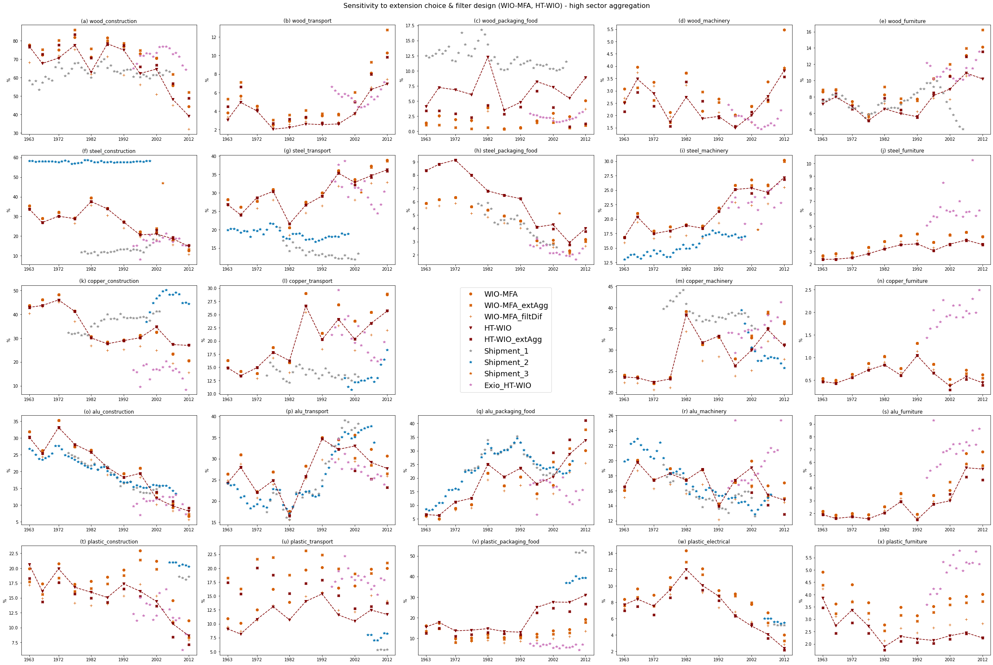

Figure S 1.1: Equivalent to main paper Figure 2 for scenarios that check sensitivity of WIO-MFA and HT-WIO to mass filters and choice of ‘material sectors’ (extensions)

### S.1.3.3 Additional result plots EXIOBASE (MIOT-based results for HT-WIO)

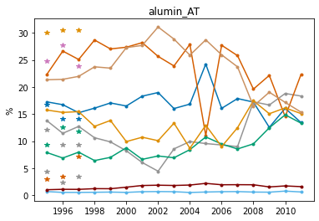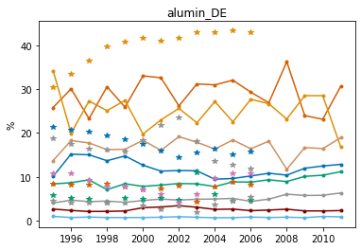

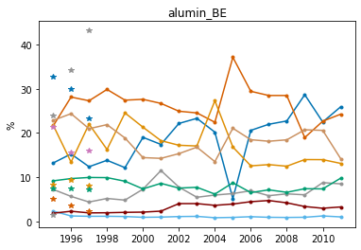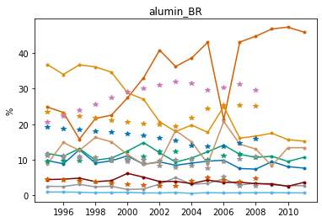

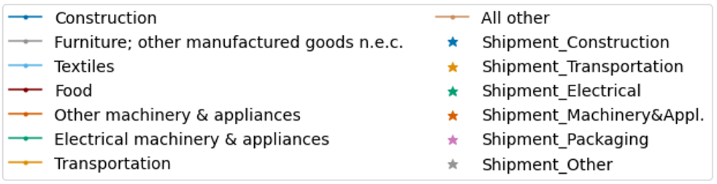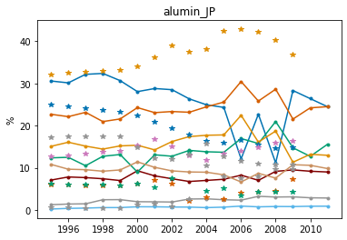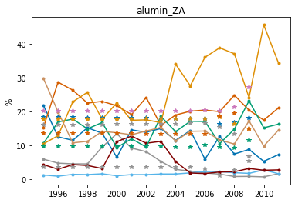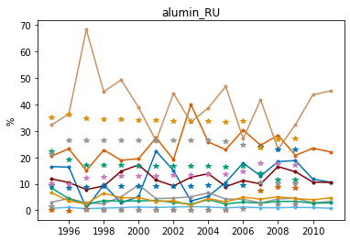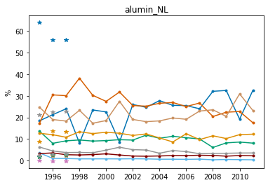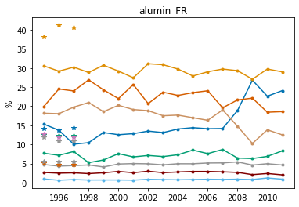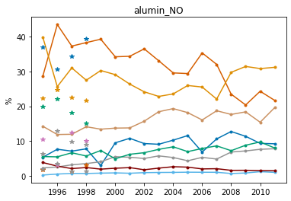

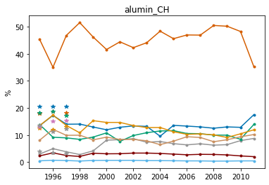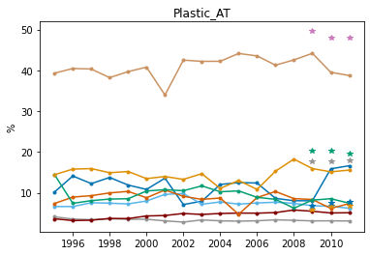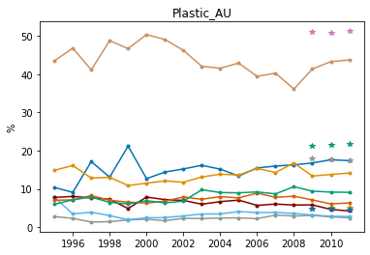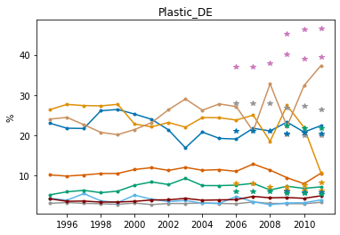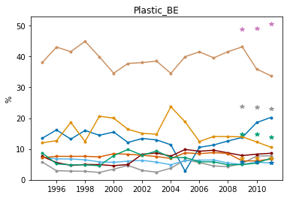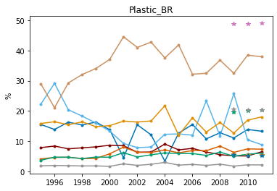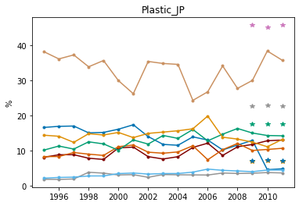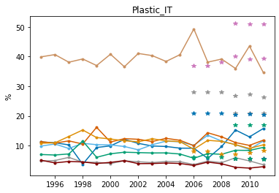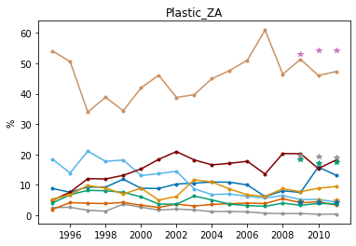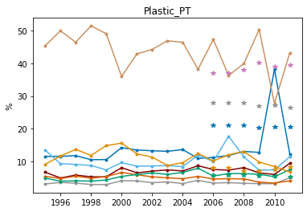

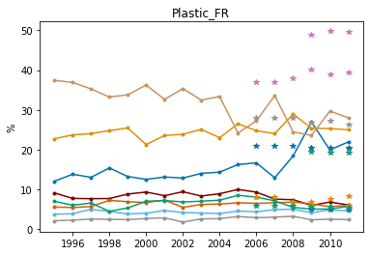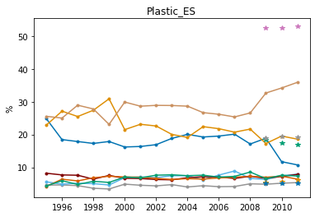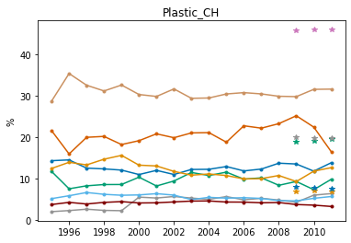



Sources for industry shipments are: aluminum - Liu and Müller 2013, plastics - Euromap 2016; Plastics Europe 2006-2021

# Supplementary information 2 (SI2)



# Data SI 1



Note: currently very small negative end-use shares can occur for Ghosh-IO AMC due to use of the scipy function pseudo-inverse (which allows to estimate inverse of actually singlar matrix)

Publication bibliography

AAI (1976–2003): Aluminum Association Inc. Aluminum statistical review 1975–2002.

AISI (1941–1999): American Iron and Steel Institute. Annual Statistical Report of the American Iron and Steel Institute. New York.

AISI (1941-2005): Annual statistical report of the American Iron and Steel Institute. New York: American Iron and Steel Institute.

AISI (2003): Annual statistical report 2003. Washington, DC.

Aryapratama, Rio; Pauliuk, Stefan (2019): Estimating in-use wood-based materials carbon stocks in Indonesia: Towards a contribution to the national climate mitigation effort. In *Resources, Conservation and Recycling* 149, pp. 301–311. DOI: 10.1016/j.resconrec.2019.06.010.

Ayres, Robert U.; Ayres, Leslie; Råde, Ingrid (2003): The life cycle of copper, its co-products and byproducts. Dordrecht, London: Kluwer Academic.

Bertram, M.; Ramkumar, S.; Rechberger, H.; Rombach, G.; Bayliss, C.; Martchek, K. J. et al. (2017): A regionally-linked, dynamic material flow modelling tool for rolled, extruded and cast aluminium products. In *Resources, Conservation and Recycling* 125, pp. 48–69. DOI: 10.1016/j.resconrec.2017.05.014.

Cabernard, Livia; Pfister, Stephan; Hellweg, Stefanie (2019): A new method for analyzing sustainability performance of global supply chains and its application to material resources. In *The Science of the total environment* 684, pp. 164–177. DOI: 10.1016/j.scitotenv.2019.04.434.

Cao, Zhi; Shen, Lei; Liu, Litao; Zhao, Jianan; Zhong, Shuai; Kong, Hanxiao; Sun, Yanzhi (2017a): Estimating the in-use cement stock in China: 1920–2013. In *Resources, Conservation and Recycling* 122, pp. 21–31. DOI: 10.1016/j.resconrec.2017.01.021.

Cao, Zhi; Shen, Lei; Løvik, Amund N.; Müller, Daniel B.; Liu, Gang (2017b): Elaborating the History of Our Cementing Societies: An in-Use Stock Perspective. In *Environmental Science & Technology* 51 (19), pp. 11468–11475. DOI: 10.1021/acs.est.7b03077.

CDA (1980): Annual Data. Copper Supply and Consumption, 1960–1979. New York.

CDA (2020): Copper Development Association Inc. Annual Data 2020. Copper Supply & Consumption — 1999–2019. Available online at https://www.copper.org/resources/market_data/pdfs/annual-data-book-2020_final.pdf, checked on 9/28/2021.

CDA (2022): Market Data. Available online at https://www.copper.org/resources/market_data/, checked on 2/25/2022.

Chen, Wei-Qiang; Graedel, T. E. (2015): Improved alternatives for estimating in-use material stocks. In *Environmental Science & Technology* 49 (5), pp. 3048–3055. DOI: 10.1021/es504353s.

Chen, Wei‐Qiang (2017): Dynamic Product‐Level Analysis of In‐Use Aluminum Stocks in the United States. In *Journal of Industrial Ecology* 22 (6), pp. 1425–1435. DOI: 10.1111/jiec.12710.

Ciacci, Luca; Chen, Weiqiang; Passarini, Fabrizio; Eckelman, Matthew; Vassura, Ivano; Morselli, Luciano (2013): Historical evolution of anthropogenic aluminum stocks and flows in Italy. In *Resources, Conservation and Recycling* 72, pp. 1–8. DOI: 10.1016/j.resconrec.2012.12.004.

Ciacci, Luca; Reck, Barbara K.; Nassar, N. T.; Graedel, T. E. (2015): Lost by Design. In *Environmental Science & Technology* 49 (16), pp. 9443–9451. DOI: 10.1021/es505515z.

Ciacci, Luca; Vassura, Ivano; Passarini, Fabrizio (2017): Urban Mines of Copper: Size and Potential for Recycling in the EU. In *Resources* 6 (1), p. 6. DOI: 10.3390/resources6010006.

Dahlström, Kristina; Ekins, Paul; He, Juanchun; Davis, Jeniffer; Clift, Roland (2004): Iron, Steel and Aluminium in the UK. Material Flows and their Economic Dimensions. Available online at https://www.surrey.ac.uk/ces/files/pdf/0304_WP_Biffaward_Steel_Al-Final.pdf, checked on 10/16/2019.

Daigo, Ichiro; Igarashi, Yuma; Matsuno, Yasunari; Adachi, Yoshihiro (2007): Accounting for Steel Stock in Japan. In *ISIJ Int.* 47 (7), pp. 1065–1069. DOI: 10.2355/isijinternational.47.1065.

Dietzenbacher, Erik; van Burken, Bob; Kondo, Yasushi (2019): Hypothetical extractions from a global perspective. In *Economic Systems Research* 31 (4), pp. 505–519. DOI: 10.1080/09535314.2018.1564135.

Duchin, Faye; Levine, Stephen H. (2010): Embodied Resource Flows and Product Flows. In *Journal of Industrial Ecology* 14 (4), pp. 586–597. DOI: 10.1111/j.1530-9290.2010.00258.x.

Duchin, Faye; Levine, Stephen H. (2013): Embodied Resource Flows in a Global Economy. In *Journal of Industrial Ecology* 17 (1), pp. 65–78. DOI: 10.1111/j.1530-9290.2012.00498.x.

Elshkaki, Ayman; Graedel, T. E.; Ciacci, Luca; Reck, Barbara K. (2018): Resource Demand Scenarios for the Major Metals. In *Environmental Science & Technology* 52 (5), pp. 2491–2497. DOI: 10.1021/acs.est.7b05154.

Euromap (2016): Plastics Resin Production and Consumption in 63 Countries Worldwide 2009 - 2020. Euromap - European Plastics and Rubber Machinery. Frankfurt am Main. Available online at https://www.pagder.org/images/files/euromappreview.pdf, checked on 12/7/2020.

Euromap (2020): Plastics consumption by application (%). Available online at https://www.euromap.org/en/markets/market-data/, checked on 2020.

Fu, Chenling; Zhang, Yan; Deng, Tianjie; Daigo, Ichiro (2021): The evolution of material stock research: From exploring to rising to hot studies. In *Journal of Industrial Ecology* 123, p. 153. DOI: 10.1111/jiec.13195.

Geyer, Roland; Jambeck, Jenna R.; Law, Kara Lavender (2017): Production, use, and fate of all plastics ever made. In *Science advances* 3 (7), e1700782. DOI: 10.1126/sciadv.1700782.

Glöser, Simon; Soulier, Marcel; Tercero Espinoza, Luis A. (2013): Dynamic Analysis of Global Copper Flows. Global Stocks, Postconsumer Material Flows, Recycling Indicators, and Uncertainty Evaluation. In *Environmental Science & Technology* 47 (12), pp. 6564–6572. DOI: 10.1021/es400069b.

Graedel, T. E.; Harper, E. M.; Nassar, N. T.; Reck, Barbara K. (2015): On the materials basis of modern society. In *Proceedings of the National Academy of Sciences of the United States of America* 112 (20), pp. 6295–6300. DOI: 10.1073/pnas.1312752110.

Haberl, Helmut; Wiedenhofer, Dominik; Pauliuk, Stefan; Krausmann, Fridolin; Müller, Daniel B.; Fischer-Kowalski, Marina (2019): Contributions of sociometabolic research to sustainability science. In *Nature Sustainability* 2 (3), pp. 173–184. DOI: 10.1038/s41893-019-0225-2.

Hashimoto, Seiji; Tanikawa, Hiroki; Moriguchi, Yuichi (2007): Where will large amounts of materials accumulated within the economy go? – A material flow analysis of construction minerals for Japan. In *Waste Management* 27 (12), pp. 1725–1738. DOI: 10.1016/j.wasman.2006.10.009.

Hertwich, Edgar G. (2021): Increased carbon footprint of materials production driven by rise in investments. In *Nat. Geosci.* 44, p. 1888. DOI: 10.1038/s41561-021-00690-8.

Hu, Mingming; Pauliuk, Stefan; Wang, Tao; Huppes, Gjalt; van der Voet, Ester; Müller, Daniel B. (2010): Iron and steel in Chinese residential buildings: A dynamic analysis. In *Resources, Conservation and Recycling* 54 (9), pp. 591–600. DOI: 10.1016/j.resconrec.2009.10.016.

IAI (2022): Global Aluminium Cycle 2019. International Aluminium Institute. Available online at https://alucycle.international-aluminium.org/public-access/, checked on 2/24/2022.

ISSB (1979): Annual statistics for the United Kingdom. London: Iron and Steel Statistics Bureau.

IWCC (2017): Copper & Copper Alloy Semis: End-use data. International Wrought Copper Council. London. Available online at http://www.coppercouncil.org/Documents/Stats/GenEUse.pdf, checked on 8/14/2018.

Jiang, Xiaobin; Wang, Tao; Jiang, Meng; Xu, Ming; Yu, Yadong; Guo, Baohua et al. (2020): Assessment of Plastic Stocks and Flows in China: 1978-2017. In *Resources, Conservation and Recycling* 161, p. 104969. DOI: 10.1016/j.resconrec.2020.104969.

Kapur, Amit; Keoleian, Gregory; Kendall, Alissa; Kesler, Stephen E. (2008): Dynamic Modeling of In-Use Cement Stocks in the United States. In *Journal of Industrial Ecology* 12 (4), pp. 539–556. DOI: 10.1111/j.1530-9290.2008.00055.x.

Lanau, Maud; Liu, Gang; Kral, Ulrich; Wiedenhofer, Dominik; Keijzer, Elisabeth E. E.; Yu, Chang; Ehlert, Christina (2019): Taking stock of built environment stock studies: Progress and prospects. In *Environmental Science & Technology*. DOI: 10.1021/acs.est.8b06652.

Liao, Z-P; Liu, Y-J (2000): Status of plastics processing industry and suggestions on its development (in Chinese). In *Modern Chem Ind* 20 (7), pp. 5–8.

Liu, Gang; Müller, Daniel B. (2013): Centennial evolution of aluminum in-use stocks on our aluminized planet. In *Environmental Science & Technology* 47 (9), pp. 4882–4888. DOI: 10.1021/es305108p.

McKeever, David B. (2009): Estimated annual timber products consumption in major end uses in the United States, 1950-2006. Madison, WI.

Müller, D. B.; Wang, T.; Duval, B.; Graedel, T. E. (2006): Exploring the engine of anthropogenic iron cycles. In *Proceedings of the National Academy of Sciences* 103 (44), pp. 16111–16116. DOI: 10.1073/pnas.0603375103.

Müller, Esther; Hilty, Lorenz M.; Widmer, Rolf; Schluep, Mathias; Faulstich, Martin (2014): Modeling Metal Stocks and Flows: A Review of Dynamic Material Flow Analysis Methods. In *Environmental Science & Technology* 48 (4), pp. 2102–2113. DOI: 10.1021/es403506a.

Mutha, Nitin H.; Patel, Martin; Premnath, V. (2006): Plastics materials flow analysis for India. In *Resources, Conservation and Recycling* 47 (3), pp. 222–244. DOI: 10.1016/j.resconrec.2005.09.003.

Myers, Rupert J.; Reck, Barbara K.; Graedel, T. E. (2019): YSTAFDB, a unified database of material stocks and flows for sustainability science. In *Scientific data* 6 (1), p. 84. DOI: 10.1038/s41597-019-0085-7.

NAICS (2017): North American Industry Classification System.

Nakamura, Shinichiro; Kondo, Yasushi; Kagawa, Shigemi; Matsubae, Kazuyo; Nakajima, Kenichi; Nagasaka, Tetsuya (2014): MaTrace: tracing the fate of materials over time and across products in open-loop recycling. In *Environmental Science & Technology* 48 (13), pp. 7207–7214. DOI: 10.1021/es500820h.

Nakamura, Shinichiro; Nakajima, Kenichi; Kondo, Yasushi; Nagasaka, Tetsuya (2007): The Waste Input-Output Approach to Materials Flow Analysis. In *Journal of Industrial Ecology* 11 (4), pp. 50–63. DOI: 10.1162/jiec.2007.1290.

Nakamura, Shinichiro; Nakajima, Kenichi; Yoshizawa, Yoshie; Matsubae-Yokoyama, Kazuyo; Nagasaka, Tetsuya (2009): Analyzing Polyvinyl Chloride in Japan With the Waste Inputâ’Output Material Flow Analysis Model. In *Journal of Industrial Ecology* 13 (5), pp. 706–717. DOI: 10.1111/j.1530-9290.2009.00153.x.

Owen, Anne; Brockway, Paul; Brand-Correa, Lina; Bunse, Lukas; Sakai, Marco; Barrett, John (2017): Energy consumption-based accounts: A comparison of results using different energy extension vectors. In *Applied Energy* 190, pp. 464–473. DOI: 10.1016/j.apenergy.2016.12.089.

Pauliuk, Stefan; Heeren, Niko (2020): Material efficiency and its contribution to climate change mitigation in Germany : A deep decarbonization scenario analysis until 2060. In *Journal of Industrial Ecology* 371 (1986), p. 260. DOI: 10.1111/jiec.13091.

Pauliuk, Stefan; Heeren, Niko; Berrill, Peter; Fishman, Tomer; Nistad, Andrea; Tu, Qingshi et al. (2020): Global Scenarios of Resource and Emissions Savings from Systemic Material Efficiency in Buildings and Cars. DOI: 10.21203/rs.3.rs-93217/v1.

Pauliuk, Stefan; Kondo, Yasushi; Nakamura, Shinichiro; Nakajima, Kenichi (2017): Regional distribution and losses of end-of-life steel throughout multiple product life cycles-Insights from the global multiregional MaTrace model. In *Resources, Conservation and Recycling* 116, pp. 84–93. DOI: 10.1016/j.resconrec.2016.09.029.

Pauliuk, Stefan; Wang, Tao; Müller, Daniel B. (2012): Moving toward the circular economy: the role of stocks in the Chinese steel cycle. In *Environmental Science & Technology* 46 (1), pp. 148–154. DOI: 10.1021/es201904c.

Pauliuk, Stefan; Wang, Tao; Müller, Daniel B. (2013): Steel all over the world: Estimating in-use stocks of iron for 200 countries. In *Resources, Conservation and Recycling* 71, pp. 22–30. DOI: 10.1016/j.resconrec.2012.11.008.

PCA (2005): as cited by Kapur (2008).

PCA (2016): Portland Cement Association. U.S. Cement Industry Annual Yearbook 2016. Available online at http://www2.cement.org/econ/pdf/Yearbook2016_2sided.pdf, checked on 9/28/2021.

Plank, Barbara; Streeck, Jan; Virág, Doris; Krausmann, Fridolin; Haberl, Helmut; Wiedenhofer, Dominik (2022): From resource extraction to manufacturing and construction: flows of stock-building materials in 177 countries from 1900 to 2016. In *Resources, Conservation and Recycling* 179, p. 106122. DOI: 10.1016/j.resconrec.2021.106122.

Plastics Europe (2006-2021): Plastics - the Facts 2006-2021. Available online at https://plasticseurope.org/resources/market-data/, checked on 2/24/2022.

SERC (2012): as cited by Pauliuk et al. 2013. Spark Steel & Economy Research. Available online at http://www.steelscenario.com/research, updated on 1/25/2012.

Southern Gujarat Chamber of Commerce and Industry (2000): The Indian Plastic Industry, compiled by the PlastIndia Foundation. India.

Spatari, S.; Bertram, M.; Gordon, Robert B.; Henderson, K.; Graedel, T. E. (2005): Twentieth century copper stocks and flows in North America: A dynamic analysis. In *Ecological Economics* 54 (1), pp. 37–51. DOI: 10.1016/j.ecolecon.2004.11.018.

Stadler, Konstantin; Wood, Richard; Bulavskaya, Tatyana; Södersten, Carl-Johan; Simas, Moana; Schmidt, Sarah et al. (2018): EXIOBASE 3: Developing a Time Series of Detailed Environmentally Extended Multi-Regional Input-Output Tables. In *Journal of Industrial Ecology* 22 (3), pp. 502–515. DOI: 10.1111/jiec.12715.

Stadler, Konstantin; Wood, Richard; Bulavskaya, Tatyana; Södersten, Carl-Johan; Simas, Moana; Schmidt, Sarah et al. (2021): EXIOBASE 3.

Streeck, Jan; Dammerer, Quirin; Wiedenhofer, Dominik; Krausmann, Fridolin (2021): The role of socio‐economic material stocks for natural resource use in the United States of America from 1870 to 2100. In *Journal of Industrial Ecology* 140, p. 1880. DOI: 10.1111/jiec.13166.

Streeck, Jan; Wiedenhofer, Dominik; Krausmann, Fridolin; Haberl, Helmut (2020): Stock-flow relations in the socio-economic metabolism of the United Kingdom 1800–2017. In *Resources, Conservation and Recycling* 161, p. 104960. DOI: 10.1016/j.resconrec.2020.104960.

U.S. Bureau of Mines (1941): Minerals Yearbook Review of 1940. Keiser, H.D. (Ed.), Prepared Under the Direction of E.W. Pehrson, p. 97. Washington.

UNEP (2016): Global Material Flows Database. Available online at https://www.resourcepanel.org/global-material-flows-database, checked on 11/28/2019.

United Nations (2009): System of national accounts 2008. New York: United Nations.

US BEA (2018): United States of America Bureau of Economic Analysis. Historical Benchmark Input-Output Tables. Available online at https://www.bea.gov/industry/historical-benchmark-input-output-tables, checked on 12/23/2021.

US BEA (2021): United States of America Bureau of Economic Analysis. Input-Output Accounts Data. Available online at https://www.bea.gov/industry/input-output-accounts-data, checked on 12/23/2021.

USGS (2015): Historical Statistics for Mineral and Material Commodities in the United States. Available online at https://www.usgs.gov/centers/nmic/historical-statistics-mineral-and-material-commodities-united-states#steelscrap, checked on 8/25/2020.

Wiedenhofer, Dominik; Fishman, Tomer; Lauk, Christian; Haas, Willi; Krausmann, Fridolin (2019): Integrating Material Stock Dynamics Into Economy-Wide Material Flow Accounting: Concepts, Modelling, and Global Application for 1900–2050. In *Ecological Economics* 156, pp. 121–133. DOI: 10.1016/j.ecolecon.2018.09.010.

Wieland, Hanspeter; Giljum, Stefan; Eisenmenger, Nina; Wiedenhofer, Dominik; Bruckner, Martin; Schaffartzik, Anke; Owen, Anne (2020): Supply versus use designs of environmental extensions in input–output analysis: Conceptual and empirical implications for the case of energy. In *Journal of Industrial Ecology* 24 (3), pp. 548–563. DOI: 10.1111/jiec.12975.

World Steel Association (2012): Sustainable steel: at the core of a green economy. World Steel Association. Brussels. Available online at https://worldsteel.org/publications/bookshop/sustainability2012/, checked on 2/24/2022.

Yokoi, Ryosuke; Nakatani, Jun; Moriguchi, Yuichi (2018): An Extended Model for Tracking Accumulation Pathways of Materials Using Input–Output Tables: Application to Copper Flows in Japan. In *Sustainability* 10 (3), p. 876. DOI: 10.3390/su10030876.

Zhang, Guang-Hua; Zhu, Jun-Feng; Okuwaki, A. (2007): Prospect and current status of recycling waste plastics and technology for converting them into oil in China. In *Resources, Conservation and Recycling* 50 (3), pp. 231–239. DOI: 10.1016/j.resconrec.2006.11.007.

1. An example for a case in which services are involved is for instance, when ‘aluminum in air crafts’ are intermediate input to the service sector ‘government defense’. Accordingly, before delivery to final demand the ‘aluminum in air crafts’ is classified as the end-use ‘aluminum in government defense’. Thereby, the actual physical end-use in a MFA-sense (‘air crafts’) is lost. One might argue that ‘air crafts’ should not be intermediate input to other sectors following SNA (United Nations 2009) in the first place, but entirely delivered to final demand; however this is not always the case as several instances in the national U.S. benchmark MIOTs show (US BEA 2021); e.g. for 2007/12 use tables 14-15% of total commodity output of the sector ‘Aircraft manufacturing’ is reported to be delivered to the interindustry sector ‘Federal general government (defense)’.
2. and for a single year for steel, and more years for copper, however with uninformative end-use categories (see Table 2)
3. for comparison to ‘Shipment_Machinery&Appl.’ sum up EXIOBASE results for ‘Electrical machinery & appliances’ and ‘Other machinery & appliances’
4. summary of EXIOBASE sectors 'Machinery and equipment n.e.c. ' and 'Medical, precision and optical instruments, watches and clocks'