BD CAPTURE &
INTELLIGENCE PLATFORM
Product Requirements Document
Version 1.2 | April 2026 | CONFIDENTIAL
Document Owner | Sam Gruverman
Status | POC / Draft
Version | 1.2
Date | June 2026

Table of Contents
1. Executive Summary 7
2. Problem Statement 7
2.1 Current State 7
2.2 Desired State 7
3. Goals & Success Criteria 8
3.1 POC Goals 8
3.2 Success Metrics 8
4. User Personas 8
4.1 BD Lead (Primary User) 8
4.2 Proposal Manager 8
4.3 Standard User 9
4.3 BD Leadership / Executive 9
4.4 System Administrator 9
5. Feature Requirements 9
5.1 Authentication & Access Control 9
5.2 Deal Pipeline Dashboard 10
5.3 - Deal Detail — Core Data 10
1. Opportunity Information: 10
a. Client: 10
b. Program Name and Brief Description: 10
c. Estimated Value: 10
d. Estimated Release and Procurement Method: 10
e. Place of Performance: 10
f. Contract Type: 10
g. Estimated Duration: 10
h. [Company] Role: 10
i. Anticipated Partners and Workshare: 10
i. Why Do We Want To Do This? 10
2. Major Anticipated POW or PWS areas (actual if available) 10
collect key area and [company] alignment in pairs. Allow user to “save”, “save and exit”, “save and create new” 10
3. Schedule and Key Dates: 11
a. RFI: 11
b. Industry Day: 11
c. Draft RFP Release: 11
d. RFP Response Due: 11
e. Current Contract Expire: 11
4. Incumbent’s Information 11
a. Notes/History of the Opportunity 11
b. High Level Capabilities Alignment 11
c. Probable Competitors 11
d. What Do We Know About the Customer? 11
e. Acquisition Information/Procurement Info 11
f. Possible Schedule and Key Date 11
g. Value Information and Current Burn 11
5. Incumbent 11
h. Incumbent’s Name: 11
i. Contract Period of Performance: 11
j. Award Value and Latest Annual Burn: 11
k. Set Aside Type: 11
l. Procurement Method: 11
m. Link to Press Releases Related to Award: 11
n. Last Funding Action: 11
o. Link to FPDS 11
p. Information on Performance: 11
q. Possible Subcontractors: 11
Data entry should capture, in separate fields, the following; 11
1. Company name 11
2. Company demography: SB, WOSB, DVSB, ANC, Native American, Large 11
3. Why would they pursue it? 11
4. Notes 11
Allow user to “save”, “save and exit”, “save and create new” 11
• Contracting Office Information – CO & CS 12
• Possible COR 12
Gather the following data about customer stakeholders: 12
1. Name 12
2. Role / Title 12
3. Biases and/or concerns 12
4. Other notes 12
5. [Company] access? 12
Allow user to “save”, “save and exit”, “save and create new” 12
• Do we have the old solicitation? 12
• Have we reviewed publicly available information (press release, G2X, incumbent site)? 12
• Is this an agency support if not, can we pull a team member who does? 12
• Do we have a way to get in front of the customer? 12
• Opportunity Notes & History 12
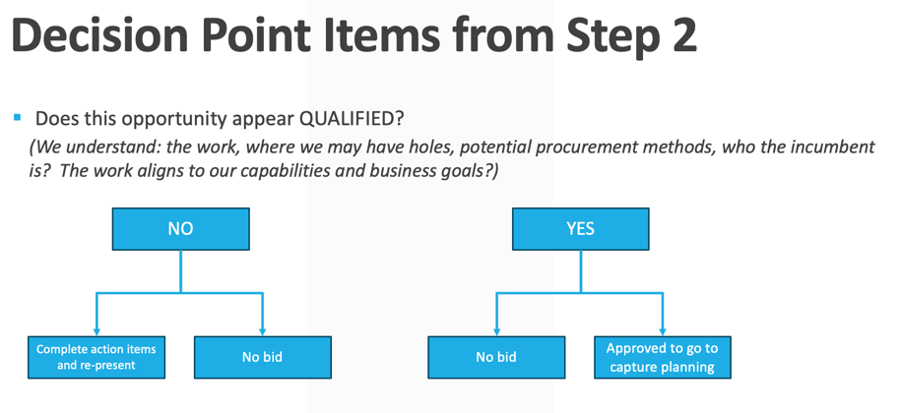 12
1. Opportunity Status 12
2. Strengths Weaknesses and Benefits 12
3. Customer Knowledge 12
4. Voice of the Customer 12
5. Key Meetings 12
6. High Level Capabilities Alignment 12
7. Probable Competitors 12
8. What Do We Know About the Customer? 12
9. Acquisition Information/Procurement Info 12
10. Possible Schedule and Key Date 13
11. Value Information and Current Burn 13
1. Changes Since Step 2: 13
2. Recent Modifications of Funding Changes: 13
** ?? Contract Status may not need to be explicit data capture but could show the latest updated data and notes. 13
Gather the following data about customer stakeholder concerns or needs: 13
**Allow the user to either pick from the list of previously entered stakeholders or add new 13
1. Name 13
2. Role / Title 13
3. Concerns / Needs 13
4. Solution, or how we might address these? 13
5. Other notes 13
6. [Company] access? 13
Allow user to “save”, “save and exit”, “save and create new” 13
** capture meeting title/type, dates, attendees and notes from each meeting 13
• Industry Day? 13
• NCMA Events? 13
• Customer Meetings? 13
• Teaming Meetings? 13
• Anticipated Contract Type: 13
• Estimated Value: 13
• Current Annual Burn: 13
• Estimated [Company] W2 Percentage: 13
• Capture Lead: 13
• Additional BD/Account Support: 13
• Associated [Company] 13
• Director: 13
• SME/Solution Support: 14
• Proposal Support: 14
5.4 Deal Detail — Proposal Management Data 15
5.5 Actions Management 15
5.6 Risk Management 16
6. Data Model Overview 16
6.1 Core Tables 16
6.2 Deal Sub-Tables (one per deal) 16
7. Technical Architecture 17
7.1 Technology Stack 17
7.2 API Design 17
8. Shipley Methodology Alignment 17
9. Out of Scope — Future Phases 18
Phase 2 Priorities 18
Phase 3 Priorities 18
10. Constraints & Assumptions 18
Constraints 18
Assumptions 19
11. Appendix 19
11.1 Live Application URLs 19
11.2 GitHub Repository 19
11.3 Database 19
11.4 Test Coverage 19

1. Executive Summary
The BD Capture & Intelligence Platform replaces a 50-slide Microsoft PowerPoint-based business development process with a purpose-built web application. The platform centralizes data for deal tracking, competitive intelligence, proposal management, and team collaboration using the Shipley Business Development Lifecycle methodology.

The current state requires BD leads to manually maintain a 50-slide PowerPoint deck per opportunity, duplicating data across slides, with no shared access, no version control, and no reporting capability. The platform eliminates that overhead and gives leadership a real-time view of the entire BD pipeline.

This document defines requirements for Version 1.0 (Proof of Concept), which is currently deployed as a live application at bd-platform-app.vercel.app with a PostgreSQL database and REST API backend.

2. Problem Statement

2.1 Current State
Business development opportunities are tracked using a manually maintained PowerPoint template with approximately 50 slides per opportunity. This approach has several critical limitations:
- No single source of truth — each BD lead maintains their own copy
- No pipeline visibility — leadership cannot see all active opportunities at once
- Manual data entry creates inconsistency and version conflicts
- No workflow enforcement — Shipley gate reviews are tracked informally
- No audit trail — changes are not logged, reviewers are not tracked
- No collaboration — stakeholders cannot annotate or contribute in real time
- Reporting requires manual consolidation of multiple decks

2.2 Desired State
A centralized web platform where every active opportunity is captured, tracked, and reported in a consistent structure aligned with Shipley methodology. BD leads, proposal managers, and leadership each have role-appropriate views and actions. Data is able to be integrated and synchronized with applications such as SalesForce and Microsoft Power Platform, and others as needed via API. Basic Data from one deal is available for use in other deals, to reduce manual input. An AI tool (Claude, Codex, Ollama, Perplexity, etc) is able to review and make recommendations, scour public records and websites for additional context and data. AI would be able to access contextual [Company] documents and make suggestions for capability alignment to key SOW or PWS sections.

App is able to be integrated with MSFT AD/Entra and M365, or Google ecosystems for user provisioning and access to relevant [Company] data files and directories.

App is built to modern architecture standards, is platform agnostic and can be deployed in Azure, AWS or GCP in a container or other standard deployment model. App can be backed up, with version control, is scannable, securable, and takes the current post-Mythos state of vulnerability management and security into consideration.

Data from the app would be able to feed AI based proposal response generation tools downstream.

Key documents can be uploaded or added from existing [Company] directories. If the SOW or PWS is added to the deal, an AI tool will read and parse it out for alignment with capabilities.

The App’s connected AI can generate draft proposal responses, for refinement by staff or a specific proposal response writing tool. All content generated by AI in the app is to be based on contextual documents (as available), fully factual and referenceable, be framed or written in a way that conveys what, how and examples if available. If the AI does not know the answer or how to respond, it will ask. The app’s AI tool can be either fully web grounded or behind an MCP server.
** additional AI guardrails can be added to the app context.

3. Goals & Success Criteria

3.1 POC Goals
- Replace the PowerPoint template with a structured data model covering all 50+ data points
- Provide a dashboard view of the full BD pipeline with deal status at a glance
- Enforce Shipley gate review stages (Red Team, Blue Team, White Team)
- Track open actions and risks per opportunity with owner and due date
- Support role-based access for BD leads, proposal managers, and administrators
- Deploy as a cloud-hosted application accessible from any browser
- Include an executive read out view, that steps or scrolls through the

3.2 Success Metrics
Metric | Target
POC operational | Deployed and accessible — August 2026
Data parity with PowerPoint template | All 50+ data fields captured in the platform
User Management | Users can self-enroll with admin approval after
User authentication | Login with JWT, role-based access enforced, MFA/TFA is a future state.
API coverage | REST endpoints covering all data entities
Test coverage | 94 automated tests passing (update as needed)
Pipeline visibility | Dashboard showing all active deals with key metrics

4. User Personas

4.1 BD Lead (Primary User)
Owns one or more active opportunities. Responsible for capture planning, competitive analysis, teaming decisions, and proposal strategy. Creates and maintains all deal data, assigns actions, and tracks risks, can assign data capture and entry to standard users
- Needs: full edit access to their deals, action assignment, risk logging
- Pain point today: maintains 50-slide PowerPoint manually, no version control
- Can assign read, write, delete permissions to users on a deal-by-deal basis

4.2 Proposal Manager
Manages the proposal production process for assigned deals. Tracks gate review stages (Red Team, Blue Team, White Team), manages proposal team actions, and monitors compliance with RFP requirements.
- Needs: gate stage updates, action tracking, RFP modulation data
- Pain point today: no visibility into BD lead's capture work until late in the cycle

4.3 Standard User
Can add data, edit if allowed by the admin the proposal production process for assigned deals. Participates in pre-bid and Shipley activities (Red Team, Blue Team, White Team), contributing data, analytics, past performance and other key contextual details that could influence decisions.
- Needs: Visibility into deals and the ability to contribute when asked
- Pain point today: no visibility into BD lead's capture work until late in the cycle

4.3 BD Leadership / Executive
Needs a portfolio-level view of all active opportunities. Reviews pipeline health, monitors high-priority risks, and tracks win probability across the portfolio.
- Needs: dashboard view, pipeline metrics, read-only access across all deals
- Pain point today: must request manual status briefings from each BD lead

4.4 System Administrator
Manages user accounts, reviews audit logs, and maintains system configuration. Not a BD practitioner but responsible for platform health.
- Needs: user management, full audit trail access, system monitoring

5. Feature Requirements

5.1 Authentication & Access Control
Feature | Description | Priority | Status
User Login | Email/password authentication with JWT token issuance. 24-hour token expiry. | P1 | Built
Role-Based Access | Four roles that can be assigned to users: bd_lead, proposal_manager, stanard_user, admin. Role enforced on every API endpoint. | P1 | Partial
Audit Logging | Every create, update, and delete action logged with user, timestamp, and resource ID. | P1 | Built
Session Management | Auto-logout on token expiry. Token refresh not yet implemented. | P2 | Partial
Fine-grained permissions | The BD lead or Admin can assign read/write/edit/delete/view permissions to standard users on a deal-by-deal basis | P3 | Not Built

5.2 Deal Pipeline Dashboard
Feature | Description | Priority | Status
Deal Cards | Each active deal shown as a card with: name, agency, award amount, due date, BD lead, proposal manager, current gate, open risks/actions count. | P1 | Built
Deal Color Classification | Blue (new business), Green (recompete), White (IDIQ/task order). Color badge with description on each card. | P1 | Partial
Gate Review Badges | Shipley review stage shown on deal card: Pink Team, Red Team, Blue Team, White Team, Gold Team. | P1 | Built
Pipeline Metrics | Header KPIs: total deals, total portfolio value, open actions, open risks. | P1 | Built
Search & Filter | Filter deals by status, gate, color, and keyword search. | P2 | Built

5.3 - Deal Detail — Core Data
** The following data should be captured during the pre-bid process. The intent is to be able to present a view for executive decision making about whether to proceed to the next stage

Baseline Data Capture

Opportunity Information:

Client:

Program Name and Brief Description:

Estimated Value:

Estimated Release and Procurement Method:

Place of Performance:

Contract Type:

Estimated Duration:

[Company] Role:

Anticipated Partners and Workshare:

Why Do We Want To Do This?

Major Anticipated POW or PWS areas (actual if available)

collect key area and [company] alignment in pairs. Allow user to “save”, “save and exit”, “save and create new”

Schedule and Key Dates:

RFI:

Industry Day:

Draft RFP Release:

RFP Response Due:

Current Contract Expire:

Step 2 Items

Incumbent’s Information

Notes/History of the Opportunity

High Level Capabilities Alignment

Probable Competitors

What Do We Know About the Customer?

Acquisition Information/Procurement Info

Possible Schedule and Key Date

Value Information and Current Burn

Incumbent

Incumbent’s Name:

Contract Period of Performance:

Award Value and Latest Annual Burn:

Set Aside Type:

Procurement Method:

Link to Press Releases Related to Award:

Last Funding Action:

Link to FPDS

Information on Performance:

Possible Subcontractors:

High Level Capabilities Alignment
** For the following, display as a table after capturing the data

- Major Anticipated SOW or PWS Areas
  - [Company] Aligned Capabilities

Probable Competitors:

Data entry should capture, in separate fields, the following;

Company name

Company demography: SB, WOSB, DVSB, ANC, Native American, Large

Why would they pursue it?

Notes

Allow user to “save”, “save and exit”, “save and create new”

What do we know about the Customer:

Contracting Office Information – CO & CS

Possible COR

Gather the following data about customer stakeholders:

Name

Role / Title

Biases and/or concerns

Other notes

[Company] access?

Allow user to “save”, “save and exit”, “save and create new”

What else do we know about the Opportunity?

Do we have the old solicitation?

Have we reviewed publicly available information (press release, G2X, incumbent site)?

Is this an agency support if not, can we pull a team member who does?

Do we have a way to get in front of the customer?

Opportunity Notes & History

Decision Point Items from Step 3



STEP 3

Opportunity Status

Strengths Weaknesses and Benefits

Customer Knowledge

Voice of the Customer

Key Meetings

High Level Capabilities Alignment

Probable Competitors

What Do We Know About the Customer?

Acquisition Information/Procurement Info

Possible Schedule and Key Date

Value Information and Current Burn

Contract Status

Changes Since Step 2:

Recent Modifications of Funding Changes:

** ?? Contract Status may not need to be explicit data capture but could show the latest updated data and notes.

Voice of the Customer

Gather the following data about customer stakeholder concerns or needs:

**Allow the user to either pick from the list of previously entered stakeholders or add new

Name

Role / Title

Concerns / Needs

Solution, or how we might address these?

Other notes

[Company] access?

Allow user to “save”, “save and exit”, “save and create new”

Key Meetings Regarding this Opportunity.

** capture meeting title/type, dates, attendees and notes from each meeting

Industry Day?

NCMA Events?

Customer Meetings?

Teaming Meetings?

Pricing Intel

Anticipated Contract Type:

Estimated Value:

Current Annual Burn:

Estimated [Company] W2 Percentage:

Capture Roles

Capture Lead:

Additional BD/Account Support:

Associated [Company]

Director:

SME/Solution Support:

Proposal Support:

STEP 3 – Capture Planning Assessment
** For the following, display as a table after capturing the data
Key Activities:
- Have we gathered preliminary or customer intelligence – desire to move from incumbent any issues?
  - Yes/No
  - Notes or Actions
- Have we participated in industry briefings or other meetings?
  - Yes/No
  - Notes or Actions
- Have we cultivated any positioning with the customer?
  - Yes/No
  - Notes or Actions
- Do we understand the basic requirements, understand how they may appear in this iteration of the contract, and have a plan to fill any holes?
  - Yes/No
  - Notes or Actions
- Have we defined competitors and assessed our competitive potential?
  - Yes/No
  - Notes or Actions
- Have we analyzed fit, competitive potential, and initial pricing range?
  - Yes/No
  - Notes or Actions

Decision Point Items from Step 3
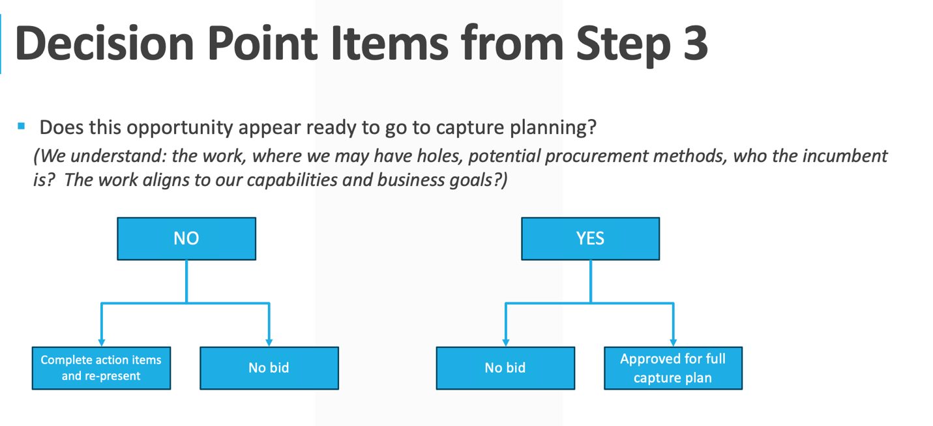

Feature | Description | Priority | Status
Overview Tab | Deal leads, award amount, period of performance, due date, executive summary, contract type. | P1 | Built
Program Details Tab | Program name, agency/customer, contract vehicle, base and option periods. | P1 | Built
Competitive Tab | Competitors list, competitive advantages, preliminary win strategy. | P1 | Built
Stakeholders Tab | Stakeholder matrix with name, organization, role, relationship owner, support status. | P1 | Built
SWOT Tab | Strengths, weaknesses, opportunities, threats — structured entry per category. | P1 | Built
Partners Tab | Teaming partners with role, work share %, legal agreement status, involvement status. | P1 | Built

5.4 Deal Detail — Proposal Management Data
Feature | Description | Priority | Status
Win Strategy | Win themes, discriminators, engagement approach — aligned with Shipley capture planning. | P1 | Built
Evaluation Criteria | RFP evaluation factors and subfactors with weights and approach notes. | P1 | Built
Gap Analysis | Gaps vs. evaluation criteria with severity, mitigation plan, and owner. | P1 | Built
RFP Modulation | Compliance matrix cross-referencing RFP sections to proposal volumes. | P1 | Built
Review Stages | Red Team, Blue Team, White Team review tracking with reviewer, date, and findings. | P1 | Built
Pricing Detail | Price-to-win analysis, cost basis, competitive pricing notes. | P2 | Built
Loss Factors | Documented lessons from bid/no-bid decisions and losses. | P2 | Built
Lessons Learned | Post-award or post-loss lessons captured for institutional knowledge. | P2 | Built

5.5 Actions Management
Feature | Description | Priority | Status
Action Tracking | Create actions linked to a deal. Fields: title, description, priority (High/Medium/Low), status, owner, due date. | P1 | Built
Overdue Flagging | Actions past due date are visually flagged in red. | P1 | Built
Action Filters | Filter by status, priority, owner, and deal. | P1 | Built
Mark Complete | One-click completion with completion date recorded. | P1 | Built

5.6 Risk Management
Feature | Description | Priority | Status
Risk Tracking | Create risks linked to a deal. Fields: title, context, severity (Red/Yellow/Green), probability, status, owner. | P1 | Built
Mitigation Plans | Each risk includes a structured mitigation plan separate from the risk context. | P1 | Built
Risk Filters | Filter by severity, status, and deal. | P1 | Built
Risk Dashboard | Risk count per deal visible on dashboard deal cards. | P1 | Built

6. Data Model Overview
The platform uses a relational PostgreSQL database with 23 tables. All entities include created_at, updated_at timestamps and foreign key constraints.

6.1 Core Tables
- users — authentication, role, profile
- deals — master deal record, all key metrics
- deal_stages — gate review history per deal
- audit_log — immutable audit trail of all write operations

6.2 Deal Sub-Tables (one per deal)
- proposal_review_stage — Red/Blue/White Team review records
- stakeholders — stakeholder matrix
- partners, deal_partners, legal_agreements — teaming data
- competitive_analysis, competitive_edge — competitive intelligence
- swot — SWOT analysis entries
- evaluation_criteria — RFP evaluation factor tracking
- gap_analysis — gaps vs. evaluation criteria
- win_strategy — win themes and engagement plans
- rfp_modulation — compliance matrix
- budget, pricing_detail — financial analysis
- call_plan — customer engagement tracking
- loss_factors, lessons_learned — institutional knowledge
- actions — action items (linked to deal)
- risks — risk register (linked to deal)

7. Technical Architecture

7.1 Technology Stack
Layer | Technology | Hosting
Frontend | React 18, Vite, Tailwind CSS | Vercel (bd-platform-app.vercel.app)
Backend API | Node.js, Express, JWT Auth | Vercel Serverless (bd-platform-api.vercel.app)
Database | PostgreSQL 16 — 23 tables | Supabase (us-east-1)
Real-time | Socket.io (disabled in serverless) | Future phase
Source Control | GitHub (SamGruvr/BD_ITA) | Public repo
CI/CD | Vercel auto-deploy on git push | On every main branch commit

7.2 API Design
RESTful API with 31 endpoints organized by resource. All endpoints except /health and /api/auth/login require a valid JWT Bearer token. Role checks are enforced at the route level.

- POST /api/auth/login — issue JWT
- GET|POST|PUT /api/deals — deal CRUD
- GET /api/deals/:id/details — aggregated deal with all sub-resources
- GET|POST|PUT /api/deals/:id/[resource] — sub-resource CRUD (12 resource types)
- GET|POST|PUT /api/actions — action management
- GET|POST|PUT /api/risks — risk management
- GET /api/audit-logs — admin audit trail

8. Shipley Methodology Alignment
The platform is designed around the Shipley Business Development Lifecycle. Terminology and workflow stages map directly to Shipley conventions.

Shipley Stage | Platform Feature | Data Captured
Opportunity Identification | Deal card, color classification | Agency, program, contract type, award amount, BD lead
Capture Planning | Win Strategy tab | Win themes, discriminators, engagement approach
Competitive Analysis | Competitive tab, SWOT | Competitors, advantages, SWOT, pricing intelligence
Teaming | Partners tab | Partner roles, work share, legal status
Proposal Planning | Evaluation Criteria, Gap Analysis, RFP Modulation | Compliance matrix, gaps, evaluation factors
Red Team Review | Review Stages — Red Team | Reviewer, date, findings, action items
Blue Team Review | Review Stages — Blue Team | Reviewer, date, findings, action items
White Team / BAFO | Review Stages — White Team | Final review, pricing approval, submission sign-off
Post-Submission | Loss Factors, Lessons Learned | Win/loss analysis, institutional knowledge

9. Out of Scope — Future Phases

Phase 2 Priorities
- Real-time collaboration — Socket.io notifications when another user updates a deal
- Document generation — auto-generate proposal outline from capture data
- Email notifications — action due date reminders, gate review alerts
- Reporting & analytics — win rate dashboards, pipeline forecasting
- Search across portfolio — full-text search across all deals and documents

Phase 3 Priorities
- OAuth2 / OIDC integration — Microsoft Entra ID (Azure AD) SSO
- Two-factor authentication
- API versioning and Swagger documentation
- Export to PDF/PowerPoint — generate summary decks from deal data
- Webhook integrations — CRM and GovWin data feed connections
- Mobile-responsive design optimization

10. Constraints & Assumptions

Constraints
- POC is single-user (Sam Gruverman) — no multi-user access during proof of concept phase
- Vercel Hobby plan — serverless functions only, no persistent server processes
- Supabase free tier — 500MB database storage, 2GB bandwidth
- No file attachment support in v1.0 — proposal documents remain in SharePoint/Teams
- Socket.io real-time features disabled in serverless deployment — future persistent hosting required

Assumptions
- Users have access to a modern web browser (Chrome, Edge, Safari, Firefox)
- Shipley terminology and gate review naming conventions will remain consistent
- Deal data is input manually by BD leads — no automated CRM integration in v1.0
- The platform does not replace GovWin or FPDS for opportunity identification — it supplements them

11. Appendix

11.1 Live Application URLs
- Frontend: https://bd-platform-app.vercel.app
- Backend API: https://bd-platform-api.vercel.app
- API Health Check: https://bd-platform-api.vercel.app/health

11.2 GitHub Repository
- Repository: https://github.com/SamGruvr/BD_ITA
- Branch: main
- CI/CD: Vercel auto-deploys on every push to main

11.3 Database
- Provider: Supabase (us-east-1)
- Project: bd-platform (srguiseeksrguemxdduo)
- Tables: 23 (schema at /database/schema.sql)

11.4 Test Coverage
- 94 automated tests — all passing
- Unit: middleware, validation, API structure
- Integration: database connectivity, endpoint response codes
- Test command: npm test (from /backend directory)

