**電工實驗（四）**

**微處理器實驗3**

**中斷處理程式與時鐘**

**第十四組**

**許銘森B063011058**

程式碼

1. 主程式

#include "M451Series.h"//加入自訂M451的標頭檔

#include "TimebaseAgent.h"

#include "SevenSegmentAgent.h"//加入自訂七段顯示器 的標頭檔

#include "ButtonAgent.h"//加入自訂按鈕的標頭檔

#include "StepMotorAgent.h"//加入自訂馬達的標頭檔

uint32_t timecount;

uint8_t dir;//方向

uint8_t speed;//速度

uint8_t oldspeed;//停下來前的速度

int flag;//記錄有沒有停下來過 1：有 0：沒有

int __main(){

Timebase_Initial();//呼叫 Timebase初始化函式

_7Seg_Initial();//呼叫七段顯示器初始化函式

Btn_Initial();//呼叫按鈕初始化函式

StepMtr_Initial();//呼叫馬達初始化函式

GPIO_SetMode(PB,BIT2,GPIO_MODE_OUTPUT);//呼叫 LED初始化函式

dir = 1;

speed = 25;

_7Seg_WriteBuf(2,5);

flag=0;

while(1){

if(Btn_IsDown(0xF) == 0x03)//兩個按鈕0x03和0x04同時按，LED亮

PB2 = 0;

else

PB2 = 1;

if(flag==1 && Btn_IsOneShot(0x04) == 0x04)//馬達停下來再按0x04按鈕，轉回停下來前的速度

{

speed=oldspeed;

flag=0;

_7Seg_WriteBuf(1000/speed/10,1000/speed%10);

Btn_OneShotClear(0x04);

}

/* if the button pressed */

if(Btn_IsOneShot(0x01) == 0x01){//按0x04按鈕加速

speed++;

//write to 7seg output buffer

_7Seg_WriteBuf(1000/speed/10,1000/speed%10);

//clear one-shot flag

Btn_OneShotClear(0x01);

}

if(Btn_IsOneShot(0x02) == 0x02){//按0x04按鈕減速

if(speed)

speed--;

//write to 7seg output buffer

_7Seg_WriteBuf(1000/speed/10,1000/speed%10);

Btn_OneShotClear(0x02);

}

if(Btn_IsOneShot(0x04) == 0x04){//按0x04按鈕停下

oldspeed=speed;//把停下來前的速度存起來

speed=0;

flag=1;

_7Seg_WriteBuf(1000/speed/10,1000/speed%10);

Btn_OneShotClear(0x04);

}

if(Btn_IsOneShot(0x08) == 0x08){//按0x03按鈕改變轉向

if(dir==0)

{

dir=1;

}

else if(dir==1)

{

dir=0;

}

//write to 7seg output buffer

_7Seg_WriteBuf(1000/speed/10,1000/speed%10);

Btn_OneShotClear(0x08);

}

/* Step motor output */

StepMtr_Task(dir, speed);//把方向速度給馬達

/* Scan button */

Btn_Task();

/* 7 segment output */

_7Seg_Task();

}

}

1. 步進馬達
2. #ifndef __STEPMOTORAGENT_H__//定義步進馬達

#define __STEPMOTORAGENT_H__

#include "M451Series.h"

#define MTR_A PE11

#define MTR_B PE10

#define MTR_A_BAR PE13

#define MTR_B_BAR PE12

extern uint32_t timecount;

void StepMtr_Initial(void);

void StepMtr_Task(uint8_t dir, uint32_t d);

#endif /* __STEPMOTORAGENT_H__ */

void StepMtr_Task(uint8_t dir, uint32_t d){//步進馬達運作函式

static uint32_t StepMtrOldCount = 0;

if((uint32_t)(timecount - StepMtrOldCount) < d)

return;

StepMtrOldCount = timecount;

if(d ==0 )

StepMtrState = 4;

switch(StepMtrState){

case 0://state 0輸出1001

MTR_A = 1;

MTR_B = 0;

MTR_A_BAR = 0;

MTR_B_BAR = 1;

StepMtrState=dir?1:3;//dir為1時，順向。0時，逆向。

break;

case 1://state 1輸出1100

MTR_A = 1;

MTR_B = 1;

MTR_A_BAR = 0;

MTR_B_BAR = 0;

StepMtrState=dir?2:0;

break;

case 2://state 2輸出0110

MTR_A = 0;

MTR_B = 1;

MTR_A_BAR = 1;

MTR_B_BAR = 0;

StepMtrState=dir?3:1;

break;

case 3://state 3輸出0011

MTR_A = 0;

MTR_B = 0;

MTR_A_BAR = 1;

MTR_B_BAR = 1;

StepMtrState=dir?0:2;

break;

case 4://state 4輸出0000

MTR_A = 0;

MTR_B = 0;

MTR_A_BAR = 0;

MTR_B_BAR = 0;

StepMtrState=dir?0:4;

break;

default://default輸出0000

StepMtrState = 4;

}

}

3. 按鍵

#ifndef __BUTTONAGENT_H__//定義按鍵

#define __BUTTONAGENT_H__

#include "M451Series.h"

#define SW1 PE2

#define SW2 PA8

#define SW3 PB6

#define SW4 PB7

#define BTN_STATE_UP 0

#define BTN_STATE_BOUNCING 1

#define BTN_STATE_ONESHOT 2

#define BTN_STATE_DOWN 3

#define DEBOUNCEDELAY 100

extern uint32_t timecount;

void Btn_Initial(void);

void Btn_Task(void);

uint8_t Btn_IsDown(uint8_t btnSelMask);

uint8_t Btn_IsOneShot(uint8_t btnSelMask);

void Btn_OneShotClear(uint8_t btnSelMask);

#endif /* __BUTTONAGENT_H__ */

#include "ButtonAgent.h"

uint8_t BtnDownFlag;

uint8_t BtnOneShot;

uint8_t BtnState[4];

uint32_t BtnOldCount[4];

volatile uint32_t* pSW[4];

1. void Btn_Initial(void){//步進馬達運作函式

GPIO_SetMode(PE, BIT2, GPIO_MODE_INPUT);//呼叫按鍵初始化函式

GPIO_SetMode(PA, BIT8, GPIO_MODE_INPUT);

GPIO_SetMode(PB, BIT6, GPIO_MODE_INPUT);

GPIO_SetMode(PB, BIT7, GPIO_MODE_INPUT);

BtnDownFlag = 0;

BtnOneShot = 0;

pSW[0] = &SW1;

pSW[1] = &SW2;

pSW[2] = &SW3;

pSW[3] = &SW4;

for(uint8_t i = 0; i < 4 ; i++){

BtnState[i] = BTN_STATE_UP;

BtnOldCount[i] = 0;

}

}

void Btn_Task(void){

for(uint8_t i = 0 ; i < 4 ; i++){

switch(BtnState[i]){

case BTN_STATE_UP://按鍵為沒按的狀態

if(*pSW[i] == 0){

BtnState[i] = BTN_STATE_BOUNCING;

}

BtnOldCount[i] = timecount;

BtnDownFlag &= ~(0x01 << i);

BtnOneShot &= ~(0x01 << i);

break;

case BTN_STATE_BOUNCING://按鍵彈跳中

if(*pSW[i] == 1){

BtnState[i] = BTN_STATE_UP;

}else if((uint32_t)(timecount - BtnOldCount[i]) > DEBOUNCEDELAY){

BtnState[i] = BTN_STATE_ONESHOT;

}

break;

case BTN_STATE_ONESHOT://按鍵的oneshot訊號發出

BtnState[i] = BTN_STATE_DOWN;

BtnOneShot |= 0x01 << i;

break;

case BTN_STATE_DOWN://按鍵為按的狀態

if(*pSW[i] == 1){

BtnState[i] = BTN_STATE_UP;

}else {

BtnDownFlag |= 0x01 << i;

}

break;

default:

BtnState[i] = BTN_STATE_UP;

}//switch(BtnState[i])

}//for(0:3)

}

uint8_t Btn_IsDown(uint8_t btnSelMask){

return BtnDownFlag & btnSelMask;

}

uint8_t Btn_IsOneShot(uint8_t btnSelMask){

return BtnOneShot & btnSelMask;

}

void Btn_OneShotClear(uint8_t btnSelMask){

BtnOneShot &= ~btnSelMask;

}

程式碼流程

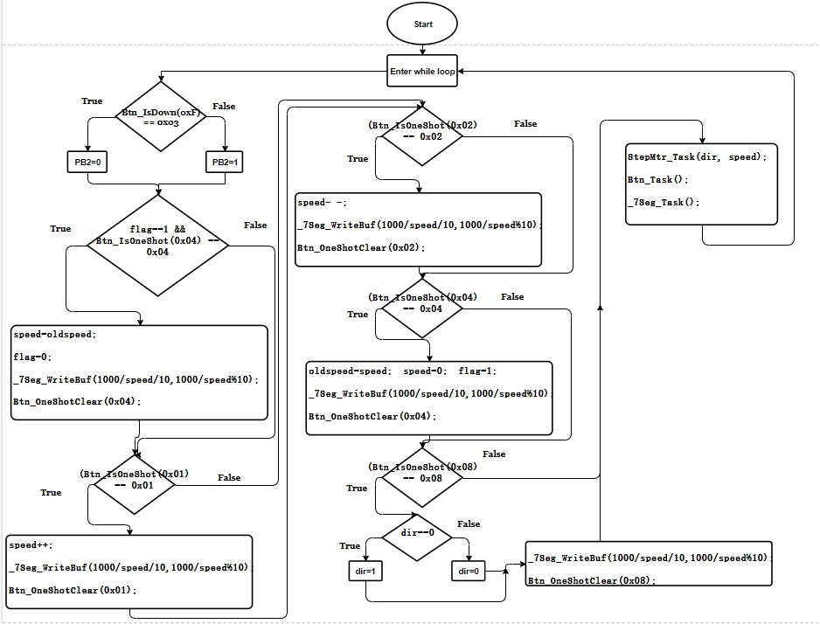

心得

這次實驗是第三次使用微控器，和上次一樣用到c語言去設定M451的腳位輸入輸出，但是這次有寫好的標頭檔，不用另外再設定。這次實驗的重點時要把Clock和interrupt的概念弄清楚，再結合state machine 的概念去控制馬達。中斷處理程式是時鐘的實行方法，設定中斷頻數便可以用time count數數，Clock就可以實現。

state是控制馬達的轉動波形，有五個state。這次實驗也不難，主要目的為熟悉軟體操作如何做出跟Clock有關的的IO及運用，實驗過程大致順利。