**電工實驗（四）**

**微處理器實驗4**

**ADC**

**第十四組**

**許銘森B063011058**

程式碼

1. ADC

//ADC標頭檔

#ifndef __ADCAGENT_H__

#define __ADCAGENT_H__

#include "M451Series.h"

extern uint32_t timecount;

void ADC_Initial(void);

void ADC_Task(void);

uint8_t ADC_GetTemperature(void);

uint8_t ADC_GetVR(void);

#endif /* __ADCAGENT_H__ */

//ADC標頭檔C檔

#include "ADCAgent.h"

uint8_t ADCState;

uint16_t TempBuf;

uint16_t VRBuf;

void ADC_Initial(void){ //ADC初始化函式

CLK->APBCLK0 |= CLK_APBCLK0_EADCCKEN_Msk; //ADC 時脈 啓用

CLK->CLKDIV0 &= ~CLK_CLKDIV0_EADCDIV_Msk; //ADC 時脈 除頻

CLK->CLKDIV0 |= 0 << CLK_CLKDIV0_EADCDIV_Pos; //(div + 1)

EADC->CTL |= EADC_CTL_ADCEN_Msk; //ADC 啓用

EADC->CTL &= ~EADC_CTL_DIFFEN_Msk;

EADC->CTL &= ~EADC_CTL_SMPTSEL_Msk;

EADC->CTL |= EADC_CTL_SMPTSEL8; /ADC 取樣時間

EADC->SCTL[0] &= ~EADC_SCTL_TRGSEL_Msk;

EADC->SCTL[0] |= EADC_SOFTWARE_TRIGGER;

EADC->SCTL[0] &= ~EADC_SCTL_CHSEL_Msk;

EADC->SCTL[0] |= 6 << EADC_SCTL_CHSEL_Pos;

SYS->GPB_MFPH &= ~SYS_GPB_MFPH_PB9MFP_Msk; //set channel 6 pin(PB9) as analog input

SYS->GPB_MFPH |= SYS_GPB_MFPH_PB9MFP_EADC_CH6;

PB->DINOFF |= BIT9; //disable digital input path

SYS->IVSCTL |= SYS_IVSCTL_VTEMPEN_Msk; //啓用溫度感應器

ADCState = 0; //inititial adc agent state

}

void ADC_Task(void){

static uint32_t ADCOldCount = 0;

if((uint32_t)(timecount - ADCOldCount) < 10)

return;

ADCOldCount = timecount;

switch(ADCState){

case 0:/* 程式觸發VR和溫度感應器*/

EADC->SWTRG |= (BIT0 | BIT17);

ADCState = 1;

break;

case 1:/* 等待所有轉換完成 */

if(EADC->SWTRG == 0){

ADCState = 2;

}

break;

case 2:/*獲取數據*/

VRBuf = (EADC->DAT[0] & 0xFFF);

TempBuf = (EADC->DAT[17] & 0xFFF);

ADCState = 0;

break;

default:

ADCState = 0;

}

}

uint8_t ADC_GetTemperature(void){/*讀取溫度數據*/

/* Vtemp(mV) = Gain(mV/C) * Temperature(C) + Offset(mV)

** Gain = 1.672(mV/C)

** Offset = 740 (mV)

** Vref+ = Vcc = 3.3V

** Vref- = 0V

** Resolution = 2^12 = 4096LSB

************************************************************************

** Vtemp(mV) = (3300(mV) - 0(mV))*(Dtemp(LSB) / 4096(LSB))

** Temperature(C) = (Vtemp(mV) - Offset(mV)) / Gain(mV/C)

** = (( (3300 - 0) * (Dtemp / 4096)) - 740) / - 1.672

** = ((3300 * Dtemp / 4096) - 740) / -1.672

** = (740 - (3300 * Dtemp / 4096)) / 1.672

** = (740000 - (3300000 * Dtemp / 4096)) / 1.672

*/

return (740000 - (TempBuf * (3300000 >> 12))) / 1672;

}

uint8_t ADC_GetVR(void){/*讀取VRBuf 數據*/

return VRBuf >> 4;

}

2.主程式

#include "M451Series.h"//加入自訂M451的標頭檔

#include "TimebaseAgent.h"

#include "SevenSegmentAgent.h"//加入自訂七段顯示器 的標頭檔

#include "ButtonAgent.h"//加入自訂按鈕的標頭檔

#include "StepMotorAgent.h"//加入自訂馬達的標頭檔

#include "ADCAgent.h"//加入自訂ADC的標頭檔

uint32_t timecount;

uint8_t dir;//方向

uint32_t speed;//速度

uint8_t mtr_speed;//速度（rpm）

int DisplayMode;//顯示模式

uint32_t StepMtr_RPMtoD(uint8_t rpm);

void DisplayTask (void);

int __main(){

Timebase_Initial();//呼叫 Timebase初始化函式

_7Seg_Initial();//呼叫七段顯示器初始化函式

Btn_Initial();//呼叫按鈕初始化函式

StepMtr_Initial();//呼叫馬達初始化函式

ADC_Initial（）；//呼叫ADC初始化函式

GPIO_SetMode(PB,BIT2,GPIO_MODE_OUTPUT);//呼叫 LED初始化函式

dir = 1;

speed = 0;

while(1){

if(Btn_IsOneShot(0x01) == 0x01){

DisplayMode=1;//1=顯示溫度

//clear one-shot flag

Btn_OneShotClear(0x01);

}

if(Btn_IsOneShot(0x02) == 0x02){

DisplayMode=2;//2=顯示速度

Btn_OneShotClear(0x02);

}

if(Btn_IsOneShot(0x04) == 0x04){

DisplayMode=3;//3=顯示方向

dir=!dir;

Btn_OneShotClear(0x04);

//Btn_OneShotClear(0x04);

}

/*將類比轉換為數位*/

ADC_Task();

mtr_speed=ADC_GetVR();

speed=StepMtr_RPMtoD(mtr_speed);

DisplayTask();/* 寫進7_seg buffer */

StepMtr_Task(dir,speed);//把方向速度給馬達

Btn_Task();

_7Seg_Task();/* 7 segment 輸出 */

}

}

void DisplayTask (void){

static uint32_t Dpoldcount=0;

if((uint32_t)timecount-Dpoldcount<1000)return;

Dpoldcount=timecount;

switch(DisplayMode)

{case 1://1=顯示溫度

_7Seg_WriteBuf((ADC_GetTemperature()/10)%10, ADC_GetTemperature()%10);

break;

case 2://2=顯示速度

_7Seg_WriteBuf((mtr_speed/10)%10,mtr_speed%10);

break;

case 3://3=顯示方向

_7Seg_WriteBuf(dir/10,dir);

break;

default:

_7Seg_WriteBuf((ADC_GetTemperature()/10)%10, ADC_GetTemperature()%10);

}

}

uint32_t StepMtr_RPMtoD(uint8_t rpm)

{

return rpm?6000/rpm:0;

}

程式碼流程

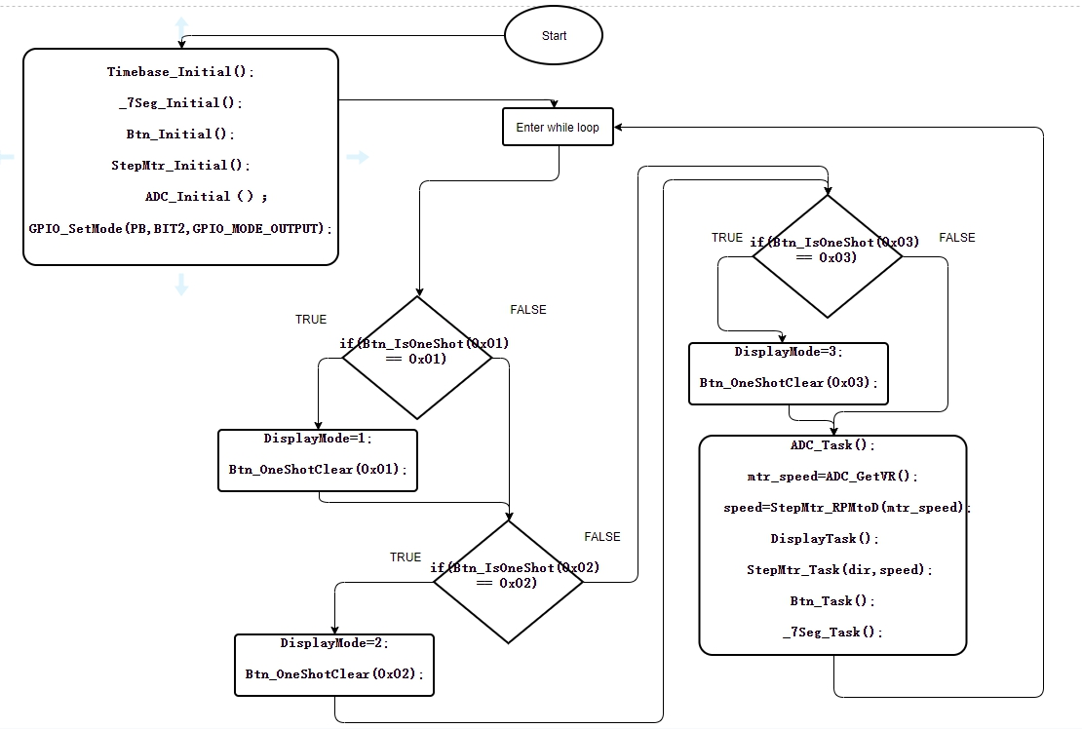

心得

這次實驗是第四次使用微控器，和上次一樣用到中斷處理程式與時鐘

，再結合state machine 的概念去控制馬達。這次不同的是有ADC，將類比轉換為數位，也是用state machine 的概念去控制轉換訊號，等待所有轉換完成才讀取溫度數據。這次實驗也不難，主要目的為結合上三次實驗的概念再加以利用，實驗過程大致順利。