**電工實驗（四）**

**微處理器實驗五**

**系統整合實驗**

**第十四組**

**許銘森B063011058**

程式碼

**1. Include**

#include <stdio.h>

#include "M451Series.h"//加入自訂M451的標頭檔

#include "TimebaseAgent.h"//加入自訂時間的標頭檔

#include "SevenSegmentAgent.h"//加入自訂七段顯示器的標頭檔

#include "ButtonAgent.h"//加入自訂按鈕的標頭檔

#include "StepMotorAgent.h"//加入自訂馬達的標頭檔

#include "ADCAgent.h"//加入自訂ADC的標頭檔

**2. Define**

#define TASK_CLKSHOW 0

#define TASK_CLKSET 1

#define TASK_MTRSHOW 2

#define TASK_MTRSET 3

#define TASK_MTRADC 4

#define STATE_CLKSHOW_SEC 0

#define STATE_CLKSHOW_MIN 1

#define STATE_CLKSHOW_HRS 2

#define STATE_CLKSET_ON 0

#define STATE_CLKSET_OFF 1

#define STATE_MTRSHOW_SPEED 0

#define STATE_MTRSHOW_DIR 1

#define STATE_MTRSHOW_TEMP 2

#define STATE_MTRSET_ON 0

#define STATE_MTRSET_OFF 1

#define STATE_MTRADC_SPEED 0

#define STATE_MTRADC_DIR 1

#define STATE_MTRADC_TEMP 2

uint32_t timecount;

uint8_t Task_ID;

uint8_t mtr_set;

uint8_t Task_ClkShow_State;//CLK顯示state

uint8_t Task_ClkSet_State;//CLK調整state

uint8_t Task_MtrShow_State;//馬達顯示state

uint8_t Task_MtrSet_State;//馬達調整state

uint8_t Task_MtrADC_State;//馬達analog —》Digital state

uint8_t _7seg_lo;

uint8_t _7seg_hi;

uint8_t mtr_speed; //rpm

uint8_t mtr_dir;

uint32_t mtr_d;

uint8_t stop;

int8_t clk_sec;

int8_t clk_min;

int8_t clk_hr;

void DisplayTask(uint8_t hi, uint8_t lo);

void ClkShow(void);

void ClkSet(void);

void MtrShow(void);

void MtrSet(void);

void MtrADC(void);

void CLOCK(void);

uint32_t StepMtr_RPMtoD(uint8_t rmp);

**3.main**

int __main(){

Timebase_Initial();//呼叫各元件初始化函式

_7Seg_Initial();

Btn_Initial();

StepMtr_Initial();

ADC_Initial();

clk_sec = 0;

clk_min = 0;

clk_hr = 0;

_7seg_hi = 0;

_7seg_lo = 0;

mtr_dir = 1;

mtr_speed = 25;

stop = 0;

mtr_d = StepMtr_RPMtoD(mtr_speed);

Task_ID = TASK_CLKSHOW;

Task_ClkShow_State = STATE_CLKSHOW_SEC;

Task_ClkSet_State = STATE_CLKSET_ON;

Task_MtrShow_State = STATE_MTRSHOW_SPEED;

Task_MtrSet_State = STATE_MTRSET_ON;

Task_MtrADC_State = STATE_MTRADC_SPEED;

while(1){

switch(Task_ID)//五個模式用ID切換

{

case TASK_CLKSHOW:

ClkShow();

break;

case TASK_CLKSET:

ClkSet();

break;

case TASK_MTRSHOW:

MtrShow();

CLOCK();//數時間

break;

case TASK_MTRSET:

MtrSet();

CLOCK();

break;

case TASK_MTRADC:

MtrADC();

CLOCK();

break;

default:

Task_ID = TASK_CLKSHOW;

}

DisplayTask(_7seg_hi, _7seg_lo); //10Hz update rate

_7Seg_Task(); //1kKz switch rate

ADC_Task(); //ADC conversion

StepMtr_Task(mtr_dir, mtr_d); //Step motor output

Btn_Task(); //Button scan

}

}

**4.DisplayTask//**七段顯示器設定

void DisplayTask(uint8_t hi, uint8_t lo){

static uint32_t DpOldCount = 0;

if((uint32_t)(timecount - DpOldCount) < 1000)//100ms

return;

DpOldCount = timecount;

_7Seg_WriteBuf(hi, lo);

}

**5.CLOCK**//計時間

void CLOCK(void)

{

static uint32_t ClkOldCount = 0;

/* Clock tick */

if((uint32_t)(timecount - ClkOldCount) >= 10000)

{

if(++clk_sec >= 60){

clk_sec = 0;

if(++clk_min >= 60){

clk_min = 0;

if(++clk_hr >= 24)

clk_hr = 0;

}

}

ClkOldCount = timecount;

}

}

**6.Clkshow**

void ClkShow(void){

CLOCK();

/* Button control */

if(Btn_IsDown(0x01) == 0x01)//同時按兩個按鈕

{

if(Btn_IsOneShot(0x02) == 0x02)//按1 2號按鈕

{

Task_ID = TASK_MTRSHOW; //TASK_MTRSHOW

Btn_OneShotClear(0x02);

}

if(Btn_IsOneShot(0x04) == 0x04){//按1 4號按鈕

Task_ID = TASK_CLKSET; //TASK_CLKSET

Btn_OneShotClear(0x04);

}

if(Btn_IsOneShot(0x08) == 0x08){//按1 8號按鈕

Btn_OneShotClear(0x08);

}

}else{

if(Btn_IsOneShot(0x02) == 0x02){//按2號按鈕

Task_ClkShow_State = STATE_CLKSHOW_HRS;//state為顯示小時

Btn_OneShotClear(0x02);

}

if(Btn_IsOneShot(0x04) == 0x04){//按4號按鈕

Task_ClkShow_State = STATE_CLKSHOW_MIN;//state為顯示分

Btn_OneShotClear(0x04);

}

if(Btn_IsOneShot(0x08) == 0x08){//按8號按鈕

Task_ClkShow_State = STATE_CLKSHOW_SEC;//state為顯示秒

Btn_OneShotClear(0x08);

}

}

/* 7segment control */

switch(Task_ClkShow_State){//根據ClkShow_State顯示時間單位

case STATE_CLKSHOW_SEC:

_7seg_hi = (clk_sec / 10) % 10;

_7seg_lo = clk_sec % 10;

break;

case STATE_CLKSHOW_MIN:

_7seg_hi = (clk_min / 10) % 10;

_7seg_lo = clk_min % 10;

break;

case STATE_CLKSHOW_HRS:

_7seg_hi = (clk_hr / 10) % 10;

_7seg_lo = clk_hr % 10;

break;

default:

Task_ClkShow_State = STATE_CLKSHOW_SEC;

}

}

**7.ClkSet**

void ClkSet(void){

static uint32_t ClkOldCount = 0;

if((uint32_t)(timecount - ClkOldCount) >= 3000){

Task_ClkSet_State = !Task_ClkSet_State;

ClkOldCount = timecount;

}//調整閃爍快慢

if(Btn_IsDown(0x01) == 0x01)//同時按兩個按鈕

{

if(Btn_IsOneShot(0x02) == 0x02){

Btn_OneShotClear(0x02);

}

if(Btn_IsOneShot(0x04) == 0x04){

Btn_OneShotClear(0x04);

}

if(Btn_IsOneShot(0x08) == 0x08){

Btn_OneShotClear(0x08);

}

}

else

{

if(Btn_IsOneShot(0x02) == 0x02)//按2號按鈕

{

switch(Task_ClkShow_State)//根據ClkShow_State加時間

{

case STATE_CLKSHOW_SEC:

if(++clk_sec >= 60)

clk_sec = 0;

break;

case STATE_CLKSHOW_MIN:

if(++clk_min >= 60)

clk_min = 0;

break;

case STATE_CLKSHOW_HRS:

if(++clk_hr >= 24)

clk_hr = 0;

break;

}

Btn_OneShotClear(0x02);

}

if(Btn_IsOneShot(0x04) == 0x04)//按4號按鈕

{

switch(Task_ClkShow_State)//根據ClkShow_State減時間

{

case STATE_CLKSHOW_SEC:

if(--clk_sec < 0)

clk_sec = 59;

break;

case STATE_CLKSHOW_MIN:

if(--clk_min < 0)

clk_min = 59;

break;

case STATE_CLKSHOW_HRS:

if(--clk_hr < 0)

clk_hr = 23;

break;

}

Btn_OneShotClear(0x04);

}

if(Btn_IsOneShot(0x08) == 0x08)//按8號按鈕

{

Task_ID = TASK_CLKSHOW;//跳回顯示時間模式

Btn_OneShotClear(0x08);

}

}

/* 7segment control */

switch(Task_ClkSet_State){//根據ClkSet_State顯示時間單位

case STATE_CLKSET_ON:

switch(Task_ClkShow_State){

case STATE_CLKSHOW_SEC:

_7seg_hi = (clk_sec / 10) % 10;

_7seg_lo = clk_sec % 10;

break;

case STATE_CLKSHOW_MIN:

_7seg_hi = (clk_min / 10) % 10;

_7seg_lo = clk_min % 10;

break;

case STATE_CLKSHOW_HRS:

_7seg_hi = (clk_hr / 10) % 10;

_7seg_lo = clk_hr % 10;

break;

default:

Task_ClkShow_State = STATE_CLKSHOW_SEC;

}

break;

case STATE_CLKSET_OFF:

_7seg_hi = 10;

_7seg_lo = 10;

break;

default:

Task_ClkSet_State = STATE_CLKSET_ON;

}

}

**8.馬達顯示**//原理如Clk_show

void MtrShow(void){

static uint32_t MtrShowOldCount = 0;

if((uint32_t)(timecount - MtrShowOldCount) < 1000)//100 ms

return;

MtrShowOldCount = timecount;

if(Btn_IsDown(0x01) == 0x01)

{

if(Btn_IsOneShot(0x02) == 0x02){

Task_ID = TASK_MTRADC;//切換模式TASK_MTRADC

Btn_OneShotClear(0x02);

}

if(Btn_IsOneShot(0x04) == 0x04){

Task_ID = TASK_MTRSET;//切換模式TASK_MTRSET

Btn_OneShotClear(0x04);

}

if(Btn_IsOneShot(0x08) == 0x08){

mtr_d= 0;//馬達速度爲零

Btn_OneShotClear(0x08);

}

}

else

{

if(Btn_IsOneShot(0x02) == 0x02)

{

Task_MtrShow_State=STATE_MTRSHOW_SPEED;//state為顯示速

Btn_OneShotClear(0x02);

}

if(Btn_IsOneShot(0x04) == 0x04)

{

Task_MtrShow_State=STATE_MTRSHOW_DIR;//state為顯示方向

Btn_OneShotClear(0x04);

}

if(Btn_IsOneShot(0x08) == 0x08)

{

Task_MtrShow_State=STATE_MTRSHOW_TEMP;//state為顯示溫度

Btn_OneShotClear(0x08);

}

}

/* 7segment control */

switch(Task_MtrShow_State){//根據MtrShow_State顯示馬達參數

case STATE_MTRSHOW_SPEED:

_7seg_hi = (mtr_speed / 10) % 10;

_7seg_lo = mtr_speed % 10;

break;

case STATE_MTRSHOW_DIR:

_7seg_hi = 0;

_7seg_lo = mtr_dir % 10;

break;

case STATE_MTRSHOW_TEMP:

_7seg_hi =(ADC_GetTemperature()/10)%10;

_7seg_lo = ADC_GetTemperature()%10;

break;

default:

Task_MtrShow_State = STATE_MTRSHOW_SPEED;

}

}

**9.馬達設定**//原理如Clkset

void MtrSet(void){

static uint32_t MtrSetOldCount = 0;

if((uint32_t)(timecount - MtrSetOldCount) >= 3000)//100 ms

{

Task_MtrSet_State =!Task_MtrSet_State;

MtrSetOldCount = timecount;

}//調整閃爍快慢

if(Btn_IsDown(0x01) == 0x01)

{

if(Btn_IsOneShot(0x02) == 0x02){

Btn_OneShotClear(0x02);

}

if(Btn_IsOneShot(0x04) == 0x04){

Btn_OneShotClear(0x04);

}

if(Btn_IsOneShot(0x08) == 0x08){

Btn_OneShotClear(0x08);

}

}

else

{

if(Btn_IsOneShot(0x02) == 0x02)

{

if(Task_MtrShow_State==STATE_MTRSHOW_SPEED)//如果顯示速度

{

mtr_speed++;//加速

_7seg_hi = (mtr_speed / 10) % 10;

_7seg_lo = mtr_speed % 10;

Btn_OneShotClear(0x02);

}

if(Task_MtrShow_State==STATE_MTRSHOW_DIR)//如果顯示方向

{

mtr_dir=1;//換向

Btn_OneShotClear(0x02);

}

}

if(Btn_IsOneShot(0x04) == 0x04)

{

if(Task_MtrShow_State==STATE_MTRSHOW_SPEED)//如果顯示速度

{

mtr_speed--;//減速

_7seg_hi = (mtr_speed / 10) % 10;

_7seg_lo = mtr_speed % 10;

Btn_OneShotClear(0x04);

}

if(Task_MtrShow_State==STATE_MTRSHOW_DIR)//如果顯示方向

{

mtr_dir=0;

Btn_OneShotClear(0x04);

}

}

if(Btn_IsOneShot(0x08) == 0x08)

{

Task_ID = TASK_MTRSHOW;//切換模式TASK_MTRSHOW

Btn_OneShotClear(0x08);

}

}

mtr_d = StepMtr_RPMtoD(mtr_speed);

/* 7segment control */

switch(Task_MtrSet_State){//根據MtrSet_State顯示馬達參數

case STATE_MTRSET_ON:

switch(Task_MtrShow_State){

case STATE_MTRSHOW_SPEED:

_7seg_hi = (mtr_speed / 10) % 10;

_7seg_lo = mtr_speed % 10;

break;

case STATE_MTRSHOW_DIR:

_7seg_hi = 0;

_7seg_lo = mtr_dir % 10;

break;

case STATE_MTRSHOW_TEMP:

_7seg_hi =(ADC_GetTemperature()/10)%10;

_7seg_lo = ADC_GetTemperature()%10;

break;

default:

Task_ClkShow_State = STATE_MTRSHOW_SPEED;

}

break;

case STATE_MTRSET_OFF:

_7seg_hi = 10;

_7seg_lo = 10;

break;

default:

Task_MtrSet_State = STATE_MTRSET_ON;

}

}

**9.馬達ADC模式**

void MtrADC(void){

static uint32_t SpeedUpdateOldCount = 0;

static uint8_t select_speed ;

select_speed = mtr_speed;

if((uint32_t)(timecount - SpeedUpdateOldCount) >= 1000)//100 ms

{

if(Btn_IsDown(0x01) == 0x01)

{

if(Btn_IsOneShot(0x02) == 0x02){

Task_ID = TASK_CLKSHOW;//切換模式TASK_MTRSHOW

Btn_OneShotClear(0x02);

}

if(Btn_IsOneShot(0x04) == 0x04){

mtr_dir = (mtr_dir)? 0 : 1;//切換馬達方向

Btn_OneShotClear(0x04);

}

if(Btn_IsOneShot(0x08) == 0x08){

stop = stop? 0 : 1;

select_speed = (stop)? 0 : mtr_speed;//按著馬達停

Btn_OneShotClear(0x08);

}

}

else

{

if(Btn_IsOneShot(0x02) == 0x02)

{

Task_MtrADC_State=STATE_MTRADC_SPEED;

Btn_OneShotClear(0x02);

}

if(Btn_IsOneShot(0x04) == 0x04)

{

Task_MtrADC_State=STATE_MTRADC_DIR;

Btn_OneShotClear(0x04);

}

if(Btn_IsOneShot(0x08) == 0x08)

{

Task_MtrADC_State=STATE_MTRADC_TEMP;

Btn_OneShotClear(0x08);

}

}

mtr_speed = ADC_GetVR();//用可變電阻控制馬達速度

mtr_d = StepMtr_RPMtoD(select_speed);

SpeedUpdateOldCount = timecount;

}

/* 7segment control */

switch(Task_MtrADC_State){//根據MtrADC_State顯示馬達參數

case STATE_MTRADC_SPEED:

_7seg_hi = (mtr_speed / 10) % 10;

_7seg_lo = mtr_speed % 10;

break;

case STATE_MTRADC_DIR:

_7seg_hi = 0;

_7seg_lo = mtr_dir % 10;

break;

case STATE_MTRADC_TEMP:

_7seg_hi =(ADC_GetTemperature()/10)%10;

_7seg_lo = ADC_GetTemperature()%10;

break;

default:

Task_MtrADC_State = STATE_MTRADC_SPEED;

}

}

uint32_t StepMtr_RPMtoD(uint8_t rmp)

{

return rmp ? 6000/rmp : 0;

}

程式碼流程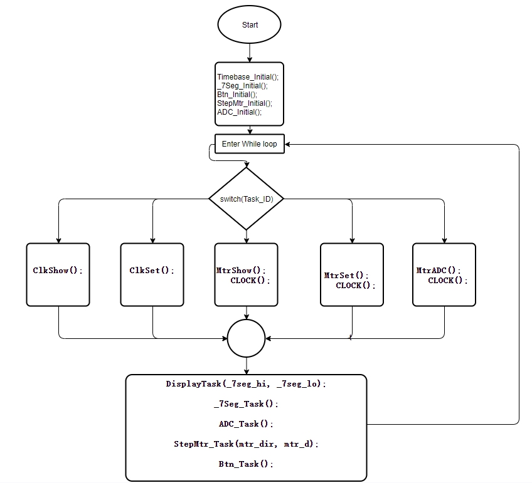

心得

這次實驗是第五次使用微控器，和上次一樣用到中斷處理程式與時鐘

，再結合state machine 的概念去控制馬達。這次主要是把上幾次實驗的功能一次做出，code很長需要仔細思考，把注解寫出來會比較清楚。