**電工實驗（四）**

**微處理器實驗六**

**RS232**

**第十四組**

**許銘森B063011058**

主程式

**UART標頭檔**

#ifndef __UARTAGENT_H__

#define __UARTAGENT_H__

#include "M451Series.h"

extern uint32_t timecount; //用來計時的

typedef struct{ //宣告成CQ_t struct

uint8_t data[64]; //包含64大小的buf

uint8_t head; //包含head tail

uint8_t tail;

}CQ_t;

void UART0_Initial(void);

void UART0_TxTask(void);

void UART0_IRQHandler(void);

uint8_t UART0_IsRxDataReady(void);

uint8_t UART0_IsTxBufFull(void);

void UART0_WriteByte(uint8_t Data);

uint8_t UART0_ReadByte(void);

static void CQ_EnQ(CQ_t *ptrBuf, uint8_t Data);

static uint8_t CQ_DeQ(CQ_t *ptrBuf);

static uint8_t CQ_IsFull(CQ_t *ptrBuf);

static uint8_t CQ_IsEmpty(CQ_t *ptrBuf);

static void CQ_Clear(CQ_t *ptrBuf);

#endif /* __UARTAGENT_H__ */

**UART 主程式**

#include "UARTAgent.h"

static CQ_t TxBuf; //宣告txbuffer

static CQ_t RxBuf; //宣告rxbuffer

void UART0_Initial(void){

CLK->APBCLK0 |= CLK_APBCLK0_UART0CKEN_Msk; //UART0 Clock Enable

CLK->CLKSEL1 &= ~CLK_CLKSEL1_UARTSEL_Msk; //UART0 Clock Source Selection

CLK->CLKSEL1 |= 0x3 << CLK_CLKSEL1_UARTSEL_Pos; //22.1184MHz

CLK->CLKDIV0 &= ~CLK_CLKDIV0_UARTDIV_Msk; //UART 除頻

CLK->CLKDIV0 |= 0 << CLK_CLKDIV0_UARTDIV_Pos; //22.1184MHz / (0 + 1) = 22.1184MHz

UART0->BAUD &= ~UART_BAUD_BAUDM0_Msk; //Set Baud Rate Divide Mode

UART0->BAUD &= ~UART_BAUD_BAUDM1_Msk; //0 = UART_CLK / [16 * (BRD+2)]

UART0->BAUD &= ~UART_BAUD_BRD_Msk;

UART0->BAUD |= 34 << UART_BAUD_BRD_Pos; // 22118400 / (16 * (34 + 2)) = 38400

UART0->FUNCSEL &= ~UART_FUNCSEL_FUNCSEL_Msk; //UART Function Selection

UART0->FUNCSEL |= 0 << UART_FUNCSEL_FUNCSEL_Pos; //00 = UART function.

UART0->LINE &= ~UART_LINE_WLS_Msk; //Word Length Selection

UART0->LINE |= 0x3 << UART_LINE_WLS_Pos; //11 = 8 bits.

UART0->LINE &= ~UART_LINE_NSB_Msk; //Number Of "STOP Bit"

UART0->LINE |= 0x0 << UART_LINE_NSB_Pos; //0 = One "STOP bit"

UART0->LINE &= ~UART_LINE_PBE_Msk; //Parity Bit Enable Bit

UART0->LINE |= 0x0 << UART_LINE_PBE_Pos; //0 = No parity bit generated.

UART0->INTEN = 0;

UART0->INTEN |= UART_INTEN_RDAIEN_Msk;//Receive Data Available Interrupt Enable Bit

NVIC->ISER[1] |= 0x1 << (36 - 32); //enable NVIC UART0 interrupt(36)

/* Set pin function as Tx Rx pin */

SYS->GPD_MFPL &= ~(SYS_GPD_MFPL_PD6MFP_Msk | SYS_GPD_MFPL_PD1MFP_Msk);

SYS->GPD_MFPL |= (SYS_GPD_MFPL_PD6MFP_UART0_RXD | SYS_GPD_MFPL_PD1MFP_UART0_TXD);

CQ_Clear(&TxBuf);

CQ_Clear(&RxBuf);

}

void UART0_TxTask(void){

/* If transmitter holding register(THR) is empty and Tx buffer is not empty */

if((UART0->INTSTS & UART_INTSTS_THREIF_Msk) && !CQ_IsEmpty(&TxBuf)){

UART0->DAT = CQ_DeQ(&TxBuf);

}

}

void UART0_IRQHandler(void){

uint8_t c;

if(UART0->INTSTS & UART_INTSTS_RDAIF_Msk){

c = UART0->DAT;

if(!CQ_IsFull(&RxBuf)){

CQ_EnQ(&RxBuf, c);

}

}

}

uint8_t UART0_IsRxDataReady(void){ //確認準備傳資料

return !CQ_IsEmpty(&RxBuf); //RXbuf不為空

}

uint8_t UART0_IsTxBufFull(void){ //確認Txbuf不是滿

return CQ_IsFull(&TxBuf);

}

void UART0_WriteByte(uint8_t Data){ //寫入資料

CQ_EnQ(&TxBuf, Data);

}

uint8_t UART0_ReadByte(void){ //讀取資料

return CQ_DeQ(&RxBuf);

}

static void CQ_EnQ(CQ_t *ptrBuf, uint8_t Data){ //寫入資料到CQ

ptrBuf->data[ptrBuf->head++] = Data;

ptrBuf->head &= 0x3F;

}

static uint8_t CQ_DeQ(CQ_t *ptrBuf){ //讀取資料到CQ

uint8_t ret;

ret = ptrBuf->data[ptrBuf->tail++];

ptrBuf->tail &= 0x3F;

return ret;

}

static uint8_t CQ_IsFull(CQ_t *ptrBuf){

return (((ptrBuf->head + 1) & 0x3F) == ptrBuf->tail);

}

static uint8_t CQ_IsEmpty(CQ_t *ptrBuf){

return (ptrBuf->head == ptrBuf->tail);

}

static void CQ_Clear(CQ_t *ptrBuf){

ptrBuf->head = 0;

ptrBuf->tail = 0;

}

**Main**

#include <stdio.h> //導入各標頭檔

#include "M451Series.h"

#include "TimebaseAgent.h"

#include "SevenSegmentAgent.h"

#include "ButtonAgent.h"

#include "StepMotorAgent.h"

#include "ADCAgent.h"

#include "UARTAgent.h"

char const strHello[] = "\nHello!\n";

char sendbuf[64];

uint32_t timecount;

uint8_t _7seg_lo;

uint8_t _7seg_hi;

uint8_t mtr_speed; //rpm

uint8_t mtr_oldspeed;

uint8_t mtr_dir;

uint32_t mtr_d;

int8_t clk_sec;

int8_t clk_min;

int8_t clk_hr;

void DisplayTask(uint8_t hi, uint8_t lo);

void ClockTick(void);

uint8_t StrPush(char *str);

uint32_t StepMtr_RPMtoD(uint8_t rmp);

int __main(){

char c;

Timebase_Initial(); //呼叫各初始化涵式

_7Seg_Initial();

Btn_Initial();

StepMtr_Initial();

ADC_Initial();

UART0_Initial();

clk_sec = 10;

clk_min = 16;

clk_hr = 20;

_7seg_hi = 0;

_7seg_lo = 0;

mtr_dir = 1;

mtr_speed = 253;

mtr_d = StepMtr_RPMtoD(mtr_speed);

StrPush((char*)strHello);

while(1){//前面實驗有關

if(Btn_IsOneShot(0x01) == 0x01){

StrPush("This is BTN1\n");

Btn_OneShotClear(0x01);

}

if(Btn_IsOneShot(0x02) == 0x02){

Btn_OneShotClear(0x02);

StrPush("This is BTN2\n");

}

if(Btn_IsOneShot(0x04) == 0x04){

Btn_OneShotClear(0x04);

StrPush("This is BTN3\n");

}

if(Btn_IsOneShot(0x08) == 0x08){

Btn_OneShotClear(0x08);

StrPush("This is BTN4\n");

}

if(UART0_IsRxDataReady()){

c = UART0_ReadByte();

switch(c){//電腦控制

case '+':

if(mtr_speed == 255){

StrPush("Max speed\n");

}else{

mtr_speed++;

mtr_d = StepMtr_RPMtoD(mtr_speed);

StrPush("Speed Up\n");

}

break;

case '-':

if(mtr_speed == 0){

StrPush("Min speed\n");

}else{

mtr_speed--;

mtr_d = StepMtr_RPMtoD(mtr_speed);

StrPush("Speed Down\n");

}

break;

case 's':

mtr_speed = 0;

mtr_d = StepMtr_RPMtoD(mtr_speed);

StrPush("Stop\n");

break;

case 'r':

mtr_dir ^= 1;

StrPush("Reverse\n");

break;

case 'p':

sprintf(sendbuf, "Speed: %d rpm\nDirection: %s\n",

mtr_speed, mtr_dir ? "Clockwise":"Counterclockwise");

StrPush(sendbuf);

case 't':

sprintf(sendbuf, "Time: [%02d:%02d:%02d]\n", clk_hr, clk_min, clk_sec);

StrPush(sendbuf);

break;

default:

StrPush("Unknown\n");

}

}

_7seg_hi = (mtr_speed/10)%10;

_7seg_lo = mtr_speed%10;

ClockTick();

UART0_TxTask(); //傳送資料

DisplayTask(_7seg_hi, _7seg_lo); //10Hz update rate

_7Seg_Task(); //1kKz switch rate

ADC_Task(); //ADC conversion

StepMtr_Task(mtr_dir, mtr_d); //Step motor output

Btn_Task(); //Button scan

}

}

void DisplayTask(uint8_t hi, uint8_t lo){

static uint32_t DpOldCount = 0;

if((uint32_t)(timecount - DpOldCount) < 1000)//100ms

return;

DpOldCount = timecount;

_7Seg_WriteBuf(hi, lo);

}

void ClockTick(void){

static uint32_t ClockOldCount = 0;

if((uint32_t)(timecount - ClockOldCount) < 10000)

return;

ClockOldCount = timecount;

UART0_WriteByte(7);

if(++clk_sec >= 60){

clk_sec = 0;

if(++clk_min >= 60){

clk_min = 0;

if(++clk_hr >= 24){

clk_hr = 0;

}

}

}

}

uint8_t StrPush(char *str){

uint8_t i = 0;

while(str[i] && !UART0_IsTxBufFull()){

UART0_WriteByte(str[i++]);

}

return i;

}

uint32_t StepMtr_RPMtoD(uint8_t rmp)

{

return rmp ? 6000/rmp : 0;

}

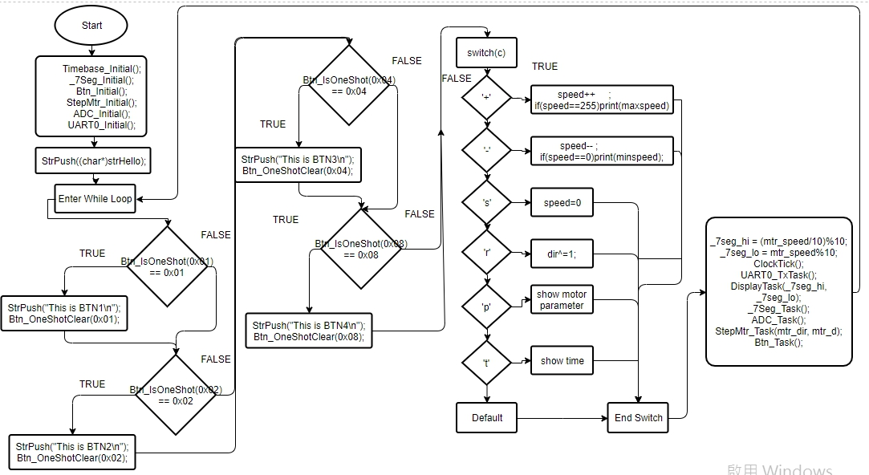流程圖

心得

這次實驗是第六次使用微控器，RS232為微控器和電腦連綫很重要的協定，Circular Queue buffer 是RS232的重點。微控器要和電腦傳資料才有意義，所以這次實驗可以結合前五次的内容，用電腦做控制。