**Summary**

In this report, we are putting ourselves in the shoes of Basil Karatzas, who is the projects and finance director of Compass Maritime Services. The case study suggests that Karatzas has to help a client choose a ship that fulfills the client’s demands and give a valuation to the ship based on two comparable ships. The ship that Karatzas ends up choosing is Bet Performer, which was built in 1997 and has the DWT of 172,000 and the capesize index of 12479.

In our group project introduction, we were finding the price of Bet Performer based on comparable transactions of two ships, which are Sumihou and Cape Sun. By using Python and Excel, we got the result of $120.5 million for the value of Bet Performer. We calculated the value by finding the average price of Sumihou ($106 million) and Cape Sun ($135 million).

For this report, we are using regression analysis to figure out the value of Bet Performer. From the regression analysis, we will also analyze the correlation between each variable and the price of ships, the best variable that predicts the price of ships, and other variables that might have affected the price of the ships. Lastly, we will give a recommendation on the Bet Performer’s offer price to the client from the perspective of Basil Karatzas.

**Analysis**

* Age at Sale (years) vs. Sale Price ($US million)

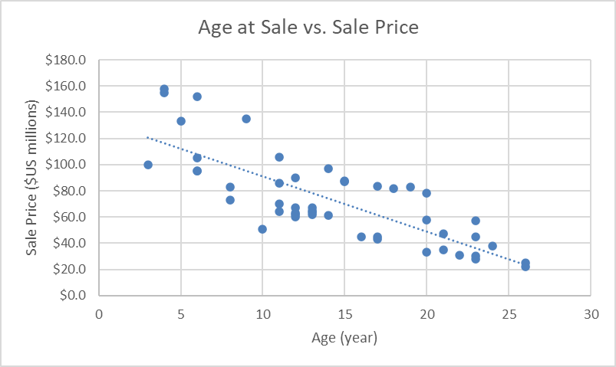

The scatter plot above shows an inverse relationship between the age at sale and sale price, meaning that as the ship gets older, the price would also decrease. This is because some parts of the ship wear off as time goes by, making the ship cheaper.

* DWT (000) vs. Sale Price ($US million)

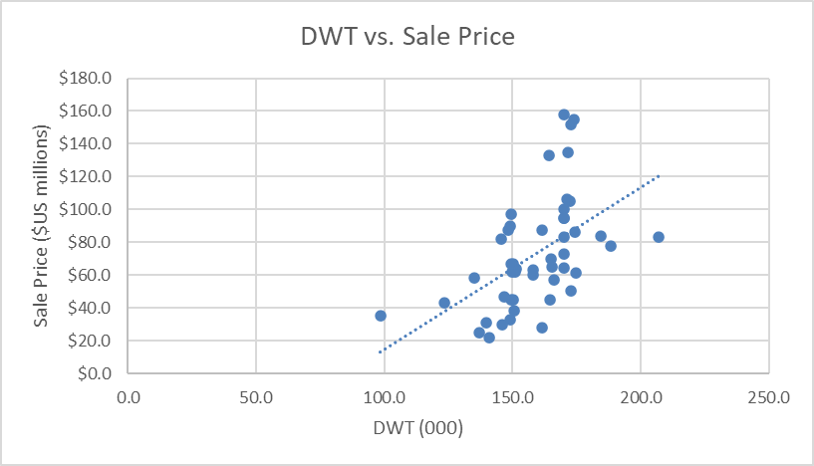

There is a positive correlation between the DWT and sale price of the ship. From the scatter plot, we can observe that as the DWT increases, the cost will also increase simultaneously. This is caused by the fact that the ship required a stronger structure to be able carry more deadweight, making the value of the ship higher.

* Capesize Index vs. Sale Price ($US million)

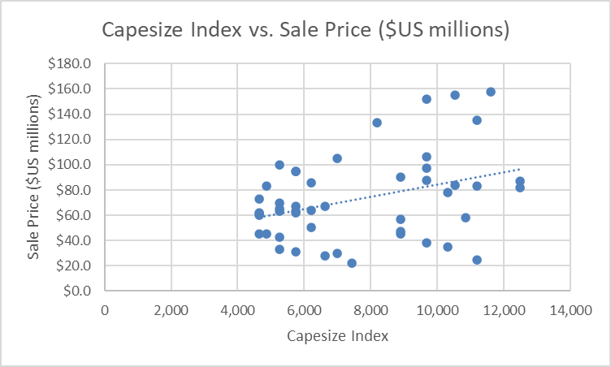

From the scatter plot above, it can be inferred that there is a linear relationship between the capesize index and the price of the ship. As the capesize index goes up, the sale price would also be more costly. This is because the average price of goods carried by the ship gets higher when the ship can contain more items, thus increasing the sale price.

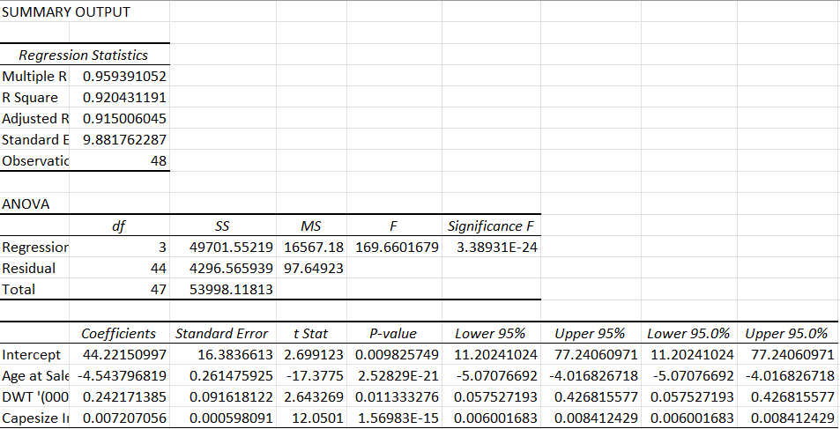 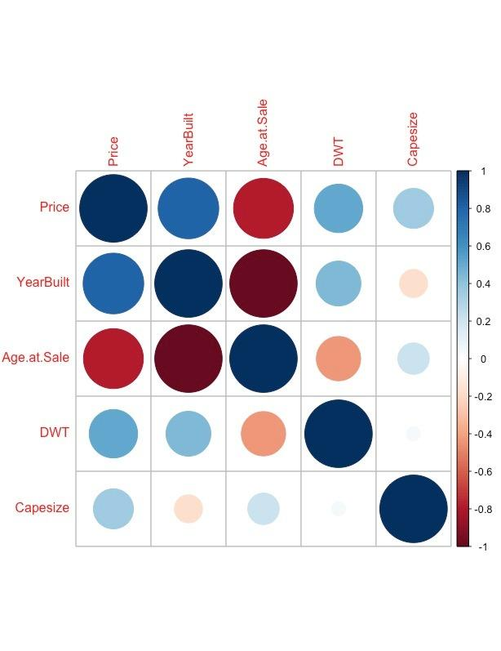

From the regression analysis above, we can see that the age at sale has the coefficient of -4.543796819, which is the highest among the coefficients of all independent variables. The high correlation between the age at sale and the sale price of the ship can also be seen from the correlation chart above. This indicates that the age of sales is the best predictor of the price of a ship. Although the coefficient is negative, it describes how strongly correlated the age at sale and and the sale price are.

There are other factors that might affect the price of the ship. **The type of engine used**, **fuel type**, **location of the ship**, **engine power (kW)**, and **speed** have a linear relationship with the sale price. The price of the ship would be more expensive if the quality of the engine and fuel type used is high. The further the location of the ship, the higher the cost of transporting the ship is, making the price of the ship go up. With the high engine power and speed, more fuel will be used, which means that the price of the ship would be more costly.

Based on the regression analysis above, we got the R-square of 0.920431191. Since the value is close to 1, it means that the independent variables (age of sale, DWT, and capesize index) jointly affect the price of the ship. Additionally, the p-value of each variable (both independent and dependent) is lower than 0.05, showing that the variables are statistically significant. These 2 pieces of information conclude that the model fits the data.

After running a regression analysis on the model, we get $125.83 million as the final price of Bet Performer (formula: 44.22150997 - 4.543796819*age + 0.242171385*DWT + 0.007207056*capesize). We would like to know what would happen to the price of the Bet Performer if the value of the variable is changed. The following are the 3 different scenarios:

* The age of Bet Performer is 5 years younger:

Price= 44.22150997 - 4.543796819*6 + 0.242171385*172 + 0.007207056*12479 = $148.45 million

* Bet Performer is 20K DWT smaller:

Price= 44.22150997 - 4.543796819*11 + 0.242171385*152 + 0.007207056*12479 = $120.89 million ·

* Capesize index is 30% lower in May 2008:

Price= 44.22150997 - 4.543796819*11 + 0.242171385*172 + 0.007207056*8735.3 = $98.84 million

**Conclusion**

To conclude, if we were Basil Karatzas, we would give the offer price of $125.83 million for the Bet Performer to the client. We believe that since the age of sales is the best predictor of the value of Bet Performer, we suggest that the client should wait for at least a year to buy the ship. That way, there is a chance that the client can get a better price for the ship.

<https://www.vesselfinder.com/vessels/details/9483231>