

SAMUEL OLAWOLE
Computer Science Student & Backend-Focused Software Developer
I build practical software, developer tools, and systems that solve real problems. Especially with Python backend systems, Flask, and REST APIs, alongside React frontends using TypeScript and JavaScript.
GitHub: github.com/SamInvader Email: olawoleolaniran@gmail.com

Selected Projects
These projects are presented from the current portfolio data. Links marked unavailable are intentionally not active.

Featured Project: NEXUS
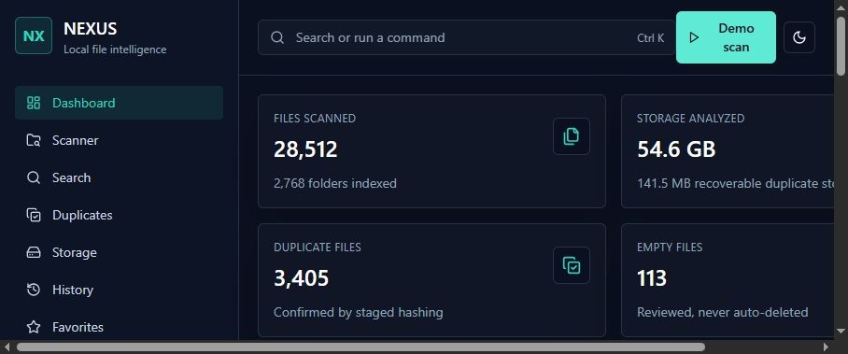
A local-first file intelligence system that analyzes, searches, organizes, and manages files while providing storage insights and duplicate detection.
Technologies: React, TypeScript, Python, Flask, REST API, TailwindCSS
- Live Demo: Not currently available
- Source Code: https://github.com/SamInvader/nexus
- Case Study: Not currently available

Project: Finance Tracker
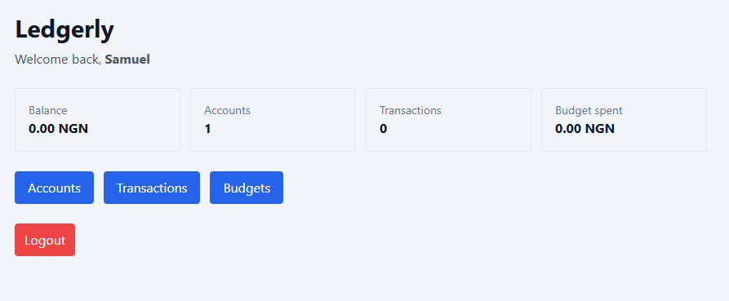
A personal finance management app for tracking income and expenses, managing budgets and savings goals, and analyzing spending patterns.
Technologies: JavaScript, HTML, CSS, Python, Flask
- Live Demo: Not currently available
- Source Code: https://github.com/SamInvader/finance-tracker
- Case Study: Not currently available

Project: Desktop Organizer
Project preview image: Not currently available
A desktop productivity application that automatically organizes files into structured folders based on their types, helping keep cluttered directories clean and manageable.
Technologies: Python
- Live Demo: Not currently available
- Source Code: https://github.com/SamInvader/DesktopOrganizerApp
- Case Study: Not currently available

What I Build

Python backend systems
Building dependable backend services with Python, especially Flask, REST APIs, data flow, and practical application logic.

React frontends
Creating clear, responsive interfaces with React, TypeScript, and JavaScript that make software easier to use.

Full-stack problem solving
Connecting thoughtful frontend experiences to backend systems that address real needs and make complexity easier to manage.

About
I’m Samuel Olawole, a Computer Science student and software developer who works especially with Python on the backend, including Flask and REST APIs. I enjoy building software that solves real problems instead of just looking polished.
I also build the frontend of my projects with React, TypeScript, and JavaScript. My interests are grounded in practical engineering: understanding how software works, connecting dependable backend logic to clear interfaces, and refining the result until it’s useful.

Skills
Languages: Python, JavaScript, TypeScript, C++, SQL
Backend: Flask, FastAPI, REST APIs, Node.js, SQLite
Frontend: React, Vite, HTML, CSS, TailwindCSS
Tools: Git, GitHub, Figma

Engineering Mindset

Build → Test → Improve
I approach software as a practical problem to be understood, tested, refined, and built to work reliably. I like projects that require both technical depth and clear decision-making.

Contact
Email: olawoleolaniran@gmail.com
GitHub: https://github.com/SamInvader

