20/7

The first lecture was an introduction lecture to the Software Engineering course where we went over the basics of the semester, how it will work and what our assessments will be. At one point in the lesson we were tasked with doing some self-learning to which I researched a few things about the assessments and sorted out a few jobs, what was unknown to us is that Adon was watching over us to see how we would use our self-directed time and if it was wise or not. After that I came to the realisation that I did mess around a lot on my phone in between tasks and overall was not focused on my work. I know now to keep this in mind and make sure that I keep myself on task and up to date on my work as to not get side-tracked as this can happen quite easily on early days especially.

23/7

This period we stated to work with Laragon which we had previously used in the first period of introductory app development, so I was familiar with the program. We were put into our groups and we were tasked with using GitHub to all work on the same project at the same time. We kept having issues mainly with pushing and pulling projects. The person who created the document would have all the necessary files to run the website on the local host, but anyone that pulled it from GitHub would not have those files and therefore could not run it. We ended up making some changes to the .readme files and installing some extra software that the host had to try and fix it but ultimately we got to a point where we could load up the project but were still getting errors when we tried to use the webpage on the local host. These issues should be ironed out by next class, if not there is another way, we can load it us with it all working but is more time consuming and tedious.

27/7

Today we continued to work on our CRUD app where we got to iron out a lot of the issues that we were having in the previous lesson. One of our issues is that we had no idea about a CRUD app and how we would go about actually making one. Adon recommended actually looking it up and learning more about CRUD which through looking it up was a template for us to create a web page that can create, update and delete data which is what we need to do. Using google seems like something that should be done in any situation where you don’t know what you’re doing, I think our problem however is that we were looking up the wrong things including how to create a array in js and how to actually use JS in Laravel, but it was much easier and simple to just look up what a CRUD app was which gave us everything we needed to know. We were also able to fix out GitHub issues which we were worried about having, once we worked them out it was much easier than we initially thought. Fixing it gave me a deeper understanding of git and how to fix these issues when they arise.

30/7

Today we were looking into user cases which are used to figure out what a user would be looking for in an application. These simple statements can be used to break down a project into tiny bite sized pieces that can be used to hand out to group member to try an implement these features in our application when we get out assignment next week. We trialled these out on a pre-existing project where we had to make these statements as a group. The problem is that we all made our individual statements and did not do them as a group. This means that we will have to work on working as a group together if we want to do well as a group on out final project.

3/8

Today was the first day of our first spring where we started to modify our CRUD app to be our outline for our project. This class I fixed up all of the user stories to be used for our website so they can be handed out to people as thing needed to be done, and the others worked mainly on the app researching how to create a crud app and make it look presentable. By the end of the lesson we had a functioning create and view part of the crud app with appropriate layout and buttons that take us to other pages. I believe already we have made a good start in our project so that we can start dividing out work to be done by each person. Next class will be a git workshop lab so we can get a greater understanding on what we can do to minimise merging when we push our work.

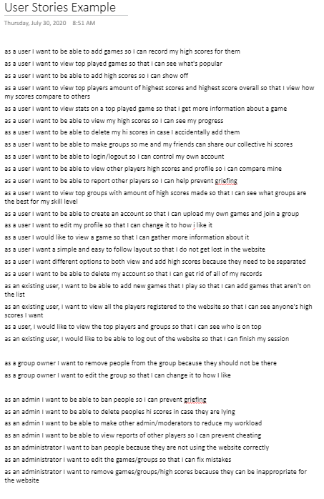

7/8

This was the second class of our first sprint where we had our interview with our client on what type of website we were making and what features we wanted in our website. This interview was short and to the point, we are to make a gaming website like the preview website from the previous year with some different features here and there. We mainly have free range on the website, but I feel like the client will make us change some of the stuff we have made so we will have to account for that later down the track. The rest of this lesson I wrote up the requirements to both one note and our GitHub project so someone can claim the task and work on it. We also had a GitHub workshop so we created our sperate branches with this information which should resolve merging issues. I stated on making a search bar with a drop-down menu to make going from page to page a lot easier, and so that we have a working webpage to show at the endo of our first sprint.

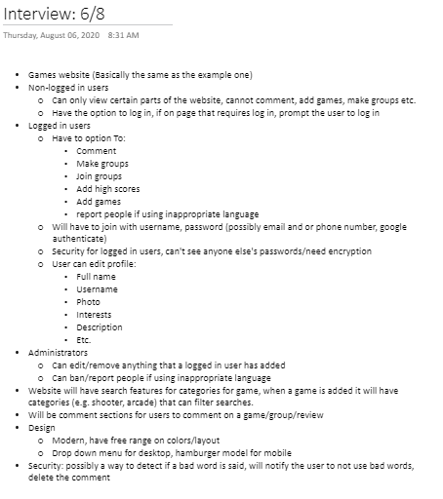

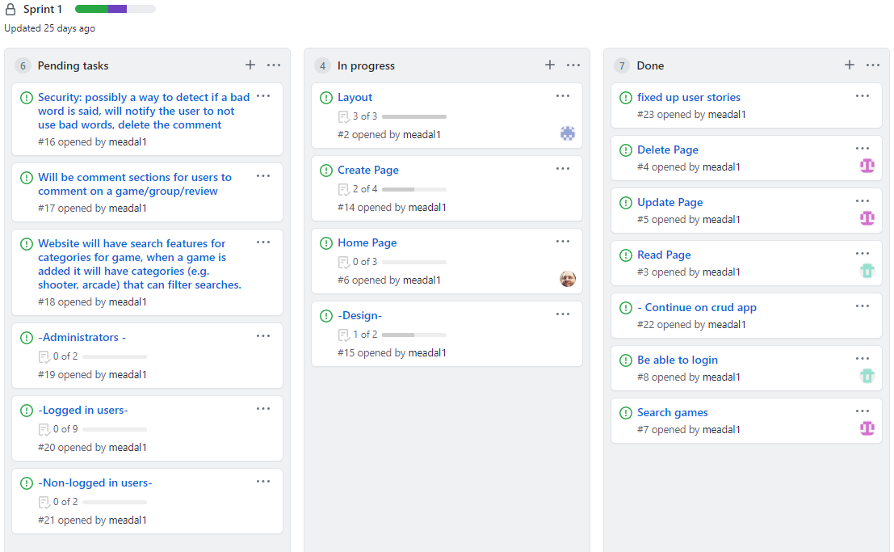

10 8, 13/8

I have combined these two days as what happened was much the same. These two days our group were working on our websites and getting everything to a point to where we could happily say that it was a working website that we would be happy to show to a client. Most of my time was spent on design and getting everyone’s features put on to the master branch so that I could make each pages layout much the same with the same colour scheme, background image and header, footer and nav bar. The other were working on login features, a home page and a search by game page. In the end we had a good-looking webpage with a lot of functionality that a client would be happy with the first time seeing it, but we still have a lot to go

17/8

This was our review lesson where one by one each group would show off their website to the class and describe the features that they have added into it by the end of the sprint. This was also a time to get some feedback by the two lecturers on how well we did and what we need to improve for next time. Our feedback was that we needed to work to our strengths, communicate more and have a better plan on what each person will be working on during the sprint. At the end of the day I reckon that we did well in the two weeks to get a functioning crud app with login features, working navigation bar to hamburger model, search features and more. Next week we will start the second sprint with a scrum and a stand-up meeting to decide on what each person will undertake over the next week or two.

24/8

This was the first day of the second sprint where we set out with a range of tasks that each member would contribute to, in the hopes that we will have a working website pushed to the master branch. This was a slow day as only two people showed and I showed up around 10 minutes late due to just having moved the day before, but even though I was late I still informed our team members using Microsoft teams, and so did our other teammates letting us know that they will not be there. I started to work on getting ever page accessible from the navigation bar so I can start to sort and organise the dropdown menus, hamburger model and authorised access to pages. This way I can fully start to figure out how to make our website laid out on both desktop and mobile.

27/8

This was the last day of our sprint which was only a short one, what I got done was really trying to sort out the dropdown menu which I changed up by using JavaScript instead of CSS as much as I felt like CSS was what was holding me back and giving me a lot of issues trying to get everything working together. Besides that, I did a lot of remodelling and cleaning up of the pages and CSS files as a lot of stuff was just placed around the pages willy-nilly with no real order. When we pushed our stuff to GitHub however a lot of the stuff I did got lost and changed from what was on my branch and what was on the master branch. I don’t know if we may have pushed our stuff wrong or if GitHub didn’t really follow what we were trying to do but in the end I had to go back into my branch and try and save some of the changes as they really ruined the layout of our website. I got that sorted however and re-pushed it to master. We also started to deploy our website to MariaDB but it does not look that great now so that will have to be a goal for the next sprint.

31/8

This was the first day of our third sprint where we set ourselves a new set of goals to complete by the end of the sprint. Before I wanted to get into any new stuff, I wanted to first fix the issues with the layout of the website and the navigation bar. The layout I had to fix by getting one of our teammates to send me over his layout.blade.php file which for some reason he was not able to push to master, once I had that file it was just a matter of putting that as well as the background image and the CSS files in the master branch. Next, I got a hand from Adon to figure out why the navigation bar was not displaying properly. He used the inspect element of the web page to find out where the errors where occurring and he was making fixes in the webpage. I had no idea you could do this so him showing me this will help me in my work or adding more to the layout of the website in the future. But for now, this allowed me to fix up the nav bar and push it to the master so each member can navigate around our webpages with ease.

4/9

this class was spent on finally fixing up the navigation bar and introducing the hamburger model as well so when the website was on a mobile device or on a smaller monitor all links would be put in the hamburger models navigation bar. At this point the navigation bar is looking exactly how I want it but there are still some issues with the hamburger model that will not take long to fix. Only two of us were here today and only one of the people that was not here let us know what happened but only after the class was over. I think we may need to work on letting each other know when we won’t be there so we can prepare what we need to individually do to keep us on track.

7/9

This was the class where I finally had to bite the bullet and modify the entire app.css and layout.css file to be into one style.less file. My main goal was to change all the colours in the files into a variable that can be used by any teammate for their own CSS changes. It took nearly the entire 2 hours to go through the more than 10,000 lines and assign each colour in the document to a value. In the end there were around 30 different values which I did shrink down as the CSS file did have a lot of very minor changes between values (these could be background variants or border variants). This was also the lesson where our big twist came out where we were to change our entire website from a games review website to a car view website. This came as a bit of a shock but the more we discussed it the better we felt about it. We would have to change our migrations for our tables and values for our tables which will be the biggest hassle, but the rest should be fine. Since I am working on layouts, I think I can help with just re-naming a lot of the values in our folder so we can move on as quick as possible.

10/9

From the previous lesson I had a fully completed style.less file but it was currently not working. I have done less in the past, but I needed to spend a bit of time doing some research on how to load in the less.js file and how to order everything. Once I did some research, I had a fully set up less file and the website was looking good. Once I finished this I crated a merge request as this was the last day of our third sprint and I just spent the rest of the lesson helping out our teammates, one with creating a new page to view the cars and another with fixing issues with the database.

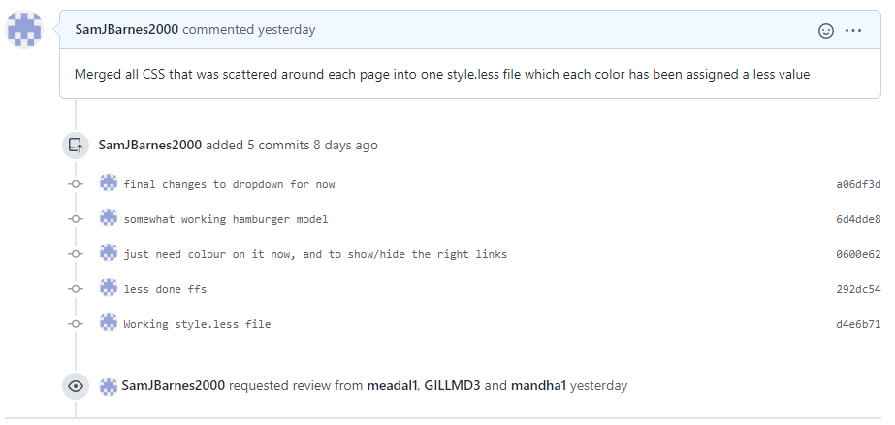

14/9

This was the first part of our fourth sprint where for the first time in a while we had each member of the group present. This made it super easy to merge all our work into the master branch which did break some things but all of us worked together to fix it. I had to fix some stuff on the navigation bar and on the search to allow us to modify our website into a car website. Adon came around to test all our stuff and suggested to me that we needed test classes to make sure that everything is working. That is what I will be working on this sprint. Once I have finished that I think I will help fix up some of the naming conventions for the website, as well as nailing down the CRUD app to keep the users inputs in the edit and restrict what the user can entre in a field (aka can’t put a year that doesn’t exist).

17/9

This was the first time I had tried to make a proper unit/feature test for html. First, I wanted to make up a test and make sure that all the example tests were working and the one I made was being recognized as a test. I had a lot of issues understanding the code behind unit testing and where each method was being called from and where it was going. It took a lot of trial and error just to get the firsts tests working with me and Adon researching and trying a bunch of fixes. In the end I had to re update the composer and uncomment a line in the php.ini file which is in the c drive which allows my tests to use sqllite. After all this trial and error, the first 2 example tests were working.

21/9

This class I wanted to try and get my image upload test working but I knew I had picked maybe one of the more difficult ones to understand and get working. After a while of failing but making some progress in getting it to a state where just my code was the problem, I was able to start a new test where it would test authentication on our sign in page. After not too long this test was working and was displaying an output that showed that our auth was working well. Hopefully, all of this working through to get one test working will allow me to make a range of tests for each of the parts of our website that could quite easily fail.

12/10

This was our first day back after the holiday break where we started our 5th sprint. This sprint is where I am going to dedicate to getting all the little issues that we are having out of the way. For instance, I want to finalise the navigation bar with the dropdown menu inside as the hamburger model was not showing and the mobile view was not working the way I want it too. There are many other issues as well including naming conventions till being games instead of cars in some places, wrong colours or ugly displays that could be re sized to better fit the web page, a responsive footer that serves some purpose and more. I also just want to help my group more and try and work on some things together as I feel like I am only really working solo now whereas we should be helping each other. By the end of this lesson I had the nav bar working how I want too but there is just one issue I will need to fix for next time.

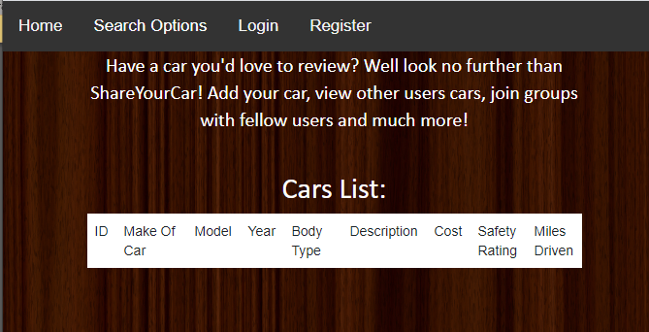Desktop View Mobile View

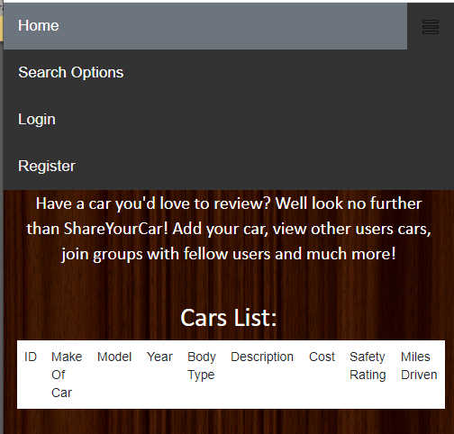

15/10

After I completed some CSS and touch up stuff including the hamburger model, I wanted to do something that I’ve never really done before and through the authentication controller make a way for people to upload a profile image that they can change as they wish. This took a lot of in class researching to be able to figure out how to not only make the profile image and get it to upload but get it to work with our already created controller for authentication. This means that as a software engineer, I would need to pick apart someone else’s code and change it to fit my own, and in the end I got it to work with each logged in user.

User with default image:

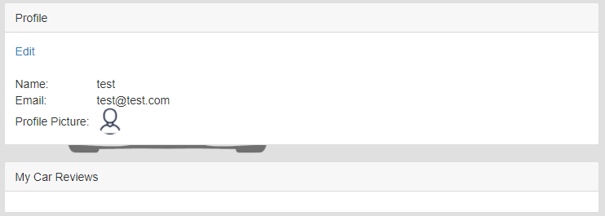

User Wanting to add an Image:

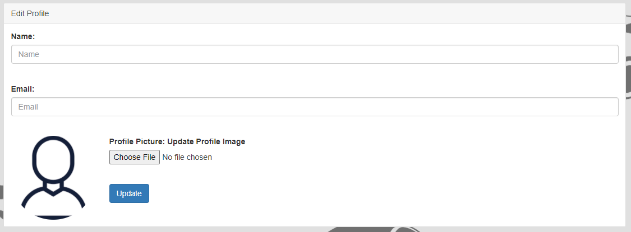

User with new Image:

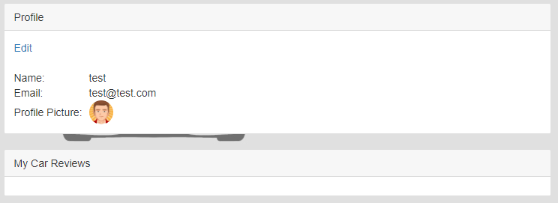

19/10

-Labour Day

29/10

After I had completed to profile picture upload I wanted to have another try at creating the unit test for uploading an image, but this time use it for my profile picture upload as I understood this code much more now that I had actually had a go at creating the code behind the test, unlike the authorisation test where I did not work on the code that I tested on. In the end I ran out of time for the sprint as we had already missed a day due to labour day so I had to merge with my other workmate where he was having some issues with both the composer and the migrations of the tables but I was able to help him out and get his website back and displaying again.

Not working Code:

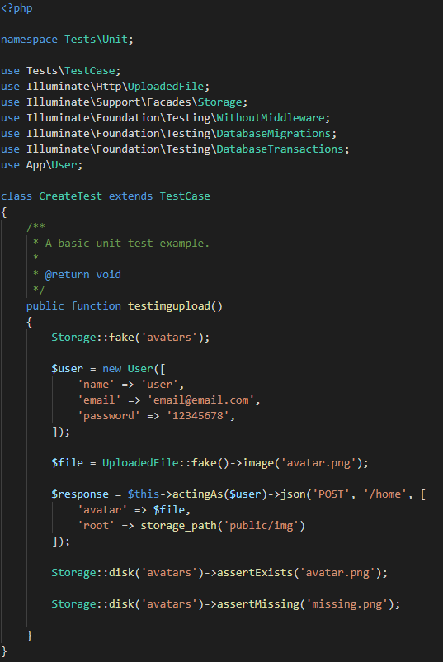

2/11

Today was the start of our final sprint that we will have for our car review website. By the time that this sprint is over I want to have the avatar upload test finished as I believe that once I finish it I will have completed a task that previously in the project I could not complete but now I believe I have the knowledge on how to overcome the task and finish it for the client. Besides that, I would like to just go over the website and try and fix any changes that we may have missed in our goings over once we had merged everything. Besides all of that this class I also spent some time helping another group member that had not pushed to master the previous sprint get all of his stuff merged and updated as he had some issues that I knew how to resolve.

5/11-9/11

These lessons were spent just going over the website and fixing up a lot of changes that we may have missed. This includes this like changing all our URLs to routes to keep consistency, fixing our authorization redirections, fixing our routes, naming conventions, crud controller duplicates, CSS for tables and sizing and more. I thought I would take these jobs as I knew the other group members were working on their own software so I assumed that their time would be taken up by that. Next lesson will be much of the same as I do not want our website having any bugs.

12/11

This would be the last in class lesson that we would have to finish our project before we present it to the client/class. I made the call to make sure everyone had pushed their work to their own branch and one by one we created a merge request on git hub and pushed all our work together. Once we completed that and we had all of our work on the master branch we huddled around my computer and tested all of our work, gave each other feedback and I would fix up the things that we pointed out. That could either be bad CSS, redirecting to the right sites, making sure the stuff we completed this sprint and previous sprints worked with others work, and then just some final touch ups. Once we did this the two other members deployed our website, one to Heroku and the other to MariaDB while I did another sweep of the website and then helped them out with commands. In the end I think we have an aesthetically pleasing website with quite a lot of functionality, and I don’t think a single project we worked on does not work. I am sure there will be some issues buried deep inside the website but on the surface, I believe we have done a pretty good job.

17-11

This lesson was the first lesson in a while where he has not had a sprint as we had finished them all, but even then, we were still touching up our website. But before we did some touch ups, I was working on my portfolio which I plan to do in Laravel and then deploy on MariaDB for ease of access. But my work was cut short after Adon had had a meeting with a member of our group and gave us a list of issues that he had found whist looking over our deployed website. He had also told our group member that he did not expect us to fix these issues as it was so close to the end of the semester. Both of my teammates were ready to throw in the towel but I suggested that we still had an hour left of this session, why don’t we all crowd around my computer and get these changes done for both our client, and so we have some more stuff it talk about on our portfolio. So, for the rest of the lesson I was looking up fixes, adding the fixes whilst also getting help and suggestions from my group members. In the end we got all the changes completed.

19/11

This was our final lesson where every group presented their website in front of the class so that we could show off what features we had completed over the sprints. This is also where both Adon, Grayson as well as the class could give us some feedback on our website and give them some feedback and ask questions about there website. In the end we had another list that we had recorded from the feedback to complete by then end of the semester. We still had an hour in class so once again we crowded around my computer and I was looking up fixes for our issues and implementing them as my team gave me suggestions and feedback. In the end we got all of our changes implemented including appropriate error messages, redirecting errors so that we don’t go to a Laravel or Heroku error page, better prompts for users, saving the users information if we refresh the page and little changes here and there. The only fix that we couldn’t do is the groups feature. This is because the groups feature was quite a large feature that was being worked on by another team member during our final few sprints. In the end he could not get it completely finished and working how he wanted too, but he got it to the point were parts of it were working, an the parts he couldn’t fix he tried to make as finished as possible without outright removing them. With only two days left until our hand in as well as working on our portfolio and other exams and assignments sue in at the same time we decided that we could not entirely fix this but we would deploy what we had done already. And with that done we were at the end of the semester.