|  |  |
| --- | --- |
| **Ex. No. 5** | **JavaScript – DOM Elements, Events and Functions** |
| **Date of Exercise** | **02.09.25** |
| **GitHub Host Link** | **https://urk23cs1218.github.io/Web-technology-Lab/ex5(4).html**  **https://urk23cs1218.github.io/Web-technology-Lab/ex5(5).html** |

**Aim:**

To design and develop a webpage using HTML, CSS, and JavaScript that demonstrates the use of DOM elements, events, and functions to dynamically calculate the total bill for a cake order based and calculates the EquatedMonthly Installment (EMI) for a bank loan by applying the given formula, using loan amount, interest rate, and tenure as inputs, and dynamically displaying the result through DOM manipulation.

**Description:**

This program demonstrates how to use HTML, CSS, and JavaScript DOM manipulation to design a dynamic web page for calculating the total bill of a cake order. The calculated EMI, total payment, and total interest are displayed dynamically using DOM manipulation Events such as onclick trigger the calculation function, demonstrating client-side interactivity.

**Procedure:**

1.**Design the HTML Structure**

* Create an HTML file and define the basic structure of the webpage using <html>, <head>, and <body> tags.
* Add appropriate headings and labels for user inputs.

2.**Create Input Fields**

* For the Cake Order program: add dropdowns, text boxes, and checkboxes.
* For the EMI Calculator: add input fields for loan amount, interest rate, and tenure.

3.**Add a Button for Calculation**

* Insert a button (<button>) that will trigger the calculation function using the onclick event.

4.**Design the Page with CSS**

* Apply CSS styling to improve the appearance of the form and results.
* Use properties like padding, margin, colors, and borders for a neat layout.

5.**Write the JavaScript Function**

* Define a function (calculateBill() or calculateEMI()) to perform the required arithmetic operations.
* Use **DOM methods** (document.getElementById(), .value, .innerHTML) to fetch inputs and display results.

6.**Implement Event Handling**

* Attach the function to the button’s onclick event so that calculations happen dynamically when the user interacts with the webpage.

7.**Perform Calculations**

* For the Cake Order program: compute the total price based on cake type, quantity, and add-ons.
* For the EMI Calculator: apply the EMI formula using loan amount, interest rate, and tenure (converted into months).

8.**Test and Verify Outputs**

* Save and run the webpage in a browser.
* Enter different sets of inputs and verify that the displayed results match manual calculations.

**Program:**

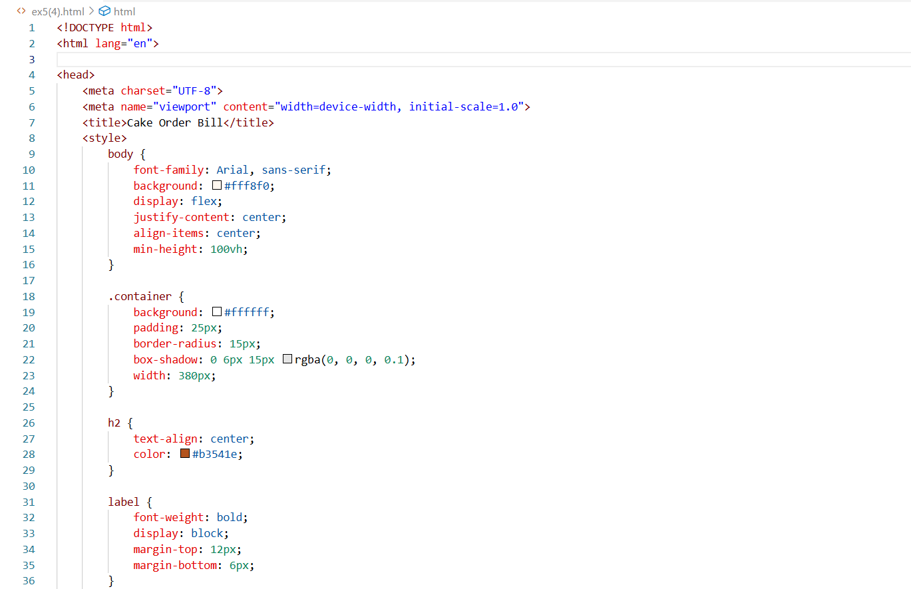

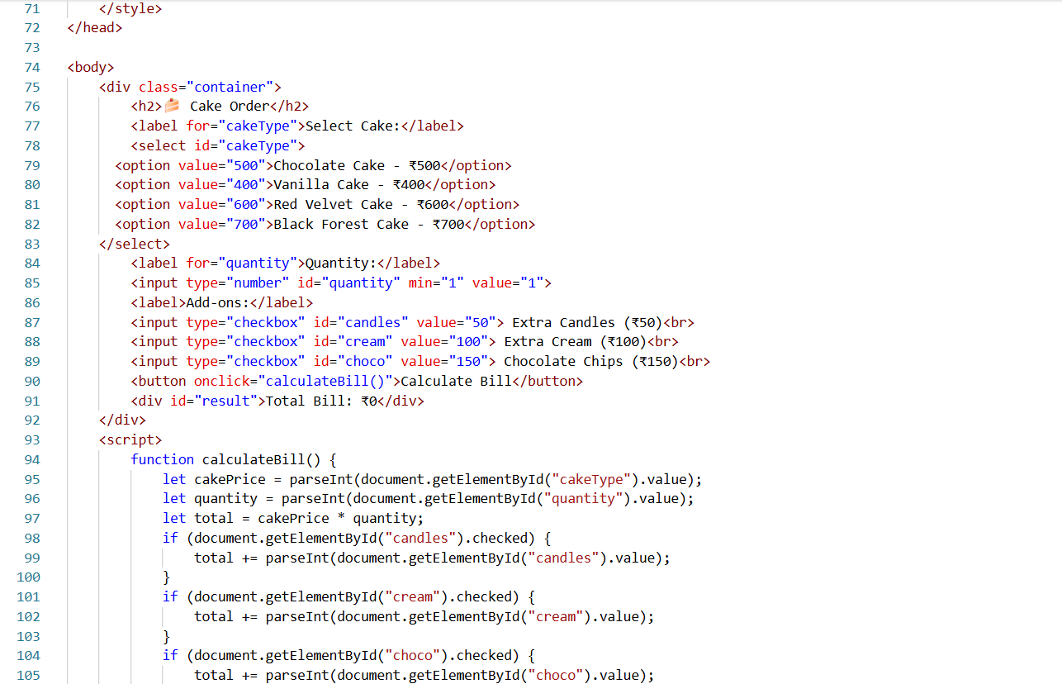

**Output:**

**Program:**

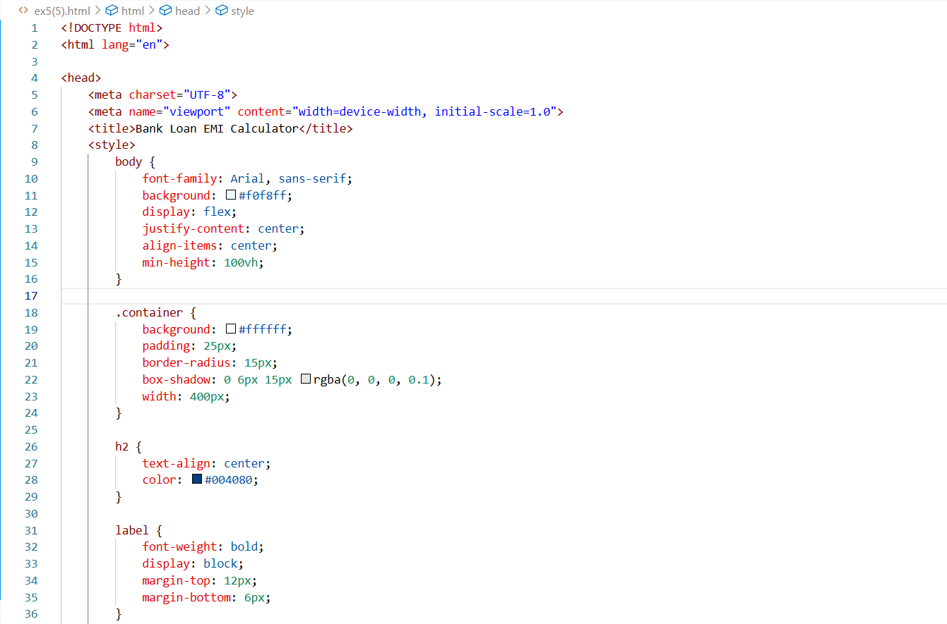

**Output:**

**Result:**

The Cake Order Bill Calculation and Bank Loan EMI Calculator web application was successfully developed using HTML, CSS, and JavaScript and dynamically calculates the total bill using DOM. The result is displayed correctly on the webpage.