Beaver vs Asteroid
How the animation was made: the full conversation, with the mock-ups along the way
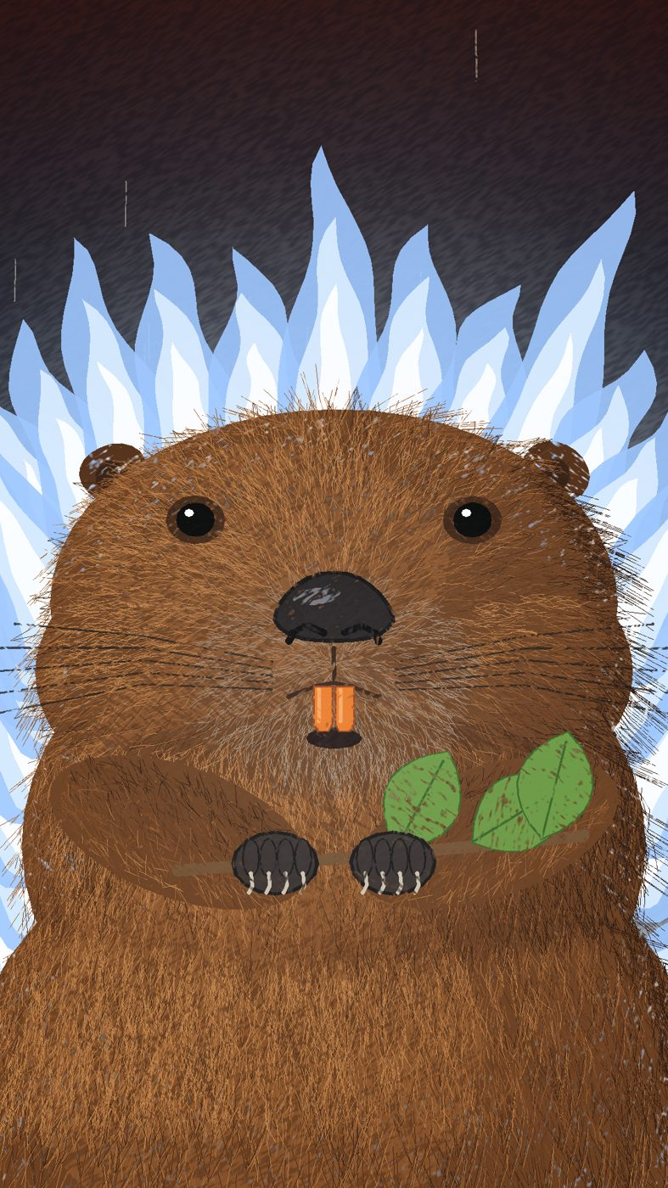
The finished beaver, mid-flight, in its white fire
Your messages are shown word for word in blue boxes. Claude's replies are summarised in plain English, and the technical back-and-forth behind the scenes is left out.

Contents
1. Setting up
2. The brief
3. First look: the cartoon version
4. Draft 2: a real beaver, and bigger shots
5. Draft 3: sound, life and a new shot
6. Draft 4: the splash fix
7. Drafts 5 and 6: the build-up, glances and feet
8. Final touches
9. Sharing on TikTok
10. The perfect prompt, and the lessons

1. Setting up
You
Create a CLAUDE.md saying: I don't know how to code. Explain everything in plain English, make choices for me rather than listing options, and always tell me where to find the finished file.
Claude
Created the file, but GitHub refused the upload because Claude did not yet have permission to save to the Animation- project. Explained how to connect GitHub and install the Claude app on the project.
You
Please try again
Claude
Tried twice more; GitHub still refused. Gave step-by-step instructions to install the Claude GitHub app on the Animation- project.
You
Done
Claude
The upload worked. The instructions file (CLAUDE.md) now tells Claude to use plain English, make choices, and always say where the finished file is.
You
I am going to try and use you to create animations. As these will get uploaded to GitHub, none of these can exceed their file limit. Do you need any additional tools set up to create animations using my prompts?
Claude
Set the project up to install the animation tools automatically at the start of every session, and added rules: every file under 50 MB, MP4 videos by default, finished animations saved in an "animations" folder.
You
You mentioned it ‘warns’ at 50. Explain.
Claude
GitHub accepts files under 50 MB quietly, warns between 50 and 100 MB, and refuses anything over 100 MB. It also keeps every old version, so big files add up. Recommended keeping animations to a few MB and only uploading finished versions.
You
Okay, let’s do that for now.
Claude
Added those rules to CLAUDE.md.
You
I do not own a computer and only have my phone and this app for this project. Once you have created an animation I like, how do I download it to my iPhone?
Claude
Explained that finished videos would be sent straight into the chat: tap the file, tap Share, then Save Video. Added a note to CLAUDE.md never to give steps that need a computer.

2. The brief
You
Please create an animation in a coloured pencil, minimalist style of no more than 20 seconds.
The beats are as follows:
1. A chubby, silly-faced Beaver sits on a dam in a forest.
2. A great light slowly appears to touch everything from above. A rumbling shaking builds. Leaves fall of trees and the water splashes and a few sticks fall off the dam. It is like something massive is falling down towards the forest and all we can see are the approaching effects.
3. Without warning, the beaver launches straight upwards into the sky, a rocket contrail beneath it. Its fur flies about, it is moving at hundreds of miles an hour.
4. It shoots like a comet through the clouds, leaving a blazing trail in its wake.
5. The beaver missiles straight into space. We see it rise above the curvature of planet Earth.
6. We zoom out: a massive flaming burning asteroid is slowly about to strike and destroy the planet.
7. We see the beaver’s unbothered silly face.
8. The beaver launches straight through the heart of the burning asteroid.
9. We briefly see the beaver smashing through the rocky interior, unbothered.
10. The beaver missiles, a streak of light, bursts from the other side and the asteroid explodes into a million tiny fragments in a blast of white light that covers the whole screen.
11. We return to the original forest scene. The beaver drops suddenly from above and lands perfectly on its dam. Its fur is slightly singed and smoke comes from it but it is otherwise unbothered.
12. It starts to chew a nearby leaf as tiny burning rock fragments fall from the heavens across the forest. The beaver remains unbothered.
Before beginning, tell me your understanding of this project in terms of art style, pacing, narrative, and what the joke is supposed to be. Explain any technical limitations you might have. Explain how you would suggest improving this product in line with the prompt I have described.
Claude
Understanding. Coloured pencil on off-white paper with simple shapes and a small set of colours. The joke is the contrast between the size of the event and how little the beaver cares: the build-up makes us think the beaver is in danger, but it turns out to be the only one who can deal with the threat, and it treats saving the planet like a trip to the shops.
Limitations. Claude draws by writing instructions, not with a hand, so the result is a simple cartoon rather than a professional illustration; it cannot watch the video play, only check still images; sound effects would be simple.
Suggestions. A vertical, phone-shaped video; a leaf set up at the start and eaten at the end; holding on the unbothered face; a final gag of a burning pebble landing on its head; simple sound with silence on the face; still images first for approval.
You
You nailed the project in terms of tone and intention. Well done.
As for improvements:
1. Yes please.
2. Agreed.
3. No blink needed. The beaver is so unbothered it need not blink.
4. Agreed.
5. Agreed.
Go.

3. First look: the cartoon version
Claude
Built a drawing program for the coloured-pencil look and made four still images to approve the style, plus a first full 20-second draft with sound. The first version came out at 54 MB, so the pencil texture was slowed down and the picture size reduced to bring it to 12.9 MB.
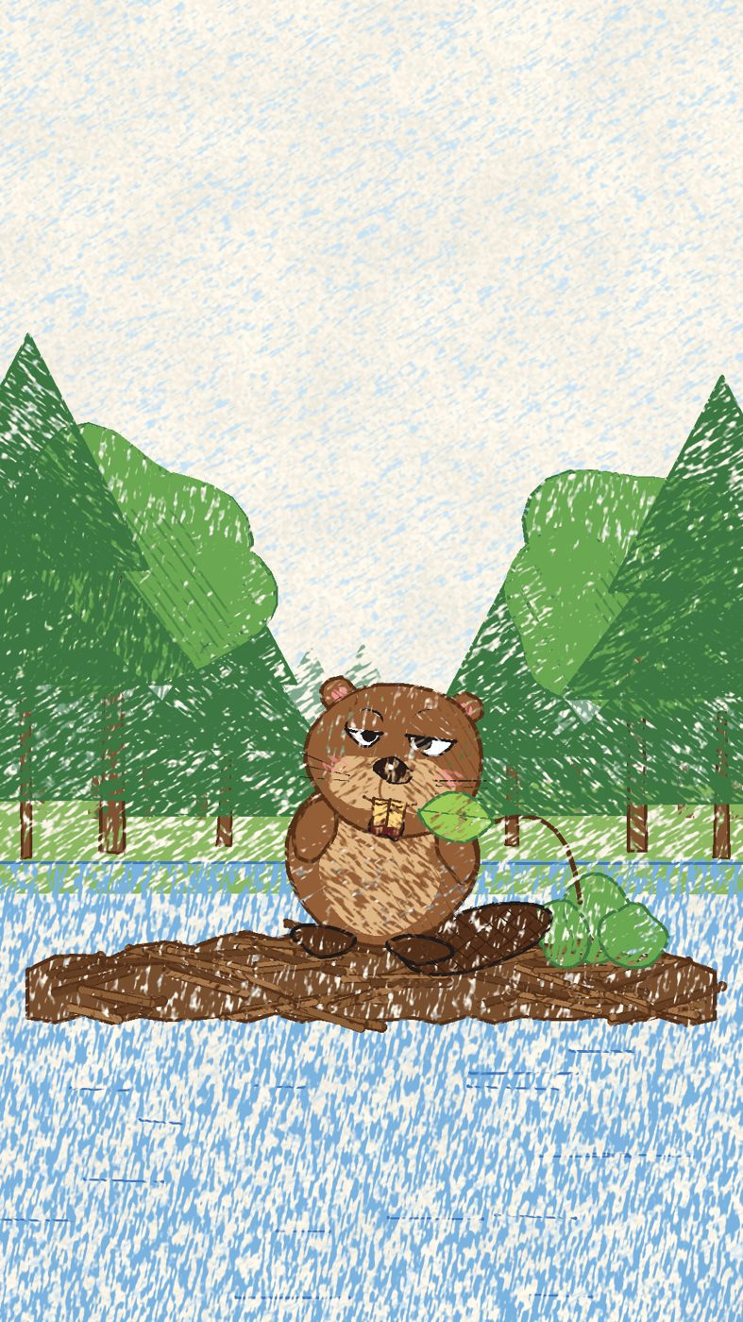
Mock-up 1: the beaver on its dam (cartoon version)
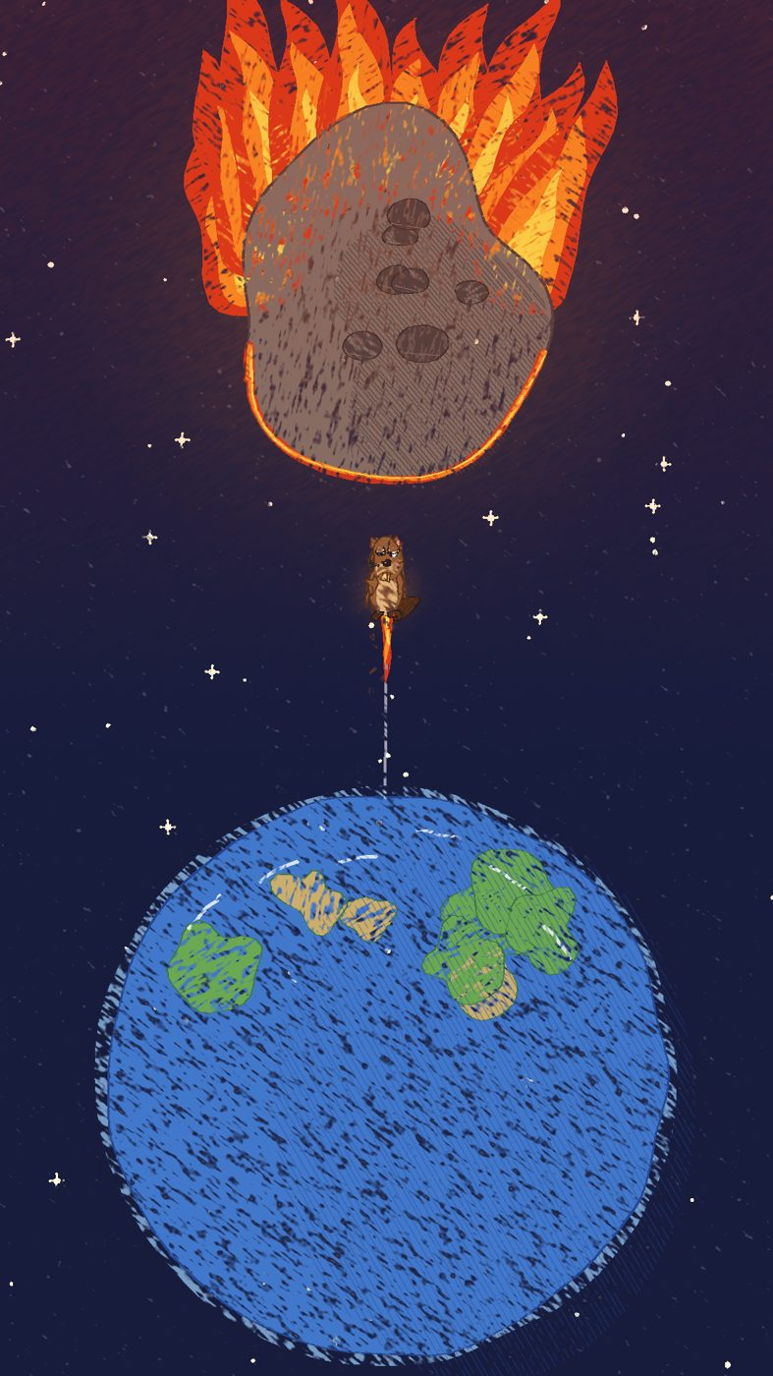
Mock-up 2: the asteroid reveal
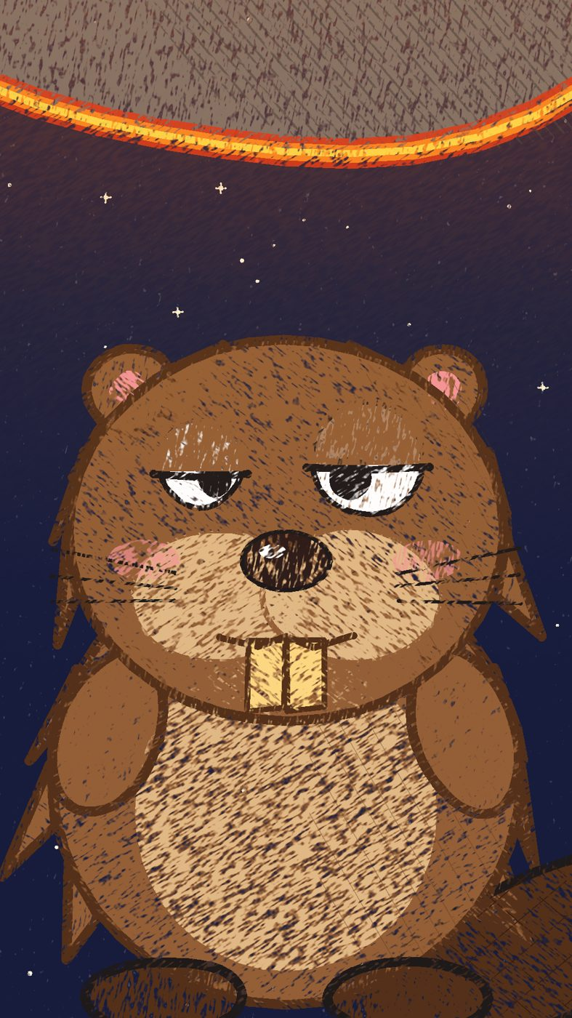
Mock-up 3: the unbothered face
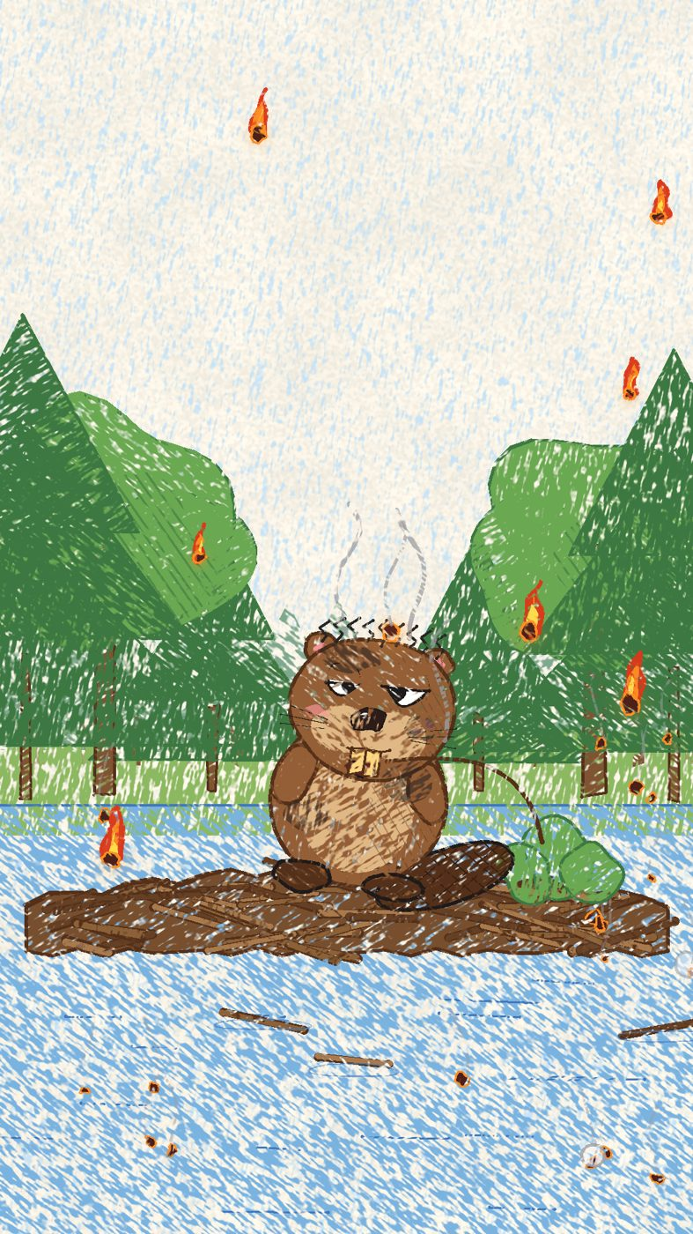
Mock-up 4: the ending, singed and smoking
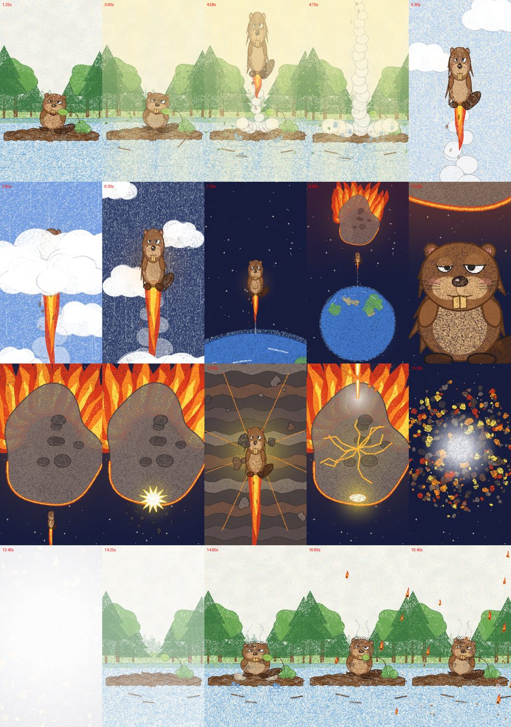
Early test frames across the whole film, used to check every shot
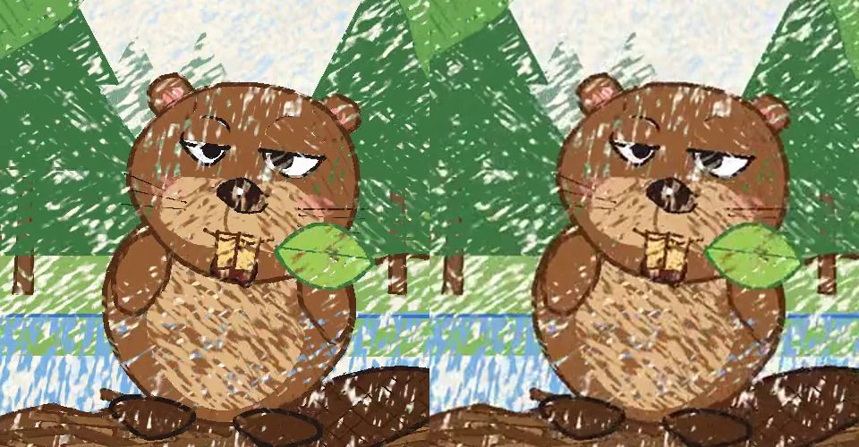
Checking picture quality at two sizes (left: 1080 wide, right: 720 wide)

4. Draft 2: a real beaver, and bigger shots
You
This is a great first draft.
1. The key criticism: currently, our beaver looks mostly like a cartoon character of a beaver. This is accurate according to the brief, however, I think this will be funnier if it is as close to an anatomically correct ‘real’ beaver as possible (see picture 1). The reason: having it with a cartoon character style gives it away as a joke too soon. This should be a picture of a beaver as if you’ve seen one drawn in a non-fiction book about animals. For example, when we cut to the unbothered face of the beaver before it hits the asteroid, it is funnier in this new style because this is literally just a normal beaver. Cartooning him reduces the absurdity.
2. Perspective. Please consult pictures 2 and 3. I would like to see the beaver bursting through the clouds from a distance. From this range, it should be a spot of brown rising up from a contrail of rocket flame. The full character should not be visible as we are far enough away. The framing in picture 2 lends a certain majesty and drama to it. We do a similar exercise with picture 3. We turn the beaver-missile into a pure streak of white light shooting out of the earth’s atmosphere. A tiny streak burning towards a massive threatening asteroid. That makes the following cut to the beaver’s uncaring face funnier. Make sure when we see the beaver’s face we see the white fire burning around it, like a Super Saiyan.
3. Pacing. We need to linger more on the building rumble and threat. Currently, there is not enough time for the viewer to absorb what is happening. So that threat needs to come slowly, the rumble and light increasing, things starting to fall off trees and the dam, and when the rumble and light is at its highest, then the beaver rockets up unexpectedly. We need to do the same exercise once the beaver hits space. The camera watches the white fire burning out of the earth’s atmosphere, absorbing the silent majesty of the planet, and then it gradually draws outwards to reveal a massive burning asteroid approaching the planet. We may need to linger a tad bit longer at the end as well, watching him chew as items rain down. It is okay to extend this project to 40 seconds if it means we get these moments right.
4. Sorry, the sound effects are legible. I would make it shattering through the asteroid just one of exploding rock, nothing cartoonish. And him dropping back to earth just a thud. The more we emphasise with clown noises the less humour there will be.
Forgive me, I did not give you the picture references. Here we have: A beaver. A rocket shooting through cloud layer. A rocket that is just a white streak in space. The majestic curvature of the Earth.
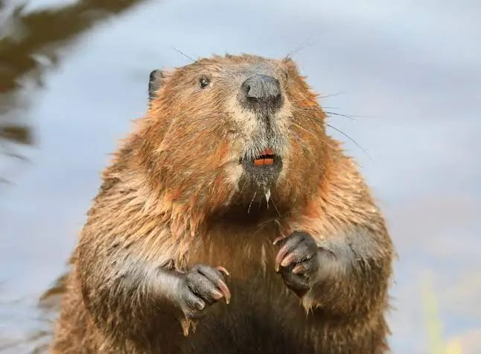
Your reference 1: a real beaver
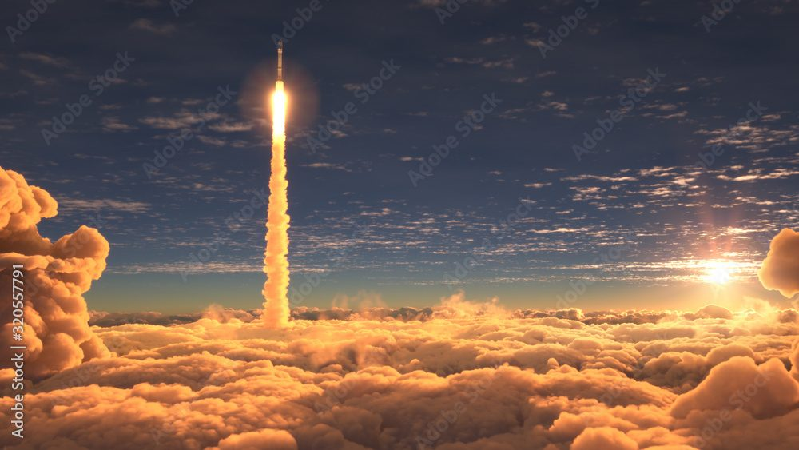
Your reference 2: a rocket shooting through a cloud layer
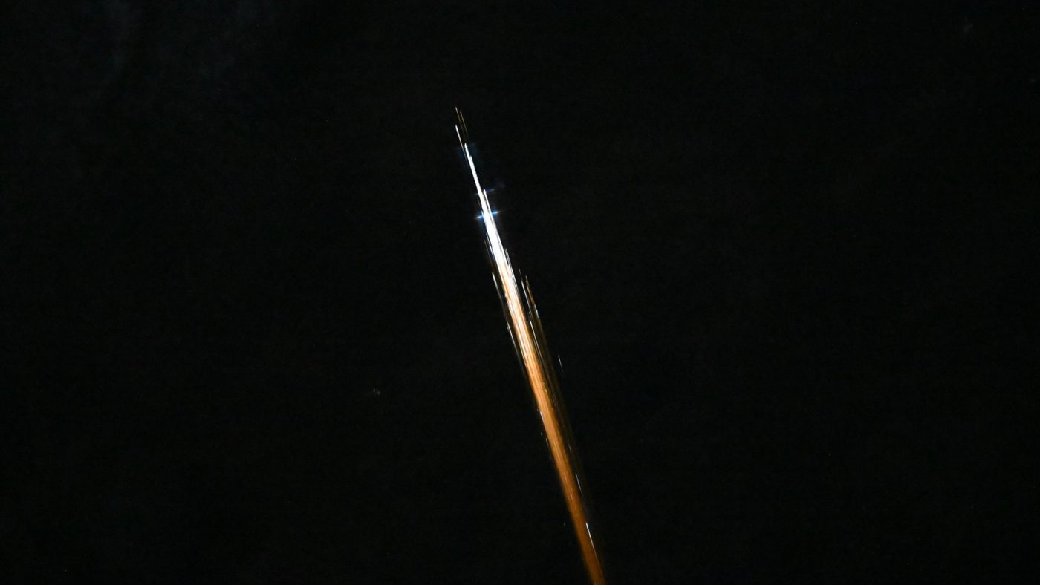
Your reference 3: a rocket as a white streak in space
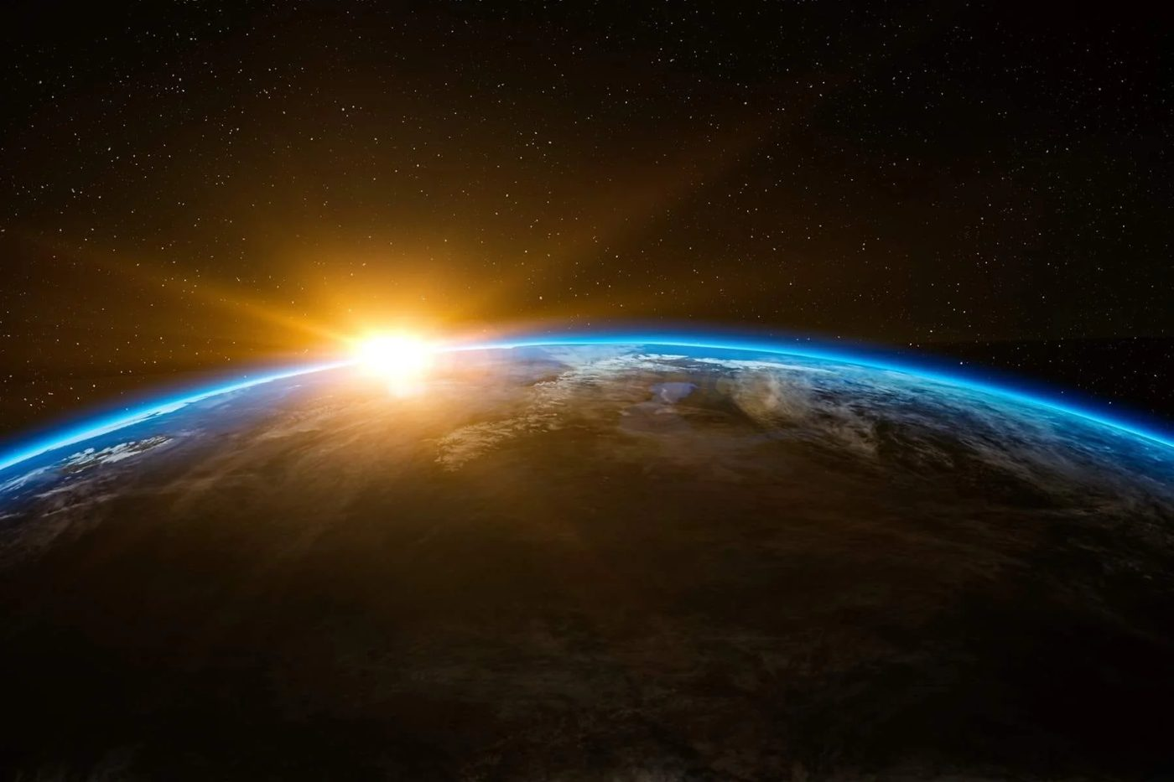
Your reference 4: the curvature of the Earth
Claude
Rebuilt the beaver as a field-guide illustration from thousands of short fur strokes, with wet-looking clumps, small black eyes, a leathery nose and orange teeth, holding a leafy twig that it keeps for the whole trip. Added the distant cloud-layer shot, the Earth and sunrise shot with the white streak, the slow pull-back to the asteroid, and the white-fire close-up. The film grew to 38 seconds, and the cartoon sounds were removed.
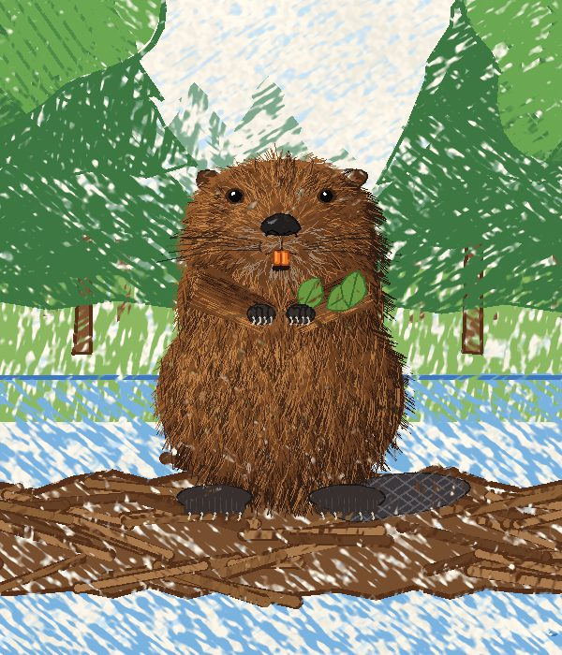
The new realistic beaver at normal size in the forest

An early version of the close-up face, still refining the arms
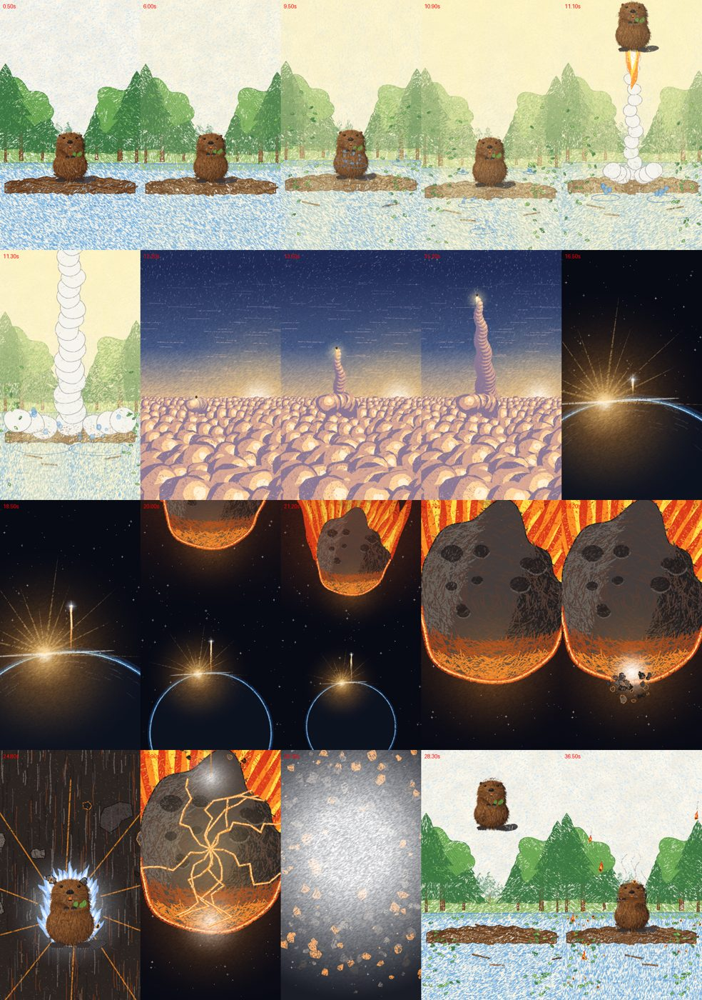
First check of every new shot. Problems spotted: the clouds looked like eggs and the trail looked like beads.
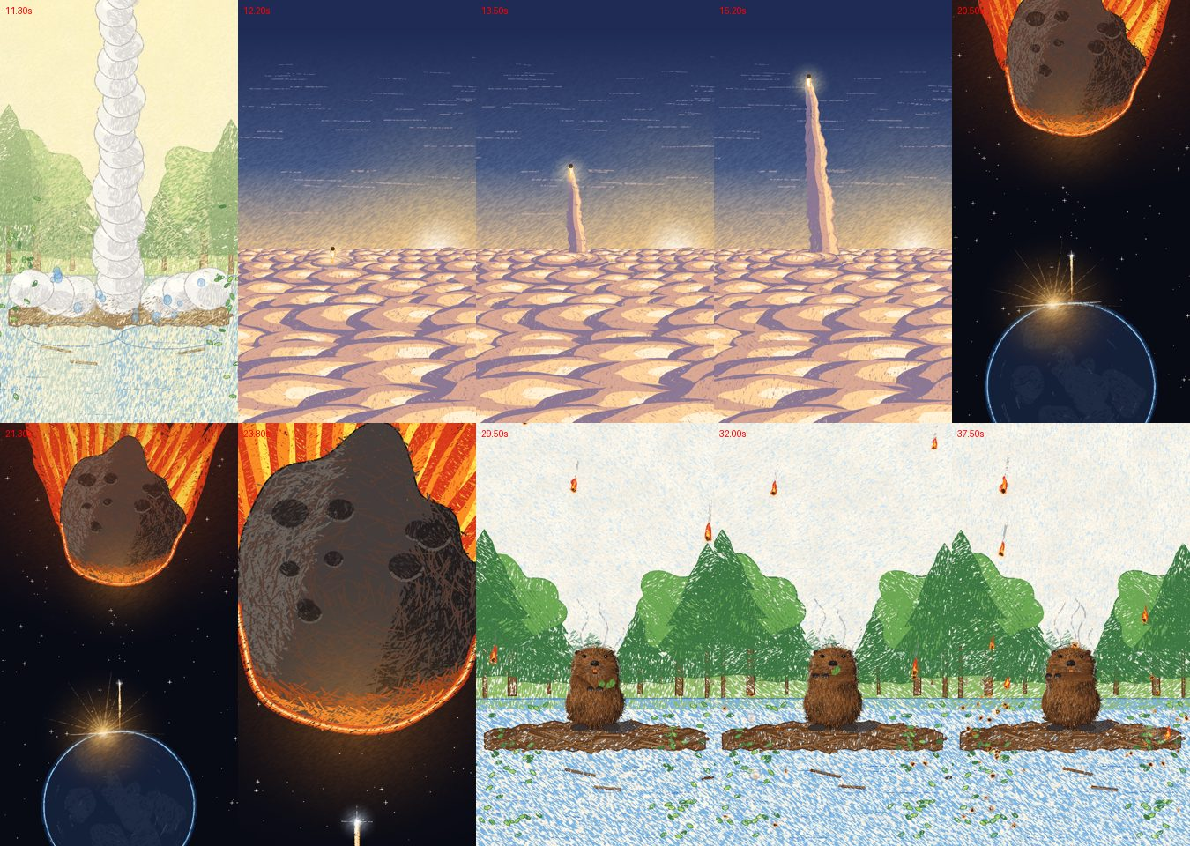
After fixes: proper cloud banks, a smooth vapour trail, the Earth visible as a planet
Draft 2 close-up: the realistic face in its white fire
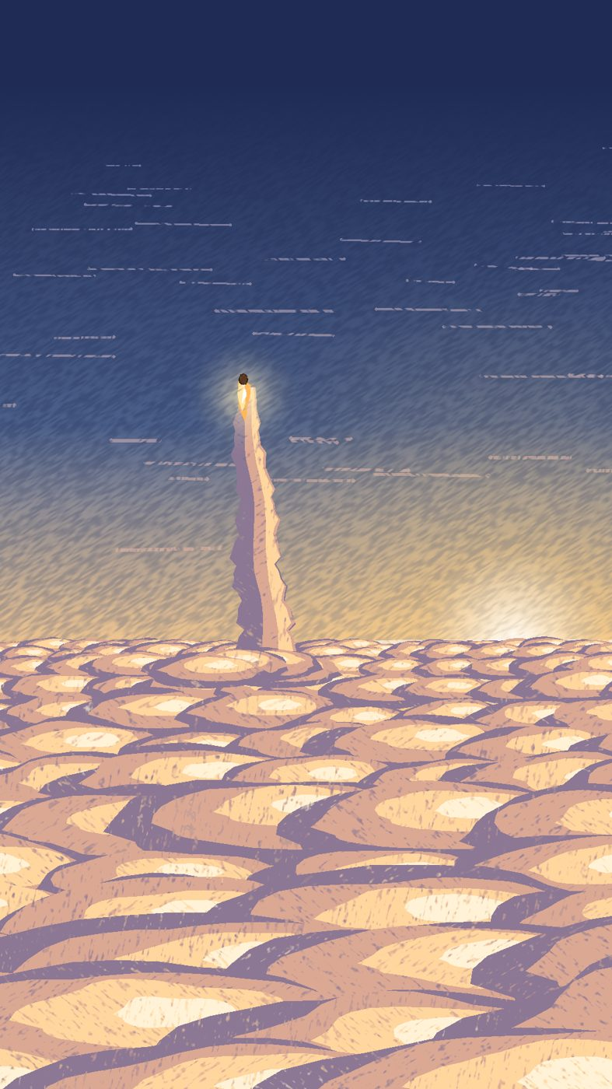
Draft 2 wide shot: a brown dot rising through the sunlit cloud layer

5. Draft 3: sound, life and a new shot
You
This is an astonishing improvement. Well done!
1. Can you make the growing rumble at the beginning more ominous and planet-shaking?
2. Can you make the asteroid explosion sound more impactful?
3. Can you add the occasional cute nose-twitch to the beaver during all forest scenes?
4. Could you add the occasional beaver blink to the forest scenes and return your idea of one blink during the cosmic close-up?
5. Can you add a mid-range shot of the beaver shooting up through normal clouds before we hit the stratospheric cloud layer? Make the beaver more distant than the forest scenes but still discernible. This should add 2 seconds to the video.
Claude
Layered the rumble (deep bass, a growl phone speakers can play, thunder-like cracks, groaning wood) and made the explosion a split second of silence followed by a crack, a falling boom and debris, measuring it so it is the loudest moment even on a phone. Added nose twitches, blinks and one slow blink in the close-up. Built a new 2-second shot through puffy white clouds, where the beaver flies into a big cloud and bursts out of the top. The film became 40 seconds.
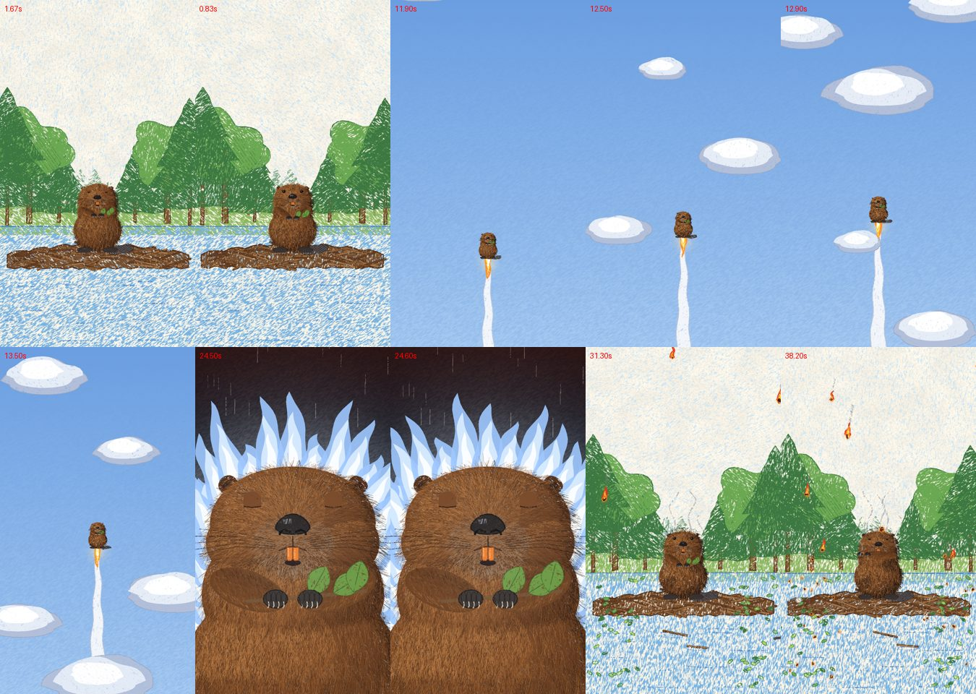
First attempt at the new cloud shot (top right): the clouds were flat saucers. The bottom row shows the blink in the close-up.
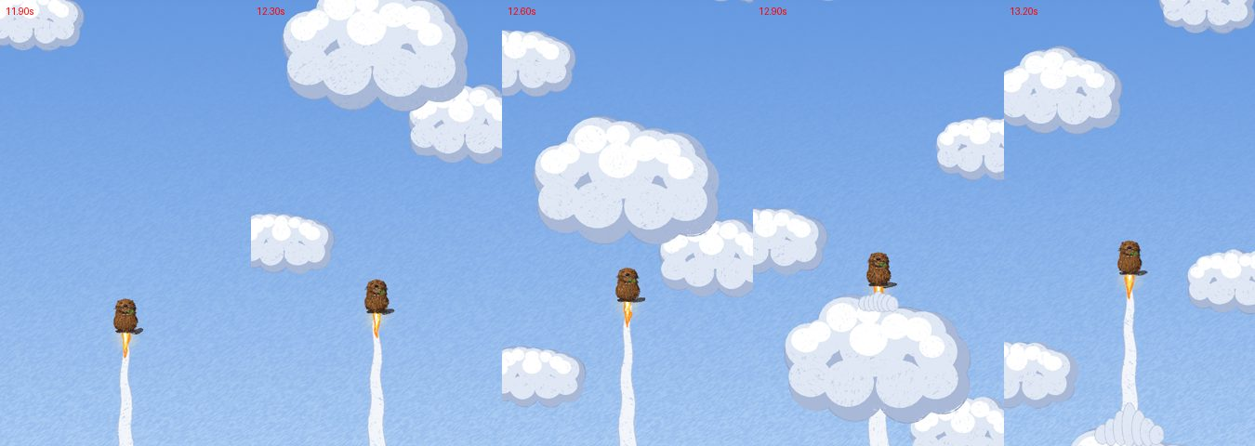
Puffy cumulus clouds, but the beaver passed the big cloud too quickly
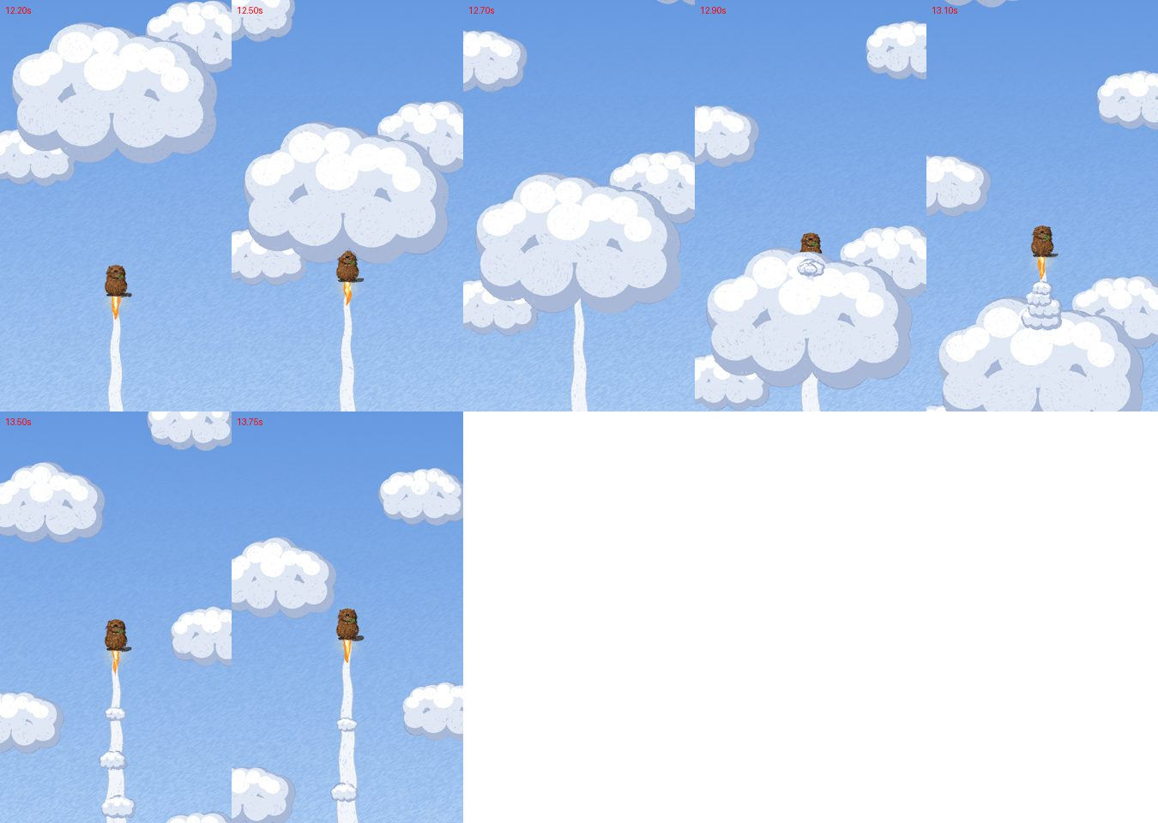
Final version: the beaver vanishes into the big cloud and bursts out of the top

6. Draft 4: the splash fix
You
Some water effects are clipping through the beaver.
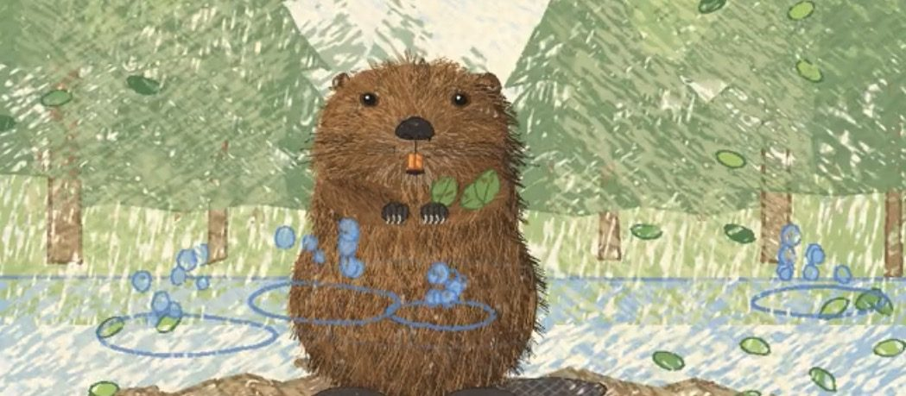
Your screenshot: splashes from behind the dam drawn on top of the beaver
Claude
Splashes and leaves on the water behind the dam are now drawn before the beaver, so they sit behind it. Checked every moment where a splash happens near the beaver.
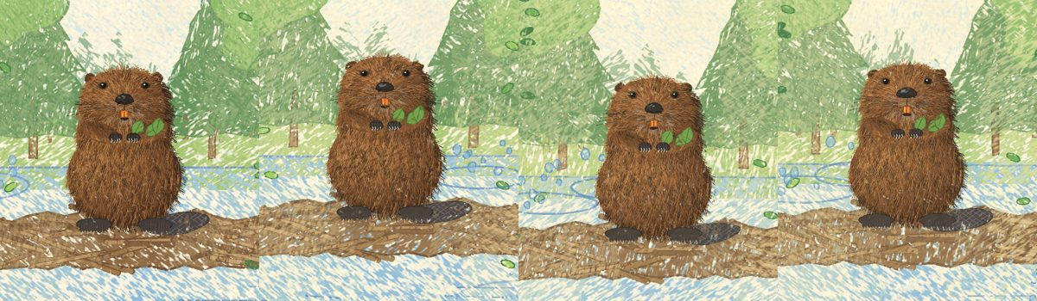
After the fix: the splashes stay behind the beaver

7. Drafts 5 and 6: the build-up, glances and feet
You
Okay, it’s almost perfect.
Please could you add a further 2 seconds of build-up before the beaver launches?
You
Add one eye movement where the beaver looks directly up. Two seconds before the launch.
Claude
Stretched the build-up, spacing out the leaves, splashes and falling sticks. Added the glance up. The first attempt showed too much eye white and looked cartoony, so it was reduced to a thin pale sliver.

Left: normal gaze. Right: glancing up at the sky, two seconds before launch.
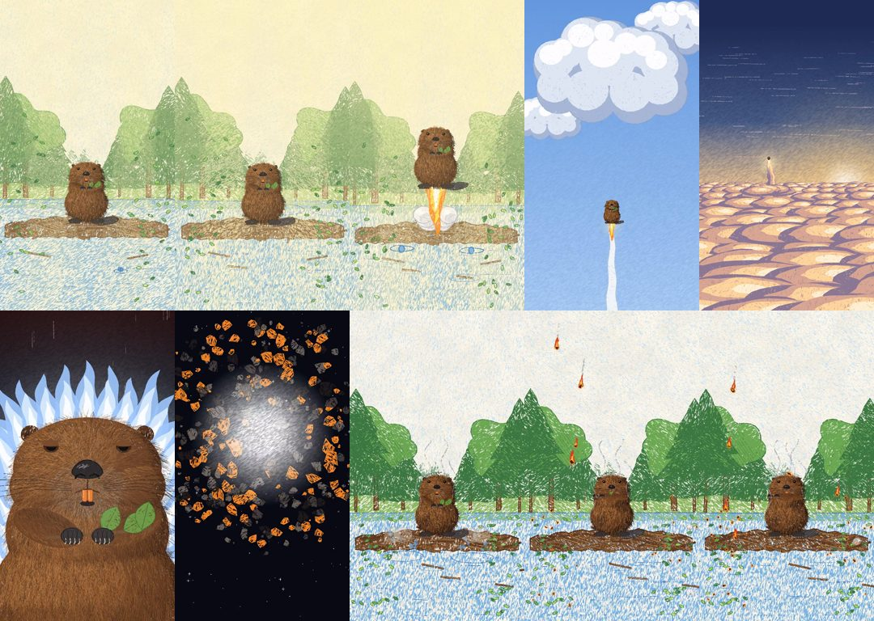
Frames from draft 5 checking the new timings
You
Build up still not quite right. Add three more seconds and another quick look-up before launch.
You
The feet and tail look a bit undetailed compared to the rest of the beaver model.
You
The feet are not quite attached to the body
Claude
Made the build-up 13 seconds with two glances up (a long one 4 seconds before launch, a quick one 1 second before). Redrew the tail as a paddle of individual leathery scales, and the back feet as big webbed feet with jointed toes and curved claws. It took three tries to get them right: first too small and spidery, then with toes fanning from one point, then properly tucked under the body with the fur falling over them.
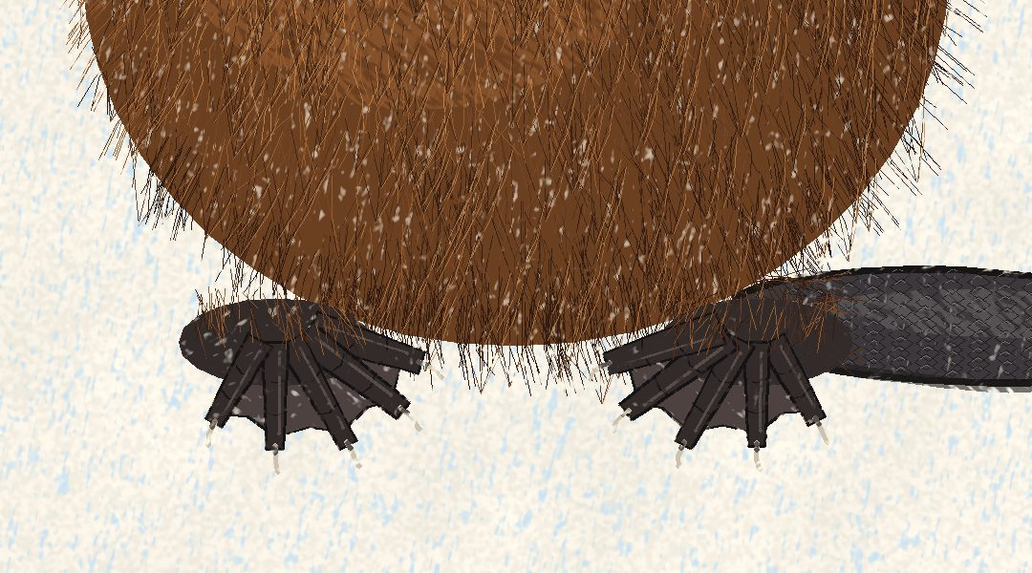
First try at the new feet: too small and spidery (the scaly tail on the right worked first time)
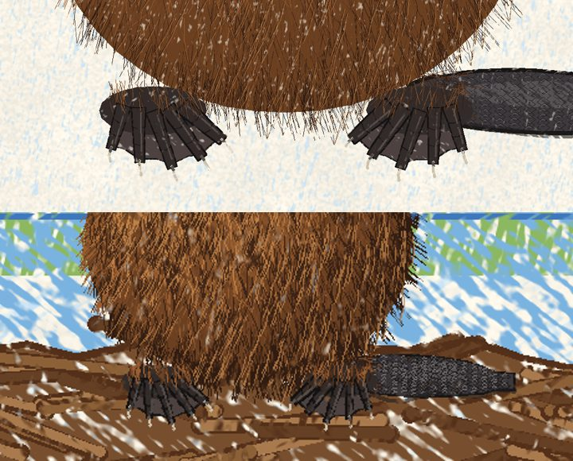
Bigger webbed feet, but they looked stuck on to the body
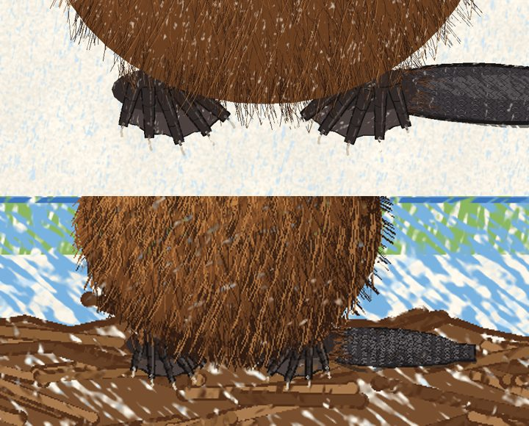
Final: the feet come out from under the body, with the fur falling over them
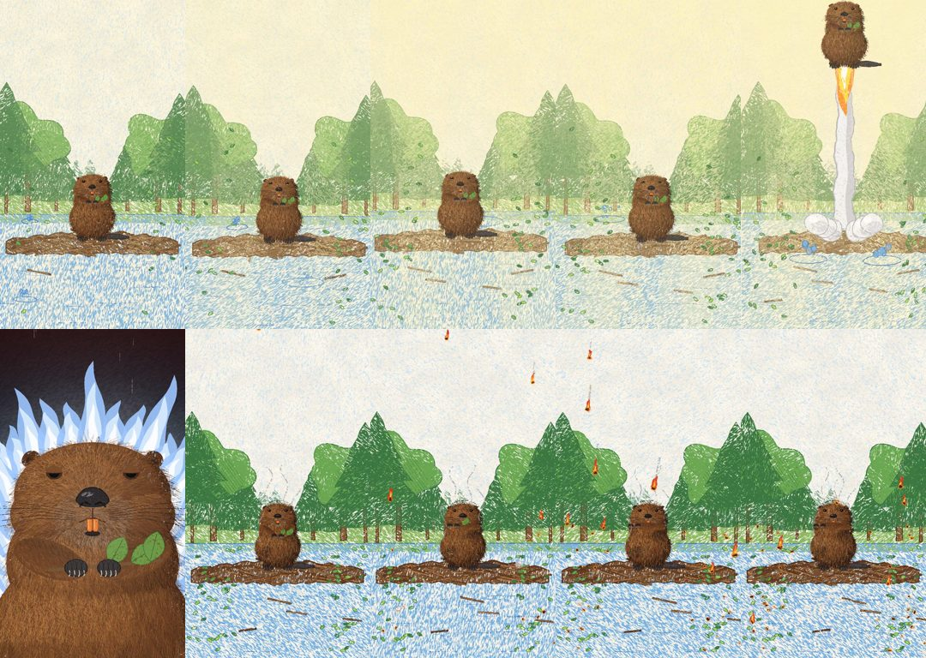
Frames from draft 6

8. Final touches
You
Perfect. Consider it final.
I want to share this with a friend on discord but it has a limit on file sharing. Is there any way we can compress this to make a seperate version I could share?
Claude
Made a copy under Discord’s 10 MB limit (9.0 MB). Two approaches were compared, and the one that keeps the full picture size held on to the fur detail better. Both versions were saved in the "animations" folder on GitHub.
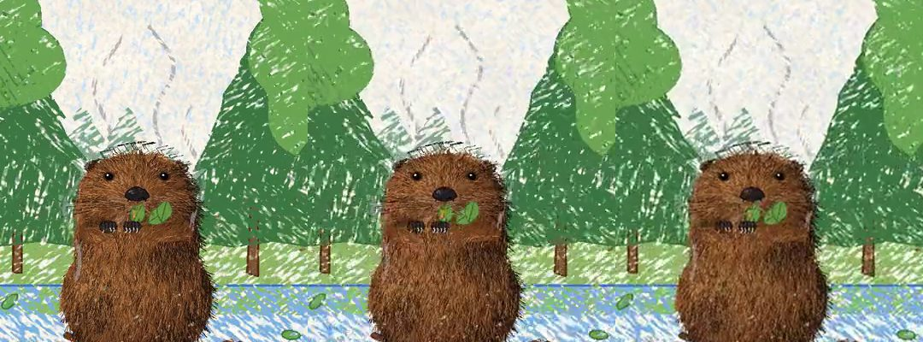
Left: full quality. Middle: the chosen Discord version. Right: the rejected smaller-picture version.
You
I am sorry, I have realised I want a further edit. Once the rumble starts to build (about 2 secs into the effect) I feel like the camera needs to very slowly draw back. Just a little distance, slowly. It just adds a feeling of gravity to the moment and then stops the moment the beaver launches. Obviously this will reveal a bit more forest scene, so far unrendered, but it doesn’t have to be much more. We just need that gradual panning out to invoke ‘big thing happening’
You
Keep the dam the same size
Claude
Added a slow pull-back of about 15% from 5 seconds until launch, stopping dead at the launch. Extended the forest, ground and water at the edges and kept the dam exactly the same size.
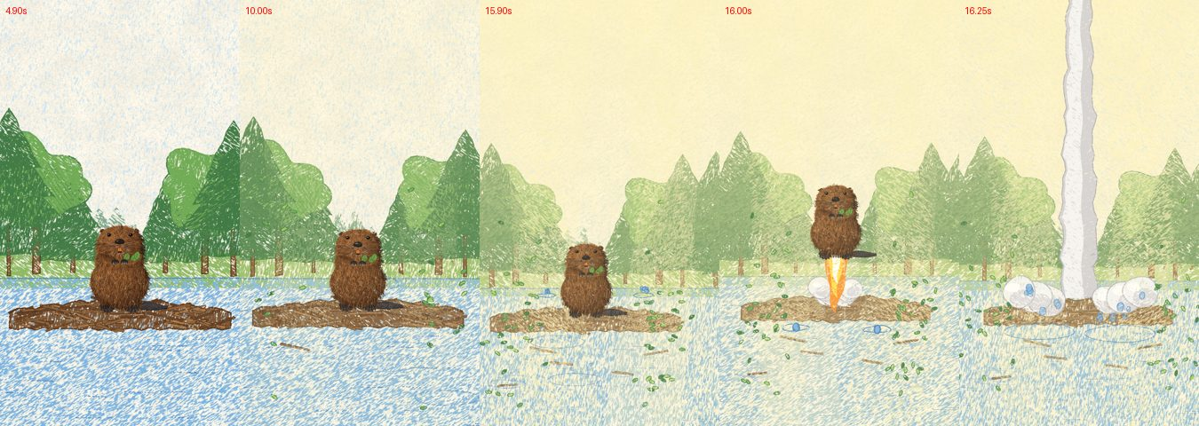
The camera slowly draws back during the build-up, then holds for the launch
You
I have just noticed there is an offensive audio crack when the space shot cuts to the close up.
Claude
The rumble was being switched off instantly at full volume, which makes a crack. It now fades out over three hundredths of a second, still an instant cut to silence but without the click. Every sound now has a tiny fade, and a checker scanned the whole soundtrack to confirm the only sharp spot left is the deliberate crack of the explosion.

9. Sharing on TikTok
You
Okay, this was a genuinely brilliant first run.
Two tasks for you.
First, I want you to give me a step by step plan how I can share this video on Tik-tok and get it in front of as many people as possible. I have never used the platform before.
Secondly, I want you to design my original prompt for this film again in a way that it would have created this finished product in the first place. Show me what that perfect prompt looks and break down the lessons I need to learn for the future.
Claude

Before you post
- Install TikTok and sign up with a character name, such as @unbotheredbeaver.
- Stay on a Personal account. Business accounts lose access to many sounds.
- Profile: the beaver’s close-up face as your photo; bio: "A beaver who does not care. Hand-drawn in coloured pencil."
- Scroll animation and funny-animal videos for 15–20 minutes so TikTok learns what your account is about.

The video
- Post the full-quality version. It is already the right tall shape.
- Add a hook in the first seconds. This is the most important step. Recommended text: "An asteroid is about to destroy Earth. This beaver is busy."
- Keep the original sound. Do not add music; the silence on the face is the joke.

Posting
- Tap +, then Upload, and pick the video from Photos.
- Caption with a question plus 3–5 hashtags: "He had one job. Actually he had lunch. Would you have saved Earth? #animation #beaver #asteroid #funnyanimals #2danimation"
- Cover: choose the white-fire face.
- Turn on the "AI-generated content" label. It is honest and protects your account.
- Post in the evening, roughly 6–10pm.

After posting
- Reply to every comment in the first hour.
- Pin a comment such as "Part 2?"
- Never delete and re-post a flop, and never buy views.

Reaching more people
- Cross-post to Instagram Reels and YouTube Shorts.
- Share on Reddit (r/animation, r/beavers) and in Discord servers.
- Make it a series. A recurring character builds followers; this is the biggest lever.
- Check Analytics, especially how many people watch to the end.
Realistic expectations: first videos usually get a few hundred views while TikTok tests them. Strong watch-through and comments get them pushed further.

10. The perfect prompt, and the lessons
This is the brief that would have produced the finished film in one go:
Project: a 45-second comedy animation for TikTok, called "Beaver vs Asteroid".
The joke: a completely ordinary, real beaver casually saves the planet from an asteroid and does not care at all. The comedy comes from realism and deadpan. The beaver must never look or sound like a cartoon, because that gives the joke away. The bigger and more serious the threat feels, the funnier its indifference is.
Look: coloured pencil on off-white paper, with visible pencil strokes and paper texture. Backgrounds are simple and minimalist: forest, water, dam, sky. The beaver is drawn realistically, like an illustration in a non-fiction book about animals (see reference photo 1): wet, clumpy brown fur, small black eyes, a leathery nose, orange incisors, dark clawed paws, big webbed back feet, a flat scaly tail. No cartoon eyes or expressions. The beaver holds a small leafy twig in its front paws for the whole film.
Format: vertical 9:16 MP4 with sound, 45 seconds. Keep it under 50 MB, and also make a copy under 10 MB for Discord. It will mostly be watched on phone speakers.
Shots and timing:
1. 0–3s, wide forest shot. The beaver sits on its dam, slowly lifting the twig towards its mouth. Birdsong.
2. 3–16s, the threat builds slowly (let it breathe). A great light grows from above. A deep rumble builds until the ground shakes. First a few leaves fall, then the water starts to splash, then sticks drop off the dam one by one. From 5s the camera very slowly pulls back a little, adding weight, and stops dead at the launch. The beaver just sits there. It glances up at the sky once around 12s, and quickly once more at 15s.
3. 16s, launch, without warning. At the peak of the rumble the beaver rockets straight up on a column of flame and smoke.
4. 17–19s, medium distance. Blue sky with puffy white clouds. The beaver is small but clearly visible. It flies into a big cloud, vanishes, and bursts out of the top.
5. 19–22.5s, far away (reference photo 2). A sunlit sea of clouds seen from high up. The beaver is just a brown dot on a flame, rising on a tall vapour trail.
6. 22.5–28.5s, space (reference photos 3 and 4). The curve of the Earth with a sunrise on the rim. The beaver is a tiny white-hot streak rising out of the atmosphere. Silence and majesty. Then the camera slowly pulls back to reveal a huge burning asteroid heading for Earth.
7. 28.5–30.5s, the face (the key comedy beat). A close-up of the beaver’s utterly normal face, surrounded by white fire like a Super Saiyan. Total silence. One slow blink.
8. 30.5–33.5s. The streak hits the asteroid, the beaver smashes through the rock inside, bursts out the other side as a streak of light, and the asteroid explodes into fragments in a flash of white that fills the screen.
9. 34.5–45s, back home. The beaver drops onto its dam with a thud, singed and smoking. It sits a moment, then calmly eats the leaves off its twig as tiny burning rocks rain down on the forest. One lands on its head. It keeps chewing.
Life details: in the forest scenes, occasional nose twitches and blinks.
Sound (realistic and understated, no cartoon noises): the rumble should feel planet-shaking, including on a phone speaker. Launch: a blast, then a roar. Space: near silence, then a deep threatening rumble as the asteroid appears. The face: complete silence, with no click where the sound cuts out. Asteroid: exploding rock, then a split second of silence before a huge explosion. Landing: a single dull thud. Ending: small sizzles and quiet chewing.
Process: before animating, send me 3–4 still images to approve the look. Then send a full draft with sound. Explain your choices and your limitations.

Lessons for next time
- Explain the joke, and what would ruin it. "Deadpan and realistic, no cartoon noises" did more than any visual detail.
- Attach reference pictures at the start. Your four photos changed the film more than anything else.
- Say the camera distance for each moment: wide, medium, close-up, pull back.
- Give seconds, not just order, and name the moments to linger on. Build-ups need more time than you think; ours grew from 3 to 13 seconds.
- Direct the sound as carefully as the picture, silences included. The silent close-up is the biggest laugh.
- Add acting notes: blinks, twitches and glances make a character feel alive.
- Say where it will be watched. Phone speakers, TikTok and Discord each changed technical choices.
- Ask for stills first. Changing the look is cheap before animating and expensive after.
- Expect a few rounds, even with a perfect prompt.
- Keep giving feedback the way you did: specific, with the reason.

Glossary
- Beat: one moment or event in the story.
- Wide shot / medium shot / close-up: far away / character plus surroundings / mostly the face.
- Pull back: the camera moves away, revealing more.
- Cut: an instant switch between shots.
- Hold / linger: stay on a moment so it sinks in.
- Pacing: how fast or slow the story moves.
- Deadpan: comedy delivered with a completely straight face.
- Hook: whatever grabs the viewer in the first 1–2 seconds.

