IoTSSC Lab #1

getting started with EmBEDDED Programing*

Introduction to MBED online compiler

*Manual based on updated ARM University Program 2014 material and mbed-cli documentation.  
*Manual updated in 2019 for the FRDM-K64F boards

# Hardware/ software Setup

1. Update board firmware [optional]
   * Download the latest mbed interface firmware from <https://armmbed.github.io/DAPLink/?board=FRDM-K64F>
   * Set the “POWER” switch on the board to “ON” (so that the board will power from USB when plugged); do not plug the board just yet.
   * Press and hold down the reset button, while connecting the USB cable between the board and the computer. You should then see an LED blinking on the board.
   * The FRDM-K64F Development Kit should now enumerate as "BOOTLOADER" (you can open a file browser to see if such a drive has been recognized).
   * Copy the binary file that you downloaded previously to the BOOTLOADER drive.
   * Wait until the drive dismounts and the LED is flashing continuously on your board.
   * Re-plug the board (this time without pressing the reset button). The board should enumerate and mount as DAPLINK.

Note that for some lab exercises, you will have to download a program that you obtain by exporting a project from the mbed online compiler (see the “Exporting from mbed online compiler” section below).

# exporting from mbed online compiler

The mbed online Compiler provides a lightweight online C/C++ IDE that is pre-configured to let you quickly write programs, compile them, and download them to be executed on your mbed Microcontroller. The mbed online compiler is web based, hence you don't have to install or set up anything to get started with mbed.

## create your first mbed online project

1. Go to https://mbed.org, and click “compiler”

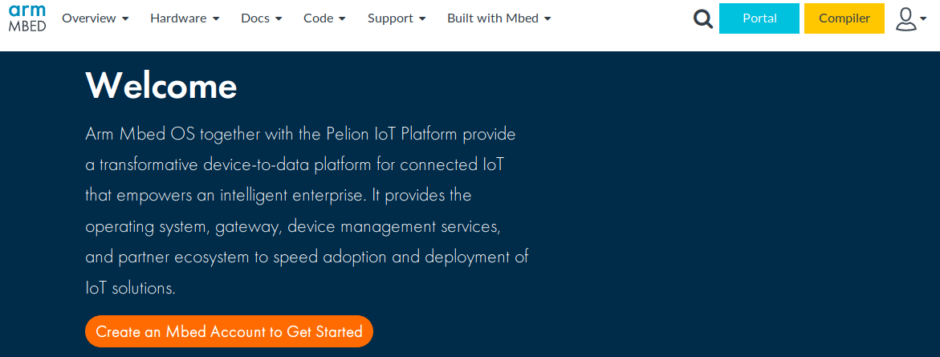

1. Register an account and then login

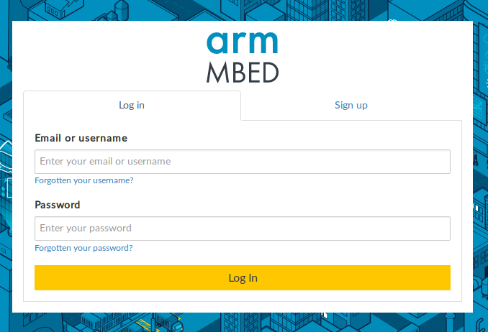

1. Open the Compiler. The main mbed IDE will be displayed. Here you can manage your projects, create new ones, import program from the mbed.org community…
2. On the top-right corner select the board you are currently working with. If it’s the first time using this board press add a new platform.

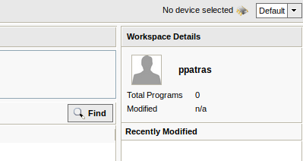

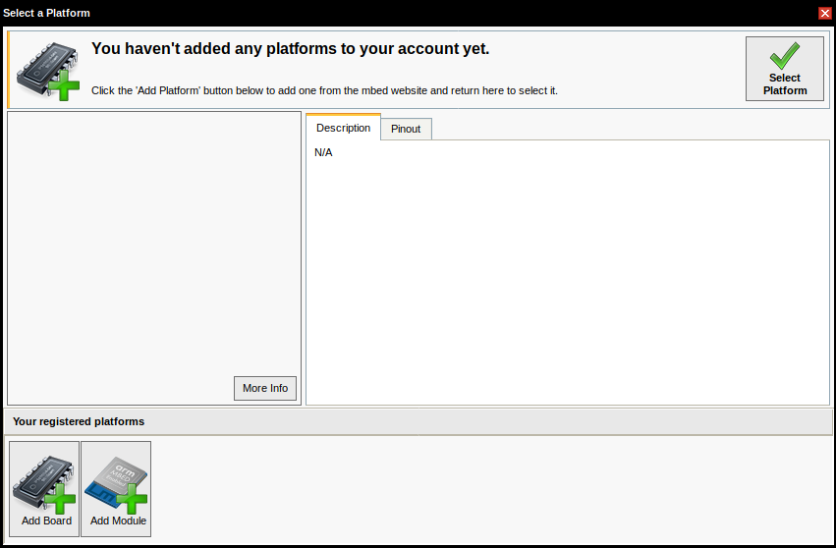

Browse for your device among all the mbed enabled platforms. You can filter by manufacturer (**NXP Semiconductors**) to find the FRDM-K64F board faster.

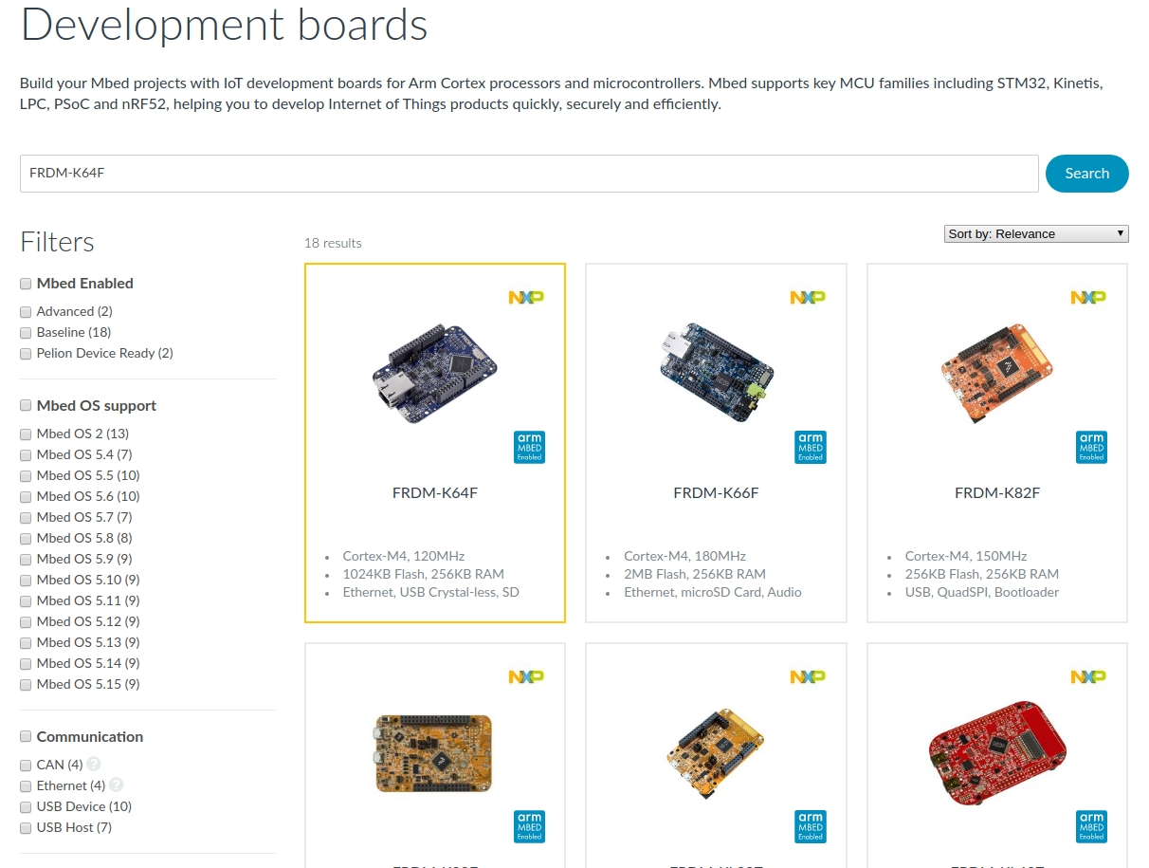

Select the target board, then click ‘Add to your Mbed Compiler’.

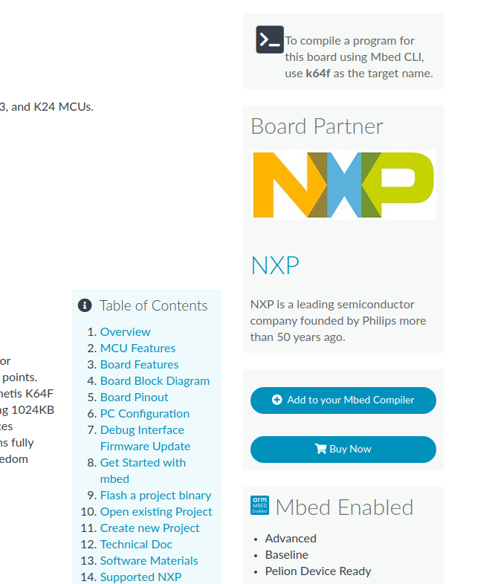

Go back to the Compiler interface. You should now be able to select this platform.

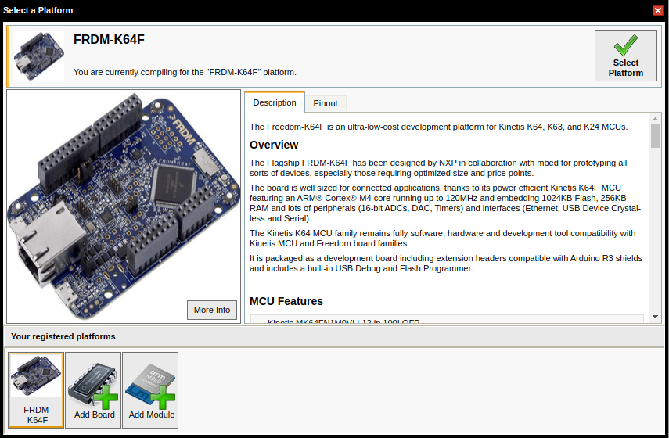

1. Create a helloworld project (blinky LED program).

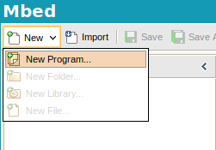 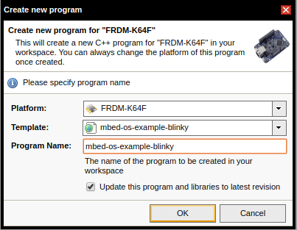

1. Compile the program.

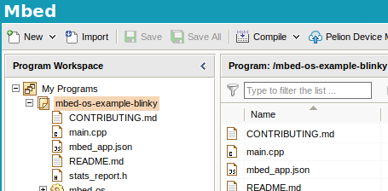

1. The program file will be generated and downloaded to your default download directory (set by your web browser).
2. Connect the board to your PC via an USB cable, the mbed will appear as a removable storage device.
3. Copy the downloaded program file to the mbed board’s root directory.
4. Reset the mbed board, the latest copied program file will be the default program to run.

SETTING UP A LOCAL DEVELOPMENT ENVIRONMENT

You may often wish to develop embedded code locally, to speed up deployment and avoid relying on Internet connectivity at all times. While some of the steps listed below are not necessary on DICE, since some software packages have been installed already, you will need to follow closely the steps below if you wish to set up a development environment on your own machine.

# Installing the GNU embedded toolchain for ARM (Not nEEDED on DICE)

The code you will develop for the embedded boards will be written in C, C++, or assembly. In order to be able to install on the boards an application that you develop on a PC, you will need to cross-compile the source tree for the target platform (for this lab the FRDM-K64F development kit). There exist multiple compiler options, but the recommended one is the GNU arm embedded toolchain (GCC). You can find the latest release and platform specific installation instructions at <https://developer.arm.com/open-source/gnu-toolchain/gnu-rm/downloads>

DICE machines already have the gcc-arm toolchain installed, hence you do not need to reproduce this step (which wouldn’t be possible anyway, given that super user privileges would be required).

# SETTING UP a PyTHON Virtual Environment

This step might not be required on your personal computer. On the other hand, given that you only have limited privileges on DICE, you will have to set up a virtual environment, so as to be able to install the necessary packages that will allow you to develop and deploy embedded applications. In these labs, we will rely on the Conda environment management system. Using this can also prove useful on your on machine, if you are working on multiple projects that have different dependencies and require different libraries.

To set up Conda for your DICE user, follow steps 2 and 3 in the guide available at <https://github.com/CSTR-Edinburgh/mlpractical/blob/mlp2018-9/lab1/notes/environment-set-up.md> making sure that you given an appropriate name to the environment used for this course, e.g.

conda create -n iotssc python=3

# Install the Arm Mbed command-line tool

While you should be able to do most of the work only using the gcc-arm compiler, you will find out that you often need to meet certain dependencies and reuse already existing code that is public. To this end, we will use the Arm mbed command-line tool, which is Python based.

With the Conda environment active, install and configure the mbed-cli as follows:

pip install mbed-cli

mbed config -G GCC_ARM_PATH "/opt/gcc-arm-none-eabi/bin"

## create your first mbed project USING MBED-CLI

We will create our first project once again based on the LED blinking example. For this, first import the example, then navigate into that project folder and compile the code with nRF51-DK as the target platform. Following this sequence of commands will also deploy the application on the board:

mbed import https://github.com/ARMmbed/mbed-os-example-blinky

cd mbed-os-example-blinky

mbed compile --target K64F --toolchain GCC_ARM --flash

# System debugging

To board will also expose a serial port when connected to a host PC, which can be used for debugging purposes. First, find out what is the identifier of the serial port exposed on the machine that you are using. You can do this with the following command

mbed detect

This should produce output that indicates on which serial port he board is using. You should see an identifier of the form /dev/ttyXYZ0. To connect to that port and inspect the embedded system reporting, on DICE you can use the following command

screen /dev/ttyXYZ0 9600

Remember to modify ttyXYZ0 to the actual identifier on your system. Here 9600 is the port’s Baud rate.

## EXERCISE

Starting from the example above, write an embedded application that executes a continuous loop in which each of the LEDs available on the board is blinked once every second consecutively, then all of them flash simultaneously for a second, and the process repeats.