IoTSSC Lab #7

Lab Exercise: Performance Measuring and optimization across the IoT stack

# Overview

In this lab you will focus on different methods for measuring performance optimization on the embedded device, the android application and the cloud. Specifically:

1) Investigating memory usage and stack and heap profiling.

2) Investigating raw CPU usage of your embedded device.

3) Profiling android application performance.

4) Profiling Google cloud services

## Requirements

For the embedded system component you will need the **FRDM-K64F** board.

For the android app profiling component you will need an android application (preferably the working Bluetooth application introduced in Lab 5).

For the cloud profiling component you will need a working Google Cloud service that integrates with the Stackdriver logging tool. This includes Pub/Sub, App Engine or Google Cloud Functions.

## Embedded Profiling

One simple way of measuring embedded performance is through the memory requirements on the code itself.

Whenever the command **mbed compile** is issued the memory requirements of the compiled program are displayed as followed:

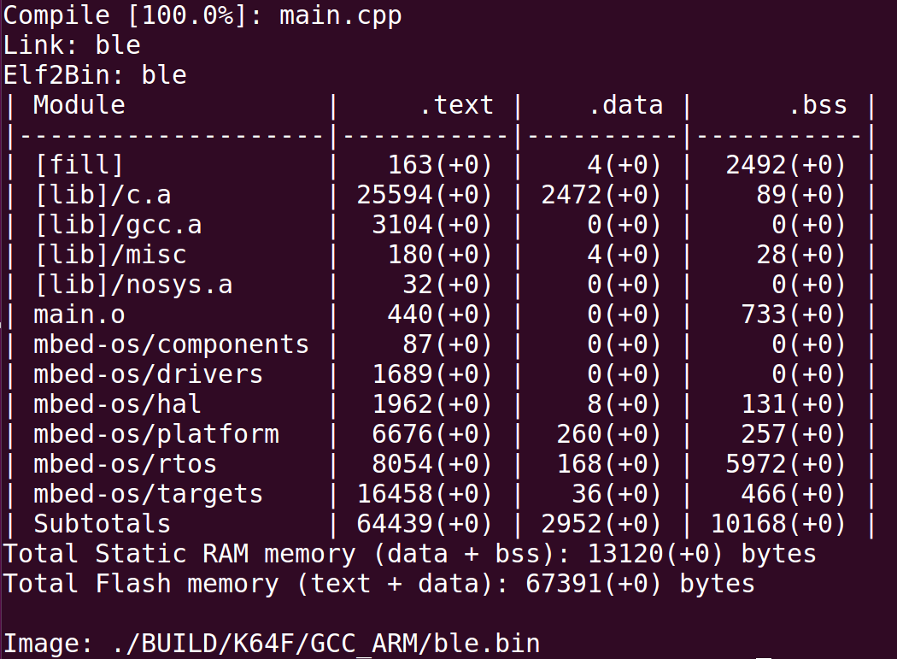We strongly recommend documenting these stats as you optimize your embedded application. Smaller memory requirements are **better** when comparing application that are functionally identical.

Digging deeper into the actual CPU usage of your embedded application, a dedicated tool is required:

<https://os.mbed.com/users/dextorslabs/code/CPU_Usage/>

The above library allows you to easily measure the CPU usage percentage in arbitrary locations in your code.

**Experiment measuring CPU usage throughout your code base to find out which parts of your application are most heavily utilizing the CPU. Look for possible code optimizations in these areas.**

## Android Application Profiling

## Cloud Profiling

Go into the hashing folder and run the example. This will demonstrate a couple of different ways to run SHA-256 hashing.

Can you change this to perform MD5 hashing instead? If not try to figure out why this isn’t possible.

Go into the benchmark folder and run the example. This will demonstrate encryption speeds for the algorithms included in the library.

Go into the authcrypt folder and run the example showcasing how to perform encryption. Identify the type of encryption implemented in this example.

Think about how you could incorporate any of functionality demonstrated in this lab into your project. Remember to consider performance trade-offs!