|  |
| --- |
|  |
| StockTracker  2701ICT Interactive App Development |
| |  |  |  | | --- | --- | --- | | Samrat Kunwar (s5108723) | 5/15/20 | Assignment 2 | |

# Introduction

ABC Consumer’s is a registered supplier of food products with client’s around Australia. They supply consumer products like meat, seafood and friable goods. They have been implementing excel spreadsheet to keep track of their stocks. Recently, they have been getting a high volume of orders and are finding it hard to keep track of their stocks. They have been finding it hard to go in their device and manually add and update their list.

So, they have requested for the development of an android application which can be download by any staff and update the list in real time.

# App Overview:

The app will implement the “Angular” background of “Ionic”. It is a JavaScript based app development platform with its own tools and components. The app will replace the companies old record keeping system with a new app version and a better looking UI (user interface).

Within the application, user’s can login with a specific username and password provided by the company. Once logged in, the user can check what items are in stock, add new ones and update the item details of the stock present. Similarly, they can keep track of their sales with charts.

# Stakeholders:

The application is focused towards record keeping, the main stakeholders of the app are as follows:

* ABC Consumer’s admin staff
* Accountant
* Sales staff
* Ordering Staff

# Functionalities:

The functionalities based on the screen flow of the application are as follows:

## Login page:

* The application authenticates user based on username and password with credentials stored in the database
* The application givers denies access and gives an error message on wrong data in any field
* The application allows used to see the password written in the respective field for a split second to check if it is correct

## Home Page:

* The application displays a list of all the products present in the database along with the item picture and description
* The app provides different functionality option based on the type of user logged in
* It allows Supplier/Owner of the app to add new product to the system, edit or remove the existing product.
* IT allows Customers to order the items listed in the home page

## Product Page:

* In the product page, it allows user to change data if edit command is passed
* It allows customers to specify the quantity of the item they want to order and add it to cart
* The application provides a functionality to close the model presented and go back to the home page by pressing “X” at the top left corner of the screen

## Navigation Menu:

* The app provides a navigation menu to different pages for easy access to modals
* It provides a link provides an option to logout from the system

## Add-Item Page:

* User can add new items to the record by entering item-name, price and quantity.
* The user can select image of the product by either selecting from library or by taking captures from their camera.

## Charts Page:

* The app allows user to specify sales quantity of a particular day and displays sales report chart with the help of date-time picker.
* The user has an option to see either a line chart or a bar chart with the help of a radio button

# Wireframes:

|  |  |
| --- | --- |
| Login | Home |
| Products Page | Add Item Page |
| Navigation Menu | Charts Page |

# Storyboard:

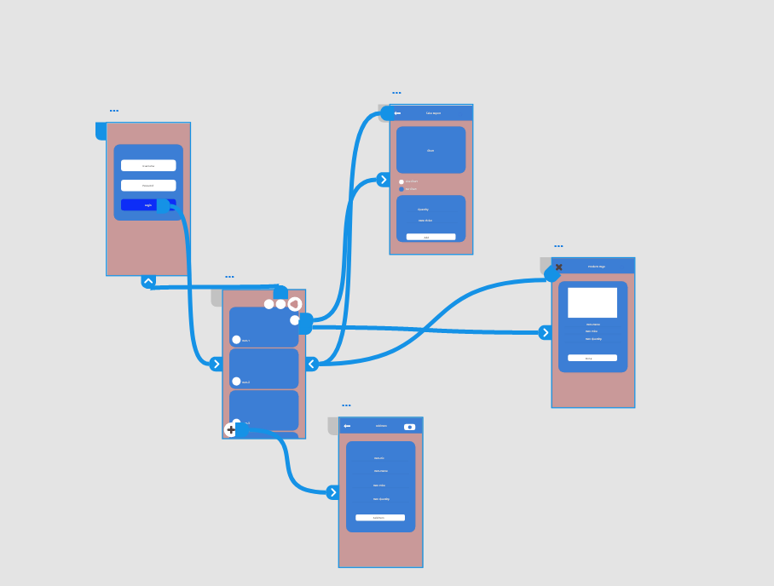

The above figure represents the storyboard of the application. Once the user launches that app, he/she is approached y a login screen. The user needs to enter the credentials provided by the company to login. Once logged in, the user can click on the product image to delete it or update the details. The home screen also have a navigation menu I the form of floating button allowing them to navigate to other pages. The user can click on the bottom left corner button to navigate to the add item page. Here, the user can add details of new items and add picture from either capture or image gallery. The user can navigate charts page where, they can find the sales chart. They can choose between line or bar chart and add new sales amount specifying date of sales. Finally, the user can logout through the link in the navigation menu.

# Prototype

Prototype Link: <https://xd.adobe.com/view/dc7fa4b6-9fb8-4c45-7882-97a0975e936b-aa4e/>

# Screen Design Change:

1. Home Page:

The home page layout has been changed since the last version. The new version contains a more user friendly and batter UI design.

The older version implemented a card with the header as image and content as all the details of the item. Similarly, each card had a vertical-outline icon , to display edit and delete options.

However, the new version has an improved UI with the removal of such icon. The new layout implements an a card with product image and name. The user can click on the card to get the options. Similarly, in the new version, the options emerge as an action message popup rather than option slider. Moreover, the app now has an add item button on the bottom left corner. Once it is pressed, the user is taken to a different page where he/she can add new product to the record.

|  |  |
| --- | --- |
| New Version | Old Version |
|  |  |

1. Charts Page:

Previously, the chart’s was displayed in the user profile page. However, the functionality of app has changed since then developing the unnecessity of a profile page. Similarly, the user did not have the option to choose chart type.

The new version not only has an improved UI but allows user to chose chart type, and add in sales data to the record. Similarly, the user can now choose the date of the sales rather than automatic addition on chart update.

|  |  |
| --- | --- |
| New Version | Older Version |
|  |  |

1. Removed Components

The purpose of the app has been changed from record keeping and ordering app to just record keeping app. The functionality of placing order to different suppliers inflicted conflict of the ordering functionality. Thus, it was removed along with the user profile page.

|  |  |
| --- | --- |
| Profile Page: | Cart: |
| Signup: | Checkout: |
|  |  |

1. Camera Component:

The user now has the option to choose product image from image gallery or real time capture and upload it to storage, The image will then be displayed as a product image on all pages.

# Implementation Details:

1. Shared Module:

During the implementation of modules that were shared around different components of the application specially nav-menu, the error received was : it is a part of 2 modules, add it to a higher module crashing the application.

So, I searched through my course note and all the lab files and implemented changed that were made in them. The result was still the same. I googled the error through stack overflow and other website to find the solution.

The solution required the implementation of a manual created shared module component where the desired module needs to be declared. Then the shared module needs to be imported on other components.

1. Storage:

During the implementation of ionic storage “Indexed DB”, I encountered several errors stating the defined storage is unreachable or not a form of storage. I had to go through lecture slides and online resources to find the solution

I had to re install storage module and SQLite module, import and declare it in the constructor function which solved the error.

1. Component Auto-reload:

My application was not auto reloading the home page when items were added to the record. I had to refresh the entire application to get the new data. I had to go through online resources and lecture notes to get the solution. The solution required the implementation of ViewChild component to be imported and used to display the desired module and reload it on navigation

1. Chart Component:

While creating dynamic chart component, I encountered error of creating chart and storing new data.

For the storage, while starting the app, I got all the data and stored it in an array to be displayed and while storing it back, I replaced the entire value with the new array list.

1. Image storage:

While implementing the image capture and uploader function, the lecture slides and resources were not enough. So, I had to find online resources through YouTube tutorials, stack overflow etc to find the right solution. The error I encountered was the image reference stored in the item list array doubled every time. To solve it, I had to get only the image in the position “0” i.e. recently added and add it as a reference in the storage.