Samuel David Lindaman 18309004

Elearning Platform

Due January 5, 2020

Elearning Platform

The Elearning platform that I have created allows users to to find the classes that are offered for the coming semester, view the description, teacher, schedule and prerequisites of the class. The user can then add the class to their course list and view that in a separate view. The user can also search for a specific class that they need to take

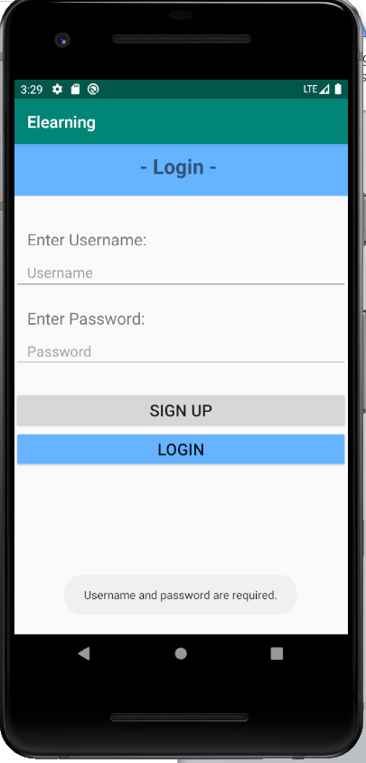

The first page asks a user to sign up or login. If any of the fields are empty, a message appears telling the user that all fields are required.

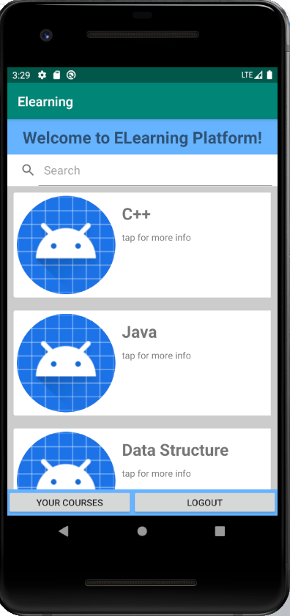

If the user logs in successfully, then they are brought to the home screen where a list of the available courses is displayed on the home page.

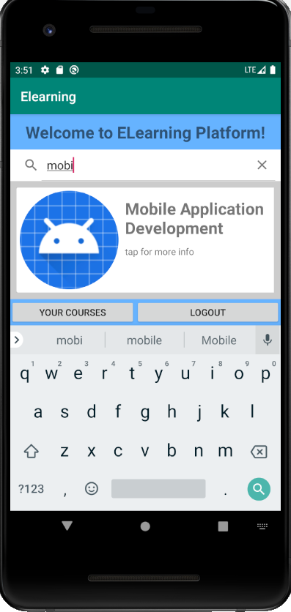

The user is able to search for the course that they would like to add

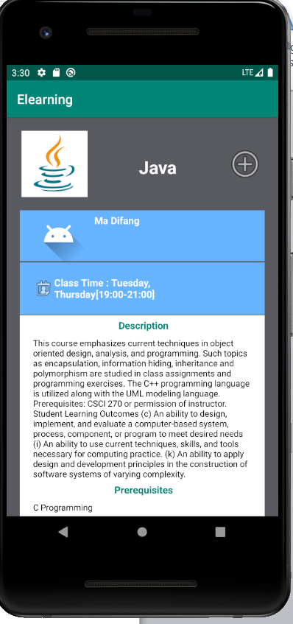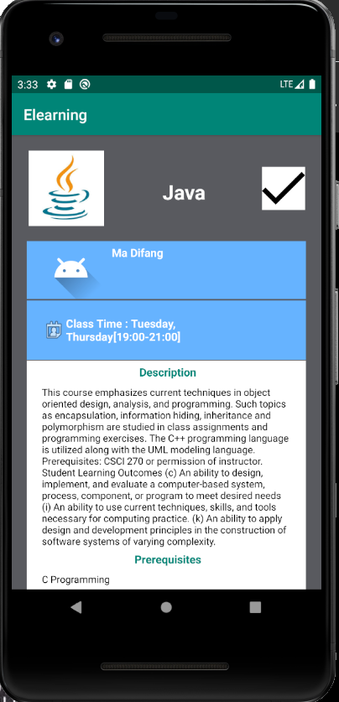

If the user clicks on one of the classes from the list, then they are brought to a page that displays the relevant info of the class. The user can add the course to their list of added courses by tapping the button in the top right corner. They can select or deselect this course.

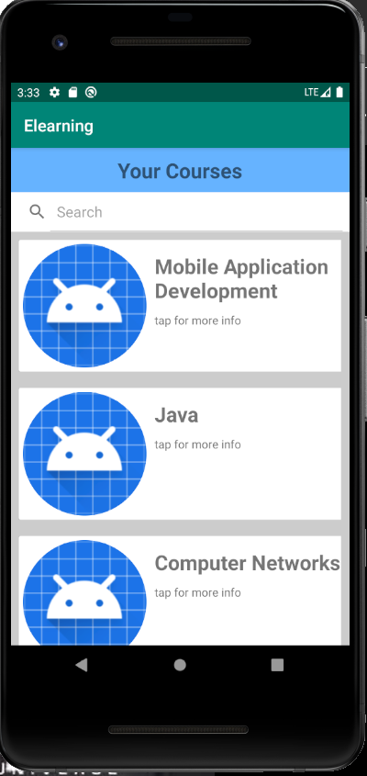

The user can view their courses that they have added from the button labled “your courses” on the home page.

Known errors:  
When signing up/logging in, if a user tries to log out immediately, there is sometimes not enough time for the database to add the user and the info to the database, and an error is thrown and the app crashes. This might have to do with internet connections/VPN use.

There are some random errors when logging in/signing up that are unable to repeat on a regular basis. This is a connection issue with the database, but when I reset the database from the webpage <http://18.220.228.1/apps/My%20Bitnami%20Parse%20API/browser/_User> Then the functionality works again. This is not an error that occurs in my final project that uses the same database.

Future implementations:

Find images for the teachers

Add a calendar that displays the time slots of each class