18309004

Samuel David Lindaman

Due: January 5, 2020

Instagram Clone

This project is an Android application focused on social media. The major components of this project are implementing a Parse server, and storing users, and their photos to a database, as well as allowing users to like other user’s photos, and store the number of likes of each in the database as well. Instagram is a very popular APP in the USA for photo sharing. It was bought by Facebook, so unfortunately it is inaccessible in China. Instagram is such a popular social media APP because it allows users to only share photos. It is a simple to use app that does not have a large number of features that can confuse users. This is a major difference from the apps that I have seen in china vs. in the USA. Chinese apps have huge functionality that allow users to do many different things within the app, many side buttons and flashing images, however what I am used to is apps with very simple, yet pleasant features. This project is an attempt to recreate one of my favorite apps that I have used for a long time.

As with many apps today, the first screen when opening the app is a login/signup feature.

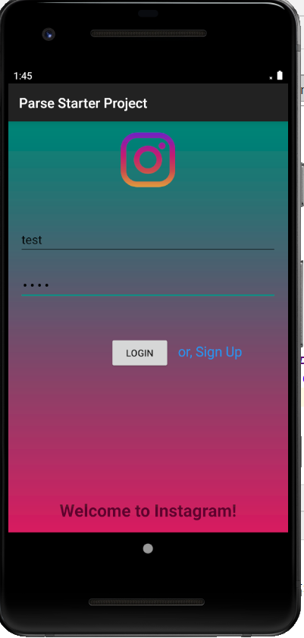

On the signup page, a user is asked to enter their username/password. If this username already exists and a user tries to signup, a message appears informing the user that that specific username is already taken. If the user tries to login with a username/password that does not match, a message displays informing them that they have the wrong username/password. If any fields are left blank, a message displays informing the user that all fields are required to login/signup.

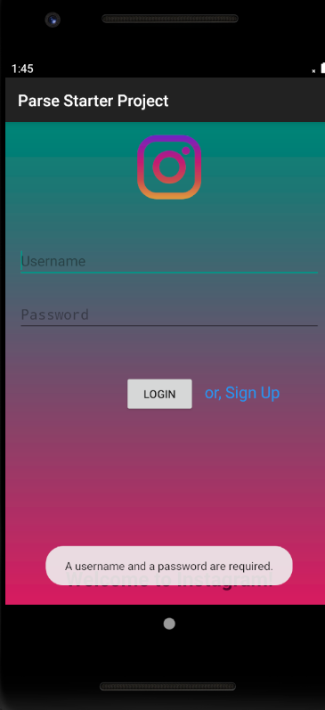

Once the user is logged in, all of the other users that have previously signed up for the app are displayed in a list on the home page **except** for the current user. There is a menu button in the top right corner of the screen where, if a user taps this, a dropdown menu appears with options for the user to share a photo, change their password, view their own photos, or logout.

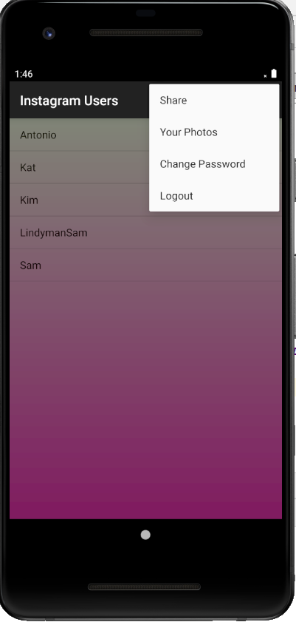

If a user selects to share a photo, the app asks permission to access the user’s camera roll. If the user accepts, then they are brought to their photos to select the photo they would like to share.

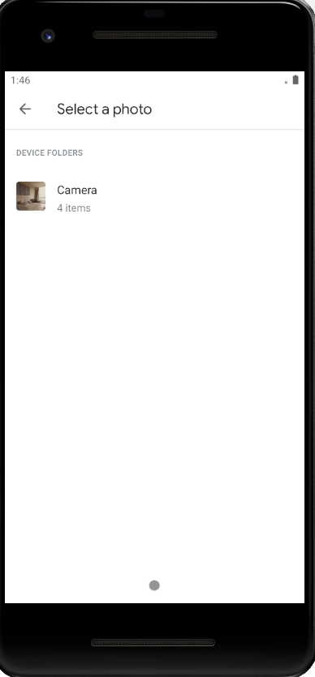

If the user selects to view their own photos, then a view appears showing a scrolling menu of all photos that they have posted, and the number of likes associated with each.

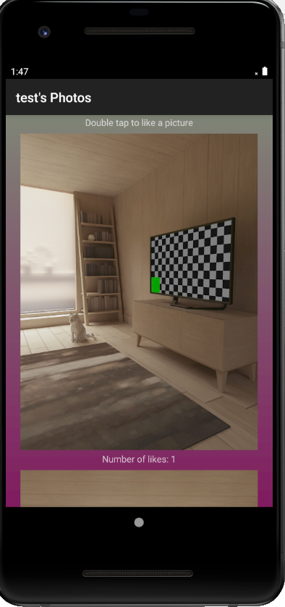

If the user selects to change their password, then a new view appears asking the user to confirm their old password, write a new password, and verify their new password. Just like in the login/signup page, if there are any errors in any of the fields, a small toast message will appear at the bottom of the screen informing the user.

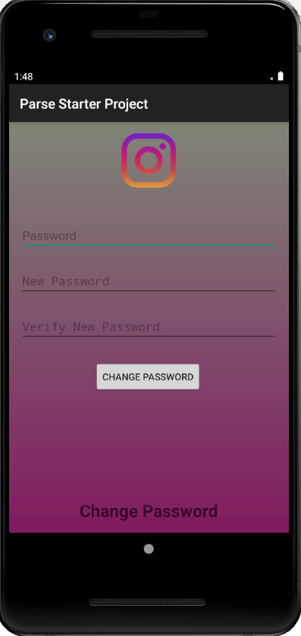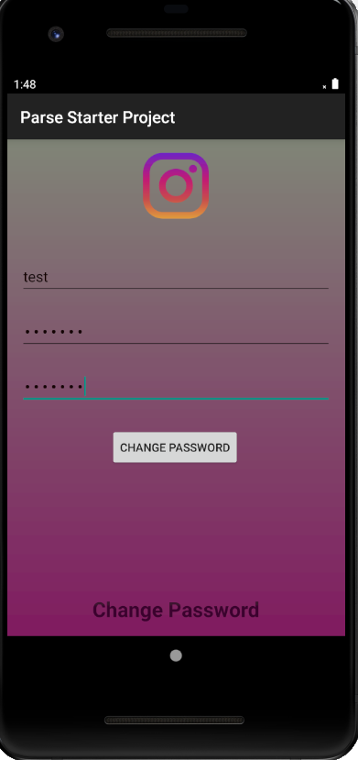

If the user successfully changes there password, then the new password replaces the old one in the parse database, and the user is logged in again and returned to the home page. Unfortunately, when using a vpn and running the emulator, there can be a delay when changing the password, and the app attempts to log the user in while the password is being changed. This results in a message displaying saying: ”invalid username and password.” However if the change password button is hit again, the user is successfully logged in. This is a bug found during testing.

If the user is at the home page and they tap one of the names of the other users in the list, then they are brought to that user’s page and shown their posted photos. Another unfortunate thing about using the emulator, and not owning a android phone, is that I was only able to post photos that come stock on the emulator, I was not able to post photos from my camera roll on my IPhone which would have made for a much more interesting display, however the functionality is all there.

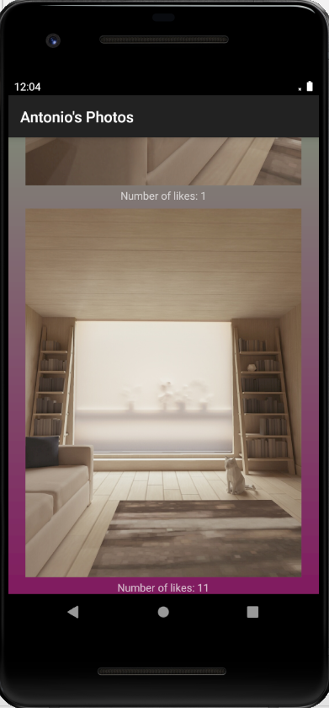

This is all the basic functionality of the app and this is what has made it so popular in the US. As a continuation to this project, I would like to play with a photo editing feature, which allows users to add filters to their photos. This is one of the main features that the true instagram has. I tried to implement this for quite a long time; however I never got it to work properly within the App, other than adding opacity, or changing the color balance to the photos. This will be a feature that I will continue to work on in the future. I have added the proper comments in the code to explain how the database works, and the features that are implemented.