Detecting Cyber-Attacks on the EV CAN Bus with ANFIS
A reproduction and extension: hybrid vs non-hybrid soft computing, and the effect of clustering-based initialisation

Soft Computing — Alternative Assessment Task (Hybrid Systems)
Sam M Jacob
22 October 2026

Reproduced paper: O. A. Al Isawi, K. A. Al Jaafari, A. S. Al-Sumaiti, “Electric Vehicles CAN Bus Cyber Attacks Detection Using Adaptive Neuro Fuzzy Inference System,” IEEE Access, vol. 13, pp. 90862–90874, 2025. DOI 10.1109/ACCESS.2025.3550970.

Abstract
Al Isawi et al. report that an Adaptive Neuro-Fuzzy Inference System (ANFIS), initialised by subtractive clustering (SC) or fuzzy c-means (FCM) and stacked with a second ANFIS, detects DoS and Impersonation attacks on the OTIDS CAN-bus dataset with ≈99.7 % accuracy. We reimplemented the full pipeline in Python (ANFIS from scratch in PyTorch, hybrid least-squares + gradient learning) and evaluated it under one protocol shared by every model: train-only scaling and SMOTE, validation-only tuning and five random seeds.
The paper's numbers reproduce (our ANFIS-FCM+stk: 99.99 % binary, 100 % multiclass accuracy), but the data analysis shows why: the class label is a function of the CAN ID, which is also an input. On a fairer benchmark that removes the ID (A-noID), a Random Forest is the best model (macro-F1 0.990 / 0.989). The hybrid ANFIS clearly beats its own non-hybrid ingredients: +0.036 / +0.101 macro-F1 over a pure fuzzy (FCM) classifier, and +0.019 over an MLP in the binary task.
For initialisation, a clustering start beats random placement, and SC is the most reliable choice because it sizes the rule base itself. However, the ranking between clustering methods depends on the rule count and largely disappears after stacking. Finally, re-labelling Impersonation by attack time shows that the attacker's frames are statistically indistinguishable from the genuine ECU's. The paper's Impersonation result therefore measures ‘is this ID 0x164?’ rather than attack detection.

1. Introduction
The Controller Area Network (CAN) carries every control message inside a vehicle but has no authentication: any node can transmit any identifier. Intrusion-detection systems (IDS) therefore try to recognise malicious frames from their identifier, payload and timing. Al Isawi et al. apply ANFIS, a hybrid that combines a Takagi–Sugeno fuzzy rule base (interpretable IF–THEN rules) with neural-network-style learning of its parameters, to the OTIDS dataset. They compare it with classical classifiers and deep-learning baselines.
This project reproduces that study and uses it to answer two questions about hybrid soft computing:
- Q1. Non-hybrid vs hybrid. Does the neuro-fuzzy hybrid outperform a pure neural model (MLP), a pure fuzzy model (FCM classifier) and classical models (LDA, LR, linear/RBF SVM, Random Forest)?
- Q2. Initialisation. How much does the clustering method used to build the initial fuzzy inference system matter: Random vs K-Means (hard) vs Subtractive Clustering vs Fuzzy C-Means (fuzzy)?
The rules were fixed before any results: nothing is tuned on the test set, the hybrid used for the headline comparison (ANFIS-FCM+stk, the paper's best architecture) was chosen in advance, and negative results are reported as found.

2. Dataset and what it actually contains
OTIDS (HCRL, Korea University) contains four CAN logs recorded from a KIA Soul: attack-free traffic, a DoS attack (flooding with the highest-priority ID 0x000), a fuzzy attack and an impersonation attack on ID 0x164. Each line holds a timestamp, CAN ID, DLC and up to eight data bytes. All 4.6 M lines were parsed without loss.
Table 1. The four OTIDS logs.
log | rows | duration (s) | frames/s | unique IDs | 0x000 frames | 0x164 frames
dos | 656,579 | 306 | 2144 | 46 | 335,624 | 17,271
fuzzy | 591,990 | 347 | 1704 | 45 | 0 | 41,590
impersonation | 995,472 | 483 | 2062 | 45 | 0 | 57,472
attack_free | 2,369,398 | 1038 | 2284 | 45 | 0 | 126,605

2.1 Labelling findings
The paper labels all 0x000 frames as DoS and every 0x164 frame as Impersonation. Before designing experiments we checked whether these labels correspond to something visible in the frames:
- DoS is genuinely distinct. The DoS log contains 335,624 injected 0x000 frames with a single all-zero payload, in bursts (median gap 0.5 ms), throughout the log. However, all-zero payloads also occur on normal IDs (159,104 such frames in the attack-free log), so without the ID, DoS must be recognised partly by timing.
- Impersonation is invisible. In the impersonation log, 0x164 traffic before and after the documented attack start (250 s) has the same rate (119.2 vs 118.9 Hz), the same payload patterns (χ² = 3.6, p = 0.999; no post-250 s payload is new), the same rolling-counter behaviour, the same total bus load, and no ID changes rate by more than 3 %. Only a tiny inter-arrival shift exists (KS D = 0.068 vs D = 0.016 for the same comparison on attack-free data).
- Consequence. The paper's Impersonation class is defined by the ID alone: genuine and malicious 0x164 frames share one label. With the CAN ID as an input feature, the task reduces to an ID lookup.
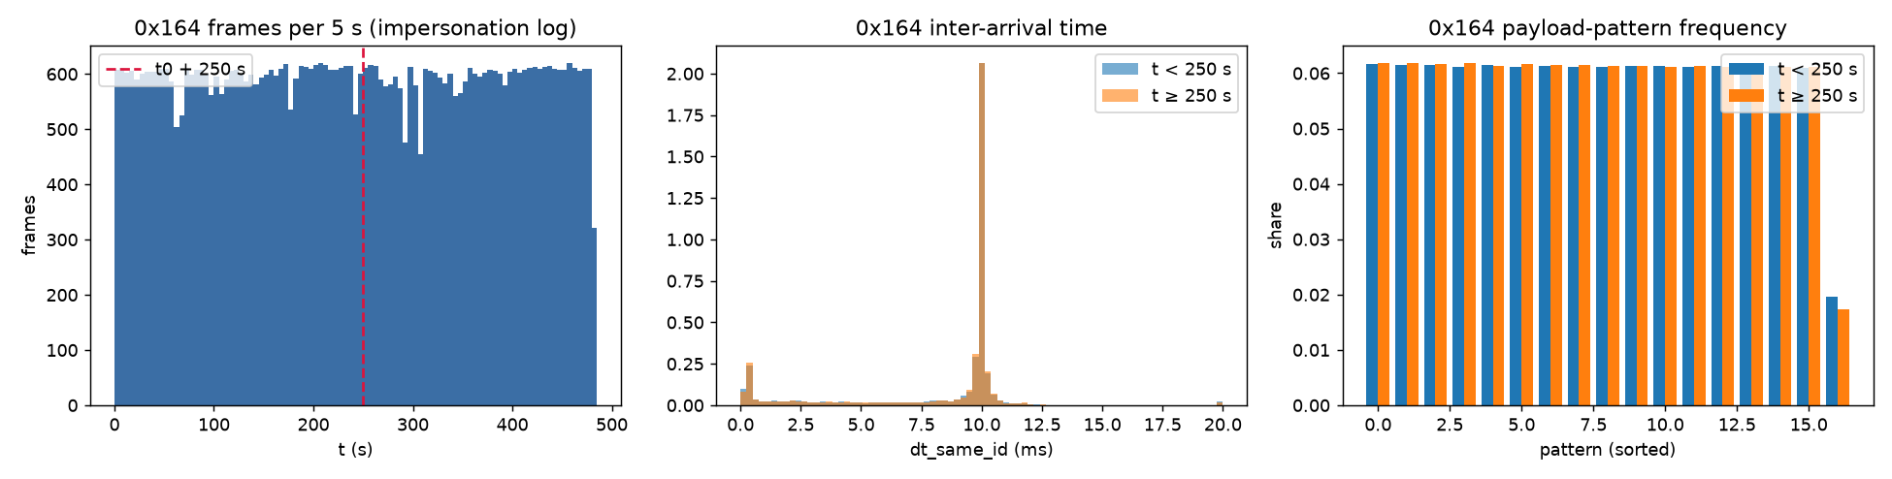
Figure 1. 0x164 traffic in the impersonation log before vs after the 250 s attack start: message rate, inter-arrival time and payload-pattern frequency are indistinguishable.
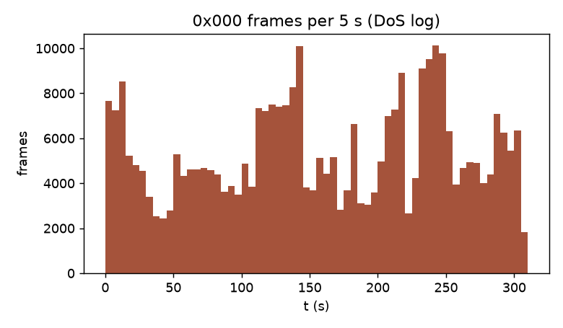
Figure 2. DoS log: 0x000 injection runs over the whole recording.

3. Method

3.1 Experimental settings
Because of the findings above, the study runs four settings. A-noID is the main benchmark for both research questions.
Table 2. Experimental settings.
Setting | Labels | Inputs | Purpose
A | by CAN ID (paper) | CAN ID, DLC, d0–d7 | Reproduce the paper
A-noID | by CAN ID (paper) | DLC, d0–d7, log10 Δt (same ID) | Main benchmark: label-leaking ID removed
B | Imp = 0x164 after 250 s | as A-noID | Is the true attack learnable?
B-ID | as B | as A-noID + CAN ID | As B, with the ID

3.2 Protocol (identical for every model)
- Sample: 20,000 frames per seed with the paper's class totals (1,497 DoS / 979 Imp / 17,524 Normal), stratified 80/20 train/test split.
- Preprocessing: min-max scaling fitted on the training set only, then SMOTE (k = 30) applied to the training set only.
- Tuning: baseline hyperparameters are selected on a validation split (20 % of training, carved out before SMOTE). ANFIS uses the paper's hyperparameters unchanged. The test set is never used for any choice.
- Seeds: 5 (each re-draws subsample, split and SMOTE). Reported as mean ± std. The primary metric is macro-F1, since accuracy is dominated by the 88 % Normal class.
- Significance: paired per-seed differences. A difference counts as ‘within noise’ if |mean Δ| ≤ its std over seeds or |Δ| < 0.0025 (≈ one Impersonation test error). An exact McNemar test is run on seed 0.

3.3 Models
Table 3. Model ladder.
Family | Model | Notes
Hybrid (neuro-fuzzy) | ANFIS (OvR) | First-order Takagi–Sugeno, Gaussian MFs. One ANFIS per class (one-vs-rest).
 | ANFIS + stacking (+stk) | Paper's design: a second ‘augmented’ ANFIS takes the stage-1 class scores and regresses the class index.
Non-hybrid soft computing | MLP | Pure neural network (sklearn, early stopping).
 | FCM classifier | Pure fuzzy: FCM clusters → membership-weighted class vote.
Classical ML | LDA, LR, linear SVM, RBF SVM, Random Forest | Validation-tuned.

ANFIS implementation. Rules have Gaussian membership functions per input and linear consequents. Firing strengths are computed in log space and normalised. Training follows Jang's hybrid rule: in each epoch, the consequent parameters are solved by (ridge) least squares and the premise centres and widths are updated by one Adam pass. The consequents are re-solved after the final epoch. The initial FIS comes from clustering the joint [input, target] space (as MATLAB's genfis2/genfis3 do). Initialisations:
- Random: R = 10 centres drawn at random from the training points; widths = global feature std.
- K-Means: R = 10 hard clusters; widths = per-cluster standard deviation.
- Subtractive clustering (SC): Chiu's method with the paper's radius and squash factor; the number of rules is decided by the algorithm.
- FCM: R = 10 fuzzy clusters (m = 2); widths = membership-weighted standard deviation.
Unit tests check the parser, train-only preprocessing, subtractive clustering on synthetic blobs, ANFIS fitting sin·cos and XOR, and agreement of the least-squares step with numpy (13 tests, all pass).

4. Results

4.1 Reproducing the paper (Setting A)
Table 4. Setting A: paper vs our reproduction (accuracy and macro-F1, mean ± std over 5 seeds).
task | model | paper acc | ours acc | paper macro-F1 | ours macro-F1
binary | LDA | 0.8593 | 0.9185 ± 0.0075 | 0.819 | 0.8519 ± 0.0107
binary | LR | 0.9118 | 0.9983 ± 0.0006 | 0.866 | 0.9962 ± 0.0013
binary | RBF-SVM | 0.9750 | 0.9988 ± 0.0005 | 0.951 | 0.9972 ± 0.0011
binary | RF | 0.9928 | 1.0000 ± 0.0000 | 0.984 | 1.0000 ± 0.0000
binary | ANFIS-SC+stk | 0.9958 | 1.0000 ± 0.0000 | 0.991 | 1.0000 ± 0.0000
binary | ANFIS-FCM+stk | 0.9968 | 0.9999 ± 0.0002 | 0.993 | 0.9998 ± 0.0005
multi | ANFIS-SC+stk | 0.9965 | 1.0000 ± 0.0000 | 0.988 | 1.0000 ± 0.0000
multi | ANFIS-FCM+stk | 0.9968 | 1.0000 ± 0.0000 | 0.989 | 1.0000 ± 0.0000
multi | ANFIS-SC+stk (Imp F1) | – | – | 0.968 | 1.0000 ± 0.0000
multi | ANFIS-FCM+stk (Imp F1) | – | – | 0.968 | 1.0000 ± 0.0000

The ANFIS results are reproduced and slightly exceeded. However, 11 of 15 models reach macro-F1 ≥ 0.99 in multiclass, including the MLP, RF, RBF-SVM and our validation-tuned LR. The paper's weak linear baselines are explained by the ID: 0x164 = 356 sits in the middle of the ID range, so one linear threshold cannot isolate it (LR on the ID alone: macro-F1 0.718). With the regularisation chosen on the validation split, LR reaches 0.996. The paper's LR (0.866) matches an untuned, strongly regularised fit. The ≈99.7 % headline is a property of the setting, not evidence that the hybrid is needed.
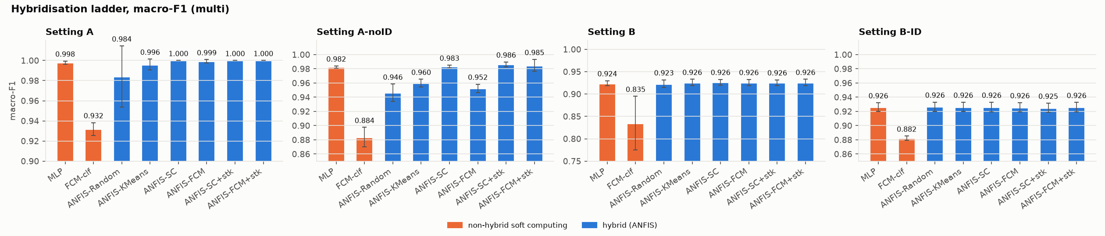
Figure 3. Model ladder (multiclass macro-F1) across settings. Blue = hybrid ANFIS, orange = non-hybrid soft computing, green = classical. In Setting A nearly everything sits at the ceiling.

4.2 Comparison 1: non-hybrid vs hybrid (A-noID)
Table 5. A-noID, binary (Attack vs Normal): test metrics, mean ± std over 5 seeds, sorted by macro-F1. Hybrid rows shaded.
model | family | macro-F1 | accuracy | F1 Attack | rules | train s
RF | classical ML | 0.9895 ± 0.0030 | 0.9954 ± 0.0013 | 0.9817 ± 0.0052 | – | 0.61
ANFIS-SC | hybrid (ANFIS) | 0.9840 ± 0.0024 | 0.9929 ± 0.0011 | 0.9720 ± 0.0042 | 43.2 | 1.17
ANFIS-SC+stk | hybrid (ANFIS) | 0.9838 ± 0.0023 | 0.9929 ± 0.0011 | 0.9718 ± 0.0040 | 50.0 | 1.62
ANFIS-KMeans+stk | hybrid (ANFIS) | 0.9798 ± 0.0040 | 0.9911 ± 0.0018 | 0.9648 ± 0.0070 | 30.0 | 0.99
ANFIS-FCM+stk | hybrid (ANFIS) | 0.9794 ± 0.0031 | 0.9909 ± 0.0014 | 0.9639 ± 0.0054 | 30.0 | 5.65
ANFIS-Random+stk | hybrid (ANFIS) | 0.9713 ± 0.0158 | 0.9870 ± 0.0076 | 0.9501 ± 0.0273 | 30.0 | 0.56
MLP | non-hybrid soft computing | 0.9606 ± 0.0170 | 0.9817 ± 0.0083 | 0.9317 ± 0.0292 | – | 1.54
ANFIS-Random | hybrid (ANFIS) | 0.9568 ± 0.0151 | 0.9799 ± 0.0074 | 0.9252 ± 0.0258 | 20.0 | 0.43
ANFIS-KMeans | hybrid (ANFIS) | 0.9557 ± 0.0147 | 0.9794 ± 0.0071 | 0.9233 ± 0.0254 | 20.0 | 0.70
ANFIS-FCM | hybrid (ANFIS) | 0.9499 ± 0.0050 | 0.9766 ± 0.0025 | 0.9133 ± 0.0086 | 20.0 | 4.08
RBF-SVM | classical ML | 0.9445 ± 0.0080 | 0.9739 ± 0.0041 | 0.9041 ± 0.0136 | – | 0.82
FCM-clf | non-hybrid soft computing | 0.9436 ± 0.0054 | 0.9733 ± 0.0028 | 0.9026 ± 0.0092 | 30.0 | 4.31
LinSVM | classical ML | 0.9424 ± 0.0059 | 0.9728 ± 0.0031 | 0.9005 ± 0.0100 | – | 0.07
LR | classical ML | 0.8942 ± 0.0216 | 0.9454 ± 0.0135 | 0.8206 ± 0.0349 | – | 0.05
LDA | classical ML | 0.7888 ± 0.0062 | 0.8709 ± 0.0052 | 0.6572 ± 0.0090 | – | 0.02

Table 6. A-noID, multiclass (DoS / Imp / Normal): test metrics, mean ± std over 5 seeds, sorted by macro-F1. Hybrid rows shaded.
model | family | macro-F1 | accuracy | F1 DoS | F1 Imp | rules | train s
RF | classical ML | 0.9886 ± 0.0030 | 0.9952 ± 0.0013 | 0.9686 ± 0.0082 | 1.0000 ± 0.0000 | – | 0.76
ANFIS-KMeans+stk | hybrid (ANFIS) | 0.9871 ± 0.0031 | 0.9950 ± 0.0013 | 0.9700 ± 0.0070 | 0.9939 ± 0.0058 | 40.0 | 1.83
ANFIS-SC+stk | hybrid (ANFIS) | 0.9861 ± 0.0035 | 0.9948 ± 0.0012 | 0.9713 ± 0.0083 | 0.9900 ± 0.0116 | 63.0 | 2.46
ANFIS-FCM+stk | hybrid (ANFIS) | 0.9847 ± 0.0084 | 0.9941 ± 0.0030 | 0.9694 ± 0.0095 | 0.9881 ± 0.0156 | 40.0 | 10.79
ANFIS-SC | hybrid (ANFIS) | 0.9832 ± 0.0019 | 0.9929 ± 0.0009 | 0.9548 ± 0.0054 | 0.9990 ± 0.0014 | 49.6 | 2.01
MLP | non-hybrid soft computing | 0.9824 ± 0.0016 | 0.9927 ± 0.0006 | 0.9544 ± 0.0044 | 0.9969 ± 0.0033 | – | 4.80
ANFIS-Random+stk | hybrid (ANFIS) | 0.9659 ± 0.0093 | 0.9887 ± 0.0032 | 0.9652 ± 0.0069 | 0.9386 ± 0.0217 | 40.0 | 1.04
ANFIS-KMeans | hybrid (ANFIS) | 0.9598 ± 0.0055 | 0.9816 ± 0.0027 | 0.8905 ± 0.0139 | 0.9995 ± 0.0011 | 30.0 | 1.41
ANFIS-FCM | hybrid (ANFIS) | 0.9525 ± 0.0059 | 0.9779 ± 0.0033 | 0.8717 ± 0.0187 | 0.9985 ± 0.0034 | 30.0 | 8.85
ANFIS-Random | hybrid (ANFIS) | 0.9463 ± 0.0122 | 0.9766 ± 0.0056 | 0.8733 ± 0.0236 | 0.9788 ± 0.0170 | 30.0 | 0.83
RBF-SVM | classical ML | 0.9441 ± 0.0189 | 0.9819 ± 0.0077 | 0.9268 ± 0.0430 | 0.9144 ± 0.0117 | – | 3.30
LinSVM | classical ML | 0.9214 ± 0.0056 | 0.9704 ± 0.0028 | 0.8477 ± 0.0140 | 0.9315 ± 0.0056 | – | 0.32
FCM-clf | non-hybrid soft computing | 0.8838 ± 0.0137 | 0.9643 ± 0.0040 | 0.8705 ± 0.0606 | 0.7967 ± 0.0364 | 30.0 | 6.60
LR | classical ML | 0.8621 ± 0.0223 | 0.9496 ± 0.0094 | 0.8559 ± 0.0138 | 0.7577 ± 0.0547 | – | 0.60
LDA | classical ML | 0.6815 ± 0.0085 | 0.8278 ± 0.0055 | 0.7780 ± 0.0161 | 0.3667 ± 0.0102 | – | 0.03

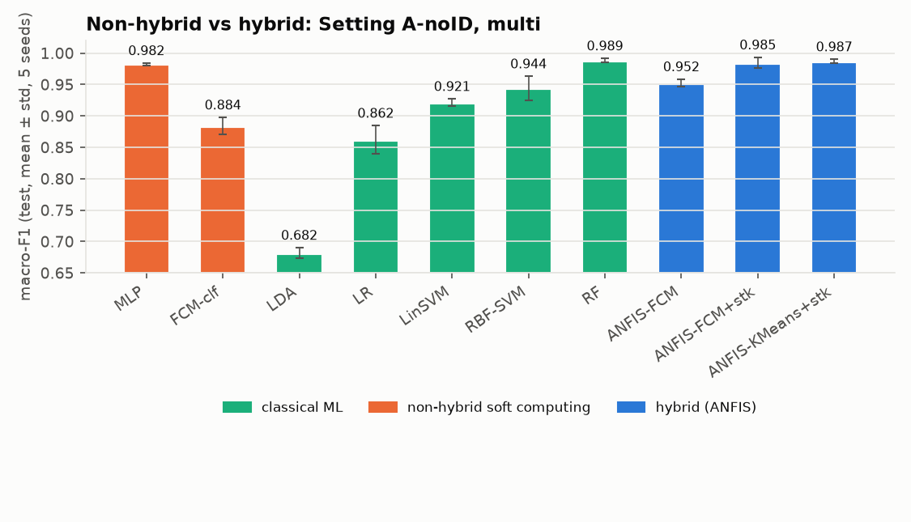
Figure 4. Comparison 1, A-noID multiclass: macro-F1 by model family (mean ± std, 5 seeds).
Table 7. Headline comparison (macro-F1). ANFIS-FCM+stk was pre-specified; ‘best ANFIS’ is chosen on test and therefore optimistic. McNemar compares best non-hybrid vs ANFIS-FCM+stk.
setting | task | best non-hybrid | MLP | FCM-clf | ANFIS-FCM+stk | best ANFIS (post-hoc) | McNemar p (seed 0)
A | binary | RF 1.0000 | 0.9972 | 0.9502 | 0.9998 | ANFIS-SC 1.0000 | 1
A | multi | RF 1.0000 | 0.9979 | 0.9318 | 1.0000 | ANFIS-Random+stk 1.0000 | 1
A-noID | binary | RF 0.9895 | 0.9606 | 0.9436 | 0.9794 | ANFIS-SC 0.9840 | 1.12e-07
A-noID | multi | RF 0.9886 | 0.9824 | 0.8838 | 0.9847 | ANFIS-KMeans+stk 0.9871 | 0.125

Table 8. Paired differences for ANFIS-FCM+stk (Δ macro-F1, positive = hybrid better; seeds won).
A-noID | vs Random Forest | vs MLP (pure neural) | vs FCM classifier (pure fuzzy)
binary | −0.010 ± 0.005 (0/5 seeds)  hybrid worse, McNemar p ≈ 1e-7 | +0.019 ± 0.018 (4/5)  hybrid better | +0.036 ± 0.007 (5/5)  hybrid better
multi | −0.004 ± 0.006 (1/5)  within noise | +0.002 ± 0.008 (4/5)  within noise | +0.101 ± 0.018 (5/5)  hybrid better

- The best overall model is non-hybrid: Random Forest. Even the best ANFIS picked post hoc (ANFIS-SC 0.984 binary; ANFIS-KMeans+stk 0.987 multi) does not beat it.
- Against its own ingredients the hybrid wins clearly. Adding neural learning (least-squares consequents + gradient-tuned membership functions) to FCM clusters is the largest single improvement in the study. The gain over the MLP is modest, and the MLP is unstable across seeds (std 0.017 in binary).
- Where the errors are. Almost all remaining errors are Normal frames predicted as DoS (seed 0: RF 19, ANFIS-FCM+stk 17 of 3,505). These are normal frames with an all-zero payload, which only timing can separate once the ID is removed. Impersonation is recognised perfectly by both models.
- Cost. ANFIS trains in 1–11 s with 20–63 rules, while RF needs under 1 s. ANFIS's advantage is a compact, inspectable rule base, not accuracy.
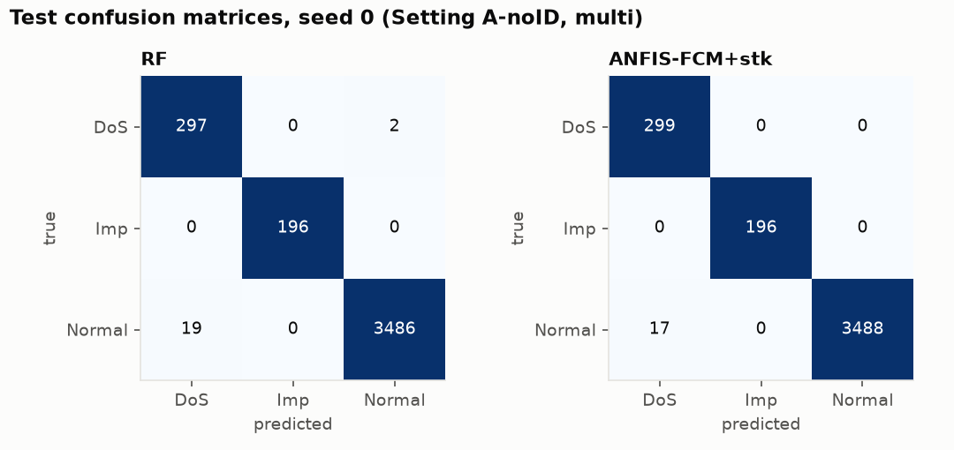
Figure 5. Seed-0 confusion matrices, A-noID multiclass: best non-hybrid (RF) vs ANFIS-FCM+stk.
Answer to Q1. Hybridisation helps relative to its components: a large gain over the pure fuzzy model and a modest, task-dependent gain over a pure MLP. It does not beat a strong classical ensemble (Random Forest) on this data.

4.3 Comparison 2: clustering initialisation (A-noID)
Only the initial FIS changes. Data, scaling, SMOTE, training (1 epoch), OvR and stacking are fixed. K-Means vs FCM isolates the value of fuzzy (partial) memberships over hard assignment at the same rule count.
Table 9. Macro-F1 (OvR / +stk), total rule count and training time per initialisation (R / K / SC / F = Random / K-Means / SC / FCM).
setting | task | Random OvR / +stk | KMeans OvR / +stk | SC OvR / +stk | FCM OvR / +stk | rules OvR (R/K/SC/F) | train s OvR (R/K/SC/F)
A | binary | 0.9856 / 0.9970 | 0.9977 / 0.9995 | 1.0000 / 1.0000 | 0.9994 / 0.9998 | 20 / 20 / 8 / 20 | 0.7 / 0.7 / 1.2 / 4.1
A | multi | 0.9841 / 1.0000 | 0.9959 / 0.9986 | 1.0000 / 1.0000 | 0.9993 / 1.0000 | 30 / 30 / 20 / 30 | 0.8 / 1.4 / 1.6 / 8.9
A-noID | binary | 0.9568 / 0.9713 | 0.9557 / 0.9798 | 0.9840 / 0.9838 | 0.9499 / 0.9794 | 20 / 20 / 43 / 20 | 0.4 / 0.7 / 1.2 / 4.1
A-noID | multi | 0.9463 / 0.9659 | 0.9598 / 0.9871 | 0.9832 / 0.9861 | 0.9525 / 0.9847 | 30 / 30 / 50 / 30 | 0.8 / 1.4 / 2.0 / 8.9

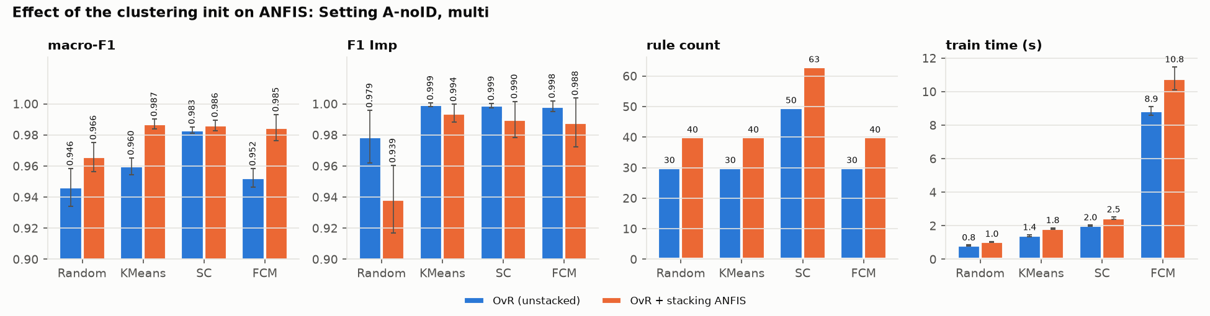
Figure 6. Comparison 2, A-noID multiclass: macro-F1, Impersonation F1, rule count and training time per initialisation, unstacked (blue) vs stacked (orange).
Table 10. Rule-count confound: unstacked macro-F1 with R = 10 vs R = 20 rules per OvR member.
init | binary, R = 10 | binary, R = 20 | multi, R = 10 | multi, R = 20
Random | 0.9568 ± 0.0151 | 0.9770 ± 0.0045 | 0.9463 ± 0.0122 | 0.9666 ± 0.0132
KMeans | 0.9557 ± 0.0147 | 0.9610 ± 0.0319 | 0.9598 ± 0.0055 | 0.9464 ± 0.0119
FCM | 0.9499 ± 0.0050 | 0.9707 ± 0.0180 | 0.9525 ± 0.0059 | 0.9824 ± 0.0019
SC (self-sized: 43–50 rules) | 0.9840 ± 0.0024 | – | 0.9832 ± 0.0019 | –

- At the paper's R = 10, SC is the best unstacked init (0.984 / 0.983), beating Random on 5/5 seeds in both tasks with the lowest variance. K-Means beats Random in multiclass (+0.014, 5/5). FCM is within noise of Random and below K-Means in multiclass (−0.007, 0/5 seeds).
- But the ranking is confounded with capacity. SC chooses more rules (43–50 vs 20–30). At R = 20, FCM rises to 0.971 / 0.982 and Random to 0.977 / 0.967, while K-Means does not improve. The FCM vs K-Means verdict flips with R. On the validation split, R = 5 is clearly worse and R = 10 ≈ R = 20.
- Stacking evens out the inits: K-Means/SC/FCM+stk all land at 0.985–0.987 (multi) and 0.979–0.984 (binary). Only Random+stk lags (0.966 multi).
- Epochs: 5 epochs (early stopping on validation, then refit) change macro-F1 by less than the seed noise for every init, as the paper states. Early stopping picks 1 epoch most often for SC.
- Time: FCM initialisation makes ANFIS-FCM 4–6× slower than K-Means/SC (8.9 s vs 1.4 / 2.0 s, multiclass).
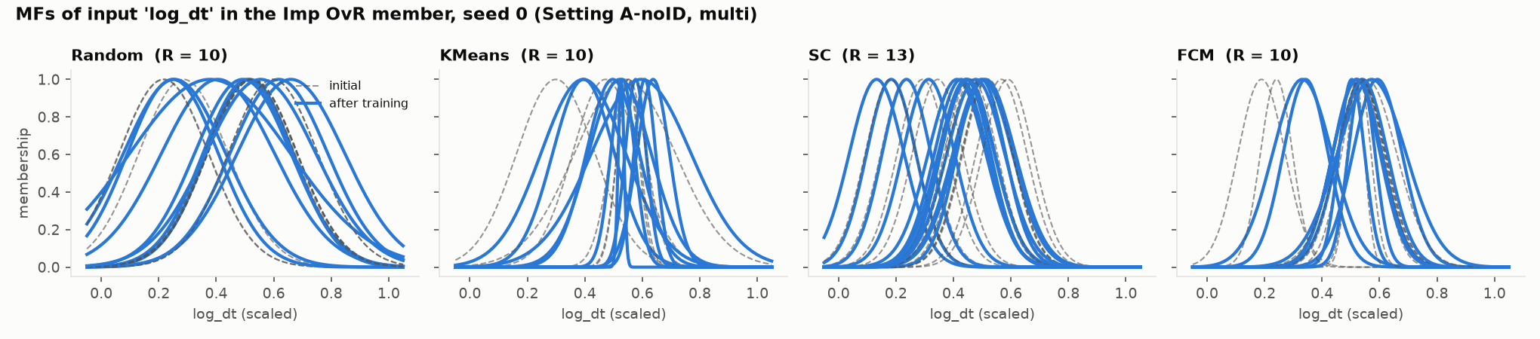
Figure 7. Membership functions of one OvR member on one input, before (dashed) and after (solid) hybrid training, per initialisation. This is the interpretable part of the hybrid.
Answer to Q2. A clustering initialisation beats random placement at the paper's rule count, and SC is the most reliable choice because it also selects a sensible rule count. Differences between clustering methods are small, depend on R and mostly disappear once the stacking ANFIS is added. We find no consistent evidence that fuzzy clustering (FCM) beats hard clustering (K-Means) as an ANFIS initialiser.

4.4 Setting B: is the real Impersonation attack learnable?
Setting B labels only 0x164 frames sent after the attack start as Impersonation; genuine 0x164 frames before 250 s are Normal. Every model (classical, MLP, all ANFIS variants) reaches Impersonation F1 ≈ 0.79. This equals the trivial rule ‘Imp iff ID = 0x164’ (0.794 ± 0.018) on the same test sets. The models learn to recognise 0x164-type messages, not the attacker.
Table 11. Learnability probe: classify each 0x164 frame as after vs before 250 s. Time-blocked 5-fold CV (10 s groups), ROC AUC per fold. Control = same probe on attack-free data with a fake boundary. AUC 0.5 = no signal.
data | features | model | ROC AUC (mean ± std over folds)
impersonation log | payload+DLC | LR | 0.501 ± 0.002
impersonation log | payload+DLC | RF | 0.500 ± 0.002
impersonation log | payload+DLC | ANFIS-FCM | 0.500 ± 0.002
attack-free log (control) | payload+DLC | LR | 0.500 ± 0.001
attack-free log (control) | payload+DLC | RF | 0.501 ± 0.002
attack-free log (control) | payload+DLC | ANFIS-FCM | 0.501 ± 0.002
impersonation log | timing (log_dt, hamming) | LR | 0.499 ± 0.004
impersonation log | timing (log_dt, hamming) | RF | 0.591 ± 0.013
impersonation log | timing (log_dt, hamming) | ANFIS-FCM | 0.496 ± 0.008
attack-free log (control) | timing (log_dt, hamming) | LR | 0.500 ± 0.002
attack-free log (control) | timing (log_dt, hamming) | RF | 0.504 ± 0.005
attack-free log (control) | timing (log_dt, hamming) | ANFIS-FCM | 0.498 ± 0.006

Payload carries no signal (AUC 0.50 everywhere). Only a non-linear model on timing finds a faint fingerprint (RF AUC 0.59–0.61 vs 0.50 on the control). Per-frame detection of OTIDS impersonation is essentially not possible from these features, so the paper's Impersonation results measure ID recognition.

4.5 Ablations
Table 12. Selected ablations on A-noID (macro-F1, paired over 5 seeds). Full list in results/ablations.md.
task | model | variant | main | variant | Δ (variant − main)
binary | ANFIS-FCM+stk | OOF stacking | 0.9794 ± 0.0031 | 0.9557 ± 0.0124 | -0.0237 ± 0.0139
multi | ANFIS-FCM+stk | OOF stacking | 0.9847 ± 0.0084 | 0.9392 ± 0.0140 | -0.0455 ± 0.0097
multi | ANFIS-SC+stk | OOF stacking | 0.9861 ± 0.0035 | 0.9854 ± 0.0036 | -0.0007 ± 0.0010
binary | FCM-clf | no SMOTE | 0.9436 ± 0.0054 | 0.7989 ± 0.0212 | -0.1447 ± 0.0228
multi | FCM-clf | no SMOTE | 0.8838 ± 0.0137 | 0.5844 ± 0.0182 | -0.2994 ± 0.0101
multi | RF | no SMOTE | 0.9886 ± 0.0030 | 0.9867 ± 0.0029 | -0.0019 ± 0.0031
multi | ANFIS-FCM | no SMOTE | 0.9525 ± 0.0059 | 0.9821 ± 0.0031 | 0.0297 ± 0.0061
multi | ANFIS-FCM+stk | no SMOTE | 0.9847 ± 0.0084 | 0.9672 ± 0.0125 | -0.0175 ± 0.0144
multi | ANFIS-SC | 5 epochs | 0.9832 ± 0.0019 | 0.9833 ± 0.0019 | 0.0001 ± 0.0003
multi | ANFIS-FCM | 5 epochs | 0.9525 ± 0.0059 | 0.9589 ± 0.0152 | 0.0065 ± 0.0140

- Paper (in-sample) vs out-of-fold stacking: OOF is worse for K-Means/FCM and equal for SC. A 10-rule stage-1 ANFIS barely overfits, so its training outputs resemble its test outputs. OOF stage 2 is instead trained on noisier scores than it sees at test time.
- SMOTE is essential for the pure fuzzy classifier (−0.14 / −0.30 without it), because the cluster class distributions get swamped by Normal. RF is unaffected, and unstacked ANFIS even improves without it.
- Removing the CAN ID (A → A-noID) costs RF only 0.010, ANFIS 0.012–0.050 and linear models up to 0.14.

5. Discussion and conclusions
- The paper reproduces, but its headline is uninformative. With the ID as input and labels defined by the ID, almost any non-linear model reaches ≈100 %.
- Hybrid vs non-hybrid: ANFIS is a genuine improvement over the pure fuzzy model it is built from and is competitive with (sometimes better than) an MLP, with a far smaller, interpretable rule base. It is not the most accurate model: a Random Forest is better or equal everywhere.
- Initialisation: any clustering start is better than random. SC is the safest default because it sets the number of rules from the data. Hard vs fuzzy clustering makes no consistent difference once rule count and stacking are accounted for.
- Dataset validity: OTIDS Impersonation, as labelled by the paper, is ID recognition. A real impersonation detector would need sequence/timing models and a dataset in which the attack leaves a trace.

6. Deviations from the paper and limitations
- The paper does not state which files its 20,000 rows came from, and its class ratios match no log. We drew DoS from the DoS log, Impersonation from the impersonation log and Normal from the attack-free log (other IDs).
- ANFIS was reimplemented in PyTorch rather than MATLAB. The stacking ANFIS regresses the class index (our reading of an ambiguous description).
- The paper tuned on its test set; we tune only on a validation split.
- The paper's deep-learning baselines (CNN, LSTM, GRU, CNN-LSTM) were not re-run; their reported numbers are quoted only.
- Five seeds give limited power. ‘Within noise’ is a seed-spread rule, not a formal test. McNemar is run on seed 0 only, without multiple-comparison correction.
- ‘Best ANFIS (post-hoc)’ is selected on test and is optimistic; the headline uses the pre-specified ANFIS-FCM+stk.
- Training times are single-machine wall-clock (ANFIS on GPU, others on CPU) and indicative only.

References
- O. A. Al Isawi, K. A. Al Jaafari, A. S. Al-Sumaiti, “Electric Vehicles CAN Bus Cyber Attacks Detection Using Adaptive Neuro Fuzzy Inference System,” IEEE Access, 13, 90862–90874, 2025.
- H. Lee, S. H. Jeong, H. K. Kim, “OTIDS: A Novel Intrusion Detection System for In-vehicle Network by Using Remote Frame,” PST 2017. Dataset: HCRL CAN-intrusion dataset.
- J.-S. R. Jang, “ANFIS: Adaptive-Network-Based Fuzzy Inference System,” IEEE Trans. SMC, 23(3), 665–685, 1993.
- S. L. Chiu, “Fuzzy Model Identification Based on Cluster Estimation,” J. Intelligent & Fuzzy Systems, 2(3), 267–278, 1994.
- J. C. Bezdek, Pattern Recognition with Fuzzy Objective Function Algorithms, Plenum, 1981.
- N. V. Chawla et al., “SMOTE: Synthetic Minority Over-sampling Technique,” JAIR, 16, 321–357, 2002.
Code, configuration and all result tables: project repository (README.md, results/).

Appendix A. System architecture and implementation details
This document describes how every part of the study is built: the data pipeline, the shared experimental protocol and each method tested. All hyperparameters live in configs/default.yaml; the values quoted here are the ones used for every reported result.

A.1. Overview
The system is a single Python package (src/) driven by a few scripts (scripts/). One run, for one setting, task and seed, goes through the same pipeline for every model, so the only thing that differs between two result rows is the model itself.
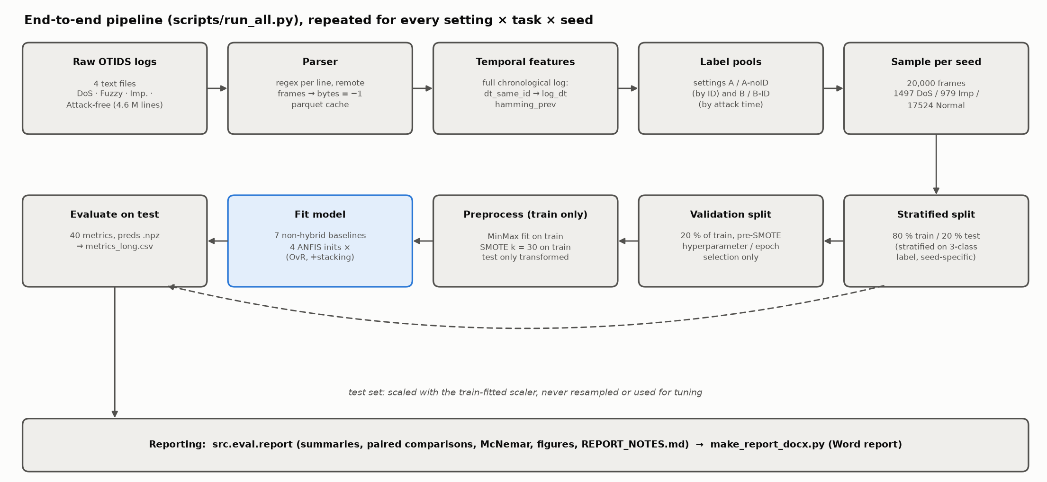
Figure 8. End-to-end pipeline. Every box except "Fit model" is shared by all 15 models.
layer | module | responsibility
data | src/data/parse_otids.py | parse the four OTIDS text logs, cache as parquet
data | src/data/features.py | per-frame temporal features on the full chronological log
data | src/data/build_dataset.py | label pools per setting, 20k sampling, splits, scaling, SMOTE
models | src/models/anfis.py | ANFIS network and hybrid learning (PyTorch)
models | src/models/subclust.py, inits.py | the four initial-FIS generators
models | src/models/anfis_classifiers.py | OvR ANFIS and the stacked (augmented) ANFIS
models | src/models/fcm_classifier.py, baselines.py | non-hybrid baselines
evaluation | src/eval/metrics.py, stats.py | per-run metrics, McNemar test
evaluation | src/eval/report.py, notes.py, plots.py | aggregation, paired comparisons, figures, notes
drivers | scripts/run_all.py | the experiment loop (settings × tasks × seeds × models)
drivers | scripts/data_report.py, probe_B.py, rule_sweep.py | data analysis, Setting B probe, R sweep
drivers | scripts/make_report_docx.py, make_arch_figures.py | Word report and these diagrams

Environment. Python 3.11 (conda env can-anfis, pinned in environment.yml): PyTorch 2.6 (CUDA 12.4), scikit-learn, imbalanced-learn, scikit-fuzzy, numpy/pandas/pyarrow, matplotlib. ANFIS runs on the GPU (RTX 4060) when available; everything else runs on the CPU. Native thread pools are capped (OpenMP, OpenBLAS and MKL at 8 threads, torch at 4, Random Forest n_jobs = 8) because uncapped pools oversubscribed the 20-core CPU and stalled runs.

A.2. Data pipeline

A.2.1 Parsing
Each OTIDS line has the form Timestamp: 0.000224 ID: 0329 000 DLC: 8 d7 a7 7f 8c 11 2f 00 10. A single regular expression extracts timestamp, CAN ID (hex), flag, DLC and the data bytes.
- Remote frames (flag 100, DLC 0) carry no data; their bytes are stored as −1.
- Short frames (DLC < 8): missing bytes are −1. Trailing ASCII columns (two Fuzzy-log lines) are ignored.
- Timestamps: the Impersonation log uses absolute UNIX time, the others start at 0, so every log gets t_rel = timestamp − first timestamp.
- All 4.6 M lines parse (0 rejected). Each log is cached to data/processed/<log>.parquet.

A.2.2 Temporal features
Computed on the full chronological log, before any sampling, so a sampled frame still sees its true predecessor:
- dt_same_id: seconds since the previous frame with the same CAN ID. The first frame of each ID gets that ID's median gap. Used as log_dt = log10(max(dt, 1e-6)), because dt is heavy-tailed and min-max scaling would otherwise squash almost all frames into a tiny range.
- hamming_prev: number of payload bits that changed versus the previous frame of the same ID (used by the Setting B probe only).

A.2.3 Label pools and settings
Labels are 0 = DoS, 1 = Impersonation, 2 = Normal. The binary task maps DoS and Imp to Attack (0) and Normal to 1.
setting | DoS pool | Imp pool | Normal pool | inputs
A | 0x000 frames, DoS log | all 0x164 frames, imp. log | attack-free log, IDs other than 0x000/0x164 | can_id, dlc, d0–d7
A-noID | as A | as A | as A | dlc, d0–d7, log_dt
B | as A | 0x164 frames with t_rel ≥ 250 s, imp. log | every other imp.-log frame (incl. genuine 0x164 before 250 s) | dlc, d0–d7, log_dt
B-ID | as B | as B | as B | can_id, dlc, d0–d7, log_dt

A.2.4 Sampling, splitting and preprocessing
1. Sample: per seed, draw without replacement exactly 1,497 DoS, 979 Imp and 17,524 Normal frames (the paper's 20,000-row class totals).
2. Split: stratified 80/20 train/test (16,000 / 4,000), stratified on the 3-class label so the binary and multiclass tasks use the same rows for a given seed.
3. Validation split (tuning only): 20 % of the training rows, carved before SMOTE. It is used to choose baseline hyperparameters and, in the 5-epoch ablation, ANFIS epoch counts. Models are then refit on the full training set.
4. Scaling: MinMaxScaler fitted on the training rows only; validation and test are only transformed.
5. SMOTE (k_neighbors = 30, sampling_strategy = "not majority") on the scaled training rows only. It brings every minority class up to the majority count: multiclass training grows from 16,000 to 42,057 rows (3 × 14,019), binary to 28,038 (2 × 14,019). If a class had ≤ 30 rows, k would be reduced automatically.
The test set is never resampled and never used for any decision.

A.3. ANFIS (hybrid neuro-fuzzy)

A.3.1 Network
A first-order Takagi–Sugeno ANFIS, written from scratch in PyTorch (src/models/anfis.py). With d inputs and R rules:
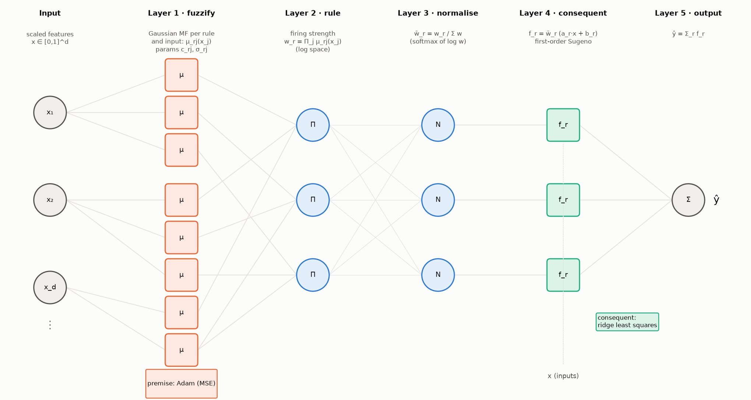
Figure 9. ANFIS as a five-layer network. Orange parameters are learned by gradient descent, green ones by least squares.
layer | operation | parameters
1 · fuzzification | Gaussian MF per rule and input: μ_rj(x_j) = exp(−(x_j − c_rj)² / 2σ_rj²) | centres c (R × d), widths σ (R × d)
2 · rule firing | product t-norm: w_r = Π_j μ_rj(x_j), computed as log w_r = −½ Σ_j ((x_j − c_rj)/σ_rj)² | –
3 · normalisation | w̄_r = w_r / Σ_k w_k, implemented as softmax(log w) | –
4 · consequents | f_r = w̄_r · (a_r · x + b_r) | a (R × d), b (R)
5 · output | ŷ = Σ_r f_r | –

Implementation choices:
- Log-space firing. With 10–11 inputs, the product of Gaussians underflows to 0 far from every centre. Computing log w and normalising with softmax is numerically identical in exact arithmetic but never divides 0 by 0.
- Widths are stored as log σ (keeps them positive under gradient steps) and clamped at σ ≥ 1e-3.
- Parameter count per ANFIS: 2Rd premise + R(d + 1) consequent. For R = 10, d = 10: 200 + 110 = 310.

A.3.2 Hybrid learning
Jang's hybrid rule, one epoch at a time:
1. Forward pass, least squares. With the premise fixed, the output is linear in the consequents: ŷ = Φθ, where each row of Φ is [w̄_1·x, w̄_1, …, w̄_R·x, w̄_R] (R(d + 1) columns). θ is solved by ridge regression from the normal equations (ΦᵀΦ + λI)θ = Φᵀy, with λ = 1e-6. ΦᵀΦ is accumulated in chunks of 8,192 rows in float64 and solved with torch.linalg.solve.
2. Backward pass, gradient descent. With θ fixed, one pass of Adam (lr 0.01, mini-batch 512, shuffled) on the MSE updates centres and log-widths.
3. After the last epoch, θ is re-solved once so the consequents match the final premise.
hyperparameter | value | source
epochs | 1 (5 in the ablation) | paper
optimiser (premise) | Adam, lr 0.01, batch 512 | ours (MATLAB's anfis uses gradient descent with an adaptive step)
ridge λ | 1e-6 | ours (numerical stability only)
σ floor | 1e-3 (network), 1e-2 (initial widths) | ours
loss | MSE against the 0/1 target (OvR) or the class index (stage 2) | standard ANFIS

5-epoch ablation. For each OvR member, training runs up to 5 epochs on the validation-split data with early stopping on validation MSE (patience 2). The epoch with the lowest validation MSE is kept, and the member is refit on the full training set for that many epochs.

A.3.3 Initial FIS: the four initialisation methods
All four produce initial centres (R × d) and widths (R × d) through one interface (src/models/inits.py). Like MATLAB's genfis2/genfis3, the three clustering methods cluster the joint space [x, target] and then drop the target coordinate, so clusters respect class structure. The Random control uses x only.
init | centres | widths | rules per member | role
Random | R training points drawn uniformly at random | global per-feature std of the training data | 10 (fixed) | control: no clustering
K-Means | K-Means centroids (n_init 10) | per-cluster per-feature std (global std if < 2 points) | 10 (fixed) | hard clustering
SC | subtractive-clustering centres | r_a × span / √8 per feature, same for all rules | data-driven (3–25 observed) | paper's method 1
FCM | fuzzy c-means centres (m = 2) | √(Σ u^m (x − c)² / Σ u^m) per cluster and feature | 10 (fixed) | paper's method 2, fuzzy clustering

All widths are floored at 1e-2 so no MF starts as a spike.
Figure 10. Membership functions on the log_dt input of the Imp OvR member (A-noID, multiclass, seed 0): initial (dashed) vs after hybrid training (solid). Random starts with identical wide widths (global std); K-Means and FCM start with narrower, data-driven MFs concentrated where the data lie; SC chooses its own rule count (13 here) with one shared initial width, and training moves several of its rules apart.
Subtractive clustering (src/models/subclust.py) follows Chiu (1994) and MATLAB's subclust:
1. Normalise data to the unit hypercube using the training-set bounds.
2. Potential of each point: P_i = Σ_j exp(−4‖z_i − z_j‖² / r_a²).
3. Repeatedly take the highest-potential point as a candidate centre. Accept it if P ≥ 0.5 × P_first; reject and stop if P ≤ 0.15 × P_first; in between (grey zone) accept only if d_min / r_a + P / P_first ≥ 1, where d_min is the distance to the nearest existing centre.
4. After accepting a centre, subtract its influence: P_i ← P_i − P_k · exp(−4‖z_i − z_k‖² / r_b²) with r_b = squash × r_a.
Settings: radius r_a = 0.20 (binary) / 0.25 (multiclass) and squash factor 0.20 / 0.25, as in the paper. MATLAB's default squash of 1.25 collapsed to 2 rules per member and lost accuracy, so the paper's values were kept. SC needs the full N × N distance matrix, so it runs on a class-stratified subsample of at most 5,000 training points, with bounds taken from the full training set.
FCM uses skfuzzy.cluster.cmeans with c = 10, m = 2, at most 100 iterations, tolerance 1e-5. It is the slowest init (4–6× K-Means) because it iterates over the full SMOTE'd training set (28–42 k rows).

A.3.4 Classifier wrappers: OvR and stacking
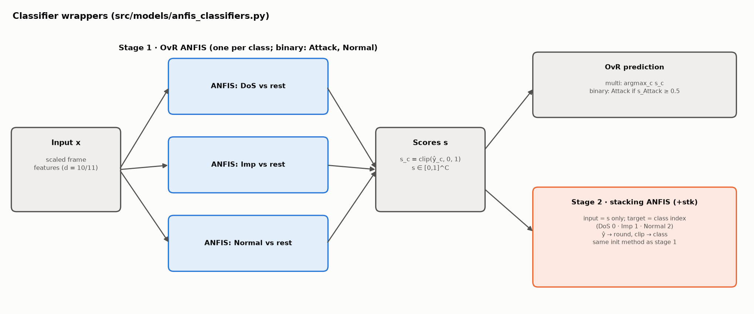
Figure 11. OvR ANFIS (stage 1) and the stacking ANFIS (stage 2).
OvR ANFIS (rows named ANFIS-<init>). One ANFIS per class (3 for multiclass; 2 for binary, Attack and Normal), each regressing the 0/1 indicator of its class with MSE. Outputs are clipped to [0, 1] and used as class scores. Multiclass prediction is the argmax; binary prediction is Attack if the Attack score is ≥ 0.5. Each member gets its own initial FIS, built from the joint space of x and its own 0/1 target.
Stacked ANFIS (rows named ANFIS-<init>+stk), the paper's "augmented ANFIS":
- Stage 1 is the OvR ANFIS above.
- Stage 2 is one more ANFIS whose input is the stage-1 score vector s only (2 or 3 values, not the original features) and whose target is the integer class index (DoS 0, Imp 1, Normal 2; binary Attack 0, Normal 1). Its prediction is rounded and clipped to a valid index. This is our reading of the paper's description. One consequence: Imp (index 1) sits between DoS and Normal, so stage-2 regression errors tend to land on Imp.
- Stage 2 uses the same init method and hyperparameters as stage 1 (10 rules, 20 in the R20 ablation, or SC's own count).
- Stacking mode. paper (default) trains stage 2 on stage 1's in-sample scores on the training set. oof (ablation) trains it on 5-fold out-of-fold scores instead.
- Both rows come from one fit: the OvR row reports stage 1 alone (its training time excludes stage 2); the +stk row reports the full model.
Rule counts: R/K-Means/FCM have 20 (binary) or 30 (multi) rules in stage 1 and 10 more in stage 2. SC totals 43 / 50 rules in stage 1 and 50 / 63 with stacking (A-noID means).

A.4. Non-hybrid baselines
All baselines use the same scaled, SMOTE'd training data. Hyperparameters marked as a grid are chosen by macro-F1 on the validation split, then the model is refit on the full training set.
model | family | implementation | fixed settings | tuned on validation
MLP | pure neural | sklearn MLPClassifier | ReLU, Adam lr 1e-3, ≤ 50 epochs, early stopping (10 % internal hold-out, patience 5) | hidden layers ∈ {(32), (64), (64, 32)}
FCM classifier | pure fuzzy | own (fcm_classifier.py) | m = 2, skfuzzy c-means | clusters k ∈ {10, 20, 30}
LDA | classical | LinearDiscriminantAnalysis | defaults (SVD solver) | –
LR | classical | LogisticRegression | lbfgs, max_iter 2000 | C ∈ {0.1, 1, 10}
Linear SVM | classical | LinearSVC | max_iter 5000 | C ∈ {0.1, 1, 10}
RBF SVM | classical | SVC(kernel="rbf") | gamma = "scale" | C ∈ {1, 10}
Random Forest | classical ensemble | RandomForestClassifier | 200 trees | max_depth ∈ {None, 20}

FCM classifier is the "fuzzy without learning" ingredient of ANFIS:
1. Fuzzy c-means on the training inputs gives k centres and a membership matrix U (k × N).
2. Each cluster gets a class distribution: the membership-weighted class frequencies, D = normalise_rows(U · onehot(y)).
3. A new frame gets memberships u (from cmeans_predict against the fixed centres), class scores u · D, and the argmax class.
It has rules (clusters) but no consequent fitting and no tuning of membership functions. Comparing it with ANFIS-FCM therefore isolates what ANFIS's neural learning adds.
The MLP is the "neural without fuzzy rules" ingredient; comparing it with ANFIS isolates what the fuzzy rule structure adds.

A.5. Evaluation

A.5.1 Per-run metrics
For each run, predictions on the 4,000 test frames give (src/eval/metrics.py):
- accuracy; macro precision, recall and F1 (unweighted mean over classes; macro-F1 is the primary metric because 88 % of frames are Normal);
- per class: precision, recall, F1 and one-vs-rest TPR, TNR, FPR, FNR, plus their macro averages;
- train_time_s (wall clock, fit only), infer_ms_per_1k, n_rules, and the chosen hyperparameters.
Everything goes to results/metrics_long.csv (one row per metric), predictions to results/preds/*.npz, and the seed-0 ANFIS membership functions (initial and trained) to results/anfis_params/*.npz.

A.5.2 Comparisons and significance
- Each table shows mean ± std over the 5 seeds.
- Paired differences. Two models are compared on the same seed (same sample, split and SMOTE), giving 5 paired differences. A difference is called "within noise" when |mean Δ| ≤ std(Δ) or |mean Δ| < 0.0025 (about one Imp test error); otherwise better or worse. The number of seeds won is reported alongside.
- McNemar test (exact binomial) on seed 0: counts the test frames only model A gets right versus only model B gets right.
- The headline hybrid for comparison 1 is fixed in advance (ANFIS-FCM+stk); the best ANFIS by test score is also shown but flagged as post hoc.

A.5.3 Auxiliary experiments
experiment | script | method
data report | scripts/data_report.py | 0x164 traffic before vs after 250 s: rates, χ² on payload patterns, KS on dt (with an attack-free control), rolling counter, per-ID rates
Setting B probe | scripts/probe_B.py | classify 0x164 frames as before/after 250 s with LR, RF and ANFIS-FCM; feature groups payload / timing / all; StratifiedGroupKFold (5 folds, 10 s time blocks as groups), ROC AUC per fold; control = same probe on attack-free data with a fake boundary
rule sweep | scripts/rule_sweep.py | ANFIS-KMeans with R ∈ {5, 10, 20} per member, scored on the validation split only
ablations | run_all.py --tag … | ep5 (5 epochs), oof (out-of-fold stacking), nosmote, R20 (20 rules)

A.6. Testing
tests/ (pytest, 13 tests, ≈ 15 s):
- parser: full line, short DLC, remote frame, trailing ASCII column, absolute timestamps;
- preprocessing: SMOTE touches training data only, the scaler is fitted on training data only, SMOTE k is reduced for tiny classes;
- subtractive clustering: finds the three centres of three synthetic blobs;
- ANFIS: fits sin(x)·cos(y) to RMSE < 0.05, learns XOR, and the least-squares step matches numpy.linalg.lstsq;
- inits: K-Means centres lie in the data range and respect the width floor; FCM and SC return correctly shaped outputs.

A.7. Reproducing
conda env create -f environment.yml && conda activate can-anfis
python -m pytest -q tests
python scripts/run_all.py --setting A A-noID B B-ID --task binary multi --seeds 5
python scripts/run_all.py --setting A A-noID B --task binary multi --models ANFIS-Random ANFIS-KMeans ANFIS-SC ANFIS-FCM --epochs 5 --tag ep5
python scripts/run_all.py --setting A A-noID --task binary multi --models ANFIS-SC ANFIS-FCM ANFIS-KMeans --stack-mode oof --tag oof
python scripts/run_all.py --setting A-noID --task binary multi --no-smote --tag nosmote
python scripts/run_all.py --setting A-noID --task binary multi --models ANFIS-Random ANFIS-KMeans ANFIS-FCM --n-rules 20 --tag R20
python scripts/rule_sweep.py && python scripts/probe_B.py
python -m src.eval.report && python scripts/make_arch_figures.py && python scripts/make_report_docx.py

Runtime on a 20-core CPU + RTX 4060: about 40 min for the main grid and 30 min for all ablations.

