System Architecture and Implementation
EV CAN-bus attack detection with ANFIS: data pipeline, hybrid neuro-fuzzy models, baselines and evaluation

Soft Computing — Alternative Assessment Task (Hybrid Systems)
Sam M Jacob
22 October 2026

This document describes how every part of the study is built: the data pipeline, the shared experimental protocol and each method tested. All hyperparameters live in configs/default.yaml; the values quoted here are the ones used for every reported result.

1. Overview
The system is a single Python package (src/) driven by a few scripts (scripts/). One run, for one setting, task and seed, goes through the same pipeline for every model, so the only thing that differs between two result rows is the model itself.
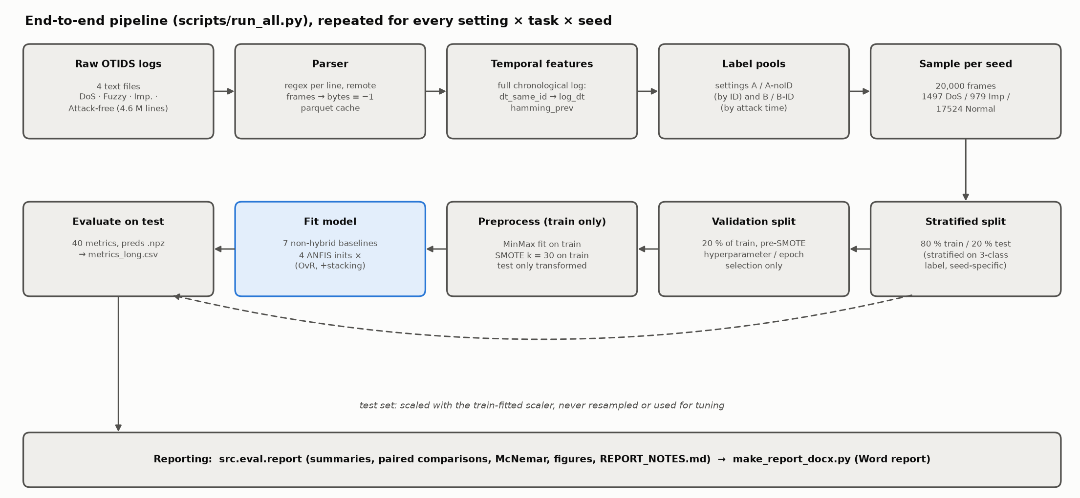
Figure 1. End-to-end pipeline. Every box except "Fit model" is shared by all 15 models.
layer | module | responsibility
data | src/data/parse_otids.py | parse the four OTIDS text logs, cache as parquet
data | src/data/features.py | per-frame temporal features on the full chronological log
data | src/data/build_dataset.py | label pools per setting, 20k sampling, splits, scaling, SMOTE
models | src/models/anfis.py | ANFIS network and hybrid learning (PyTorch)
models | src/models/subclust.py, inits.py | the four initial-FIS generators
models | src/models/anfis_classifiers.py | OvR ANFIS and the stacked (augmented) ANFIS
models | src/models/fcm_classifier.py, baselines.py | non-hybrid baselines
evaluation | src/eval/metrics.py, stats.py | per-run metrics, McNemar test
evaluation | src/eval/report.py, notes.py, plots.py | aggregation, paired comparisons, figures, notes
drivers | scripts/run_all.py | the experiment loop (settings × tasks × seeds × models)
drivers | scripts/data_report.py, probe_B.py, rule_sweep.py | data analysis, Setting B probe, R sweep
drivers | scripts/make_report_docx.py, make_arch_figures.py | Word report and these diagrams

Environment. Python 3.11 (conda env can-anfis, pinned in environment.yml): PyTorch 2.6 (CUDA 12.4), scikit-learn, imbalanced-learn, scikit-fuzzy, numpy/pandas/pyarrow, matplotlib. ANFIS runs on the GPU (RTX 4060) when available; everything else runs on the CPU. Native thread pools are capped (OpenMP, OpenBLAS and MKL at 8 threads, torch at 4, Random Forest n_jobs = 8) because uncapped pools oversubscribed the 20-core CPU and stalled runs.

2. Data pipeline

2.1 Parsing
Each OTIDS line has the form Timestamp: 0.000224 ID: 0329 000 DLC: 8 d7 a7 7f 8c 11 2f 00 10. A single regular expression extracts timestamp, CAN ID (hex), flag, DLC and the data bytes.
- Remote frames (flag 100, DLC 0) carry no data; their bytes are stored as −1.
- Short frames (DLC < 8): missing bytes are −1. Trailing ASCII columns (two Fuzzy-log lines) are ignored.
- Timestamps: the Impersonation log uses absolute UNIX time, the others start at 0, so every log gets t_rel = timestamp − first timestamp.
- All 4.6 M lines parse (0 rejected). Each log is cached to data/processed/<log>.parquet.

2.2 Temporal features
Computed on the full chronological log, before any sampling, so a sampled frame still sees its true predecessor:
- dt_same_id: seconds since the previous frame with the same CAN ID. The first frame of each ID gets that ID's median gap. Used as log_dt = log10(max(dt, 1e-6)), because dt is heavy-tailed and min-max scaling would otherwise squash almost all frames into a tiny range.
- hamming_prev: number of payload bits that changed versus the previous frame of the same ID (used by the Setting B probe only).

2.3 Label pools and settings
Labels are 0 = DoS, 1 = Impersonation, 2 = Normal. The binary task maps DoS and Imp to Attack (0) and Normal to 1.
setting | DoS pool | Imp pool | Normal pool | inputs
A | 0x000 frames, DoS log | all 0x164 frames, imp. log | attack-free log, IDs other than 0x000/0x164 | can_id, dlc, d0–d7
A-noID | as A | as A | as A | dlc, d0–d7, log_dt
B | as A | 0x164 frames with t_rel ≥ 250 s, imp. log | every other imp.-log frame (incl. genuine 0x164 before 250 s) | dlc, d0–d7, log_dt
B-ID | as B | as B | as B | can_id, dlc, d0–d7, log_dt

2.4 Sampling, splitting and preprocessing
1. Sample: per seed, draw without replacement exactly 1,497 DoS, 979 Imp and 17,524 Normal frames (the paper's 20,000-row class totals).
2. Split: stratified 80/20 train/test (16,000 / 4,000), stratified on the 3-class label so the binary and multiclass tasks use the same rows for a given seed.
3. Validation split (tuning only): 20 % of the training rows, carved before SMOTE. It is used to choose baseline hyperparameters and, in the 5-epoch ablation, ANFIS epoch counts. Models are then refit on the full training set.
4. Scaling: MinMaxScaler fitted on the training rows only; validation and test are only transformed.
5. SMOTE (k_neighbors = 30, sampling_strategy = "not majority") on the scaled training rows only. It brings every minority class up to the majority count: multiclass training grows from 16,000 to 42,057 rows (3 × 14,019), binary to 28,038 (2 × 14,019). If a class had ≤ 30 rows, k would be reduced automatically.
The test set is never resampled and never used for any decision.

3. ANFIS (hybrid neuro-fuzzy)

3.1 Network
A first-order Takagi–Sugeno ANFIS, written from scratch in PyTorch (src/models/anfis.py). With d inputs and R rules:
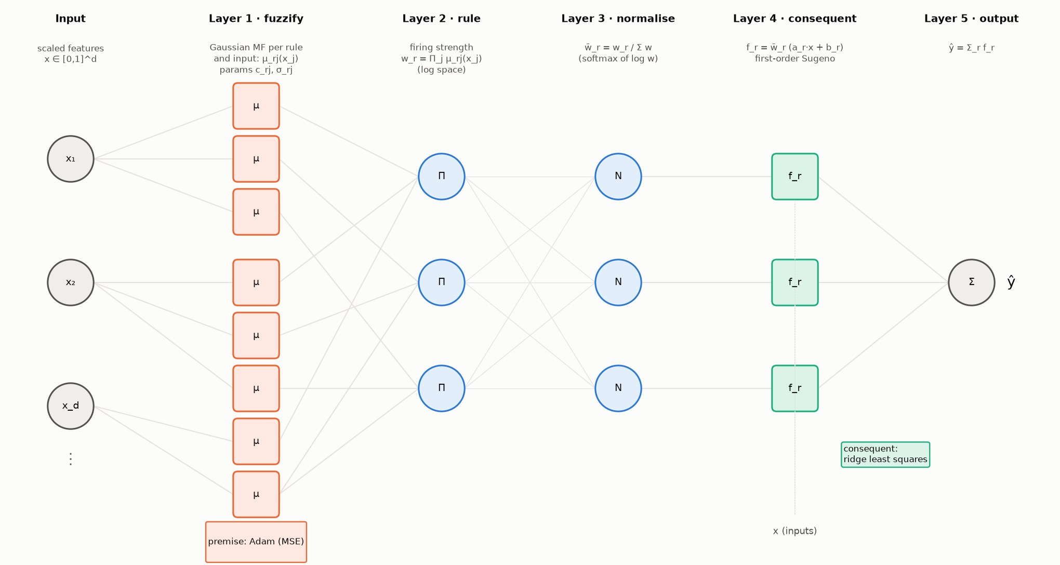
Figure 2. ANFIS as a five-layer network. Orange parameters are learned by gradient descent, green ones by least squares.
layer | operation | parameters
1 · fuzzification | Gaussian MF per rule and input: μ_rj(x_j) = exp(−(x_j − c_rj)² / 2σ_rj²) | centres c (R × d), widths σ (R × d)
2 · rule firing | product t-norm: w_r = Π_j μ_rj(x_j), computed as log w_r = −½ Σ_j ((x_j − c_rj)/σ_rj)² | –
3 · normalisation | w̄_r = w_r / Σ_k w_k, implemented as softmax(log w) | –
4 · consequents | f_r = w̄_r · (a_r · x + b_r) | a (R × d), b (R)
5 · output | ŷ = Σ_r f_r | –

Implementation choices:
- Log-space firing. With 10–11 inputs, the product of Gaussians underflows to 0 far from every centre. Computing log w and normalising with softmax is numerically identical in exact arithmetic but never divides 0 by 0.
- Widths are stored as log σ (keeps them positive under gradient steps) and clamped at σ ≥ 1e-3.
- Parameter count per ANFIS: 2Rd premise + R(d + 1) consequent. For R = 10, d = 10: 200 + 110 = 310.

3.2 Hybrid learning
Jang's hybrid rule, one epoch at a time:
1. Forward pass, least squares. With the premise fixed, the output is linear in the consequents: ŷ = Φθ, where each row of Φ is [w̄_1·x, w̄_1, …, w̄_R·x, w̄_R] (R(d + 1) columns). θ is solved by ridge regression from the normal equations (ΦᵀΦ + λI)θ = Φᵀy, with λ = 1e-6. ΦᵀΦ is accumulated in chunks of 8,192 rows in float64 and solved with torch.linalg.solve.
2. Backward pass, gradient descent. With θ fixed, one pass of Adam (lr 0.01, mini-batch 512, shuffled) on the MSE updates centres and log-widths.
3. After the last epoch, θ is re-solved once so the consequents match the final premise.
hyperparameter | value | source
epochs | 1 (5 in the ablation) | paper
optimiser (premise) | Adam, lr 0.01, batch 512 | ours (MATLAB's anfis uses gradient descent with an adaptive step)
ridge λ | 1e-6 | ours (numerical stability only)
σ floor | 1e-3 (network), 1e-2 (initial widths) | ours
loss | MSE against the 0/1 target (OvR) or the class index (stage 2) | standard ANFIS

5-epoch ablation. For each OvR member, training runs up to 5 epochs on the validation-split data with early stopping on validation MSE (patience 2). The epoch with the lowest validation MSE is kept, and the member is refit on the full training set for that many epochs.

3.3 Initial FIS: the four initialisation methods
All four produce initial centres (R × d) and widths (R × d) through one interface (src/models/inits.py). Like MATLAB's genfis2/genfis3, the three clustering methods cluster the joint space [x, target] and then drop the target coordinate, so clusters respect class structure. The Random control uses x only.
init | centres | widths | rules per member | role
Random | R training points drawn uniformly at random | global per-feature std of the training data | 10 (fixed) | control: no clustering
K-Means | K-Means centroids (n_init 10) | per-cluster per-feature std (global std if < 2 points) | 10 (fixed) | hard clustering
SC | subtractive-clustering centres | r_a × span / √8 per feature, same for all rules | data-driven (3–25 observed) | paper's method 1
FCM | fuzzy c-means centres (m = 2) | √(Σ u^m (x − c)² / Σ u^m) per cluster and feature | 10 (fixed) | paper's method 2, fuzzy clustering

All widths are floored at 1e-2 so no MF starts as a spike.
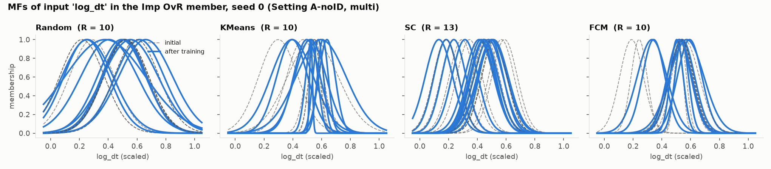
Figure 3. Membership functions on the log_dt input of the Imp OvR member (A-noID, multiclass, seed 0): initial (dashed) vs after hybrid training (solid). Random starts with identical wide widths (global std); K-Means and FCM start with narrower, data-driven MFs concentrated where the data lie; SC chooses its own rule count (13 here) with one shared initial width, and training moves several of its rules apart.
Subtractive clustering (src/models/subclust.py) follows Chiu (1994) and MATLAB's subclust:
1. Normalise data to the unit hypercube using the training-set bounds.
2. Potential of each point: P_i = Σ_j exp(−4‖z_i − z_j‖² / r_a²).
3. Repeatedly take the highest-potential point as a candidate centre. Accept it if P ≥ 0.5 × P_first; reject and stop if P ≤ 0.15 × P_first; in between (grey zone) accept only if d_min / r_a + P / P_first ≥ 1, where d_min is the distance to the nearest existing centre.
4. After accepting a centre, subtract its influence: P_i ← P_i − P_k · exp(−4‖z_i − z_k‖² / r_b²) with r_b = squash × r_a.
Settings: radius r_a = 0.20 (binary) / 0.25 (multiclass) and squash factor 0.20 / 0.25, as in the paper. MATLAB's default squash of 1.25 collapsed to 2 rules per member and lost accuracy, so the paper's values were kept. SC needs the full N × N distance matrix, so it runs on a class-stratified subsample of at most 5,000 training points, with bounds taken from the full training set.
FCM uses skfuzzy.cluster.cmeans with c = 10, m = 2, at most 100 iterations, tolerance 1e-5. It is the slowest init (4–6× K-Means) because it iterates over the full SMOTE'd training set (28–42 k rows).

3.4 Classifier wrappers: OvR and stacking
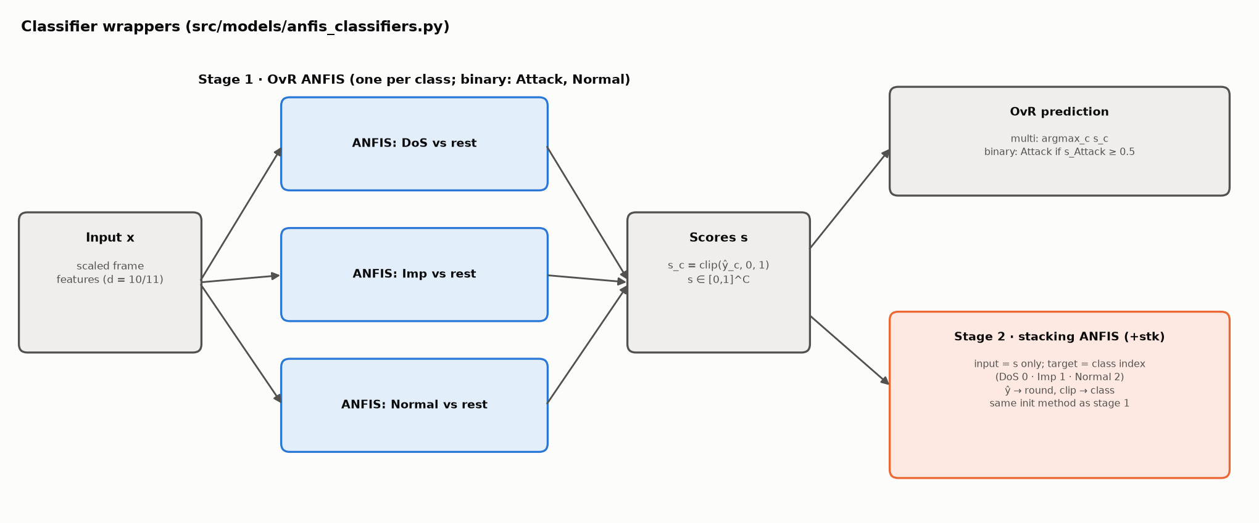
Figure 4. OvR ANFIS (stage 1) and the stacking ANFIS (stage 2).
OvR ANFIS (rows named ANFIS-<init>). One ANFIS per class (3 for multiclass; 2 for binary, Attack and Normal), each regressing the 0/1 indicator of its class with MSE. Outputs are clipped to [0, 1] and used as class scores. Multiclass prediction is the argmax; binary prediction is Attack if the Attack score is ≥ 0.5. Each member gets its own initial FIS, built from the joint space of x and its own 0/1 target.
Stacked ANFIS (rows named ANFIS-<init>+stk), the paper's "augmented ANFIS":
- Stage 1 is the OvR ANFIS above.
- Stage 2 is one more ANFIS whose input is the stage-1 score vector s only (2 or 3 values, not the original features) and whose target is the integer class index (DoS 0, Imp 1, Normal 2; binary Attack 0, Normal 1). Its prediction is rounded and clipped to a valid index. This is our reading of the paper's description. One consequence: Imp (index 1) sits between DoS and Normal, so stage-2 regression errors tend to land on Imp.
- Stage 2 uses the same init method and hyperparameters as stage 1 (10 rules, 20 in the R20 ablation, or SC's own count).
- Stacking mode. paper (default) trains stage 2 on stage 1's in-sample scores on the training set. oof (ablation) trains it on 5-fold out-of-fold scores instead.
- Both rows come from one fit: the OvR row reports stage 1 alone (its training time excludes stage 2); the +stk row reports the full model.
Rule counts: R/K-Means/FCM have 20 (binary) or 30 (multi) rules in stage 1 and 10 more in stage 2. SC totals 43 / 50 rules in stage 1 and 50 / 63 with stacking (A-noID means).

4. Non-hybrid baselines
All baselines use the same scaled, SMOTE'd training data. Hyperparameters marked as a grid are chosen by macro-F1 on the validation split, then the model is refit on the full training set.
model | family | implementation | fixed settings | tuned on validation
MLP | pure neural | sklearn MLPClassifier | ReLU, Adam lr 1e-3, ≤ 50 epochs, early stopping (10 % internal hold-out, patience 5) | hidden layers ∈ {(32), (64), (64, 32)}
FCM classifier | pure fuzzy | own (fcm_classifier.py) | m = 2, skfuzzy c-means | clusters k ∈ {10, 20, 30}
LDA | classical | LinearDiscriminantAnalysis | defaults (SVD solver) | –
LR | classical | LogisticRegression | lbfgs, max_iter 2000 | C ∈ {0.1, 1, 10}
Linear SVM | classical | LinearSVC | max_iter 5000 | C ∈ {0.1, 1, 10}
RBF SVM | classical | SVC(kernel="rbf") | gamma = "scale" | C ∈ {1, 10}
Random Forest | classical ensemble | RandomForestClassifier | 200 trees | max_depth ∈ {None, 20}

FCM classifier is the "fuzzy without learning" ingredient of ANFIS:
1. Fuzzy c-means on the training inputs gives k centres and a membership matrix U (k × N).
2. Each cluster gets a class distribution: the membership-weighted class frequencies, D = normalise_rows(U · onehot(y)).
3. A new frame gets memberships u (from cmeans_predict against the fixed centres), class scores u · D, and the argmax class.
It has rules (clusters) but no consequent fitting and no tuning of membership functions. Comparing it with ANFIS-FCM therefore isolates what ANFIS's neural learning adds.
The MLP is the "neural without fuzzy rules" ingredient; comparing it with ANFIS isolates what the fuzzy rule structure adds.

5. Evaluation

5.1 Per-run metrics
For each run, predictions on the 4,000 test frames give (src/eval/metrics.py):
- accuracy; macro precision, recall and F1 (unweighted mean over classes; macro-F1 is the primary metric because 88 % of frames are Normal);
- per class: precision, recall, F1 and one-vs-rest TPR, TNR, FPR, FNR, plus their macro averages;
- train_time_s (wall clock, fit only), infer_ms_per_1k, n_rules, and the chosen hyperparameters.
Everything goes to results/metrics_long.csv (one row per metric), predictions to results/preds/*.npz, and the seed-0 ANFIS membership functions (initial and trained) to results/anfis_params/*.npz.

5.2 Comparisons and significance
- Each table shows mean ± std over the 5 seeds.
- Paired differences. Two models are compared on the same seed (same sample, split and SMOTE), giving 5 paired differences. A difference is called "within noise" when |mean Δ| ≤ std(Δ) or |mean Δ| < 0.0025 (about one Imp test error); otherwise better or worse. The number of seeds won is reported alongside.
- McNemar test (exact binomial) on seed 0: counts the test frames only model A gets right versus only model B gets right.
- The headline hybrid for comparison 1 is fixed in advance (ANFIS-FCM+stk); the best ANFIS by test score is also shown but flagged as post hoc.

5.3 Auxiliary experiments
experiment | script | method
data report | scripts/data_report.py | 0x164 traffic before vs after 250 s: rates, χ² on payload patterns, KS on dt (with an attack-free control), rolling counter, per-ID rates
Setting B probe | scripts/probe_B.py | classify 0x164 frames as before/after 250 s with LR, RF and ANFIS-FCM; feature groups payload / timing / all; StratifiedGroupKFold (5 folds, 10 s time blocks as groups), ROC AUC per fold; control = same probe on attack-free data with a fake boundary
rule sweep | scripts/rule_sweep.py | ANFIS-KMeans with R ∈ {5, 10, 20} per member, scored on the validation split only
ablations | run_all.py --tag … | ep5 (5 epochs), oof (out-of-fold stacking), nosmote, R20 (20 rules)

6. Testing
tests/ (pytest, 13 tests, ≈ 15 s):
- parser: full line, short DLC, remote frame, trailing ASCII column, absolute timestamps;
- preprocessing: SMOTE touches training data only, the scaler is fitted on training data only, SMOTE k is reduced for tiny classes;
- subtractive clustering: finds the three centres of three synthetic blobs;
- ANFIS: fits sin(x)·cos(y) to RMSE < 0.05, learns XOR, and the least-squares step matches numpy.linalg.lstsq;
- inits: K-Means centres lie in the data range and respect the width floor; FCM and SC return correctly shaped outputs.

7. Reproducing
conda env create -f environment.yml && conda activate can-anfis
python -m pytest -q tests
python scripts/run_all.py --setting A A-noID B B-ID --task binary multi --seeds 5
python scripts/run_all.py --setting A A-noID B --task binary multi --models ANFIS-Random ANFIS-KMeans ANFIS-SC ANFIS-FCM --epochs 5 --tag ep5
python scripts/run_all.py --setting A A-noID --task binary multi --models ANFIS-SC ANFIS-FCM ANFIS-KMeans --stack-mode oof --tag oof
python scripts/run_all.py --setting A-noID --task binary multi --no-smote --tag nosmote
python scripts/run_all.py --setting A-noID --task binary multi --models ANFIS-Random ANFIS-KMeans ANFIS-FCM --n-rules 20 --tag R20
python scripts/rule_sweep.py && python scripts/probe_B.py
python -m src.eval.report && python scripts/make_arch_figures.py && python scripts/make_report_docx.py

Runtime on a 20-core CPU + RTX 4060: about 40 min for the main grid and 30 min for all ablations.

