Everything in one file
Text 1
Scope 1
Detail 2
A heading in a custom style 2
A heading named in German 2
o Control room workstations 2
o Programmable controllers 2
▪ Works one 2
(1) Filter hall 2
o Historian server 2
Pictures 2
Drawings 3
Wide register 6
Summary 7

Text
Northfield Water runs three treatment works from one control room and two pumping stations by radio.
Formatting in one sentence: bold, italic, underlined, struck out, H₂O, m², bold and italic and the command show running-config.

Scope
The method follows the guidance on the example guidance site and is described in the scope section.

Detail

A heading in a custom style

A heading named in German
  - Control room workstations
  - Programmable controllers
    - Works one
      - Filter hall
  - Historian server
Then, in order.
- Survey the control network
- Agree the zone model
  - Confirm each conduit with operations
- Plan the outage with the duty manager
Zone | Assets | Notes
Control | Controllers and panels | Same firewall policy
Supervisory | Historian | Same firewall policy
Remote sites reached by radio
Table 1: Zones and what they hold

Pictures

Figure 1: Zone A
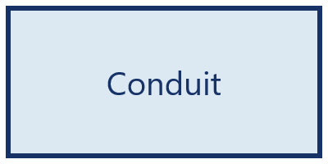
A picture floats beside this paragraph, with the text wrapped square around it. The words carry on for long enough to give the wrap something to do.

Drawings
Two shapes with words in them are anchored to this paragraph.
Operator panel
Controller
A drawing canvas holding three grouped shapes is anchored to this paragraph.
Switch
Firewall
A text box is anchored to this paragraph.
A text box that says the outage window is four hours

$$a^{2}+b^{2}=c^{2}$$

This passage is set in two columns, as a newsletter might be. Operators at each works log in with their own account and the shared account has been removed.
Engineers reach the controllers through the gateway and nowhere else. Each session is recorded and kept for ninety days.

Wide register
This section is on a landscape page.
Asset | Zone | Owner | Firmware | Last patched | Comment
Controller 4 | Control | Operations | 2.8 | March 2025 | Due this year

Summary
Everything above should arrive in the template.

The control room was rebuilt in 2019.
The radio links are licensed and are outside this review.

