VISVESVARAYA TECHNOLOGICAL UNIVERSITY
“JnanaSangama”, Belgaum -590014, Karnataka.

LAB REPORT
on
Artificial Intelligence (23CS5PCAIN)
Submitted by
Sam Manu Jacob (1BM23CS291)
in partial fulfillment for the award of the degree of
BACHELOR OF ENGINEERING
in
COMPUTER SCIENCE AND ENGINEERING

B.M.S. COLLEGE OF ENGINEERING
(Autonomous Institution under VTU)
BENGALURU-560019
Aug 2025 to Dec 2025

B.M.S. College of Engineering,
Bull Temple Road, Bangalore 560019
(Affiliated To Visvesvaraya Technological University, Belgaum)
Department of Computer Science and Engineering

CERTIFICATE
This is to certify that the Lab work entitled “Artificial Intelligence (23CS5PCAIN)” carried out by StudentName (1BM23CS000), who is bonafide student of B.M.S. College of Engineering. It is in partial fulfillment for the award of Bachelor of Engineering in Computer Science and Engineering of the Visvesvaraya Technological University, Belgaum. The Lab report has been approved as it satisfies the academic requirements in respect of an Artificial Intelligence (23CS5PCAIN) work prescribed for the said degree.

Lab faculty Incharge Name  Assistant Professor  Department of CSE, BMSCE | Dr. Kavitha Sooda  Professor & HOD  Department of CSE, BMSCE

Index
Sl.  No. | Date | Experiment Title | Page No.
1 | 30-9-2024 | Implement Tic –Tac –Toe Game  Implement vacuum cleaner agent
2 | 7-10-2024 | Implement 8 puzzle problems using Depth First Search (DFS)  Implement Iterative deepening search algorithm
3 | 14-10-2024 | Implement A* search algorithm
4 | 21-10-2024 | Implement Hill Climbing search algorithm to solve N-Queens problem
5 | 28-10-2024 | Simulated Annealing to Solve 8-Queens problem
6 | 11-11-2024 | Create a knowledge base using propositional logic and show that the given query entails the knowledge base or not.
7 | 2-12-2024 | Implement unification in first order logic
8 | 2-12-2024 | Create a knowledge base consisting of first order logic statements and prove the given query using forward reasoning.
9 | 16-12-2024 | Create a knowledge base consisting of first order logic statements and prove the given query using Resolution
10 | 16-12-2024 | Implement Alpha-Beta Pruning.

Github Link:

Program 1
Implement Tic –Tac –Toe Game
Implement vacuum cleaner agent

Algorithm:
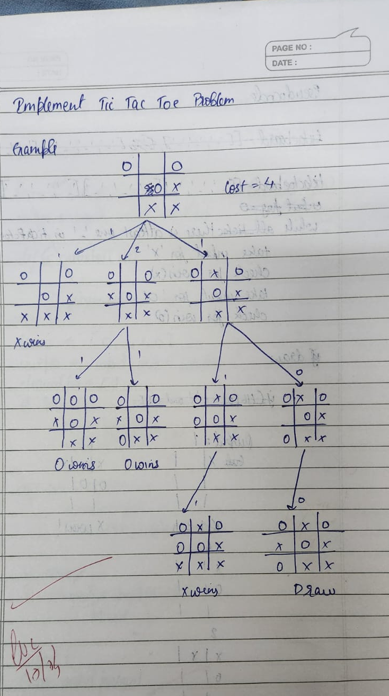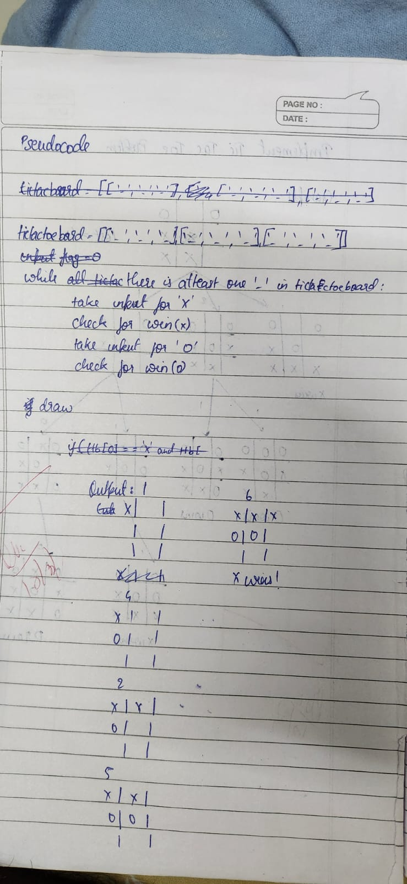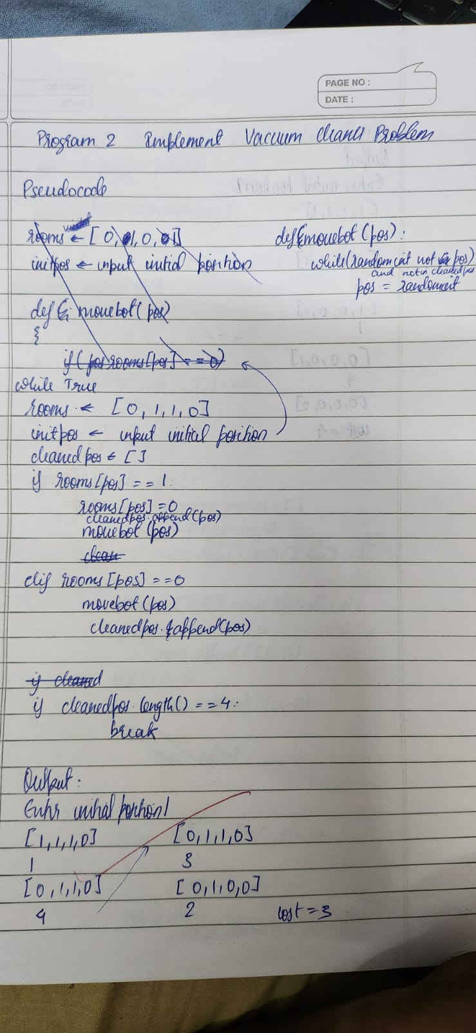
Code:
def print_board(board):
print("\n")
for i in range(3):
print(" | ".join(board[i*3:(i+1)*3]))
if i < 2:
print("-" * 10)
print("\n")

def check_winner(board, player):
win_conditions = [
[0, 1, 2], [3, 4, 5], [6, 7, 8],
[0, 3, 6], [1, 4, 7], [2, 5, 8],
[0, 4, 8], [2, 4, 6]
]
for combo in win_conditions:
count=0
for pos in combo:
if board[pos]==player:
count+=1
if count==3:
return True
return False

board = [" "] * 9
current_player = "X"
print_board(board)

while True:
while True:
pos = int(input(f"Player {current_player}, enter your move (1-9): ")) - 1
if 0 <= pos <= 8 and board[pos] == " ":
board[pos] = current_player
break
else:
print("Invalid move. Try again.")

print_board(board)

if check_winner(board, current_player):
print(f"Player {current_player} wins!")
break
if " " not in board:
print("It's a draw!")
break

# Switch players
current_player = "O" if current_player == "X" else "X"

Vacuum Cleaner:

import random
rooms=[1,1,1,1]
botpos =(int(input("Enter Initial Position"))-1)
cleanedpos=[]
cost=0

def movebot(pos):

while True:
n= random.randint(0,3)
if n != pos and n not in cleanedpos:
pos = n
break
return pos

while True:
print(str(rooms))
print(botpos+1)

if rooms[botpos]==1:

rooms[botpos]=0
cleanedpos.append(botpos)
cost+=1
if len(cleanedpos) == 4:
break
botpos=movebot(botpos)

elif rooms[botpos]==0:
cleanedpos.append(botpos)
if len(cleanedpos) == 4:
break
botpos = movebot(botpos)

print("cost="+str(cost))

Program 2
Implement 8 puzzle problems using Depth First Search (DFS)
Implement Iterative deepening search algorithm

Algorithm:
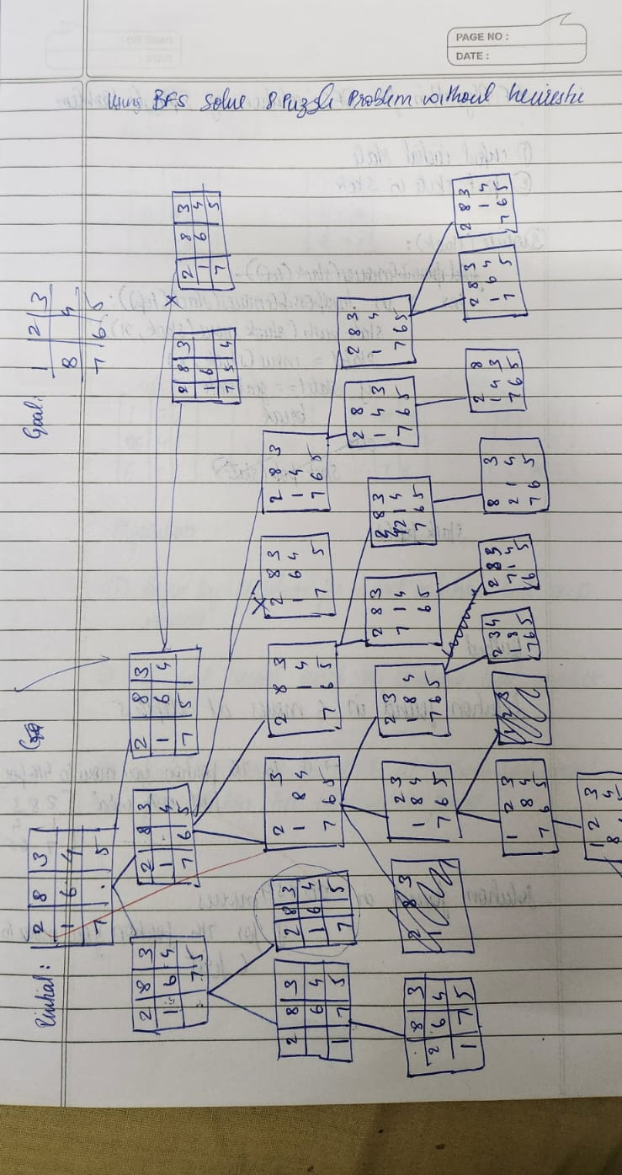
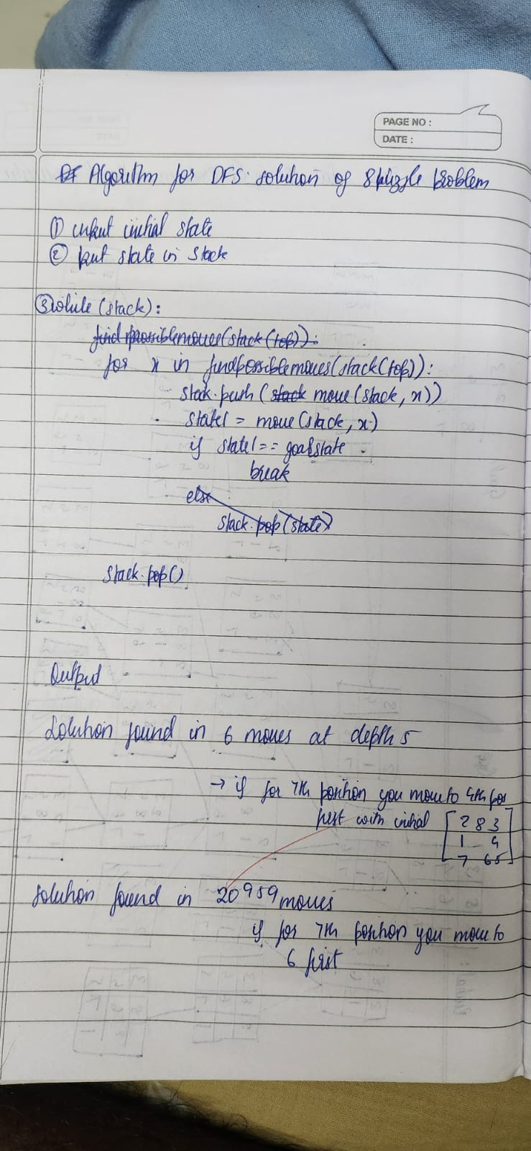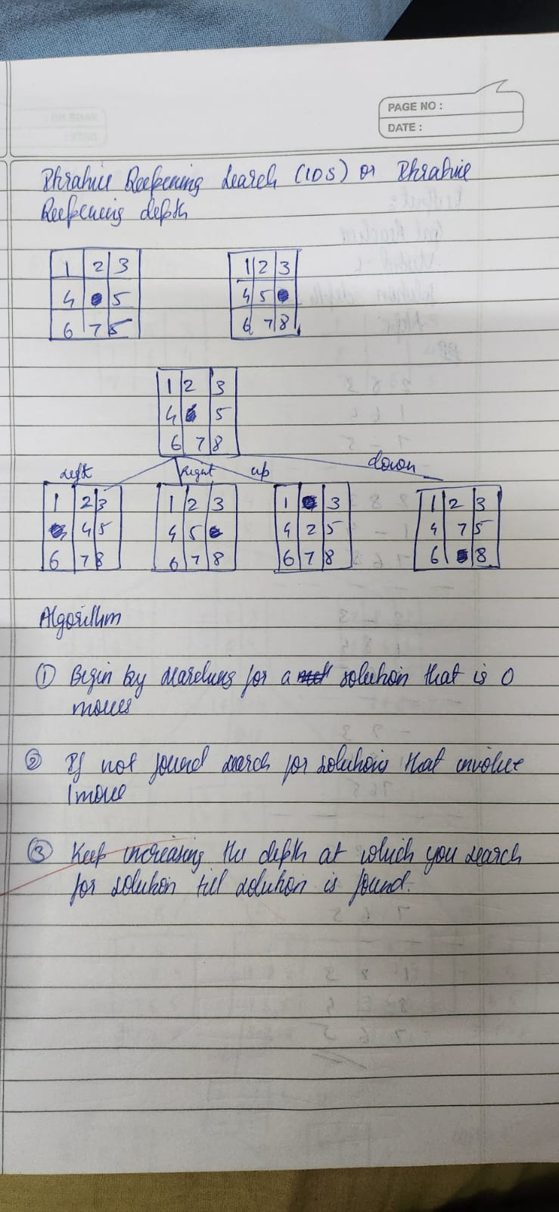
Code:
print("solution by Sam Manu Jacob- 1BM23CS291")
def find_possible_moves(state):
index = state.index('_')
moves = {
0: [1, 3],
1: [0, 2, 4],
2: [1, 5],
3: [0, 4, 6],
4: [1, 3, 5, 7],
5: [2, 4, 8],
6: [3, 7],
7: [6, 8, 4],
8: [5, 7],
}
return moves.get(index, [])

def dfs(initial_state, goal_state, max_depth=50):
stack = [(initial_state, [], 0)]
visited = {tuple(initial_state)}
states_explored = 0
printed_depths = set()

while stack:
current_state, path, depth = stack.pop()

if depth > max_depth:
continue

if depth not in printed_depths:
print(f"\n--- Depth {depth} ---")
printed_depths.add(depth)

states_explored += 1
print(f"State #{states_explored}: {current_state}")

if current_state == goal_state:
print(f"\n Goal reached at depth {depth} after exploring {states_explored} states.\n")
return path

possible_moves_indices = find_possible_moves(current_state)

for move_index in reversed(possible_moves_indices): # Reverse for DFS order
next_state = list(current_state)
blank_index = next_state.index('_')
next_state[blank_index], next_state[move_index] = next_state[move_index], next_state[blank_index]

if tuple(next_state) not in visited:
visited.add(tuple(next_state))
stack.append((next_state, path + [next_state], depth + 1))

print(f"\n Goal state not reachable within depth {max_depth}. Explored {states_explored} states.\n")
return None

initial_state = [2, 8, 3, 1, 6, 4, 7, '_', 5]
goal_state = [1, 2, 3, 8, '_', 4, 7, 6, 5]

solution_path = dfs(initial_state, goal_state, max_depth=50)

if solution_path is None:
print("No solution found.")
else:
print("Solution path:")
for step, state in enumerate(solution_path, start=1):
print(f"Step {step}: {state}")
Iterative Deepening:
import copy
print("Solution by Sam")
goal = [[1, 2, 3],
[8, 0, 4],
[7, 6, 5]]

moves = [(-1, 0), (1, 0), (0, -1), (0, 1)]

def find_blank(state):
for i in range(3):
for j in range(3):
if state[i][j] == 0:
return i, j

def is_goal(state):
return state == goal

def get_neighbors(state):
neighbors = []
x, y = find_blank(state)
for dx, dy in moves:
nx, ny = x + dx, y + dy
if 0 <= nx < 3 and 0 <= ny < 3:
new_state = copy.deepcopy(state)
new_state[x][y], new_state[nx][ny] = new_state[nx][ny], new_state[x][y]
neighbors.append(new_state)
return neighbors

def state_to_tuple(state):
return tuple(tuple(row) for row in state)

def print_state(state):
for row in state:
print(" ".join(str(num) if num != 0 else "_" for num in row))
print("----------")

def dfs_limited(state, path, depth, limit, visited, current_depth):
if depth == limit:

return None

if is_goal(state):
return path + [state]

visited.add(state_to_tuple(state))

for neighbor in get_neighbors(state):
key = state_to_tuple(neighbor)
if key not in visited:
result = dfs_limited(neighbor, path + [state], depth + 1, limit, visited, current_depth)
if result:
return result
return None

def iddfs(start_state, max_depth=50):
for limit in range(max_depth + 1):

visited = set()
path = dfs_limited(start_state, [], 0, limit, visited, 0)
if path:
print("Goal reached!")
print("Visited:", len(visited))
print("Solution depth:", len(path) - 1)
print("Steps:")
for step in path:
print_state(step)
return
print("No solution found within depth limit.")

# Example usage
start_state = [[2, 8, 3],
[1, 6, 4],
[7, 0, 5]]

iddfs(start_state, max_depth=20)

Program 3
Implement A* search algorithm

Algorithm:
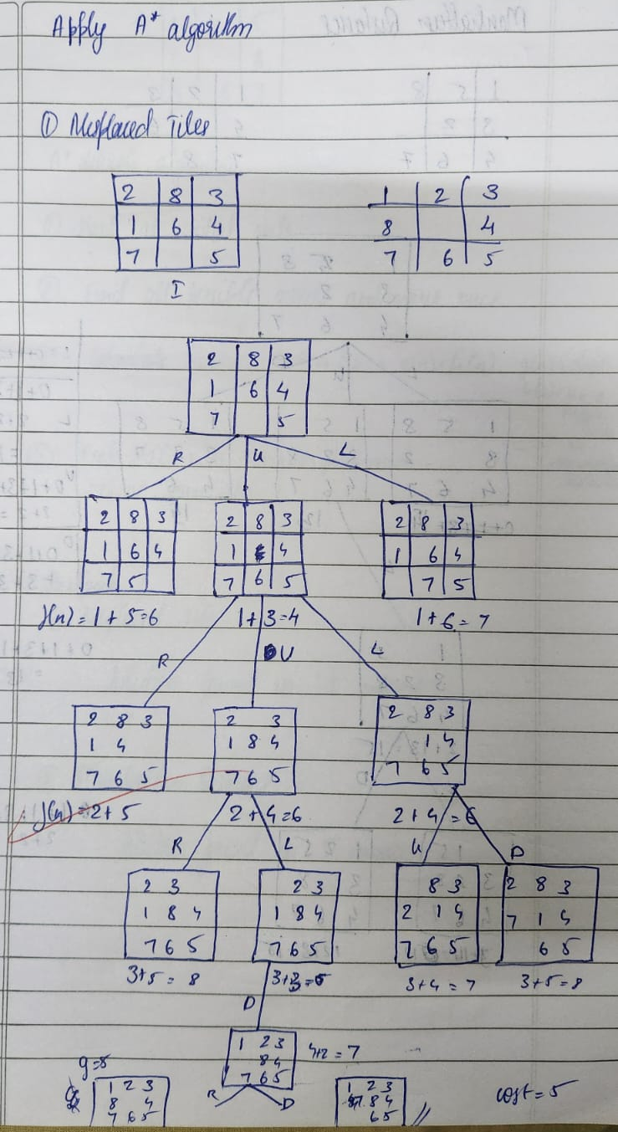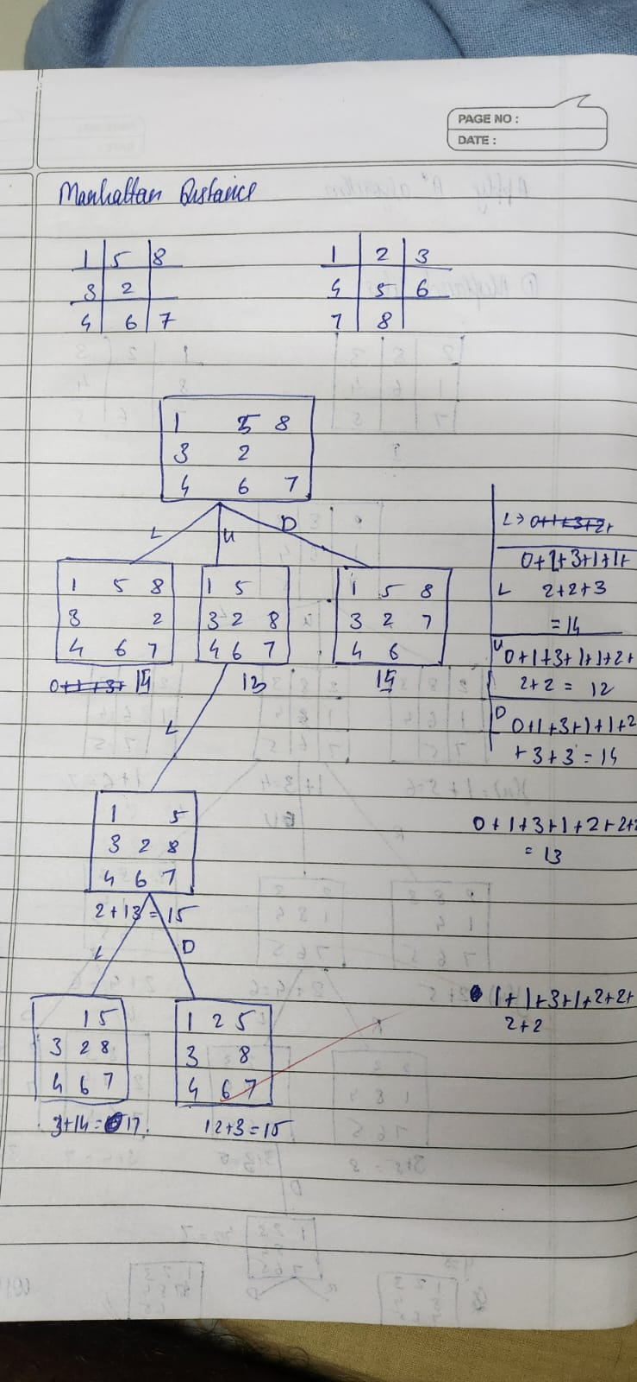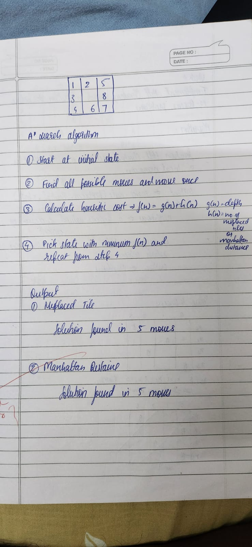

Code:

import heapq
print("Solution by Sam")
GOAL_STATE = (
(1, 2, 3),
(8, 0, 4),
(7, 6, 5)
)

def heuristic(state):
misplaced = 0
for i in range(3):
for j in range(3):
if state[i][j] != 0 and state[i][j] != GOAL_STATE[i][j]:
misplaced += 1
return misplaced

def get_neighbors(state):
neighbors = []
x = y = -1
for i in range(3):
for j in range(3):
if state[i][j] == 0:
x, y = i, j
break
if x != -1:
break

directions = [(-1, 0), (1, 0), (0, -1), (0, 1)]

for dx, dy in directions:
nx, ny = x + dx, y + dy
if 0 <= nx < 3 and 0 <= ny < 3:
new_state = [list(row) for row in state]
new_state[x][y], new_state[nx][ny] = new_state[nx][ny], new_state[x][y]
neighbors.append(tuple(tuple(row) for row in new_state))

return neighbors

def reconstruct_path(came_from, current):
path = [current]
while current in came_from:
current = came_from[current]
path.append(current)
path.reverse()
return path

def print_state(state):
for row in state:
print(" ".join(str(x) if x != 0 else " " for x in row))
print()

def a_star(start_state):
start_state = tuple(tuple(row) for row in start_state)
open_set = []
heapq.heappush(open_set, (heuristic(start_state), 0, start_state))
came_from = {}
g_score = {start_state: 0}
visited = set()

while open_set:
f_current, current_g, current = heapq.heappop(open_set)

print(f"Visited depth (g): {current_g}, f(n): {f_current}")
print_state(current)

if current == GOAL_STATE:
return reconstruct_path(came_from, current)

visited.add(current)

for neighbor in get_neighbors(current):
if neighbor in visited:
continue

tentative_g = current_g + 1

if neighbor not in g_score or tentative_g < g_score[neighbor]:
came_from[neighbor] = current
g_score[neighbor] = tentative_g
f_score = tentative_g + heuristic(neighbor)
heapq.heappush(open_set, (f_score, tentative_g, neighbor))

return None

start_state = [
[2, 8, 3],
[1, 6, 4],
[7, 0, 5]
]

path = a_star(start_state)

if path:
print(f"Solution found in {len(path) - 1} moves:\n")
for step in path:
print_state(step)
else:
print("No solution found.")

Program 4

Implement Hill Climbing search algorithm to solve N-Queens problem

Algorithm:
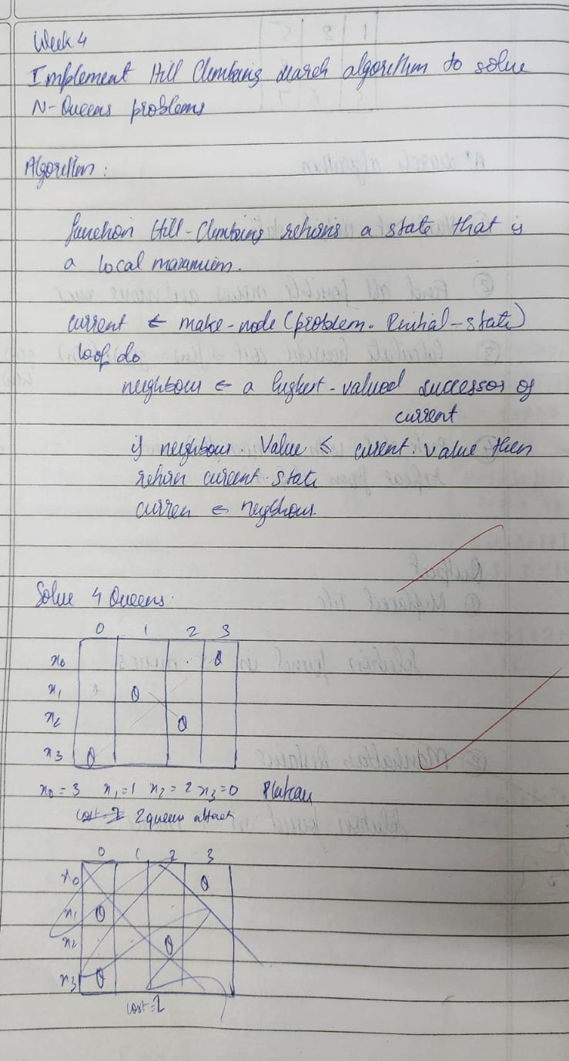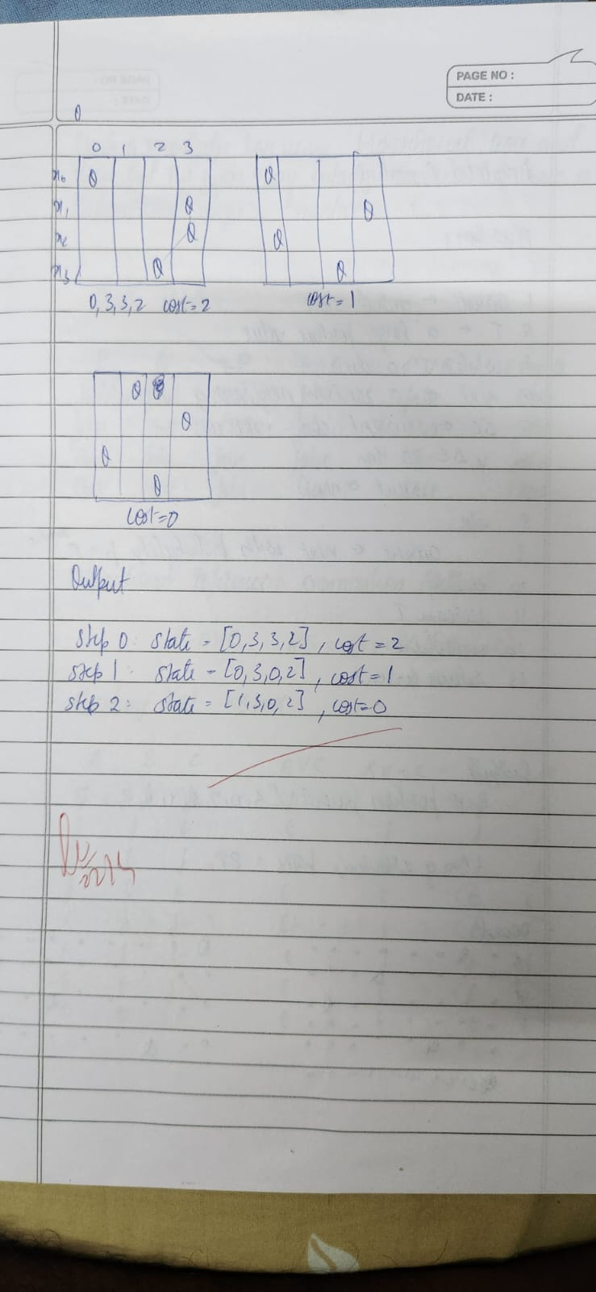
Code:

import random
import math

def compute_cost(state):
"""Count diagonal conflicts for a permutation-state (one queen per row & column)."""
conflicts = 0
n = len(state)
for i in range(n):
for j in range(i + 1, n):
if abs(state[i] - state[j]) == abs(i - j):
conflicts += 1
return conflicts

def random_permutation(n):
arr = list(range(n))
random.shuffle(arr)
return arr

def neighbors_by_swaps(state):
"""All neighbors obtained by swapping two columns (keeps permutation property)."""
n = len(state)
for i in range(n - 1):
for j in range(i + 1, n):
nb = state.copy()
nb[i], nb[j] = nb[j], nb[i]
yield nb

def hill_climb_with_restarts(n, max_restarts=None):
"""Hill climbing on permutations with random restart on plateau (no revisits)."""
visited = set()
total_states = math.factorial(n)
restarts = 0

while True:
# pick a random unvisited start permutation
if len(visited) >= total_states:
raise RuntimeError("All states visited — giving up (no solution found).")

state = random_permutation(n)
while tuple(state) in visited:
state = random_permutation(n)
visited.add(tuple(state))

# climb from this start
while True:
cost = compute_cost(state)
if cost == 0:
return state, restarts

# find best neighbor (swap-based neighbors)
best_neighbor = None
best_cost = float("inf")
for nb in neighbors_by_swaps(state):
c = compute_cost(nb)
if c < best_cost:
best_cost = c
best_neighbor = nb

# if strictly better, move; otherwise it's a plateau/local optimum -> restart
if best_cost < cost:
state = best_neighbor
visited.add(tuple(state))
else:
# plateau or local optimum -> restart
restarts += 1
if max_restarts is not None and restarts >= max_restarts:
raise RuntimeError(f"Stopped after {restarts} restarts (no solution found).")
break # go pick a new unvisited start

def format_board(state):
n = len(state)
lines = []
for r in range(n):
lines.append(" ".join("Q" if state[c] == r else "-" for c in range(n)))
return "\n".join(lines)

if __name__ == "__main__":
n = 4
print("Solution By Sam Manu Jacob - 1BM23CS291")
solution, restarts = hill_climb_with_restarts(n)
print("Found solution:", solution)
print(format_board(solution))

Program 5
Simulated Annealing to Solve 8-Queens problem
Algorithm:
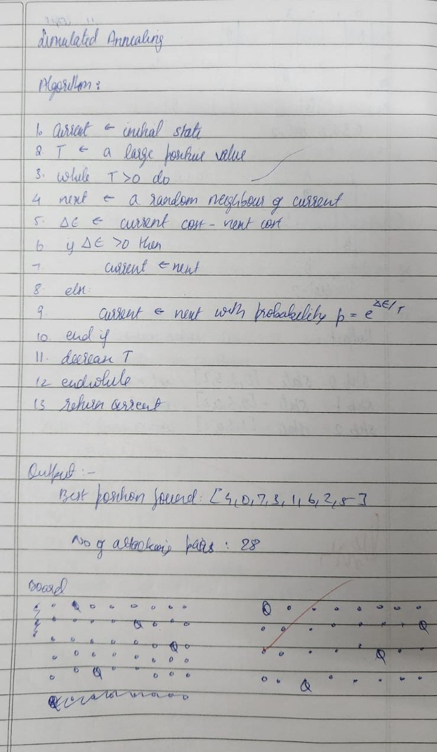
Code:

import random
import math

def cost(state):

attacks = 0
n = len(state)
for i in range(n):
for j in range(i + 1, n):
if state[i] == state[j] or abs(state[i] - state[j]) == abs(i - j):
attacks += 1
return attacks

def get_neighbor(state):

neighbor = state[:]
i, j = random.sample(range(len(state)), 2)
neighbor[i], neighbor[j] = neighbor[j], neighbor[i]
return neighbor

def simulated_annealing(n=8, max_iter=10000, temp=100.0, cooling=0.95):

current = list(range(n))
random.shuffle(current)
current_cost = cost(current)

temperature = temp
cooling_rate = cooling

best = current[:]
best_cost = current_cost

for _ in range(max_iter):
if temperature <= 0 or best_cost == 0:
break

neighbor = get_neighbor(current)
neighbor_cost = cost(neighbor)
delta = current_cost - neighbor_cost

if delta > 0 or random.random() < math.exp(delta / temperature):
current, current_cost = neighbor, neighbor_cost
if neighbor_cost < best_cost:
best, best_cost = neighbor[:], neighbor_cost

temperature *= cooling_rate

return best, best_cost

def print_board(state):

n = len(state)
for row in range(n):
line = " ".join("Q" if state[col] == row else "." for col in range(n))
print(line)
print()

n = 8
solution, cost_val = simulated_annealing(n, max_iter=20000)
print("Solution by Sam Manu Jacob")
print("Best position found:", solution)
print(f"Number of non-attacking pairs: {n*(n-1)//2 - cost_val}")
print("\nBoard:")
print_board(solution)

Program 6
Create a knowledge base using propositional logic and show that the given query entails the knowledge base or not.

Algorithm:
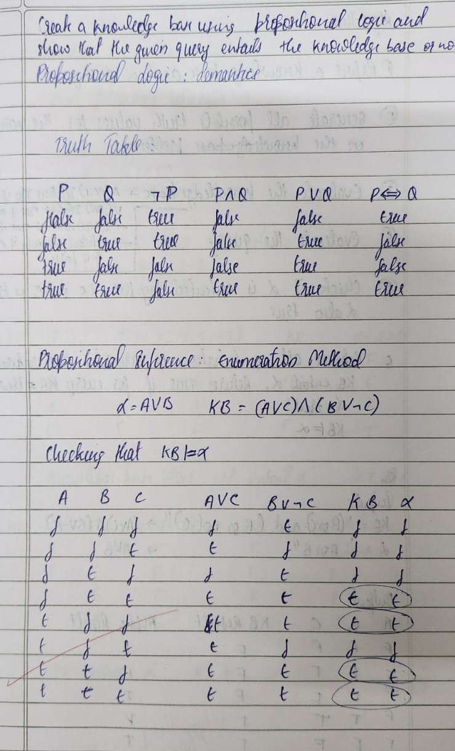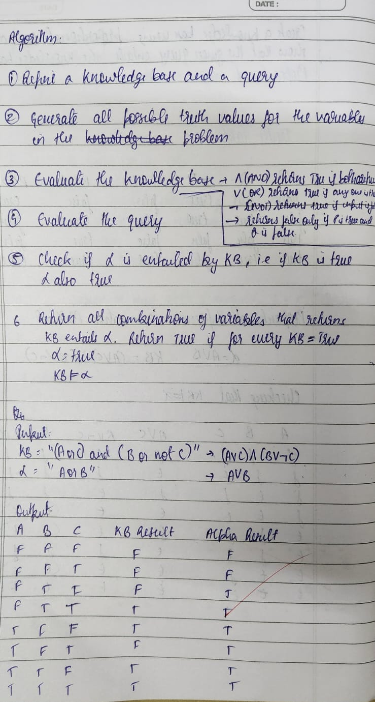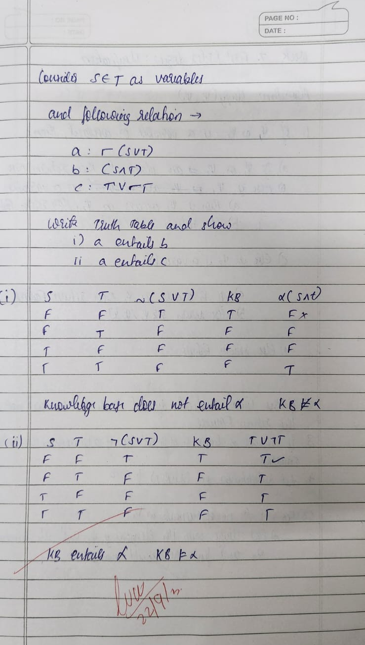
Code:

import itertools
print("Solution By Sam Manu Jacob - 1BM23CS291")
def evaluate_formula(formula, truth_assignment):
eval_formula = formula
for symbol, value in truth_assignment.items():
eval_formula = eval_formula.replace(symbol, str(value))
return eval(eval_formula)

def generate_truth_table(variables):
return list(itertools.product([False, True], repeat=len(variables)))

def is_entailed(KB_formula, alpha_formula, variables):
truth_combinations = generate_truth_table(variables)
print(f"{' '.join(variables)} | KB Result | Alpha Result")
print("-" * (len(variables) * 2 + 15))
for combination in truth_combinations:
truth_assignment = dict(zip(variables, combination))
KB_value = evaluate_formula(KB_formula, truth_assignment)
alpha_value = evaluate_formula(alpha_formula, truth_assignment)
result_str = " ".join(["T" if value else "F" for value in combination])
print(f"{result_str} | {'T' if KB_value else 'F'} | {'T' if alpha_value else 'F'}")
if KB_value and not alpha_value:
return False
return True

KB = "(A or C) and (B or not C)"
alpha = "A or B"
variables = ['A', 'B', 'C']

if is_entailed(KB, alpha, variables):
print("\nThe knowledge base entails alpha.")
else:
print("\nThe knowledge base does not entail alpha.")

Program 7
Implement unification in first order logic

Algorithm:
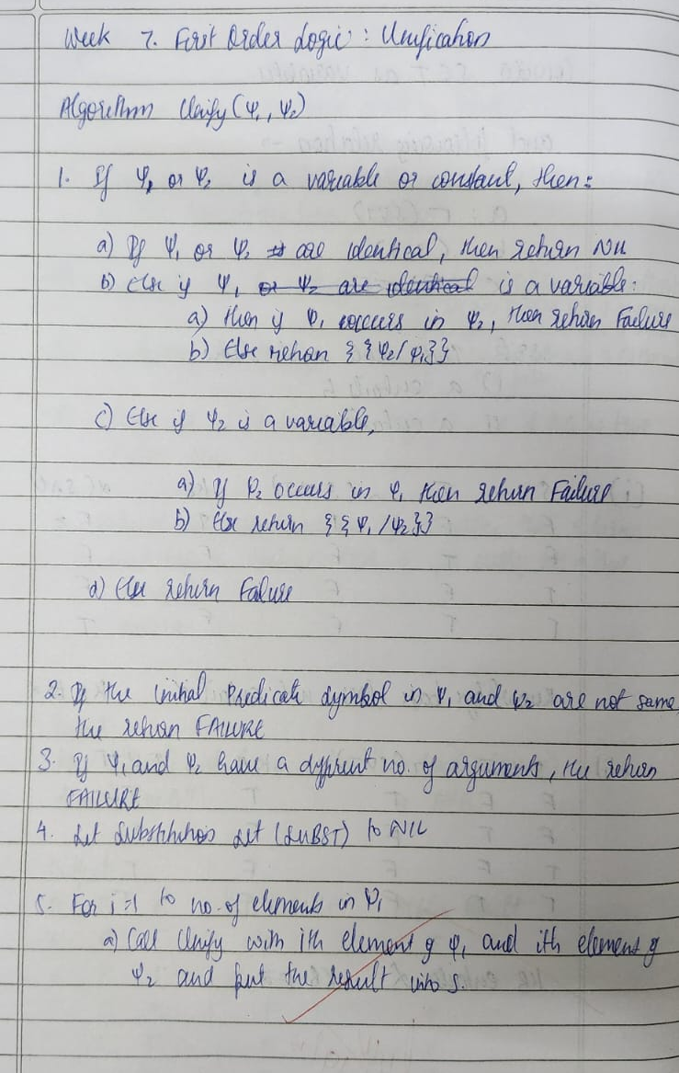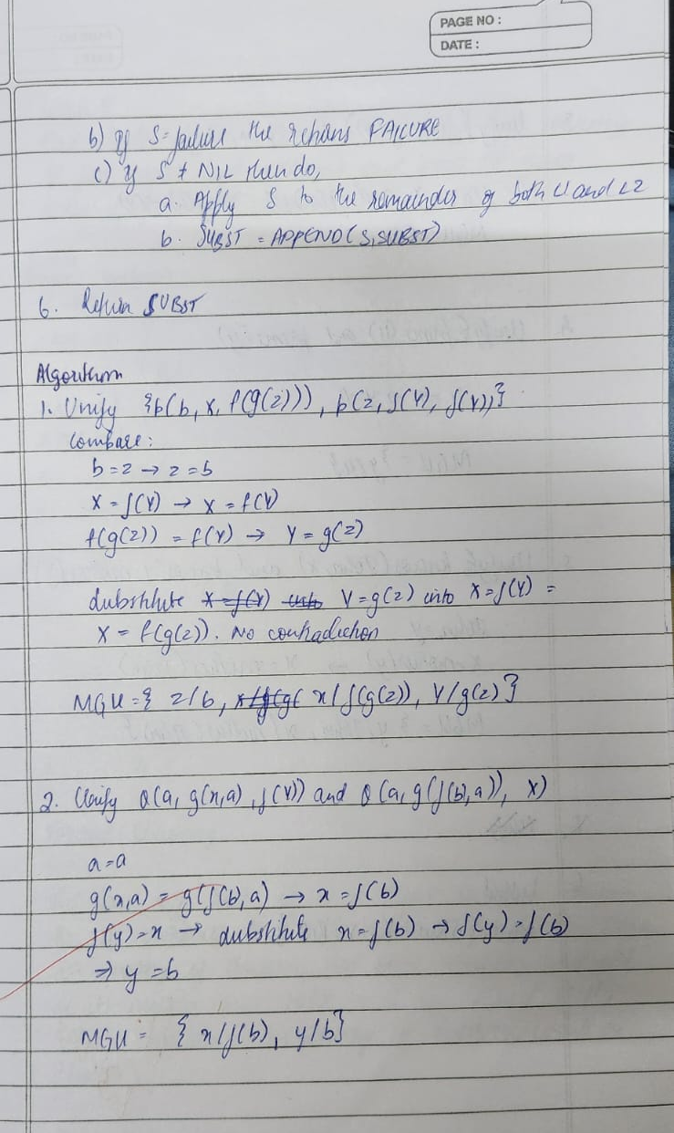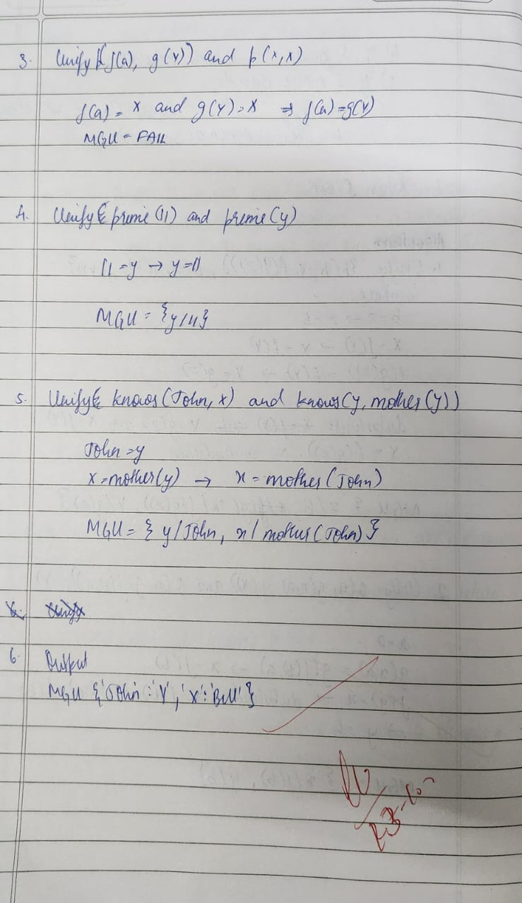
Code:

def is_variable(x):
"""Variables are strings that start with an uppercase letter."""
return isinstance(x, str) and x and x[0].isupper()

def is_compound(x):
"""Compound terms are lists: [functor, arg1, arg2, ...]"""
return isinstance(x, list) and len(x) >= 1

def occurs_check(var, x, subst):
"""Return True if var occurs in x."""
if var == x:
return True
if is_variable(x) and x in subst:
return occurs_check(var, subst[x], subst)
if is_compound(x):
return any(occurs_check(var, xi, subst) for xi in x[1:])
return False

def unify_var(var, x, subst):
if var in subst:
return unify(subst[var], x, subst)
if is_variable(x) and x in subst:
return unify(var, subst[x], subst)
if occurs_check(var, x, subst):
return "FAIL"
# otherwise record substitution var -> x (apply existing subst to x)
subst[var] = substitute(x, subst)
return subst

def substitute(term, subst):
"""Apply substitution dict to a term (deep)."""
if is_variable(term):
return substitute(subst.get(term, term), subst) if term in subst else term
if is_compound(term):
return [term[0]] + [substitute(arg, subst) for arg in term[1:]]
return term # constant (string)

def unify(x, y, subst=None):
if subst is None:
subst = {}
# apply current substitution before proceeding
x = substitute(x, subst)
y = substitute(y, subst)
if x == y:
return subst
if is_variable(x):
return unify_var(x, y, subst)
if is_variable(y):
return unify_var(y, x, subst)
if is_compound(x) and is_compound(y) and x[0] == y[0] and len(x) == len(y):
# unify arguments left-to-right
for a, b in zip(x[1:], y[1:]):
subst = unify(a, b, subst)
if subst == "FAIL":
return "FAIL"
return subst
return "FAIL"

expr1 = ["p", "b", "X", ["f", ["g", "Z"]]]
expr2 = ["p", "Z", ["f", "Y"], ["f", "Y"]]

expr3b = ["knows", "John", "X"]
expr4b = ["knows", "Y", "Bill"]
print("Solution by Sam Manu Jacob-1BM23CS291")
print("=== Problem 1 ===")
res1 = unify(expr1, expr2)
print("MGU:", res1)

print("\n=== Problem 6 ===")
res6 = unify(expr3b, expr4b)
print("MGU:", res6)

Program 8
Create a knowledge base consisting of first order logic statements and prove the given query using forward reasoning.

Algorithm:
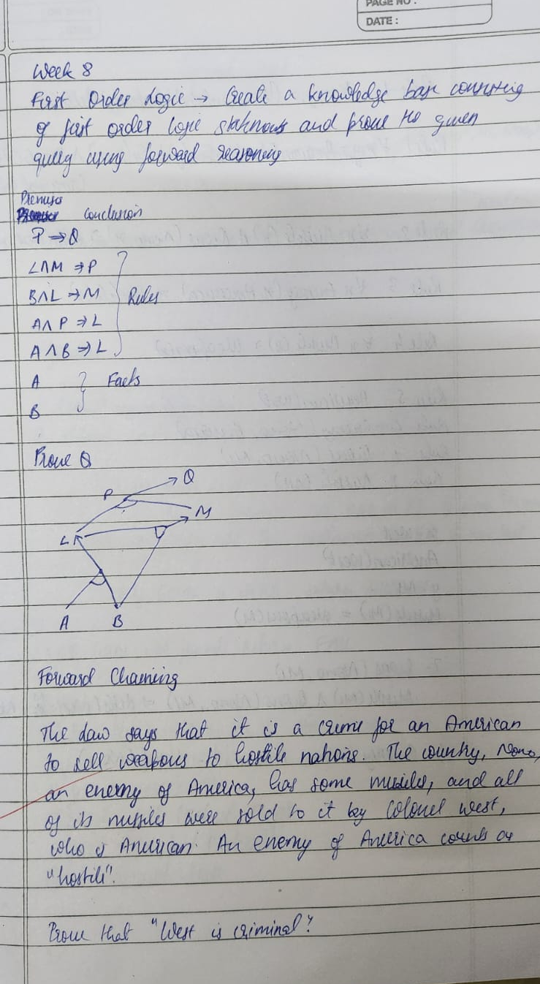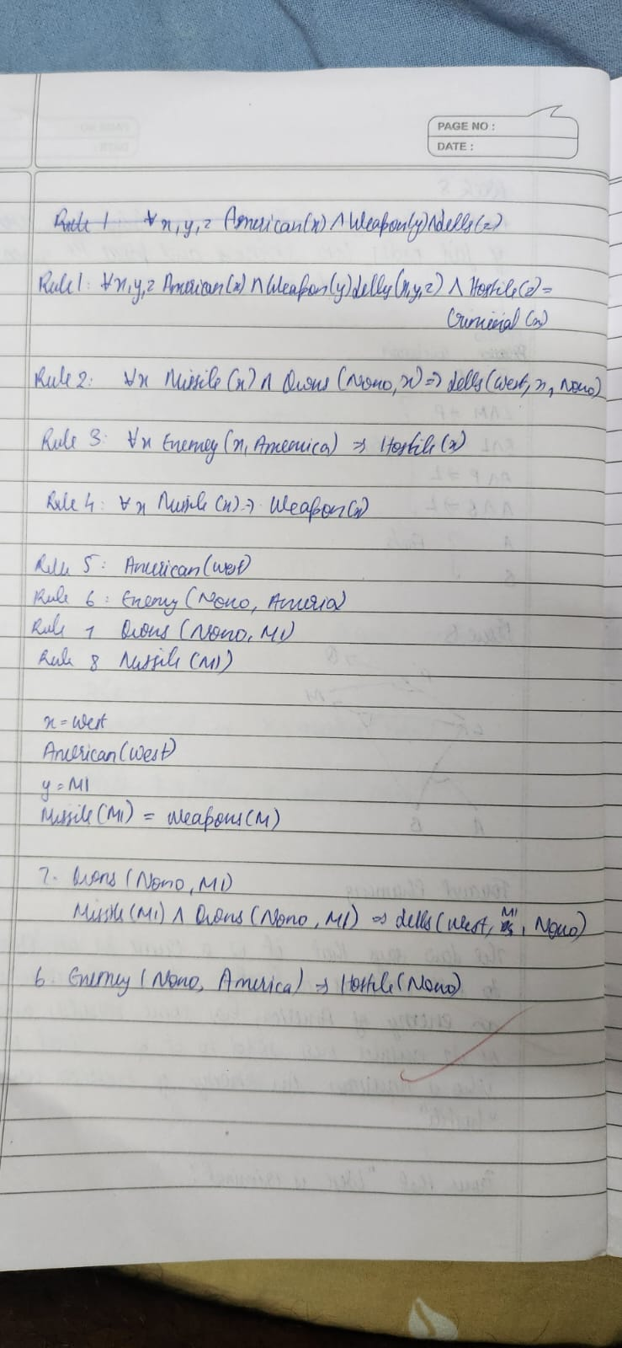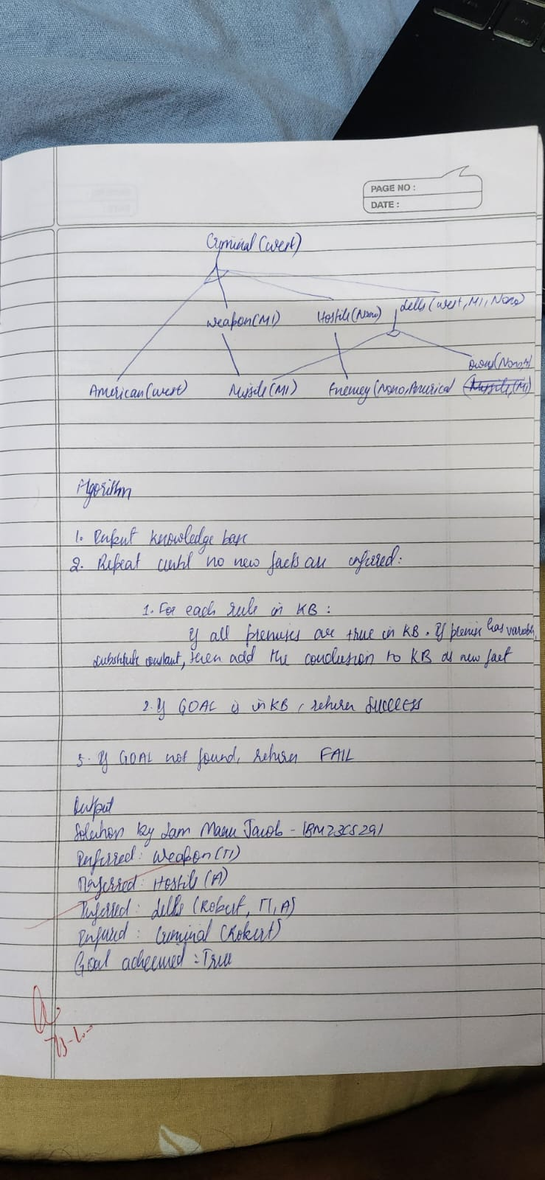
Code:

import re

print("Solution By Sam Manu Jacob-1BM23CS291")

def match_pattern(pattern, fact):
"""
Checks if a fact matches a rule pattern using regex-style variable substitution.
Variables are lowercase words like p, q, x, r etc.
Returns a dict of substitutions or None if not matched.
"""
# Extract predicate name and arguments
pattern_pred, pattern_args = re.match(r'(\w+)', pattern).groups()
fact_pred, fact_args = re.match(r'(\w+)', fact).groups()

if pattern_pred != fact_pred:
return None # predicate mismatch

pattern_args = [a.strip() for a in pattern_args.split(",")]
fact_args = [a.strip() for a in fact_args.split(",")]

if len(pattern_args) != len(fact_args):
return None

subst = {}
for p_arg, f_arg in zip(pattern_args, fact_args):
if re.fullmatch(r'[a-z]\w*', p_arg): # variable
subst[p_arg] = f_arg
elif p_arg != f_arg: # constants mismatch
return None
return subst

def apply_substitution(expr, subst):
"""Replaces all variable names in expr using the given substitution dict."""
for var, val in subst.items():
expr = re.sub(rf'\b{var}\b', val, expr)
return expr

# ---------- Knowledge Base ----------

rules = [
(["American(p)", "Weapon(q)", "Sells(p,q,r)", "Hostile(r)"], "Criminal(p)"),
(["Missile(x)"], "Weapon(x)"),
(["Enemy(x, America)"], "Hostile(x)"),
(["Missile(x)", "Owns(A, x)"], "Sells(Robert, x, A)")
]

facts = {
"American(Robert)",
"Enemy(A, America)",
"Owns(A, T1)",
"Missile(T1)"
}

goal = "Criminal(Robert)"

def forward_chain(rules, facts, goal):
added = True
while added:
added = False
for premises, conclusion in rules:

possible_substs = []
for p in premises:
for f in facts:
subst = match_pattern(p, f)
if subst:
possible_substs.append(subst)
break
else:

break
else:

combined = {}
for s in possible_substs:
combined.update(s)

new_fact = apply_substitution(conclusion, combined)

if new_fact not in facts:
facts.add(new_fact)
print(f"Inferred: {new_fact}")
added = True
if new_fact == goal:
return True
return goal in facts

print("Goal achieved:", forward_chain(rules, facts, goal)
Program 9
Create a knowledge base consisting of first order logic statements and prove the given query using Resolution
Algorithm:
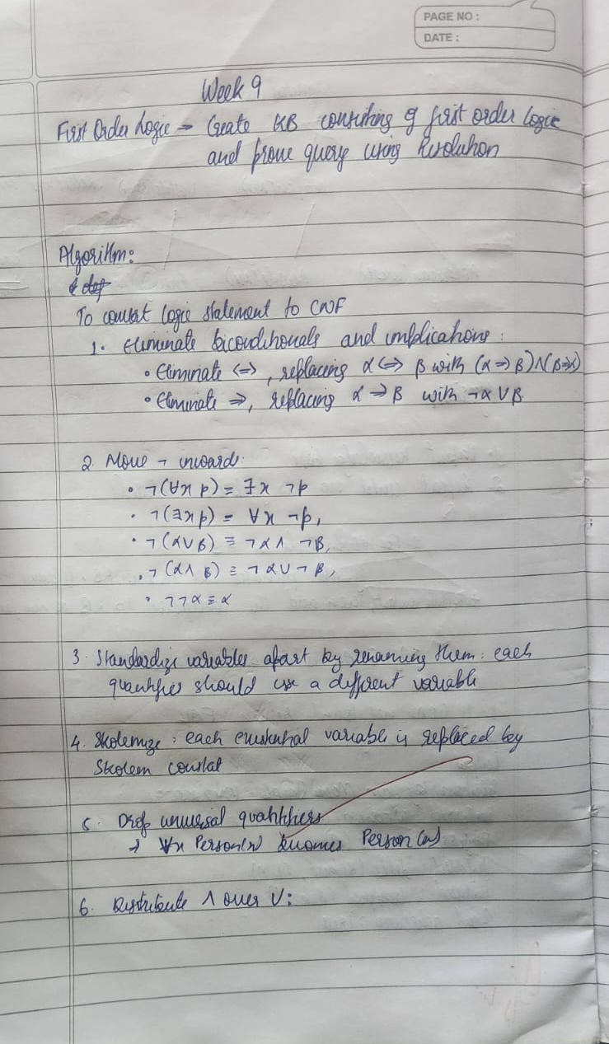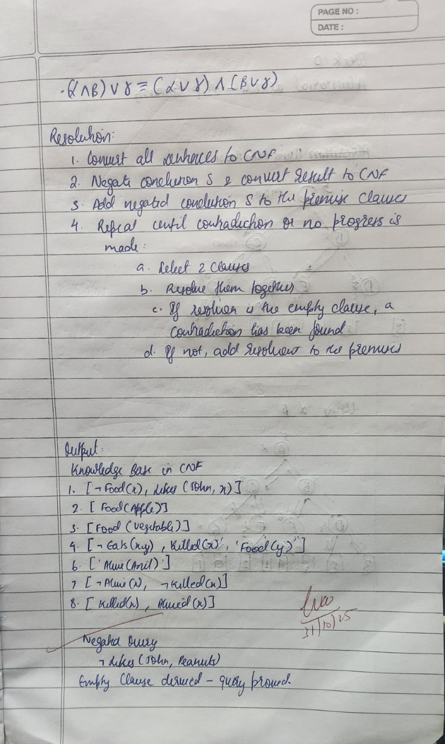

Code:
from copy import deepcopy

def print_step(title, content):
print(f"\n{'='*45}\n{title}\n{'='*45}")
if isinstance(content, list):
for i, c in enumerate(content, 1):
print(f"{i}. {c}")
else:
print(content)

KB = [
["¬Food(x)", "Likes(John,x)"],
["Food(Apple)"],
["Food(Vegetable)"],
["¬Eats(x,y)", "Killed(x)", "Food(y)"],
["Eats(Anil,Peanuts)"],
["Alive(Anil)"],
["¬Alive(x)", "¬Killed(x)"],
["Killed(x)", "Alive(x)"]
]

QUERY = ["Likes(John,Peanuts)"]

def negate(literal):
if literal.startswith("¬"):
return literal[1:]
return "¬" + literal

def substitute(clause, subs):
new_clause = []
for lit in clause:
for var, val in subs.items():
lit = lit.replace(var, val)
new_clause.append(lit)
return new_clause

def unify(lit1, lit2):
"""Small unifier for patterns like Food(x) and Food(Apple)."""
if "(" not in lit1 or "(" not in lit2:
return None
pred1, args1 = lit1.split("(")
pred2, args2 = lit2.split("(")
args1 = args1[:-1].split(",")
args2 = args2[:-1].split(",")
if pred1 != pred2 or len(args1) != len(args2):
return None
subs = {}
for a, b in zip(args1, args2):
if a == b:
continue
if a.islower():
subs[a] = b
elif b.islower():
subs[b] = a
else:
return None
return subs

def resolve(ci, cj):
"""Return list of (resolvent, substitution, pair)."""
resolvents = []
for li in ci:
for lj in cj:
if li == negate(lj):
new_clause = [x for x in ci if x != li] + [x for x in cj if x != lj]
resolvents.append((list(set(new_clause)), {}, (li, lj)))
else:
# same predicate, opposite sign
if li.startswith("¬") and not lj.startswith("¬") and li[1:].split("(")[0] == lj.split("(")[0]:
subs = unify(li[1:], lj)
if subs:
new_clause = substitute([x for x in ci if x != li] + [x for x in cj if x != lj], subs)
resolvents.append((list(set(new_clause)), subs, (li, lj)))
elif lj.startswith("¬") and not li.startswith("¬") and lj[1:].split("(")[0] == li.split("(")[0]:
subs = unify(lj[1:], li)
if subs:
new_clause = substitute([x for x in ci if x != li] + [x for x in cj if x != lj], subs)
resolvents.append((list(set(new_clause)), subs, (li, lj)))
return resolvents

def resolution(kb, query):
clauses = deepcopy(kb)
negated_query = [negate(q) for q in query]
clauses.append(negated_query)
print_step("Initial Clauses", clauses)

steps = []
new = []
while True:
pairs = [(clauses[i], clauses[j]) for i in range(len(clauses))
for j in range(i + 1, len(clauses))]
for (ci, cj) in pairs:
for r, subs, pair in resolve(ci, cj):
if not r:
steps.append({
"parents": (ci, cj),
"resolvent": r,
"subs": subs
})
print_tree(steps)
print("\n✅ Empty clause derived — query proven.")
return True
if r not in clauses and r not in new:
new.append(r)
steps.append({
"parents": (ci, cj),
"resolvent": r,
"subs": subs
})
if all(r in clauses for r in new):
print_step("No New Clauses", "Query cannot be proven ❌")
print_tree(steps)
return False
clauses.extend(new)

def print_tree(steps):
print("\n" + "="*45)
print("Resolution Proof Trace")
print("="*45)
for i, s in enumerate(steps, 1):
p1, p2 = s["parents"]
r = s["resolvent"]
subs = s["subs"]
subs_text = f" Substitution: {subs}" if subs else ""

print(f" Resolve {p1} and {p2}")
if subs_text:
print(subs_text)
if r:
print(f" ⇒ {r}")
else:
print(" ⇒ {} (empty clause)")
print("-"*45)

def main():
print_step("Knowledge Base in CNF", KB)
print_step("Negated Query", [negate(q) for q in QUERY])
proven = resolution(KB, QUERY)
if proven:
print("\n Query Proven by Resolution: John likes peanuts.")
else:
print("\n Query cannot be proven from KB.")

if __name__ == "__main__":
main()

Program 9
Create a knowledge base consisting of first order logic statements and prove the given query using Resolution
Algorithm:
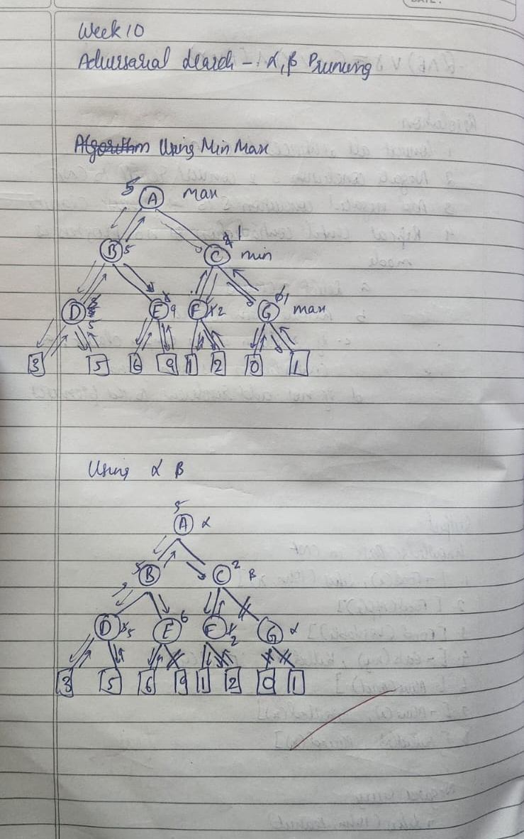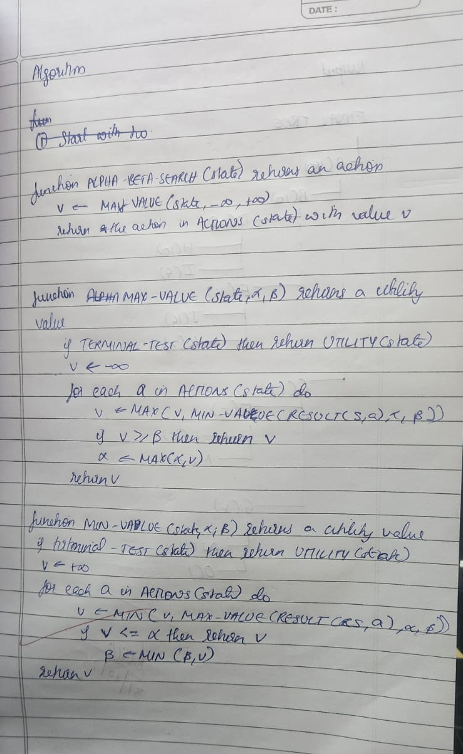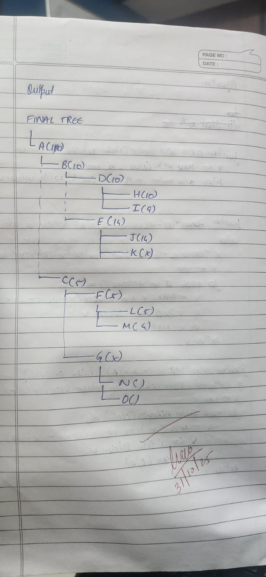
Code:
import math

print("Output by Sam Manu Jacob- 1BM23CS291")

tree = {
'A': ['B', 'C'],
'B': ['D', 'E'],
'C': ['F', 'G'],
'D': ['H', 'I'],
'E': ['J', 'K'],
'F': ['L', 'M'],
'G': ['N', 'O'],
'H': [], 'I': [], 'J': [], 'K': [],
'L': [], 'M': [], 'N': [], 'O': []
}

# Leaf node values
values = {
'H': 10, 'I': 9,
'J': 14, 'K': 18,
'L': 5, 'M': 4,
'N': 50, 'O': 3
}

# to store final display values
node_values = {}

def get_children(node):
return tree.get(node, [])

def is_terminal(node):
return len(get_children(node)) == 0

def evaluate(node):
return values[node]

def alpha_beta(node, depth, alpha, beta, maximizing):
if is_terminal(node) or depth == 0:
val = evaluate(node)
node_values[node] = val
return val

if maximizing:
value = -math.inf
for child in get_children(node):
val = alpha_beta(child, depth - 1, alpha, beta, False)
value = max(value, val)
alpha = max(alpha, val)
if beta <= alpha:
# mark remaining children as pruned
for rem in get_children(node)[get_children(node).index(child)+1:]:
node_values[rem] = "X"
break
node_values[node] = value
return value
else:
value = math.inf
for child in get_children(node):
val = alpha_beta(child, depth - 1, alpha, beta, True)
value = min(value, val)
beta = min(beta, val)
if beta <= alpha:
for rem in get_children(node)[get_children(node).index(child)+1:]:
node_values[rem] = "X"
break
node_values[node] = value
return value

# Run pruning
alpha_beta('A', depth=4, alpha=-math.inf, beta=math.inf, maximizing=True)

def print_tree(node, prefix="", is_last=True):
connector = "└── " if is_last else "├── "
value = node_values.get(node, "")
print(prefix + connector + f"{node} ({value})")
children = get_children(node)
for i, child in enumerate(children):
new_prefix = prefix + (" " if is_last else "│ ")
print_tree(child, new_prefix, i == len(children)-1)

# Display the final tree
print("\nFINAL TREE\n" )
print_tree('A')

