Configure WMS to enable ParcelCtl
configure WMS to enable Parcel Manifesting, refer to this link http://rabbit/delivery/parcel/Library/ParcelCtl/Configuration/WMDConfiguration.htm

- Configure the Installed Policy - Policy Maintenance
PARCEL-MANIFEST/INSTALLED/FASCOR/rtnum1 = 1
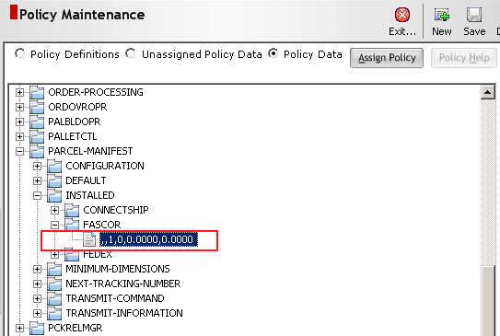

- Configure the Parcel Parameter Data - Parcel Parameter Maintenance
Configure the ParcelCtl to point to the current MOCA host and port
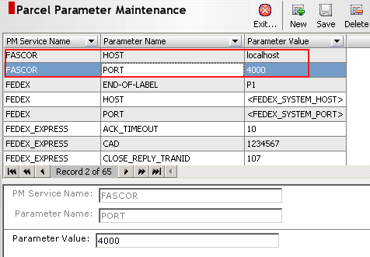

- Configure the warehouse - Warehouse Maintenance
Assign the appropriate ParcelCtltm client location ID to the default warehouse. This loc_id should match the Location # found in Fascor's Client Configuration. In most cases this will just be "1" unless more client locations exist.
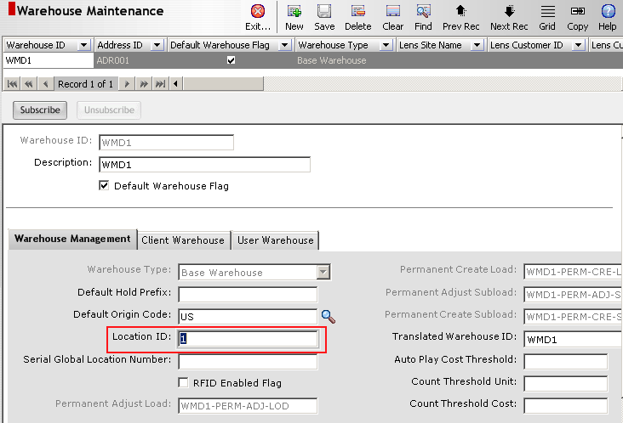

- Configure the Carrier Cross References - Carrier Maintenance
The carrier type for the carrier detail record should be “Small Package”
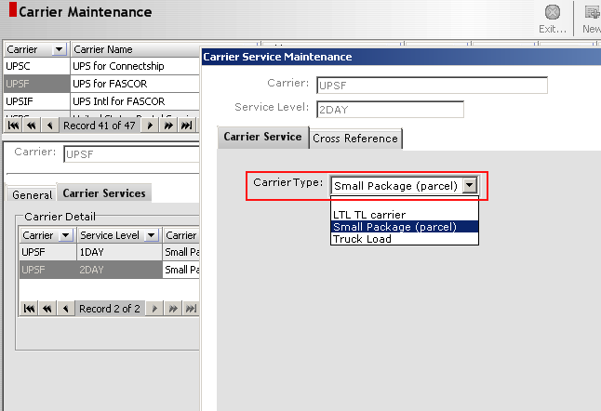

- Configure the carrier cross reference for that service level
  - Choose a PM Service name. This name should represent the mapping of the RedPrairie carrier code/service level to the parcel manifesting carrier code/service level. The list of PM service names is generated via the parcel manifesting system itself. So, for example, if you are configured to interface with ParcelCtl^{tm}, the list will be generated by ParcelCtl^{tm} and then passed back to . If the system is configured to interface with more than one parcel manifesting system (i.e, Connectship and Fedex) that list will represent both manifesting systems. Once you choose a service name, the destination name, destination carrier and destination level will be filled in.
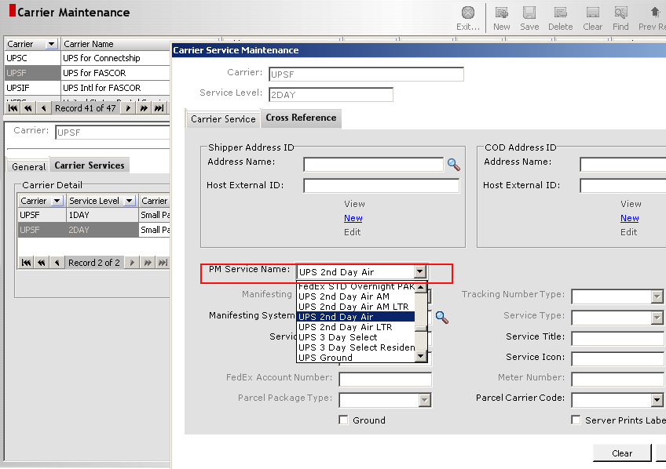

- Configure a Small Package Area - Area Maintenance
Define a small package area (WMD will distribute an area, FSTG, which is typically used as a small package area. aremst.stgflg should be 1)

- Configure Orders to go to the Small Package Area – Policy Maintenance
If there is a specific area set up for small package, then it is most likely desirable to direct all orders that will be shipped small package to that area. If all orders designated a specific carrier will be shipped small package, then define the order destination for that carrier to be the small package area defined above:
polcod | polvar | polval | rtstr1
ORDER-DESTINATION | CARRIERS | small package carrier | small package area
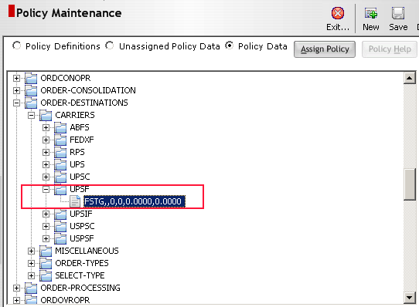

Testing

Manifest a domestic package

1) Set FSTG to be a ship staging area (aremst.stgflg =1)
Remove FSTG (Small Package Staging) from policy
SHPDCKOPR\MISCELLANEOUS\SHIP-STAGING-AREA-EXCLUSIONS

2) create an order
- Ship to customer = Rout to customer = Bill to customer = ‘1900 Park Fair’ (make sure the address has a zip code of 5 or 9 digital numbers)
- Payment type (payment_type) = ‘Consignee’ (manifest package operations will retrieve this value, or the value on that form will be null, then will raise error)

3) create inventory in an area, we need the pick work to be ‘S’ levlel

4) create shipment -> allocate shipment -> release pick works -> perform pick works

5) stage the shipment (maybe we don’t need to stage the shipment)

6) small package operations or manifest package operations -> enter the subnum in “Inventory Identifier” field, press Tab, then the “Manifest …” button on the button bar is enabled, press it, then a record is insert into manfst table with a tracking number.

Manifest an international package
Trouble shooting
http://redfusion/phpbb2/viewtopic.php?t=5768
http://redfusion/phpbb2/viewtopic.php?t=8479&highlight=clsupslabel

A code bug should be fixed
%DCSDIR%\src\cmdsrc\dcspm\get_cost_information_for_shipment.mcmd

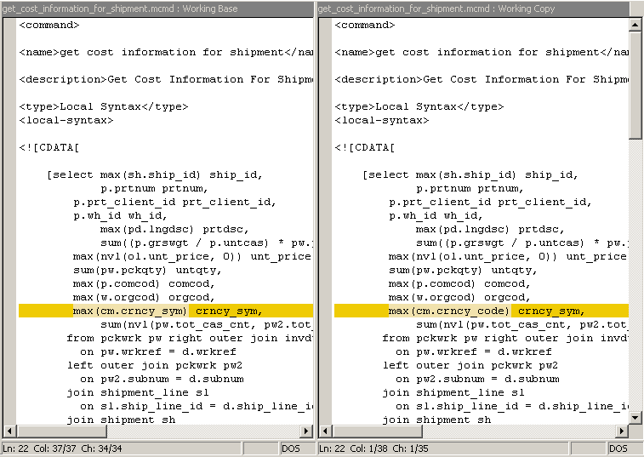

- Country Maintenance
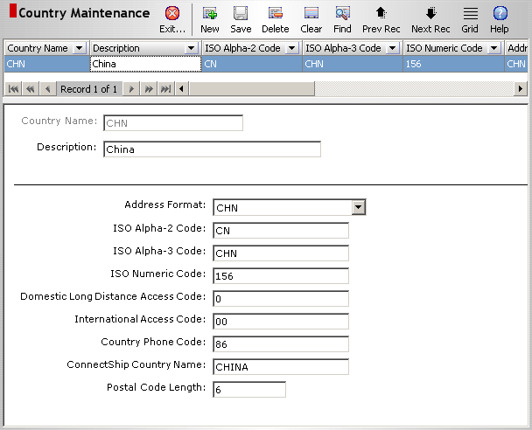

- State Maintenance
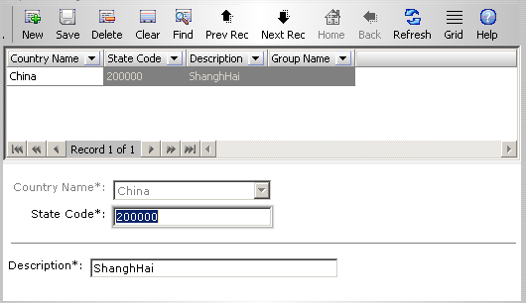

- City Postal Code Maintenance
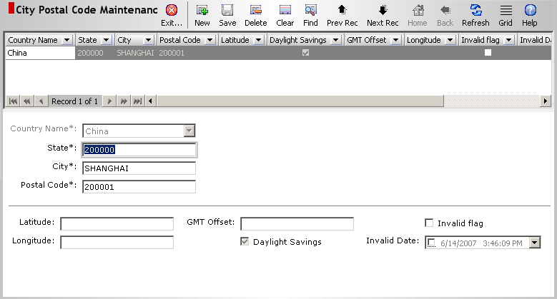

- Address Maintenance
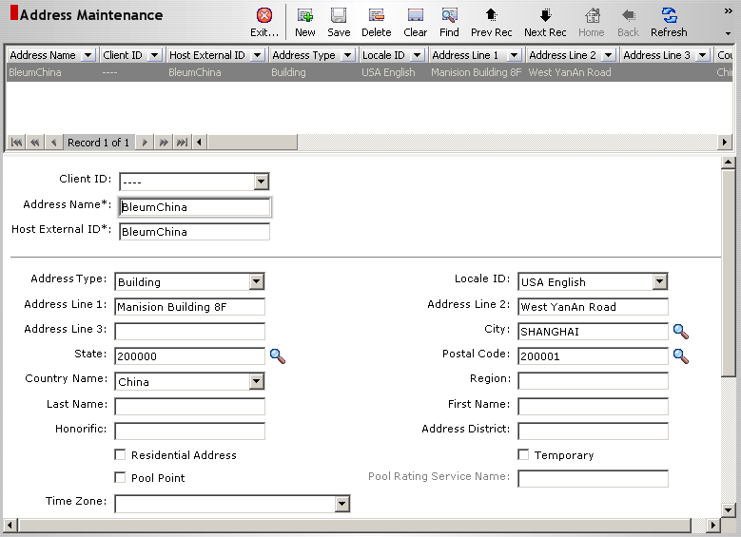

- Customer Maintenance
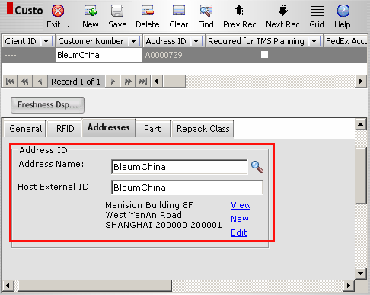

- Carrier Maintenance
The Carrier Service should have “International Delivery” flag checked on, and have Carrier Type be “Small Package”
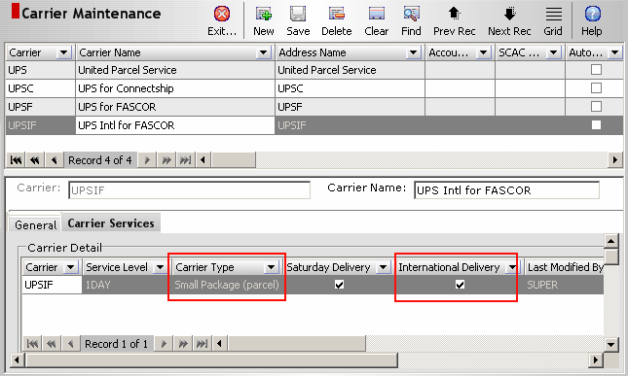

- Part Maintenance
Part should have a valid Commodity Code (comcod), it’s necessary for manifesting an international package.
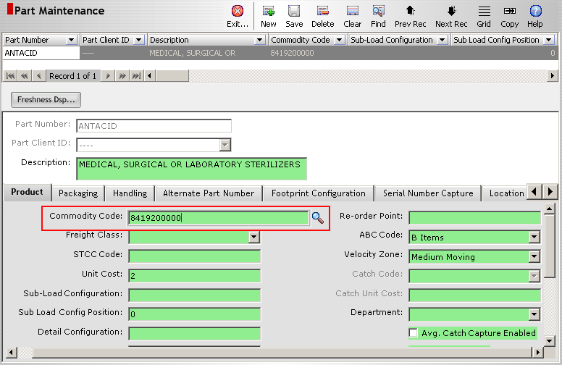

- Order Maintenance
Order should have an address out of USA (maybe the Bill-To Address),
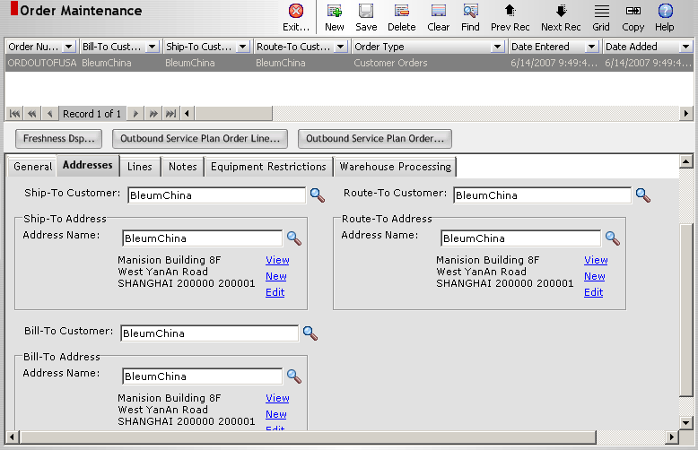
Order should have Payment Type “CostFreight” (maybe other value, but not all values will work for international packages)
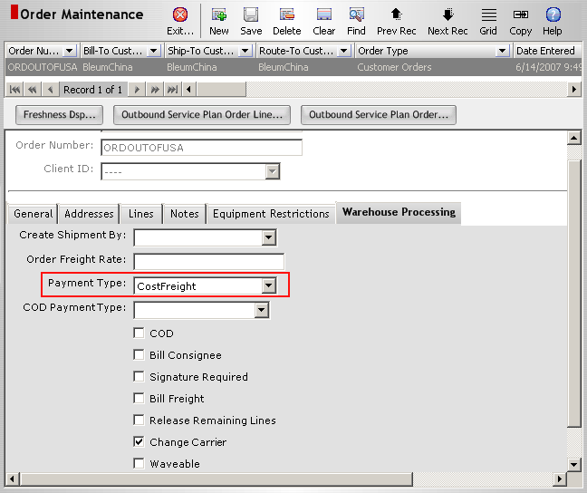
The Order Line should have “currency” set up.
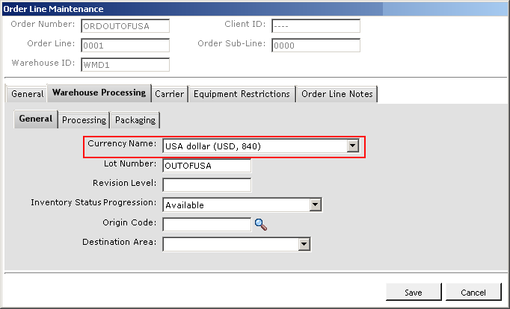
Order Line should have a International Carrier/Service setup.
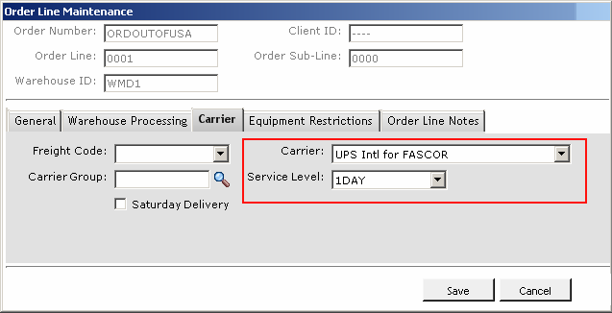

- Create inventory
- Plan shipment
- Allocate shipment to “Small Package Area” to generate a regular sub-load level pick or a Kit work
- Process pick release
- Manifest the case/carton

