**Instituto Tecnológico de Estudios Superior de Monterrey**

**Vocational Expert System**

**Samuel Octavio González Azpeitia**

**A01704696**

**Final project: Programming Languages**

**20/19/2021**

**Contents:**

1. Introduction.
2. Problem.
3. Solution.
4. Implementation.
5. Installation.
6. Conclusions.
7. References.

**Introduction**

Expert systems are based on computers, interactives and safe, can make decisions and solve complex problems and the part of make decisions is the higher level of intelligence and human experience.

The artificial intelligence could simulate that process, have enough stored knowledge for solve complex problems that only humans can solve it.

Expert systems identify because the characteristics like experience level that provides efficiency, precision and creative resolution of problems. Also react just in time give an answer in an efficient time.

The components of an expert system are five: base knowledge, inference engine, purchase of knowledge, explanation and user interface.

In this project I developed a basic expert system that consist on answer few questions, if you feel identification with the question you could choose yes or no. Based on your answers the program at the end will give you a career area that you can study.

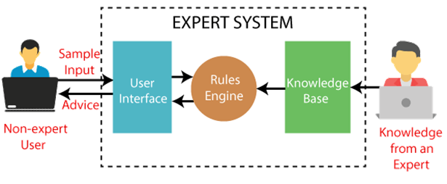

**Problem**

In the life every day you make decision, but one of the most important decision we make in our lives is choose a career because now we have a lot of options so is important make a good choice and the most important thing is enjoy the activities that we realize.

So one of the strategy of people is answer vocational tests to find the careers or the area that you can enjoy more based on your skills.

The objective of this program is help people to find an area of interesting then maybe could help them to choose a career.

The situation is to answer a test that at the end could help you to choose an area of study. So first is necessary identify the areas, the profiles for each type of career in order to have the base knowledge.



**Solution.**

To solve the problem first I investigate the principals area in these case was engineer, medicine, laws, social science, arts and administration. Then to give the answer is important investigate which are the profiles of each area like for engineers skill for math’s, or for laws negotiation skill.

So first I define the base knowledge based on the investigation that I realized. Then to provide a better user experience is important to have an interface, so I investigate and found a library that helps me to design the interface.

I already had the base knowledge and the interface, now to receive an answer you are answering the q questions that appear to you in case you answer affirmatively to a block of questions the program will answer you with that area, but if you give a negative answer the program will start with the next block of questions from the next area. It will only give you a correct area if you answer affirmatively to its entire block of questions, in case they all pass and at the end you send a negative answer it will give you the answer that it is not trained to give an answer.

**Implementation.**

The solution has been developed to run in SWI-Prolog. First the base knowledge.

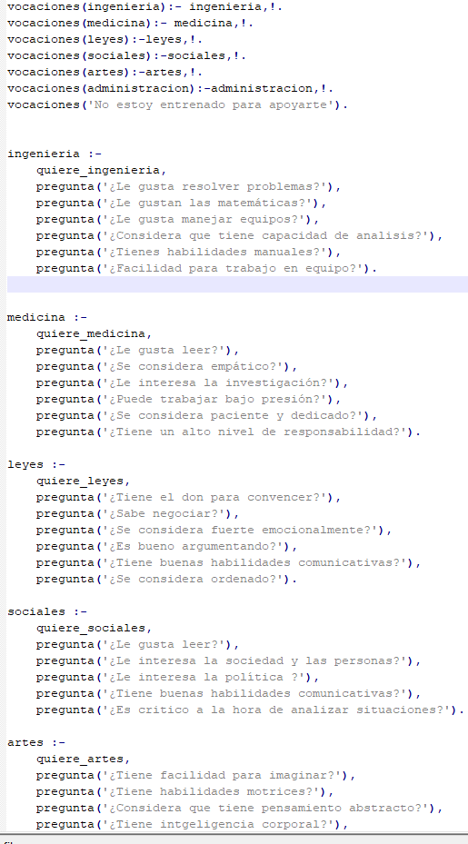

The part of the system make the validations to give you the answer, with assert, depending the answer and finally with retract unify the answers.

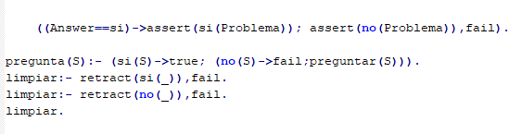

**Installation**

To run this program, it is only necessary to clone the repo and with the app SWI just write on the console and then will appears the interface.

main.

**Conclusion.**

While I developing the project I remember when I have to choose my career and the tests that I answered. I like this project because I could develop with my knowledge these system that maybe now is basic but is the base of AI so maybe one time I could be part of a team that develop a great module using AI.

Prolog was my favorite language of the semester, is a very powerful language, the paradigm first was hard to me but with practice and reading the information become easier and a topic that I enjoyed a lot.

**References.**

*Sistemas Expertos: Definición, Aplicaciones y Ejemplos*. (s. f.). Tecnologias informacion. Recuperado 18 de noviembre de 2021, de <https://www.tecnologias-informacion.com/sistemas-expertos.html>

*Aptitudes de un ingeniero civil, una profesión para diseñar el futuro*. (2016, 24 octubre). Planifica tu carrera profesional. Recuperado 18 de noviembre de 2021, de <https://blog.educaweb.mx/aptitudes-de-un-ingeniero-civil/>

*¿Qué aptitudes debo tener si pienso en estudiar medicina? | Learn Chil*. (s. f.). Learn Chile. Recuperado 18 de noviembre de 2021, de <https://www.learnchile.cl/que-aptitudes-debo-tener-si-pienso-en-estudiar-medicina/>

*26 Jun Las 10 aptitudes que necesita el buen abogado del futuro*. (2021, 26 junio). Instituto Superior de Investigasción Empresarial. Recuperado 18 de noviembre de 2021, de <https://www.isie.es/las-10-aptitudes-para-el-abogado-del-futuro/>

Página principal de SWI-Prolog: Página de donde descargar un interprete o la documentación para programar en Prolog y XPCE <http://www.swi-prolog.org>

Programming in XPCE/Prolog: Guía de usuario para aprender a programar en Prolog con el XPCE, desde lo más básico hasta lo más complejo. <http://www.swi.psy.uva.nl/projects/xpce/UserGuide/>