Classifying CIFAR10 with Neural Networks
Samuel Olatunde
Click here to find the code
Introduction
The objective of this project is to design, train, and compare multiple neural network architectures for image classification using the CIFAR-10 dataset. CIFAR-10 contains 60,000 color images sized 32×32 across 10 object categories, including airplanes, automobiles, birds, cats, and ships. Each image exhibits substantial variation in pose, lighting, and background, making the dataset an ideal benchmark for evaluating model capacity and generalization.

Two major classes of models were explored: Fully Connected Neural Networks (FCNNs) and Convolutional Neural Networks (CNNs). The FCNN approach involved building and analyzing eleven progressively deeper and wider models, allowing systematic study of depth, width, activation functions, and training hyperparameters. In contrast, the CNN approach focused on architectures inspired by well-known designs, including LeNet, AlexNet, VGG16, VGG19, and GoogLeNet (Inception-style). These models preserve spatial structure through convolution operations and serve as stronger baselines for image data.

Each model was trained, tuned, and evaluated using training and validation curves to assess convergence behavior, overfitting, and overall performance. By comparing FCNNs with CNNs and examining how architectural choices influence accuracy, the study aims to identify effective strategies for deep learning on small-scale image datasets and build a foundation for more advanced models in the final project.

Background
For background study, I reviewed the CNN architectures introduced in the lecture slides and examined the GoogLeNet (Inception) architecture using a geeksforgeeks.com article [1]. The main concepts I focused on were convolutional layers, dimensionality reduction, and the use of inception blocks for efficient feature extraction.
Methodology
This section outlines the modeling approach used in the project. Two categories of neural network architectures were developed: FCNN and CNN. Each model’s architecture is described, followed by an examination of the corresponding training curves. All FCNN models were trained for 50 epochs, while the CNN models used varied epoch counts based on convergence behavior. The purpose of this section is to highlight how the architectural differences between FCNNs and CNNs influence feature learning, optimization behavior, and overall performance on the dataset. All images were normalized to the range [0, 1] and training was performed using a validation split of 20%. The models were implemented using Keras with the JAX backend.
FCNN
The objective is to iteratively modify a baseline model and evaluate how each change influences training and validation performance.Unless otherwise stated, the default batch size was 64, the loss function was sparse categorical crossentropy, and the evaluation procedure remained consistent across all experiments.
Base Model
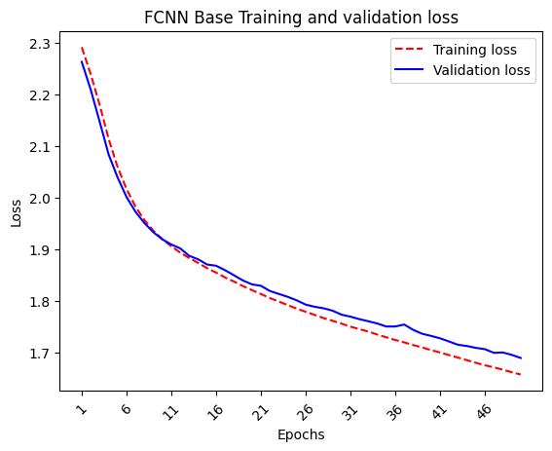
The baseline architecture consisted of a flattened input, (32,32,3), followed by 2 dense layers of 256 units with ‘sigmoid’ activation, and a final softmax output layer. Using ‘SGD’ as the optimizer, the base model yielded an approximate minimum training and validation loss of 1.7.
The learning curves are shown above. Observe how both curves are downward sloping towards the end. This indicates that the model might benefit from more training (increasing epochs). However, the model also begins to overfit, so alternate methods were applied with the goal of attaining high accuracy within 50 epochs.
Variant 1
This modification involved increasing the complexity of the base model by increasing the number of units from 256 to 512, intended to make the model more accurate in the same number of epochs. The results, presented below, showed identical performance to the base model with no improvement at all, indicating that increasing the depth wasn’t beneficial. As a result, we reverted back to 256 units for all layers.
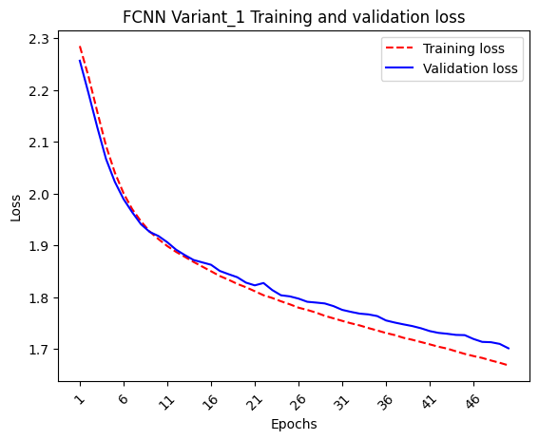

Variant 2
This model reverted the number of units per hidden layer back to 256 and changed the activations to ‘relu’ hoping that the model can learn better without bounding. The training curves below demonstrate a reduction in loss and increase in training set prediction accuracy, however, the model begins to overfit at the 5 epoch mark and it gets worse with time(epochs). Although the validation curve doesn't skyrocket. It just looks like the model is not learning to generalize as fast as it learns to predict training data. Out of curiosity, we increased the depth of the model.

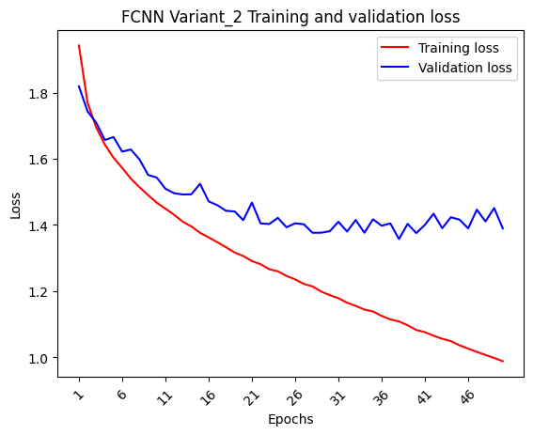
Variant 3
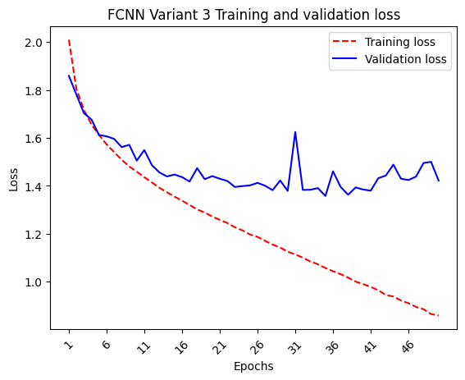
Here, the architecture was made deeper by adding two more hidden layers each with 256 neurons and ‘relu’ activation. This increased the model’s capacity but resulted in no significant improvement in performance (curves below). suggesting a need for more capacity. Additionally, the model is still overfitting but the validation curve has higher noise outliers. To help with this, we apply ‘SGD’ with momentum.

Variant 4
The optimizer was adjusted to ‘SGD’ with 0.5 momentum to improve convergence and smoothen validation curve. From the learning curves below, Training accuracy improved significantly, but validation behavior revealed worse performance compared to previous variants, illustrating substantial overfitting. ‘SGD’ with momentum didn’t help with smoothness. Next,we alter batch size, hoping to reduce variance and maybe reduce overfitting a little.
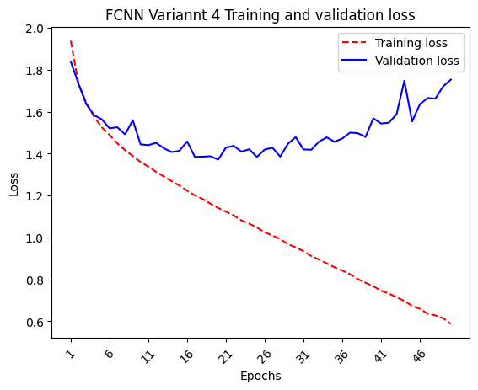

Variant 5
To reduce gradient noise, the batch size was increased to 128. Inferred from the picture below, Overfitting is reduced but the validation loss curve is still noisy indicating the learning rate is too high. Training performance also dropped. Instead of changing the learning late, we experiment with optimizers that implement adaptive learning rate.
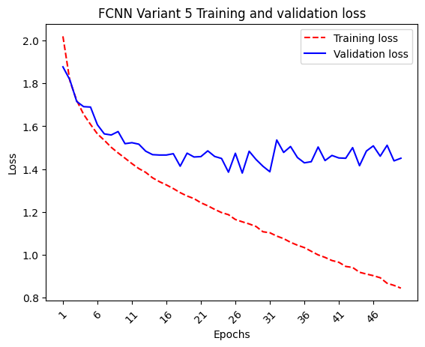

Variant 6
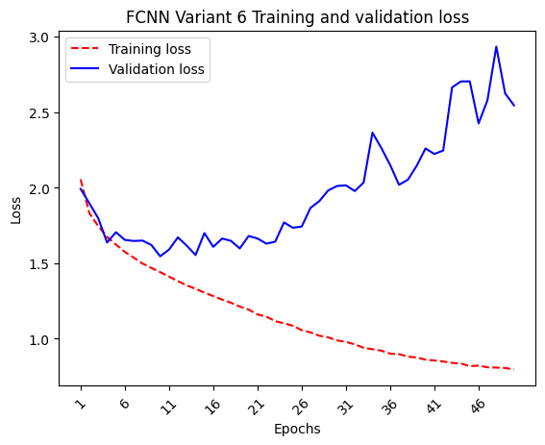
Switching to ‘RMSprop’ an adaptive optimizer. As shown, below overall model performance reduced overfitting increased, training performance reduced. . Validation loss is still noisy, its increasing nature indicates exploding gradients, a possible outcome of all hidden activation functions being RELU. Next, we try to stop exploding gradients using batch normalization

Variant 7
Batch normalization was added to every hidden layer to stabilize gradients. While this improved training performance dramatically, the model showed worse overfitting, and validation is more noisy. Next, we experiment with dropout as a regularization technique to all hidden layers.

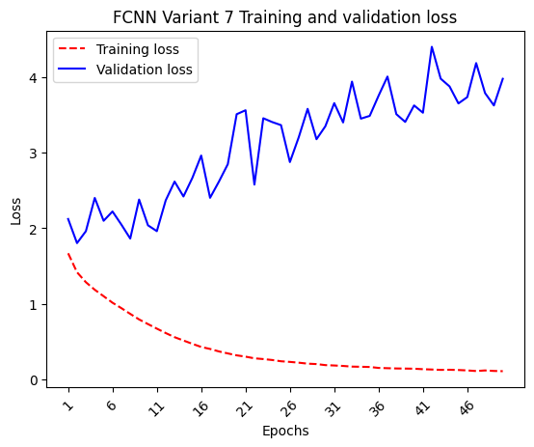

Variant 8
Dropout with 0.5 rate was added to counter the overfitting observed in previous variants. Validation performance improved in terms of loss magnitude and overfitting, but training accuracy dropped significantly. Since drop out was set to 0.5, we remove all drop outs and reduce the number of neurons per hidden layer by half.

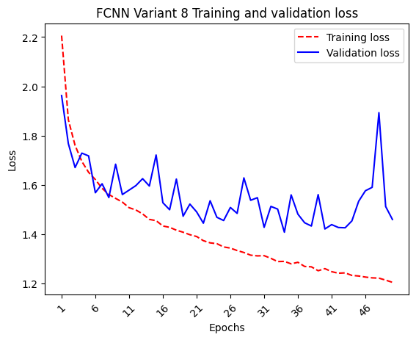
Variant 9
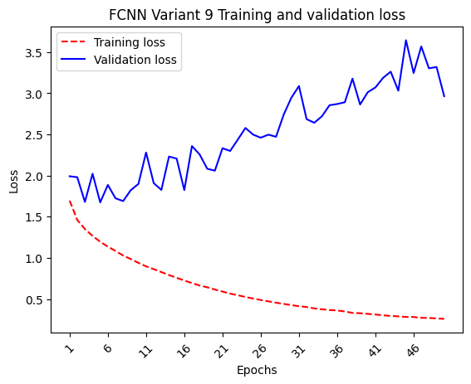
The number of units per hidden layer was reduced from 256 to 128 while removing dropout. This change increased training performance but led again to overfitting. Next, we employ l1 regularization to see if it produces better results than dropout. We choose l1 because it has the capability to push irrelevant weights to zero, essentially acting as dropout without randomization.

Variant 10
L1 regularization with a 0.00001 regularization constant was introduced to help with overfitting. Results show no significant increase in training performance and worsened overfitting. This indicates that the regularization strength is too small.
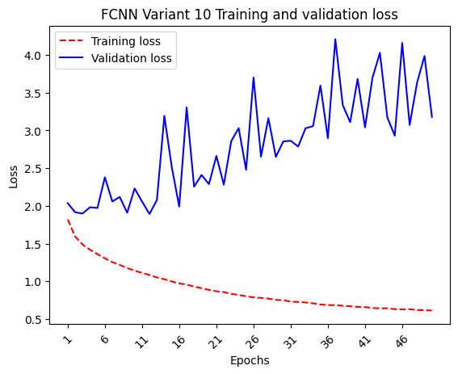
Variant 5 was used for final evaluation, results are presented in the results and discussion section.
CNN
In this section we highlight the different convolutional architectures used and discuss results.
LeNet Vairant
Table 1, summarizes a modified LeNet-style convolutional neural network designed for 32×32 RGB images.

Table 1: LeNet-Variant Architecture Summary
Layer Type | Parameters / Config | Activation | Output Shape
Input | shape = (32, 32, 3) | — | (32, 32, 3)
Conv2D | filters = 6, kernel = 5×5, padding = "same" | sigmoid | (32, 32, 6)
Conv2D | filters = 6, kernel = 3×3, padding = "same" | sigmoid | (32, 32, 6)
MaxPooling2D | pool = 2×2, stride = 2, padding = "same" | — | (16, 16, 6)
Conv2D | filters = 16, kernel = 5×5, padding = "same" | sigmoid | (16, 16, 16)
AveragePooling2D | pool = 2×2, stride = 2, padding = "same" | — | (8, 8, 16)
Flatten | — | — | (1024)
Dense | units = 120 | — (pre-act) | (120)
LayerNormalization | — | — | (120)
Dropout | rate = 0.7 | — | (120)
Activation | sigmoid | sigmoid | (120)
Dense | units = 84 | — (pre-act) | (84)
LayerNormalization | — | — | (84)
Dropout | rate = 0.5 | — | (84)
Activation | sigmoid | sigmoid | (84)
Dense | units = 10 | softmax | (10)

The model is compiled using the Nadam optimizer with a learning rate of 0.0003 and trained with a sparse categorical cross-entropy loss function, tracking accuracy as the main performance metric. Training is performed for 200 epochs with a batch size of 256, using 20% of the training data for validation. After training completes, the final model is saved to a file for later use. The chart below shows the learning curve. The model achieves a loss minima of 1.4 but it took 200 epoch, showcasing high computational constraints for minimal predictive performance improvements.
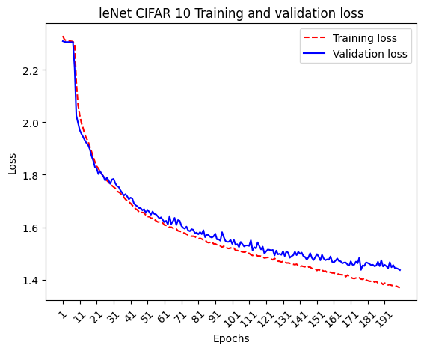

AlexNet Variant
Table 2, summarizes a modified AlexNet-style convolutional neural network designed for 32×32 RGB images.
Table 2: AlexNet-Variant Architecture Table
Type | Key Parameters | Activation | Output Shape
Input | shape = (32,32,3) | — | (32,32,3)
Conv2D | 32 filters, 7×7, same | ReLU | (32,32,32)
MaxPooling2D | 3×3, stride 2 | — | (15,15,32)
Conv2D | 96 filters, 5×5, same | ReLU | (15,15,96)
MaxPooling2D | 3×3, stride 2 | — | (7,7,96)
Conv2D | 128 filters, 3×3, same | ReLU | (7,7,128)
Conv2D | 128 filters, 3×3, same | ReLU | (7,7,128)
Conv2D | 96 filters, 3×3, same | ReLU | (7,7,96)
MaxPooling2D | 3×3, stride 2 | — | (3,3,96)
Flatten | — | — | (864,)
Dense | 512 units | — (pre-act) | (512,)
Dropout | rate = 0.7 | — | (512,)
Activation | ReLU | (512,)
Dense | 512 units | ReLU | (512,)
Dropout | rate = 0.7 | — | (512,)
Activation | ReLU | (512,)
Dense | 10 units | Softmax | (10,)

The model is compiled using the Nadam optimizer and trained with the sparse categorical cross-entropy loss function while tracking accuracy as the performance metric. Training is conducted for 11 epochs with a batch size of 128, using 20% of the training data as a validation split to monitor generalization during training. After training completes, the fully trained model is saved for future use.
Upon observation, the alexNet variant showed improved performance, achieving an end training loss of 0.8 and validation loss of 0.9, with over 90 % less epochs and half the batch size of LeNet.

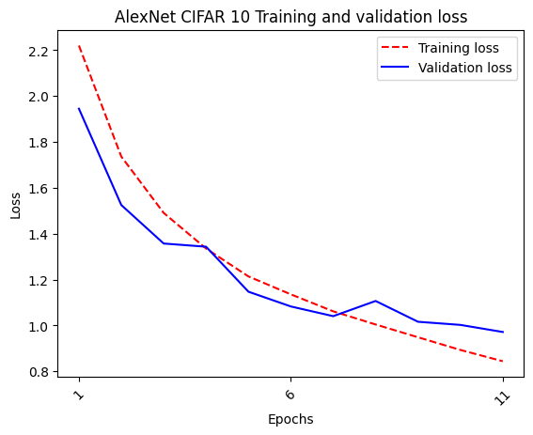
VGG16 Variant
Table 3, summarizes a modified VGG16-style convolutional neural network designed for 32×32 RGB images.

Table 3: VGG16-Variant Architecture Table
Type | Key Parameters | Activation | Output Shape
Input | (32,32,3) | — | (32,32,3)
Conv2D | 32 filters, 5×5, same | ReLU | (32,32,32)
Conv2D | 32 filters, 3×3, same | ReLU | (32,32,32)
MaxPooling2D | 2×2, stride 2 | — | (16,16,32)
Conv2D | 64 filters, 3×3, same | ReLU | (16,16,64)
Conv2D | 64 filters, 3×3, same | ReLU | (16,16,64)
MaxPooling2D | 2×2, stride 2 | — | (8,8,64)
Conv2D | 128 filters, 3×3, same | ReLU | (8,8,128)
Conv2D | 128 filters, 3×3, same | ReLU | (8,8,128)
MaxPooling2D | 2×2, stride 2 | — | (4,4,128)
Conv2D | 256 filters, 3×3, same | — | (4,4,256)
BatchNorm | momentum 0.5 | — | (4,4,256)
Activation | ReLU | (4,4,256)
Conv2D | 256 filters, 3×3, same | — | (4,4,256)
BatchNorm | momentum 0.5 | — | (4,4,256)
Activation | ReLU | (4,4,256)
Conv2D | 256 filters, 3×3, same | — | (4,4,256)
BatchNorm | momentum 0.5 | — | (4,4,256)
Activation | ReLU | (4,4,256)
MaxPooling2D | 2×2, stride 2 | — | (2,2,256)
Conv2D | 256 filters, 3×3, same | ReLU | (2,2,256)
Conv2D | 256 filters, 3×3, same | ReLU | (2,2,256)
Conv2D | 256 filters, 3×3, same | ReLU | (2,2,256)
MaxPooling2D | 2×2, stride 2 | — | (1,1,256)
Flatten | — | — | (256,)
Dense | 512 units | — (pre-act) | (512,)
Dropout | rate 0.7 | — | (512,)
Activation | ReLU | (512,)
Dense | 256 units | — (pre-act) | (256,)
Dropout | rate 0.7 | — | (256,)
Activation | ReLU | (256,)
Dense | 10 units | Softmax | (10,)

The model is compiled using the Adam optimizer with a learning rate of 0.0001, along with the sparse categorical cross-entropy loss function and accuracy as the evaluation metric. Training is performed for 8 epochs with a batch size of 128, using 20% of the training data as a validation split to monitor performance during training. After completing the training process, the resulting model is saved for later use.
As shown below, the model shows similar performance to AlexNet with a slight increase in difference between training and validation performance.
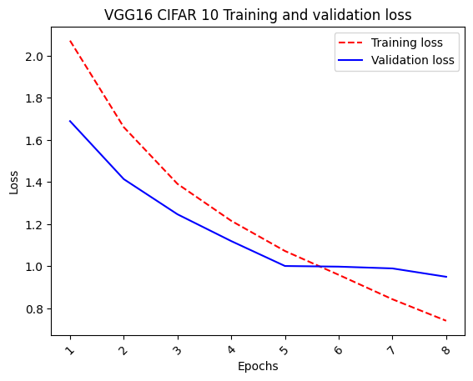
VGG19 Variant
The series of tables below summarizes a modified VGG19-style convolutional neural network designed for 32×32 RGB images.

Block 1
Type | Key Parameters | Activation | Output Shape
Input | (32,32,3) | — | (32,32,3)
Conv2D | 32 filters, 3×3, same | — | (32,32,32)
BatchNorm | momentum=0.5 | — | (32,32,32)
ReLU | — | ReLU | (32,32,32)
Conv2D | 32 filters, 3×3, same | — | (32,32,32)
BatchNorm | momentum=0.5 | — | (32,32,32)
ReLU | — | ReLU | (32,32,32)
MaxPooling2D | 2×2, stride=2 | — | (16,16,32)

Block 2
Type | Key Parameters | Activation | Output Shape
Conv2D | 64 filters, 3×3, same | — | (16,16,64)
BatchNorm | momentum=0.5 | — | (16,16,64)
ReLU | — | ReLU | (16,16,64)
Conv2D | 64 filters, 3×3, same | — | (16,16,64)
BatchNorm | momentum=0.5 | — | (16,16,64)
ReLU | — | ReLU | (16,16,64)
MaxPooling2D | 2×2, stride=2 | — | (8,8,64)

Block 3
Type | Key Parameters | Activation | Output Shape
Conv2D | 128 filters, 3×3, same | — | (8,8,128)
BatchNorm | momentum=0.5 | — | (8,8,128)
ReLU | — | ReLU | (8,8,128)
Conv2D | 128 filters, 3×3, same | — | (8,8,128)
BatchNorm | momentum=0.5 | — | (8,8,128)
ReLU | — | ReLU | (8,8,128)
MaxPooling2D | 2×2, stride=2 | — | (4,4,128)

Block 4
Type | Key Parameters | Activation | Output Shape
Conv2D | 256 filters, 3×3, same | — | (4,4,256)
BatchNorm | momentum=0.5 | — | (4,4,256)
ReLU | — | ReLU | (4,4,256)
Conv2D | 256 filters, 3×3, same | — | (4,4,256)
BatchNorm | momentum=0.5 | — | (4,4,256)
ReLU | — | ReLU | (4,4,256)
Conv2D | 256 filters, 3×3, same | — | (4,4,256)
BatchNorm | momentum=0.5 | — | (4,4,256)
ReLU | — | ReLU | (4,4,256)
Conv2D | 256 filters, 3×3, same | — | (4,4,256)
BatchNorm | momentum=0.5 | — | (4,4,256)
ReLU | — | ReLU | (4,4,256)
MaxPooling2D | 2×2, stride=2 | — | (2,2,256)

Block 5
Type | Key Parameters | Activation | Output Shape
Conv2D | 256 filters, 3×3, same | — | (2,2,256)
BatchNorm | momentum=0.5 | — | (2,2,256)
ReLU | — | ReLU | (2,2,256)
Conv2D | 256 filters, 3×3, same | — | (2,2,256)
BatchNorm | momentum=0.5 | — | (2,2,256)
ReLU | — | ReLU | (2,2,256)
Conv2D | 256 filters, 3×3, same | — | (2,2,256)
BatchNorm | momentum=0.5 | — | (2,2,256)
ReLU | — | ReLU | (2,2,256)
Conv2D | 256 filters, 3×3, same | — | (2,2,256)
BatchNorm | momentum=0.5 | — | (2,2,256)
ReLU | — | ReLU | (2,2,256)
MaxPooling2D | 2×2, stride=2 | — | (1,1,256)

The VGG19 model is compiled using the RMSprop optimizer with a momentum of 0.95 and a learning rate of 0.0001, employing sparse categorical cross-entropy as the loss function and accuracy as the evaluation metric. It is trained for 14 epochs on the training data with a batch size of 256, using 20% of the data for validation to monitor performance during training. After completing the training process, the fully trained model is saved for future use.

Analyzing the learning curve, we observe that VGG19 has a wider gap between training and validation but it still achieves better predictive performance on both fronts.
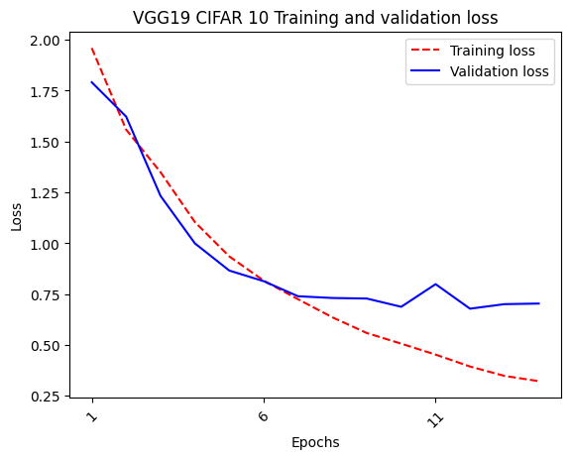
GoogLeNet Variant
The following tables summarize the GoogleNet architecture implemented for 32×32 input images with 10 output classes. The first set of tables describes the base component – the Inception block and the Auxiliary classifier – highlighting their internal layers, operations, and activation functions. The second table presents the full network architecture, showing how these components, along with standard convolutional, pooling, and fully connected layers, are sequentially connected to form the complete GoogleNet model, including the auxiliary outputs used during training.

Inception Block
Path | Type | Parameters / Notes | Activation | Output Shape
1 | Conv2D | filters=f1, 1×1, padding=same | ReLU | same as input
1 | BatchNormalization | default | — | same as input
1 | ReLU | — | ReLU | same as input
2 | Conv2D | filters=f3_in, 1×1, padding=same | ReLU | same as input
2 | BatchNormalization | default | — | same as input
2 | ReLU | — | ReLU | same as input
2 | Conv2D | filters=f3_out, 3×3, padding=same | ReLU | same as input
2 | BatchNormalization | default | — | same as input
2 | ReLU | — | ReLU | same as input
3 | Conv2D | filters=f5_in, 1×1, padding=same | ReLU | same as input
3 | BatchNormalization | default | — | same as input
3 | ReLU | — | ReLU | same as input
3 | Conv2D | filters=f5_out, 5×5, padding=same | ReLU | same as input
3 | BatchNormalization | default | — | same as input
3 | ReLU | — | ReLU | same as input
4 | MaxPooling2D | 3×3, stride=1, padding=same | — | same as input
4 | Conv2D | filters=fpool_out, 1×1, padding=same | ReLU | same as input
4 | BatchNormalization | default | — | same as input
4 | ReLU | — | ReLU | same as input
— | Concatenate | Combine all 4 paths | — | sum of path channels

Auxiliary Classifier
Type | Parameters / Notes | Activation | Output Shape
AveragePooling2D | pool_size=5×5, stride=1, padding=same | — | same as input
Conv2D | 128 filters, 1×1, padding=same | ReLU | same as input
Flatten | — | — | vector
Dense | 512 units | ReLU | 512
Dropout | rate=0.7 | — | 512
Dense | num_classes | Softmax | num_classes

Full GoogleNet Architecture (32×32 input, 10 classes)
Type | Parameters / Notes | Activation | Output Shape
Input | shape=(32,32,3) | — | (32,32,3)
Conv2D | 64 filters, 3×3 | ReLU | (32,32,64)
Conv2D | 64 filters, 3×3 | ReLU | (32,32,64)
MaxPooling2D | 2×2, stride=2 | — | (16,16,64)
Conv2D | 192 filters, 3×3 | ReLU | (16,16,192)
MaxPooling2D | 3×3, stride=2 | — | (8,8,192)
Inception Block | f1=32, f3_in=48, f3_out=64, f5_in=8, f5_out=16, fpool_out=16 | ReLU | (8,8,128)
Inception Block | f1=64, f3_in=64, f3_out=96, f5_in=16, f5_out=48, fpool_out=32 | ReLU | (8,8,240)
MaxPooling2D | 2×2, stride=2 | — | (4,4,240)
Inception Block | f1=96, f3_in=48, f3_out=104, f5_in=8, f5_out=24, fpool_out=32 | ReLU | (4,4,264)
Auxiliary Classifier | — | Linear (output) | 10
Inception Block | f1=80, f3_in=56, f3_out=112, f5_in=12, f5_out=32, fpool_out=32 | ReLU | (4,4,256)
Inception Block | f1=56, f3_in=72, f3_out=144, f5_in=16, f5_out=32, fpool_out=32 | ReLU | (4,4,264)
Auxiliary Classifier | — | Linear (output) | 10
Inception Block | f1=128, f3_in=80, f3_out=160, f5_in=16, f5_out=64, fpool_out=64 | ReLU | (4,4,368)
MaxPooling2D | 2×2, stride=2 | — | (2,2,368)
Inception Block | f1=192, f3_in=96, f3_out=192, f5_in=24, f5_out=64, fpool_out=64 | ReLU | (2,2,512)
GlobalAveragePooling2D | — | — | 512
Dropout | rate=0.4 | — | 512
Dense | 10 units | Softmax | 10

The GoogleNet model is compiled and trained with a focus on both the primary and auxiliary classifiers to improve convergence and accuracy. The model uses the Nadam optimizer with a learning rate of 0.0003, and it applies sparse categorical cross-entropy as the loss function for all outputs. The training process includes three classifiers: the main classifier (preds), and two auxiliary classifiers (aux1 and aux2). The primary classifier is responsible for the final prediction, while the auxiliary classifiers are intermediate classifiers that are introduced at different stages of the network. These auxiliary classifiers provide additional gradients during backpropagation, which helps the model to learn more efficiently.
The model uses loss_weights to balance the contribution of each classifier’s loss to the total loss during training. The main classifier (preds) is assigned a weight of 1.0, which means it has the most influence on the total loss. In contrast, the auxiliary classifiers (aux1 and aux2) each have a weight of 0.3, meaning their contribution to the loss is less significant but still important. This weighting strategy allows the model to leverage the benefits of the auxiliary classifiers without letting them overshadow the final output.
Analyzing the learning curve, we see an increase in predictive training performance but poor generalization. The exact reason for this is unknow at the moment, further research is needed.
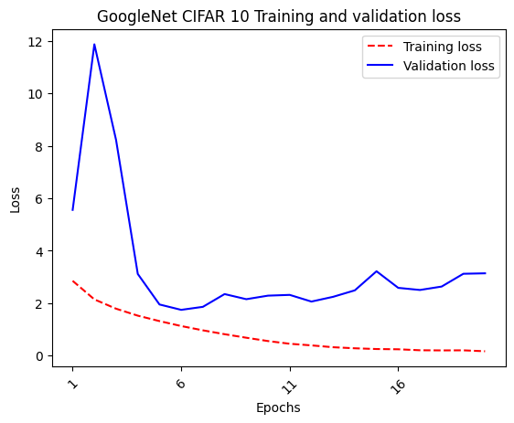

Results and Discussion
FCNN
The following table presents the performance metrics for Variant 5 of our base Fully Connected Neural Network (FCNN) model, which was evaluated on a test set. The model was trained with a straightforward architecture consisting of fully connected layers and optimized using Stochastic Gradient Descent (SGD) with momentum. The performance metrics include Loss, Accuracy, Precision, Recall, and F1 Score, which provide an in-depth view of how well the model performs on the given classification task.

Performance Metrics for FCNN Variant 5
Model | Loss | Accuracy | Precision | Recall | F1 Score
FCNN Variant 5 | 1.9871 | 0.516 | 0.5319 | 0.516 | 0.5155

FCNN Variant 5 demonstrates moderate performance across all metrics, with an accuracy of 0.516, which indicates that the model is performing slightly better than random guessing in a 10-class classification problem. The precision of 0.5319 and recall of 0.516 suggest that the model is fairly balanced, neither heavily favoring false positives nor false negatives. However, both precision and recall values are still relatively low, meaning the model is not excelling in distinguishing between classes with a high level of confidence.

The F1 Score, which balances both precision and recall, is 0.5155, showing that the model struggles to achieve a good balance between correctly identifying true positives and minimizing false positives or false negatives. This result is typical of a simpler architecture like the one used in this FCNN, where the lack of complex structures such as convolutions or attention mechanisms may limit the model's ability to capture more intricate patterns in the data.

Overall, while the model does provide a baseline performance, its relatively low metrics highlight areas for improvement in terms of both classification accuracy and generalization to unseen data. Further adjustments, such as exploring deeper architectures or different optimization techniques, could help boost its performance.

CNN
The following table presents the performance metrics for the five different CNN models evaluated on a test set. The models are assessed based on key performance indicators including Loss, Accuracy, Precision, Recall, and F1 Score. These metrics provide insights into the effectiveness of each model in terms of both classification accuracy and the ability to balance precision and recall.

Performance Comparison Table
Model | Loss | Accuracy | Precision | Recall | F1 Score
LeNet | 1.9819 | 0.523 | 0.5177 | 0.523 | 0.5128
AlexNet | 1.8667 | 0.6663 | 0.6682 | 0.6663 | 0.6644
VGG16 | 1.8237 | 0.6828 | 0.6782 | 0.6828 | 0.6768
VGG19 | 1.7070 | 0.7856 | 0.7970 | 0.7856 | 0.7851
GoogleNet | 1.6695 | 0.7946 | 0.8099 | 0.7946 | 0.7958

Among the five models, GoogleNet demonstrates the best overall performance (despite poor generalization during training), achieving an accuracy of 0.7946, a precision of 0.8099, and an F1 score of 0.7958. These metrics indicate that GoogleNet performs well in terms of both classification accuracy and balance between precision and recall. It significantly outperforms other models, especially LeNet, which has the lowest performance across all metrics with an accuracy of 0.523 and an F1 score of 0.5128.
In general, VGG19 also delivers strong results, with an accuracy of 0.7856 and an F1 score of 0.7851, positioning it just behind GoogleNet. VGG16 and AlexNet show moderate improvements over LeNet, with accuracy scores of 0.6828 and 0.6663, respectively. However, they still fall short of VGG19 and GoogleNet in terms of precision and F1 score.
This trend suggests that more complex models like VGG19 and GoogleNet are able to learn more discriminative features from the data, leading to better generalization and classification performance. Meanwhile, simpler models like LeNet seem to struggle with achieving higher performance on this test set.

Conclusion
This experiment compared the performance of multiple deep learning models, including both fully connected networks (FCNN) and convolutional neural networks (CNN), on a classification task. The results demonstrated that more complex models, particularly GoogleNet and VGG19, significantly outperformed simpler models like LeNet and FCNN Variant 5 in terms of accuracy, precision, recall, and F1 score. This reinforces the importance of utilizing deeper architectures with advanced feature extraction capabilities, such as convolutional layers and auxiliary classifiers.
Several insights were gained throughout the experiment. For instance, applying dropout before activation in CNN models improved performance by reducing overfitting, while Batch Normalization introduced noise into the validation curve, suggesting that further tuning of this technique might be necessary. These observations underline the importance of hyperparameter optimization and architectural choices in deep learning model performance.
Looking ahead, further research will focus on exploring ResNet models, which are designed to overcome the challenges faced by very deep networks, particularly the vanishing gradient problem.

References
[1]GeeksforGeeks. “Understanding GoogLeNet Model CNN Architecture.” GeeksforGeeks, May 2020, www.geeksforgeeks.org/machine-learning/understanding-googlenet-model-cnn-architecture/.

[2]Keras. “Home - Keras Documentation.” Keras.io, Keras, 2019, keras.io/.

