MSDS 6372: Homework 1

1. Chapter 23 Problem 13:

The standard treatment of ovarian cancer by the chemicals cytoxan and cisplatin substantially shrinks or eliminates tumors in about 60% of patients. Taxol, derived from the bark of yew trees, is expected to improve upon those response rates. If a clinical trial is conducted to randomly assign patients to the standard chemicals or to taxol, with equal numbers in each group, how large a sample size would be needed to distinguish a 75% response rate for taxol, at 95% conﬁdence? (Data from “Yew Drugs Show Their Mettle,” Science News 143 (May 29, 1993): 344.)

Based on the SAS output, the sample size for this study would be 30 in order to determine an effect rate on 75% of patients.



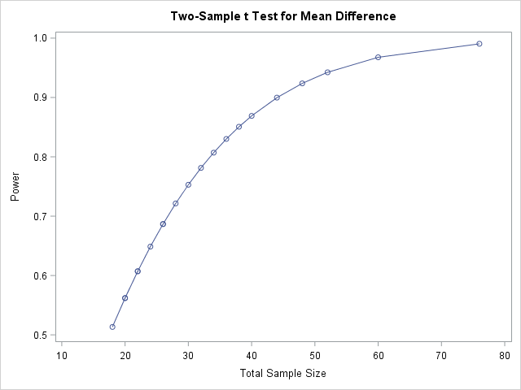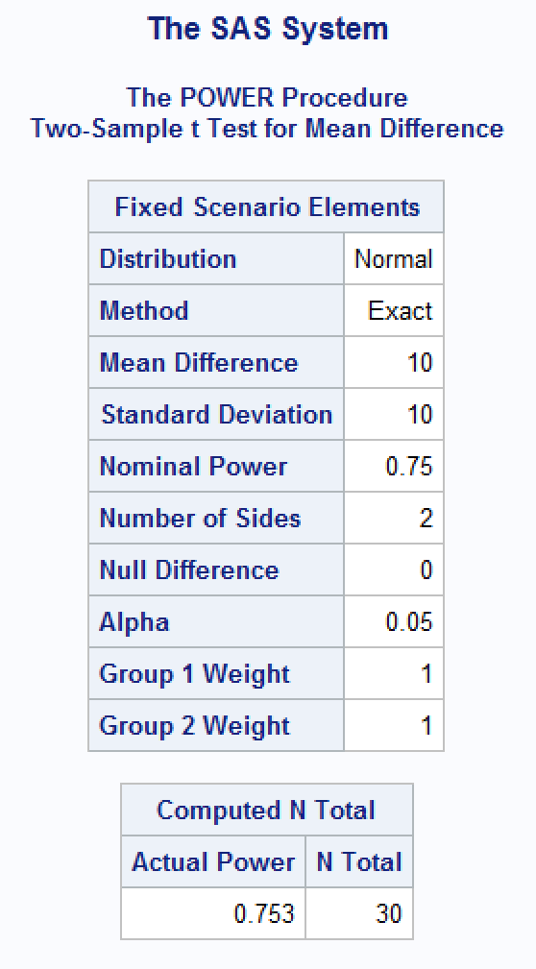

1. Chapter 23 Problem 18:

Nibbling and LDL Cholesterol. Some studies by J. Mann at the University of Otago, New Zealand, suggest that nibbling—eating small amounts of food frequently rather than eating three larger meals each day—may be a way to lower cholesterol levels. These were small studies involving hospital patients. (Data from J. Mann, “Cholesterol Worries? Nibble More on Less,” Science News, 132, March 13 1993, p. 165.) Design a study that would answer the question, “Does consuming nine small snack-sized meals each day (nibbling), rather than consuming three meals, reduce LDL cholesterol levels?” Assume that LDLcholesterol will need no transformation. Assume that the mean of the reduction in LDL cholesterol under the three-meal diet will be small and that its standard deviation will be approximately equal to its mean value. Assume also that the standard deviation of the reduction under the nibbling diet will be approximately the same as under the three-meal diet. And assume that you wish to be able to detect a mean reduction under the nibbling diet that is 20% greater than the mean reduction under the three-meal diet.

Make sure and describe your experimental design including any treatments, factors, levels etc. Also remember to include a sample size estimate with respect to the given assumptions. Use SAS proc glmpower to get your estimated sample size and use proc power to verify. Provide your code and screenshots of the output for each proc. Finally, calculate an estimate of the sample size using the formula on page 709. Note that the textbook says that the ‘n’ on page 709 represents the sample size per group when it actually represents the total sample size of all the groups.

In order to answer the question of interest (Does consuming nine small snack-sized meals each day, rather than consuming three meals, reduce LDL cholesterol levels?), we would need to conduct an experiment comparing two groups. Group_1 will be the control group, which will consume three large meals during the day. Group_2 will be the treatment group and will consume 9 snack-sized meals during the day. Because cholesterol levels from their previous diets may have an effect on early records, we will conduct the study for an extended number of days. However, considering stays at the hospital are normally reserved for those with life threatening injuries, the patient pool will have to be from the surgery recovery patient pool. All patients will have average cholesterol levels and at the beginning of the study. The medication being provided to the patients will also be held constant since most surgery recovery patients are given antibiotics for infection treatment and pain killers. Neither of the drugs are known for having an effect on cholesterol levels in the blood stream. The meals provided to the patients will all come from the same source (hospital cafeteria) and the in-house nutritionist will validate that all the meals meet the daily recommended nutrition value in order to prevent giving one party “healthier” meals than the other. The experiment will be a double-blind study. This will be achieved by replacing the names of the individuals with room numbers as their respected identifiers. The patients will be given their respective treatments as soon as they begin recovery. Their first meal will set the tone for the rest of the meals, which will not let them know there is another group getting different meals. The control group will simply stick to the normal routine of 3 meals a day. The meals will be given by a nurse, who also won’t know he/she is participating in a study. Among other duties, he/she will be tasked to provide the “meal plan prepared by the nutritionist” for the patient. The nutritionist won’t know which patients are getting what meals since the nutritionist won’t be seeing a list of patients. The meal prep will take place in the kitchen and won’t know who is the end-consumer of the meal. An LVN (or some other medical assistant) will conduct typical blood work as they normally would and final results will be provided to the doctor for evaluation on the cholesterol level. The doctor won’t know either who is in which group until the identifiers are replaced once again with the names and groups by the researcher.



 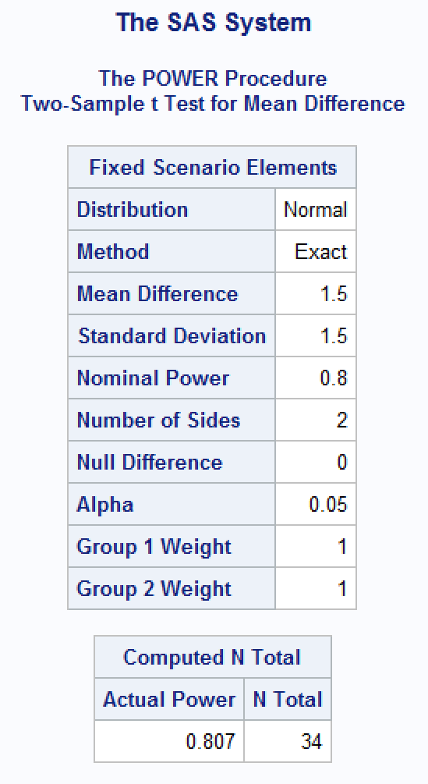



1. Chapter 23Problem 19:

Seasonal Dyslexia. Researchers at the University of Arkansas theorize that exposure to inﬂuenza and other viral diseases in the second trimester of pregnancy may be a factor increasing the odds that the child will be dyslexic. (Dyslexia is a reading disability, deﬁned as a reading score on standard tests falling at least two years behind the expected level, despite a normal IQ.) One piece of evidence that could support this would be a high rate of dyslexia in children born in the summer months, because the second trimester would have fallen in the inﬂuenza season. Design an observational study to examine this conclusion. Assume that this will be a case–control study with a random sample of dyslexic boys compared to an equally sized random sample of nondyslexic boys. Compare the frequency of births in June, July, and August with the frequency of births in December, January, and February. Ignore births in the other months. In the control group, you expect about 50% to be born in the summer months. How large should each sample be if you wish to detect a twofold difference in the odds?

In order to answer the question of interest (Does exposure to influenza during third trimester increase the frequency of dyslexia in children?), an observational (case-control) study would be conducted. There would be two factors of random boys: with dyslexia and without dyslexia. Each factor would then be with 3 levels, one for each trimester. Although we are only interested birth frequencies for children born on Dec. – Feb. and June – Aug., we could utilize the boys born in Mar. – May to improve the degrees of freedom of the analysis. Based on the numbers provided, the proper sample size would be 274.



