372 UNIT 10 HW

Check out the study on smoking and cancer:

<http://cancerres.aacrjournals.org/content/canres/48/11/3282.full.pdf>

Answer the following questions:

**1. What type of study was this? Retrospective, Prospective, Completely Observational or Randomized Experiment?**

This was a retrospective observation case-control study since the cancer was identified prior to the study and subjects were selected working backwards.

**2. What statistic is used as the response (“the measure of association”)?**

Odds ratio

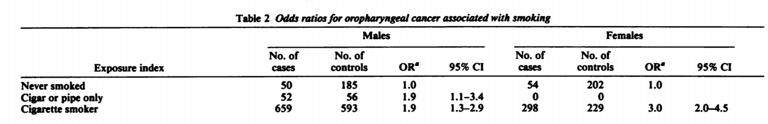

**3. Consider the table above from the paper. For males, find the odds ratio and 95% confidence interval for the odds of having cancer (being a “case”) for someone who had never smoked versus the odds of having cancer for someone who smoked cigarettes.**

Odds ratio for males with cancer who have never smoked is 1.0. The odds ratio for males with cancer who smoke cigarettes is 1.9 with 1.3 – 2.9 95% confidence interval.

**4. Do the same for females and compare the results. Does there appear to be strong evidence that cigarettes increase the “risk” (as measured by the odds ratio) for females more than it does for males?**

Odds ratio for females with cancer who have never smoked is 1.0. The odds ratio for females with cancer who smoke cigarettes is 3.0 with 2.0 – 4.5 95% confidence interval. It appears the odds are greater for females with cancer who smoke cigarettes than males who have cancer who smoke cigarettes.

**5. Notice that the odds ratios and confidence intervals are different than the ones listed in the table. Why do you think that is? (You will need to see the original table from the paper.)**

The table included in this document is an aggregate table. It doesn’t account for the additional layers included in the exposure index. The other variables are age, length of smoking, number of cigarettes/day, and duration since quitting.