Javier Saldana

HW 5 Repeated Measures Analysis

Repeated measures study designs are frequently used in clinical research within Immunology. Our immune system is adaptive and learning all the time. As the body gets introduced to foreign virus or drugs, it sets off a sequence of reactions throughout the body at all levels of the immune system from things we can observe physically from a patient (like rashes) versus small molecular reactions that directly fight off and wipe out a virus.

In this particular study, researchers wanted to understand how a specific gene IFITM3 (in a healthy human) changes over time, when the people under study have volunteered to get injected with a specific Flu strain. The gene is measured on a cohort of 17 healthy individuals who agreed to participate in the study. There are a total of 8 time points (in hrs) over a period of a few days. The first time-point (Hour 0) represents measurements taken on all of the people before the flu was injected into their bodies. The remaining time points are measurements taken post flu being introduced to the body. In addition to data being collected at each time point, each patient was classified at the end of the study as being either “Symptomatic” or “Asymptomatic”. Folks who are asymptomatic are not showing any flu like symptoms while folks in the symptomatic group are.

The IFIT3M gene is known to be a code for producing interferon. When interferon levels spike in the body, it is an indicator that the immune response has “kicked in” to fight the foreign intruder. When the immune response is fighting, we tend to see signs of that fighting through inflammation (flu like symptoms).

HW Question Set

1. Generate a plot of the data that allows us to view the data by time and also by symptom status. (The specifics of what plot to use like raw data, means and sds, etc is up to you).



1. Using the time variable and symptom status variables, generate a repeated measures model using the Compound Symmetry structure for the correlation that exists within people. Provide a plot of the residual diagnostics and comment on the validity of the assumptions.

While the residuals are normal based on the output, the residuals don’t appear to have homogenous variance. In fact, it appears they are leaning to extremes in the data set and a clear relationship is present between residuals.



1. The researchers have two specific questions. Using your knowledge of the ANOVA F-tests as well as specific contrasts to answer the following questions.
   1. Do the changes that potentially exist over time depend on which symptom status you are a part of? Provide the statistical details: test statistic, p-value, and conclusion that yields the answer to this question.

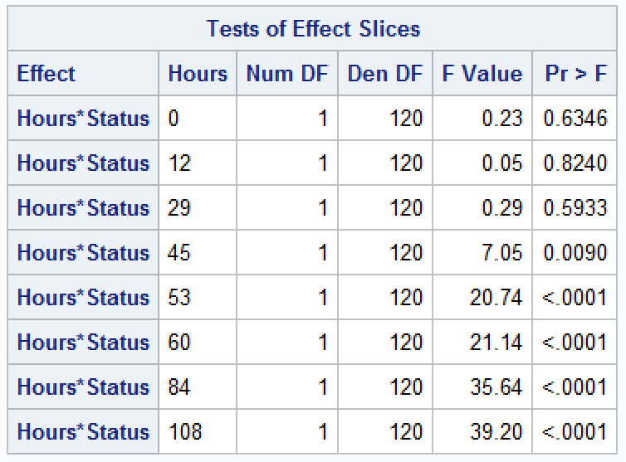

Based on the statistical output, we can see there is evidence to suggest the status (Symp v. Asymp) is not statistically significant until we reach 45 Hours. In other words, the difference in means between Hours 0, 12, and 29 are equal to zero (p values > 0.05). For all other Hours, we find there is a statistical difference between the means.



* 1. Are the means for the Asymptomatic group and the Symptomatic group at HR 0 statistically different? At what time point do we start seeing statistically different means between the two groups? Provide the statistical details: test statistic, p-value, and conclusion that yields the answer to this question. (Hint (Contrasts are helpful here, or look up the slicediff option of proc mixed)

The statistical output below produces the same output as above but provides the ANOVA table for each Hour. The ANOVA tables suggest there is not sufficient evidence that the Asymptomatic and Symptomatic groups have a mean difference other than zero (p value 0.6346, F test). In other words, there is no difference in means between both groups at Hour 0. We can see that a difference doesn’t begin to become statistically significant until Hour 45 and onward.



