# **Unit 6: Homework**

1. What are user defined functions and stored procedures? When are they typically used?

User defined functions and stored procedures allow for “business functions” to be stored in the database. They custom-made by the user and can be accessed by software outside of the database in order to perform the functions without having to update the database. They can be used to perform calculations without having to modify the database.

1. Building on our Marketing project ,

Calculate the Average Number(Count) of Orders per season ( Seasons as defined in the SQLProject_When_ToOffer file)

SELECT

if (date_format(OrderDate, "%b") in ('Nov','Dec'),'Holidays', if(date_format(OrderDate, "%b") in ('Jun','Jul','Aug','Sep'),'Summer','Other') ) as Season ,

round(count(oh.OrderNumber),2 ) as Orders_Count

FROM

OrderHeader as oh,

OrderLine as ol

WHERE

oh.OrderNumber=ol.OrderHeader_OrderNumber

GROUP BY

Season

ORDER BY

Avg_Orders_Count;

#Since the order history is only for 2017, the count of orders per season is also the average of orders per season.

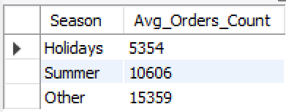

1. Is our Ecommerce DB design 1NF , 2NF and 3NF compliant ?  
   If yes , Why ? If No , why not?

The Ecommerce DB satisfies the requirements of all the normalization forms. A review of each table confirms there is only a single value being stored in each cell. Each record is unique as well per the tables. Each table contains only 1 primary key, which at times is also the foreign key which helps establish the relationships with the other tables. It’s a bit difficult to asses whether it meets 3NF but based on a preliminary review, it appears it does. A good example is the address table, which would normally have dependencies between the state and zip code. The database is currently set up where if these dependencies were in fact present, then it would satisfy those requirements as is.