**Unit 7: Homework**

1. Create the relevant database relations by decomposing the following entity into its constituent tables by applying the database normalization techniques.

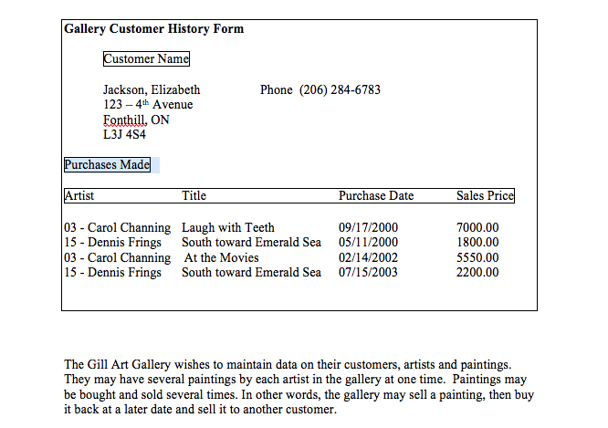

**UNF:**

**customer [ custno, cust_name, cust_addr, cust_phone, ( artist_id, artist_name, art_title, pur_date, price) ]**

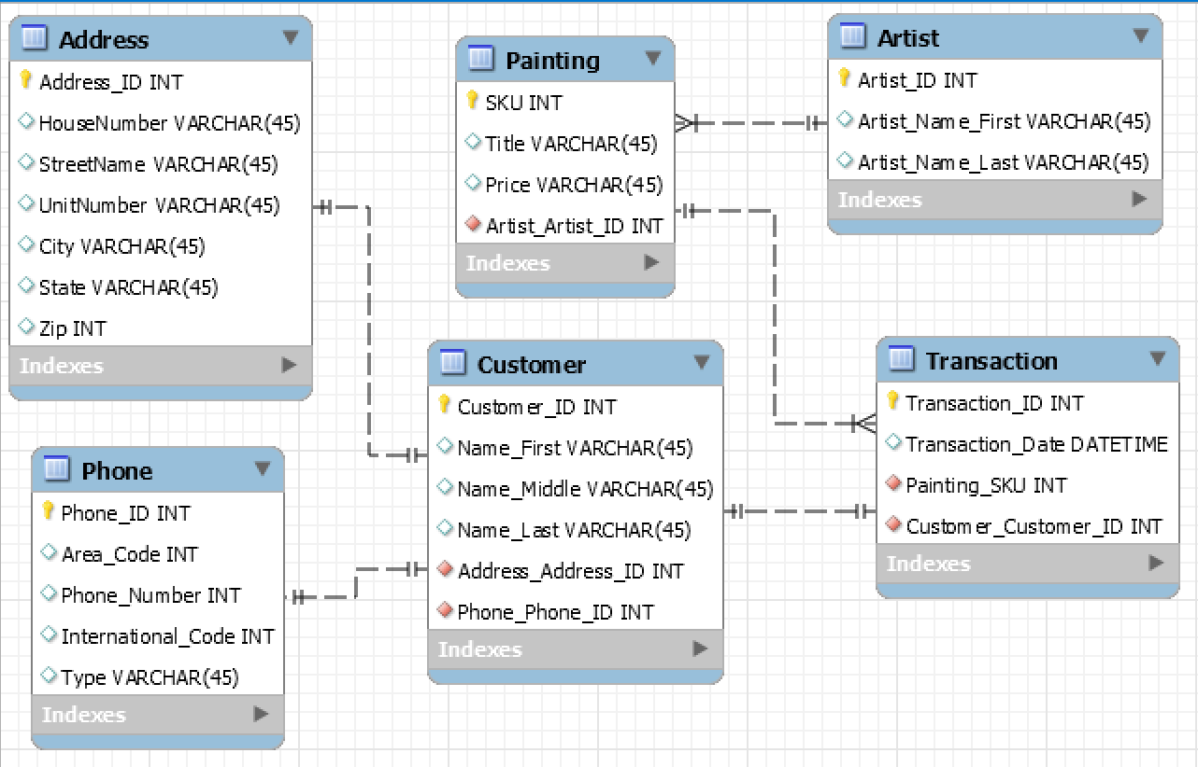

1. In addition to this assignment, submit the completed In-class Exercise #2 from Unit 7 as a part of your homework.

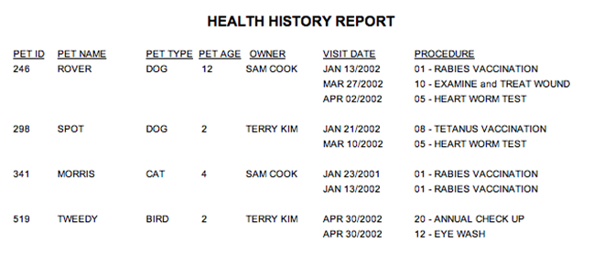

**UNF:**

**Pet [ pet_id, pet_name, pet_type, pet_age, owner, ( visitdate, procedure_no, procedure_name ) ]**

