**Unit 9: Homework**

1. Set up and configure InClass Lab #2 (Rest Services) from Unit 9 . Turn in the screenshots of the output from the 2 rest services getCustomerList and getOrderDetails

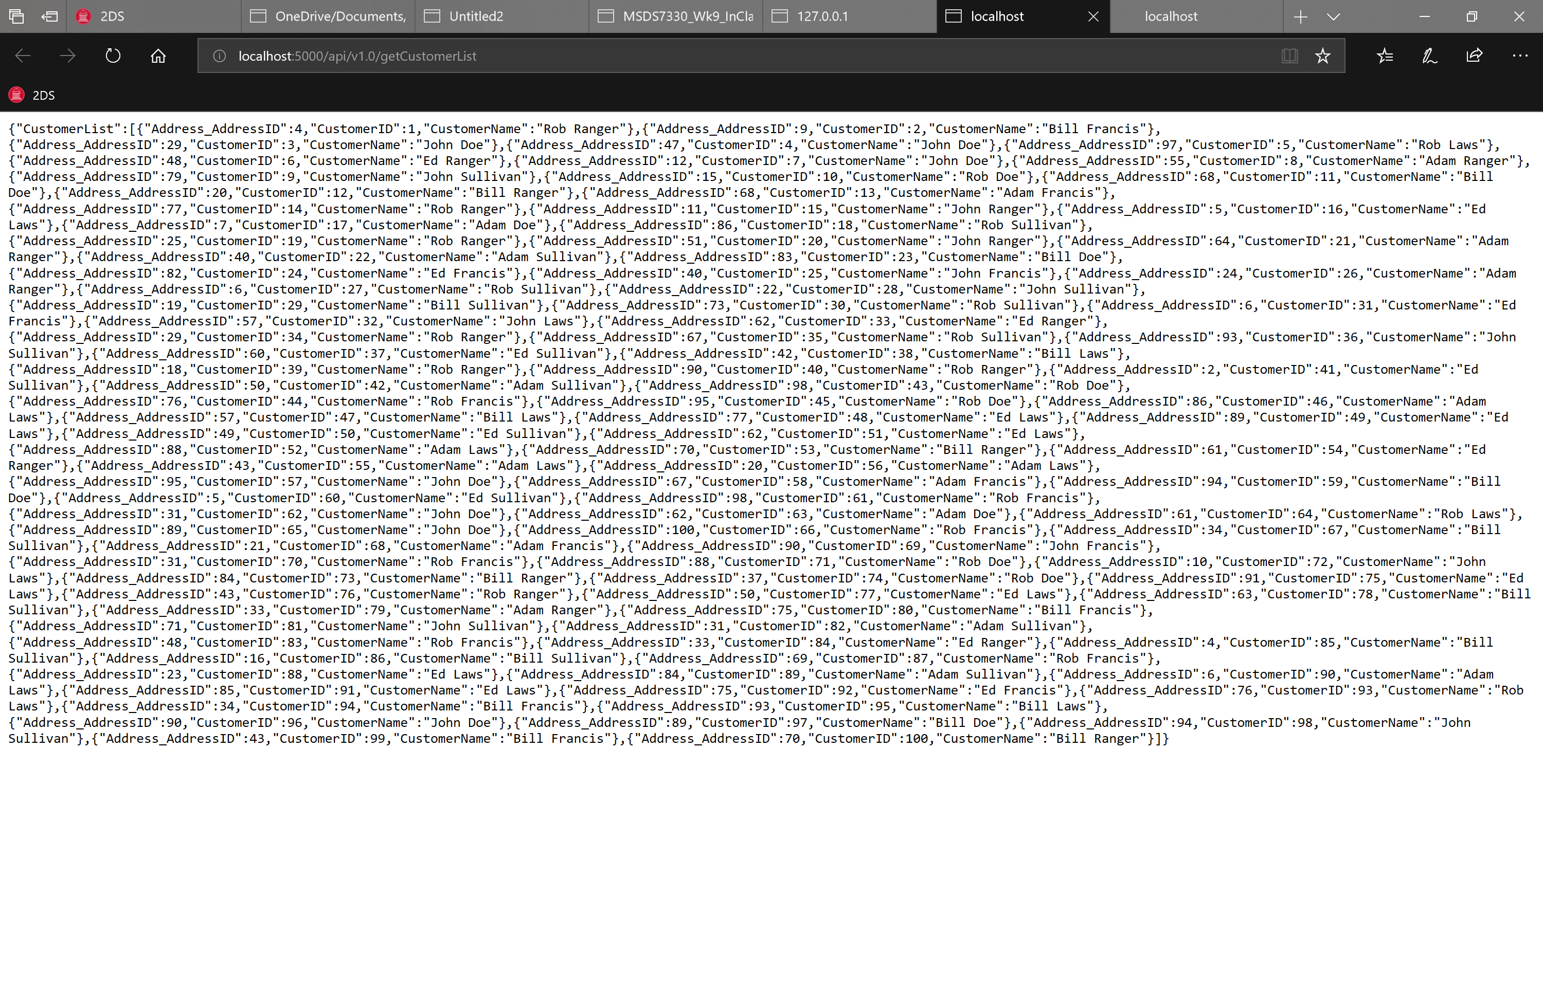 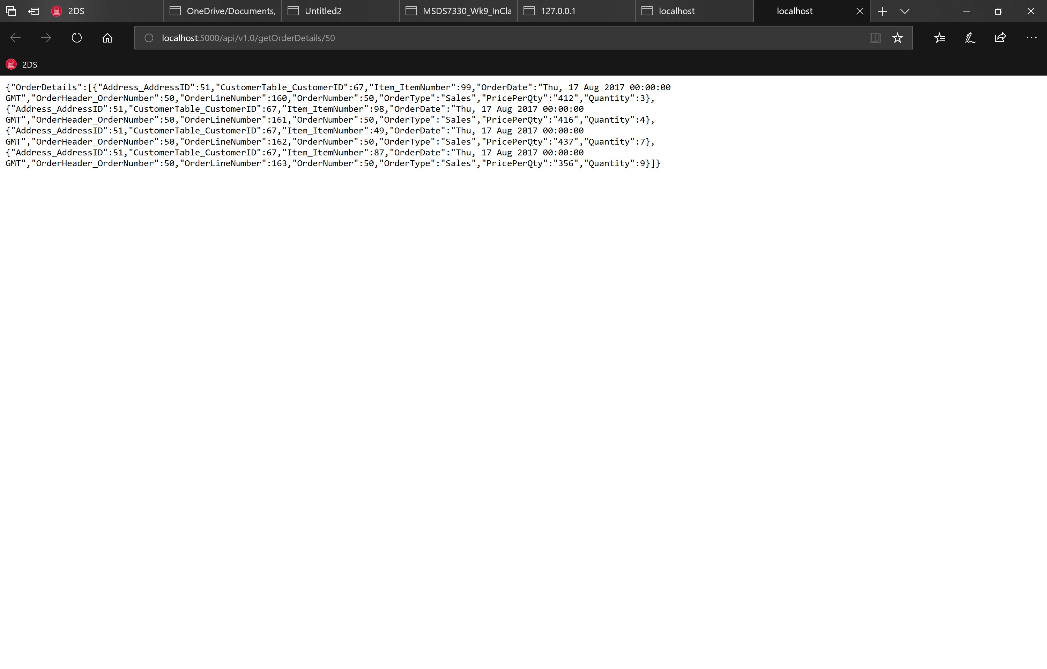

1. Write a new rest service that takes in a number as input and returns the square of the number as the output. The output of the service must be a json structure, turn in the code and the screenshot

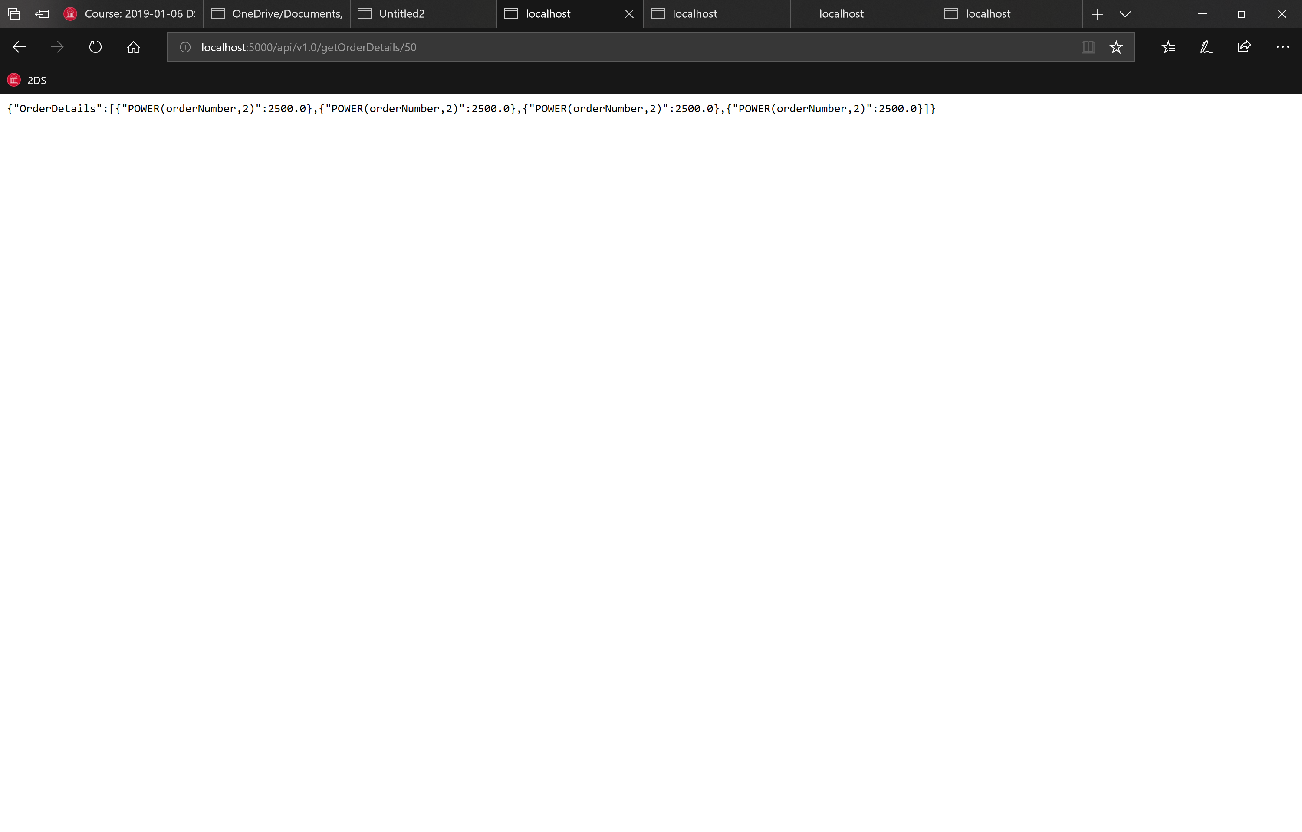 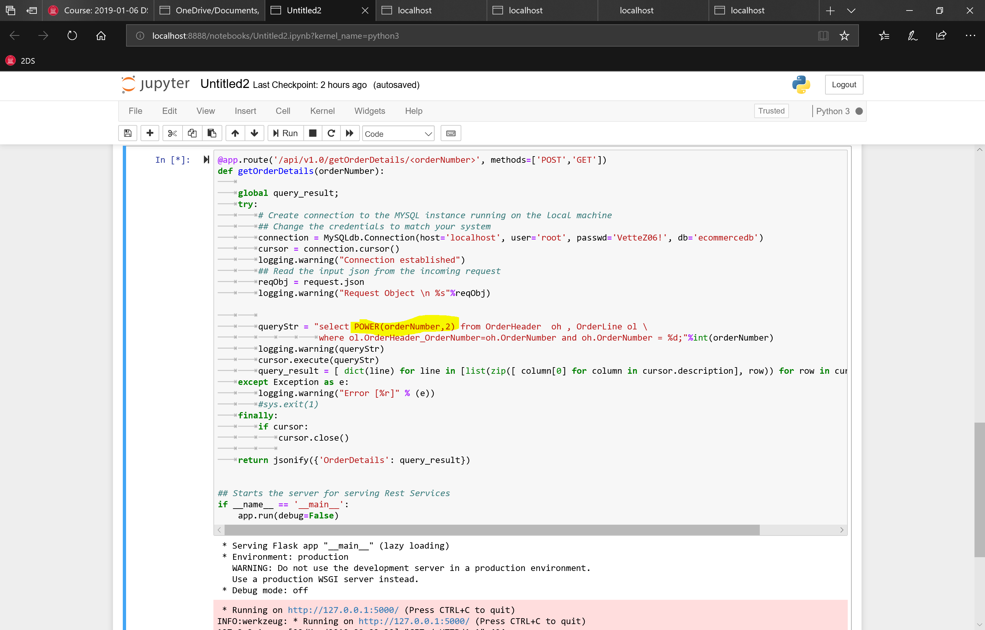

Additionally , read about the following topics online to get additional background information

* RestServices (<https://www.youtube.com/watch?v=LooL6_chvN4> , <https://www.infoq.com/articles/rest-introduction#anch15265>
* HTTP Get and Post methods (https://www.youtube.com/watch?v=UObINRj2EGY)
* Python Flask Library (<https://blog.miguelgrinberg.com/post/designing-a-restful-api-with-python-and-flask)>

Feel free to search online for any other useful materials about the above topics and share them on the course wall!