[1]

Practical Framework for a Universal Health Insurance Database

Meredith Ludlow and Javier Saldaña Jr.

*Abstract*—These instructions give you guidelines for preparing papers for IEEE Transactions and Journals*.* Use this document as a template if you are using Microsoft *Word* 6.0 or later. Otherwise, use this document as an instruction set. The electronic file of your paper will be formatted further at IEEE. Paper titles should be written in uppercase and lowercase letters, not all uppercase. Avoid writing long formulas with subscripts in the title; short formulas that identify the elements are fine (e.g., "Nd–Fe–B"). Do not write “(Invited)” in the title. Full names of authors are preferred in the author field, but are not required. Put a space between authors’ initials. Define all symbols used in the abstract. Do not cite references in the abstract. Do not delete the blank line immediately above the abstract; it sets the footnote at the bottom of this column.

*Index Terms*—business, claim, database, insurance, universal.

# INTRODUCTION

T

HE insurance industry has been slow to embrace the big data strategies many other industries (such as retail and marketing) have grown to become synonymous with. However, the slow adoption of big data strategies doesn’t mean the data isn’t being collected. In 2011, the “U.S. health care data alone reached 150 exabytes,” which is the equivalent of 161,061,273,600 gigabytes (iHT2, 2013). The data collected by health carriers may range from a wide spectrum of facets pertaining to an individuals’ life.

Consider a scenario in which a customer has an offspring added to his/her health insurance policy. Assuming the child is insured through the same carrier until he/she is old enough to be on their own policy, every medical record and/or visit of that child will be present in the health carrier’s database. In every visit, the physician must obtain health performance data in order to determine which medicine may be administered, etc. Should the same child, now a grown adult, choose to remain with the same insurance carrier, the data collected on that individual will continue until the policy and/or the customer expire. Considering the sensitivity of the health information collected, health carriers (along with anyone else who collects and stores health information in the United States) must comply with federal regulations in order to ensure the entity is practicing great care and responsibility of the data.

The three pieces of legislation that govern the health carriers are The Gramm-Leach-Bliley Act (GLBA), the Health Insurance Profitability and Accountability Act (HIPPA), and the Fair Credit Reporting Act (Nunn, 2007).

As previously mentioned, collecting and storing data is something the health carriers are already efficient in and have been doing for years. Whether it is through traditional means such as mail correspondence or digital delivery, insurance laws across the United States have bestowed the burden of proof on the claimants when seeking coverage under a policy. In other words, if a claimant files a claim for a hospital visit, it is ultimately up to them to provide the health carrier the necessary medical records in order to meet the burden of proof.

In order to comply with the federal and local regulations, carriers have developed standard processes in which employees are expected to act accordingly in order to preserve the integrity of the data but also protect the data from external threats. However, this has led to a fragmentation of databases as each carrier strives to build their own universal health care database. The fragmented databases have spurred new challenges and hurdles that carriers are now facing today.

As a result, third-party companies have taken the initiative to attempt to create collaboration between carriers and their data, which may be used to report and query prior claim information for a claimant regardless of who the carrier was at the time. However, the subscription fees tend to be very expensive and many small insurance companies are not members of such services, which creates inaccurate and/or incomplete records. Other services provide access to the verification of assets owned and prior insurance information but have the same pitfalls as the prior service. Since most of these services are membership driven, they are home to the major insurance carriers but neglect the value of the small insurance carriers. The information inaccuracies result in inefficiencies within major corporations and increase in claim cost, which results in a higher premium penalty for the customers.

In this paper, we will propose a solution to the fragmented databases by presenting the framework for a universal database with an efficient input/query system. A solution to this problem would be the development of a universal insurance database. A universal insurance database would host claim, sales, underwriting, and much more data for the insurance carriers to be used for cost-saving strategies in an effort to reduce premiums for the customers. While we believe a universal insurance database would result in quicker claim resolutions and a substantial decrease in expenses, we also believe a single database housing the information would be much more efficient and practical for all parties involved. Yet, we are also aware of the challenges and costs associated with this proposal and will also address them here along with creative solutions we believe may help overcome those challenges.

# Centralize Database Examples

## National Crime Information Center (NCIC)

One of the most successful examples of a centralized database is the National Crime Information Center, which was developed by the Federal Bureau of Investigation and launched in January 27, 1967. Originally just a small network between 15 state and city computers, the network only had 350,000 records over 5 different categories (FBI, 2017). The centralized database was improved over the years in order to expand to additional categories and new technological additions. By 1975, details for missing persons cases were added, which were then followed by the addition of Canadian arrest warrants in 1980 (FBI, 2017). By 1999, images and additional categories were added along with structural improvements which allowed for near instant query results (FBI, 2017). Today, the NCIC database contains 21 different categories and 12 million active records, while handling 14 million transactions per day and serving 90,000 criminal justice and law enforcement agencies (FBI, 2017).

The NCIC has been an instrumental tool in criminal investigations all over the country. However, it was once in a similar situation as was the current health care system today. Prior to the use of computers, law enforcement agencies kept physical criminal records and the most common way to query an individual’s criminal background was by asking neighboring law enforcement. This meant that an individual could easily move locales and/or states should they wish to start a new life without the burden of a criminal background following them. To query every law enforcement agency at the time was unheard of. Yet, the emergence of technology gave law enforcement the capabilities to add value to their record keeping. Director J. Edgar Hoover proposed the NCIC in 1965 as a centralized crime information center for all participating agencies, which would require them contribute to the system to be able to partake (FBI, 2017). What originally started in Washington, DC and surrounding metropolitan areas, soon spread to other regions and by 1971 included all 50 states.

The law enforcement saw the added value of a centralized crime database and has seen it pay dividends since its inception. In December 2016, a Tennessee state trooper queried the NCIC for licensed plates after spotting a suspicious vehicle at a rest stop. The results showed the vehicle was stolen in Kentucky and the Illinois-native who was driving the vehicle was a suspect in a Kentucky murder (FBI, 2017). The National Crime Information Center is a key example of member recognizing the data is worth more as a collective than a fragmented database.

## Insurance Services Office (ISO)

There are voids the public sector is unable to fill and it is there where the private sector is contributing. The Insurance Services Office is a subsidiary of Verisk Analytics, which is headquartered in Jersey City, New Jersey. While Verisk offers a collection of analytical services, it also has one core purposes which is similar to that of the NCIC. The Insurance Services Office servers mostly the property and casualty insurance sector, which is typically auto and property (personal and commercial). An insurance carrier/agent/broker is able to subscribe to ISO through its services, in which ISO then grants the subscriber access to the large collective data (including its analytical services). The subscriber provides its claim data to ISO, who then adds it to the collective database and sales access to it as a research claims tool for others to use. This strategy is beneficial for small companies who don’t have the data depth or infrastructure the major carriers have in order to be able to conduct cutting-edge analysis. For larger companies (and small ones as well), this helps them cut down on claim cost by ensuring the industry as a whole is evaluating claims similarly, which helps reduce the claim cost to its true value.

ISO began as a collective non-profit initiative by insurers as an effort to be able to share data from each other’s book of business and more accurately rate customers’ risk level in 1971. As the needs of the insurers evolved, so did ISO. Eventually, it became a for-profit organization and a subsidiary of Verisk Analytics. The evolution to a for-profit company allowed ISO to be able to provide analytical services to startup insurance carriers while leveraging the data of the major carriers.

However, even ISO has its limitations and shortcomings. Federal regulations prohibit ISO from obtaining the medical records from the carriers regarding claims. Instead, it circumvents this regulation by only collecting the injury type and settlements instead of the medical record itself.

## Malaysia’s Centralized Fingerprint Database

## University of Texas Health System

# Challenges & Regulations

[Text]

# Proposed Database Framework & Design

Assuming the geopolitical climate is in agreement with a centralized database for health care and all other obstacles are met, we believe the proposed design would make for an ideal starting point in the design of the database. Similar to the NCIC and ISO databases, the design would be rolled out incrementally and include a “pay-to-play” system in order to encourage participation.

## Centralized Database in a Distributed Network

While the NCIC is protected by the FBI, the value of a centralized database with health care information of millions of individuals would be too great a risk to keep in a central location. It would become an immediate target for malicious breach, which would deter many from participating in the network. As a result, a heavily encrypted distributed network would help secure the data and protect the integrity of the network.

Figure 1 below visually explains the differences between the three types of networks. A centralized network would always require the central station be online for it to be accessed. This would indicate that all health care providers and carriers would connect to this station in order to gain access to the network. This creates security concerns since all it would take to be able to reach the central station would be accessing a weak station. Should the central station be compromised then the entire network may be compromised.

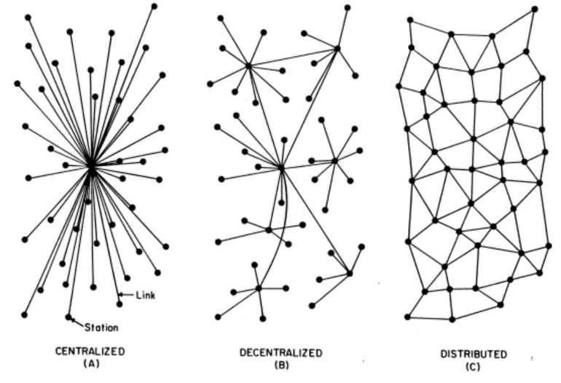

*Figure 1 – Diagram of a Centralized, Decentralized, and Distributed Network*

A decentralized network helps distribute the data to other stations, however the links from those stations to the central station are still critical. In other words, if the link between the sub-station and the central station is broken, then the stations linked to the sub-station would be completely cut off from the network. While safer than a centralized network, this still presents a problem with great risks from external attacks.

However, the distributed network design would help reduce the impact of external attacks through complexity. In this design, the network is distributed evenly throughout the grid and stations connect to multiple in order to preserve the integrity of the network. Should the event of an attack on the network take place, the affected station would be taken offline while the rest of the network continues to operate accordingly. By encrypting and distributing the data across every station available, not only would the intregrity of the network be preserved but also the security of the data itself. To gain access to the data as a whole would require gain unauthorized access to multiple stations and even then attempting to locate the correct stations would be a difficult task.

## Pay-to-Play Enrollment

The data would be collected through an initiative similar to that used by ISO. The product will be the medical data but the customers will be medical providers and health insurers.

# Conclusion

[Text]

References

1. iHT2 (2013). *Transforming Health Care Through Big Data: Strategies for leveraging big data in the health care industry*. Retrieved from: <http://c4fd63cb482ce6861463-bc6183f1c18e748a49b87a25911a0555.r93.cf2.rackcdn.com/iHT2_BigData_2013.pdf>
2. Nunn, T. (2007, March 26). *Consumer Data Protection*. Retrieved from Insurance Journal: <https://www.insurancejournal.com/magazines/mag-legalbeat/2007/03/26/78291.htm>
3. Federal Bureau of Investigation (2017, January 27). *NCIC Turns 50: Centralized Database Continues to Prove Its Value in Fighting Crime.* Retrieved from: <https://www.fbi.gov/news/stories/ncic-turns-50>

1. This rough draft was submitted for review on Mar. 17, 2019.

   M. Ludlow is a graduate student at Southern Methodist University in Dallas, TX. She is currently employed by ____ Insurance Agency in ___, TX as a Licensed Insurance Agent (e-mail: [mludlow@mail.smu.edu](mailto:mludlow@mail.smu.edu))

   J. Saldaña is a graduate student at Southern Methodist University in Dallas, TX. He is employed by Allstate Insurance in Irving, TX as a Senior Data Consultant (e-mail: [saldanaj@smu.edu](mailto:saldanaj@smu.edu)).