Physics-Informed Numerical Differentiation and Machine Learning for Smart Facility Occupancy Inference
Unit Code: MMA3001 — Numerical Methods and Machine Learning
Assessment: Major Engineering Project Deliverable
Institution: Department of Mechanical and Aerospace Engineering, Monash University
Target Facility: Building 69, Room G.57 (Smart Infrastructure / Living Lab)
Author: Sam Williamson | Date: October 2026
――――――――――――――――――――――――――――――――――――――――――――――――――――

Executive Summary
Modern Heating, Ventilation, and Air Conditioning (HVAC) systems in educational and commercial infrastructure consume approximately 40% of institutional building energy. Traditional building management systems (BMS) operate on static scheduling or continuous baseline ventilation, resulting in severe energy waste during unoccupied hours and inadequate ventilation during sudden occupancy surges. Direct occupancy monitoring through optical cameras introduces prohibitive privacy liabilities and blind spots, while passive infrared (PIR) sensors fail to detect stationary occupants during lectures and study sessions.
This project formulates, implements, and rigorously benchmarks an edge-deployable, physics-informed numerical machine learning framework to infer dynamic headcount occupancy in Monash University Building 69, Room G.57 (Living Lab). Leveraging continuous multi-modal environmental telemetry (180,314 raw records resampled to 70,601 synchronized 5-minute epochs between December 2023 and April 2026) alongside high-fidelity ground truth ceiling counter data (9,168,779 raw sensor transactions), we address the ill-posed inverse problem of building dynamics.
Because indoor ambient CO₂ behaves as a low-pass thermal and pneumatic accumulator governed by the first-order differential mass balance:
V \frac{dC}{dt} = G · N(t) - Q(t) · (C(t) - C_{\text{amb}})
static CO₂ level alone suffers from severe phase lag and hysteresis. To overcome this, we engineer first-principles numerical methods—including second-order central difference differentiation (O(h²)), cumulative trapezoidal integration for cumulative exposure dosage, and natural cubic spline interpolation with Thomas algorithm tridiagonal solving (O(n)).
We benchmark four candidate machine learning formulations across a strictly chronological 80/20 train/test evaluation split (56,480 training intervals; 14,121 unseen held-out test intervals):
- Baseline K-Nearest Neighbours (K=5) relying strictly on raw CO₂ and diurnal time (R² = 0.1305, \text{RMSE} = 6.83 people);
- Pruned Decision Tree Regressor (R² = 0.4832, \text{RMSE} = 5.27 people, zero operating-hours false negatives);
- Gaussian Process Regressor (GPR) with Squared Exponential RBF and White Noise kernel, delivering closed-form analytical predictive mean and 95% epistemic uncertainty intervals (R² = 0.4840, \text{RMSE} = 5.26 people);
- Random Forest Ensemble Regressor (R² = 0.4730, \text{RMSE} = 5.32 people, lowest \text{MAE} = 3.07 people).
Through theoretical arithmetic FLOP analysis and empirical hardware profiling over 500 repetitions, we reveal that while Random Forest requires 23,318\ \mu\text{s} per query and GPR requires 1.57\ \text{MB} of resident RAM, the Decision Tree achieves equivalent accuracy at 150.15\ \mu\text{s} latency and 5.84\ \text{KB} memory footprint, executing in merely 5 scalar comparisons. An Out-of-Distribution (OOD) bounding envelope is established to protect the BMS against anomalous sensor failure, extreme crowding, and HVAC failure. We recommend a hybrid dual-tier architecture: the Decision Tree operates directly on low-power ARM Cortex-M edge microcontrollers for real-time BMS actuation, while the GPR model runs on the local facility edge gateway to provide calibrated safety margins and anomaly detection.
――――――――――――――――――――――――――――――――――――――――――――――――――――

1. Engineering Context & Problem Formulation

1.1 Facility Specification: Monash Building 69, Room G.57
Room G.57 is a high-utilization multipurpose living laboratory and collaborative teaching facility located on the ground floor of Monash University Building 69 (Clayton campus). The room features a multi-zone variable air volume (VAV) air handling unit, high ceilings, large fenestration, and variable occupancy patterns ranging from solitary researchers during evening hours to over 90 occupants during peak collaborative workshops.
+-------------------------------------------------------------------------------+
| Monash Building 69 - Room G.57 |
| |
| [ Ceiling Optical Counter Sensor: 56923747-b390-4f2a-8930-808429132266 ] |
| Coordinates Spaces: 0f3f37f8, 941f0352, cca1ac3e, 3e5a14df, 227f1068 |
| |
| +---------------------+ +---------------------+ |
| | Environmental Node | | Environmental Node | |
| | 6012002000241 | | 6012002000326 | |
| +---------------------+ +---------------------+ |
| |
| +-----------------------------------+ |
| | Central Lab Zone / Seating | |
| | CO2, Temp, Humidity, VOC, PM | |
| +-----------------------------------+ |
| |
| +---------------------+ +---------------------+ |
| | Environmental Node | | Environmental Node | |
| | 6012002000869 | | 6012002000227 | |
| +---------------------+ +---------------------+ |
| |
| +---------------------------+ |
| | Environmental Node: 00777 | |
| +---------------------------+ |
+-------------------------------------------------------------------------------+
The facility is instrumented with:
- Environmental Sensor Telemetry: Five IoT environmental sensing nodes (`6012002000241`, `6012002000326`, `6012002000869`, `6012002000227`, `6012002000777`) logging carbon dioxide concentration (CO₂, ppm), dry-bulb temperature (T, °C), relative humidity (RH, %), volatile organic compounds (VOC, ppb), formaldehyde (\mu\text{g}/m³), atmospheric pressure (mb), and particulate matter (PM_{1.0}, PM_{2.5}, PM_4, PM_{10}, \mu\text{g}/m³).
- Ground Truth Ceiling Counters: High-precision stereoscopic optical ceiling counters (`56923747-b390-4f2a-8930-808429132266`) recording directional crossing vectors across five designated space zones (`0f3f37f8`, `941f0352`, `cca1ac3e`, `3e5a14df`, `227f1068`), continuously tracking net in-room occupants.

1.2 The Inverse Problem and Engineering Constraints
Inferring human occupancy from non-invasive indoor air quality telemetry constitutes an inverse dynamic state estimation problem. While human respiration generates carbon dioxide (G ≈ 0.005\ \text{L}/\text{s} per person at metabolic rate 1.2 met) and emits sensible and latent heat, the room volume acts as an integrator. The measured concentration at time t reflects the history of past occupancy filtered through ventilation exchange rather than instantaneous occupancy.
The engineering solution must satisfy four operational constraints:
- Zero Operating-Hours False Negatives: If occupants are present during university working hours (08:00–18:00, Monday–Friday), the system must never infer zero headcount. A false negative would shut down ventilation dampers, degrading cognitive performance and violating ASHRAE Standard 62.1 indoor air quality mandates.
- Computational Tractability on Embedded Edge Nodes: Inference must run on low-power microcontrollers (e.g., ARM Cortex-M4/M7 at 80–200 MHz, ≤ 256\ \text{KB} RAM) without requiring continuous cloud telemetry round-trips.
- Calibrated Epistemic Uncertainty: The system must provide confidence bounds to allow the BMS to distinguish between high-confidence steady states and high-uncertainty transient states.
- Out-of-Distribution Detection: Sensor failure, drift, or unprecedented thermal spikes must be flagged before passing invalid states to mechanical actuators.

1.3 Formal Input and Output Vectors
- Input Vector \mathbf{x} ∈ \mathbb{R}^{16}:
\mathbf{x} = \begin{bmatrix} C & \frac{dC}{dt} & \Delta C_{\text{amb}} & ∈t_{t-3\text{h}}^t \Delta C\, d\tau & T & \frac{dT}{dt} & RH & \frac{dRH}{dt} & t_{\text{day}} & d_{\text{week}} & \mathbb{I}_{\text{op}} & \mathbb{I}_{\text{wknd}} & \sin\theta_h & \cos\theta_h & \sin\theta_d & \cos\theta_d \end{bmatrix}^T
- Primary Continuous Output: Predicted headcount \hat{N} ∈ [0, N_{\max}], clamped by physical constraint \hat{N} ≥ 0.
- Probabilistic Output (GPR): Posterior distribution \mathcal{N}(\mu_*(\mathbf{x}), \sigma_*^2(\mathbf{x})) yielding the 95% credible interval [\mu_* - 1.96\sigma_*, \mu_* + 1.96\sigma_*].
- Operational Binary Output: \hat{y}_{\text{occ}} = \mathbb{I}(\hat{N} ≥ 1.0) ∈ \{0, 1\}.
――――――――――――――――――――――――――――――――――――――――――――――――――――

2. Mathematical & Numerical Methods Formulation

2.1 First-Principles Gas Dispersion Mass Balance
The conservation of carbon dioxide mass inside a well-mixed room volume V (m³) is governed by:
V \frac{dC(t)}{dt} = G · N(t) - Q(t) · ≤ft( C(t) - C_{\text{amb}} \right)
where:
- C(t) is the indoor CO₂ mole fraction (ppm or \text{mL}/m³),
- C_{\text{amb}} ≈ 415\ \text{ppm} is the background outdoor ambient CO₂ concentration,
- G is the average per-person metabolic CO₂ generation rate (\text{mL}/\text{min} per person),
- N(t) is the instantaneous human headcount,
- Q(t) is the volumetric outdoor air ventilation supply rate (m³/\text{min}).
Rearranging the differential equation directly for instantaneous headcount yields:
N(t) = \frac{1}{G} ≤ft[ V \frac{dC(t)}{dt} + Q(t) ≤ft( C(t) - C_{\text{amb}} \right) \right]
This physical derivation establishes that instantaneous occupancy is fundamentally proportional to a linear combination of:
- The instantaneous accumulation rate \frac{dC}{dt},
- The concentration elevation above baseline (C(t) - C_{\text{amb}}).
A model that receives only static C(t) without its derivative \frac{dC}{dt} cannot differentiate between:
- A room with 40 people entering, where CO₂ is at 550\ \text{ppm} but rising rapidly at +15\ \text{ppm}/\text{min},
- A room that has been evacuated for 30 minutes, where CO₂ remains at 550\ \text{ppm} but is decaying exponentially at -10\ \text{ppm}/\text{min}.

2.2 Numerical Differentiation: Second-Order Central Difference
Given uniformly sampled discrete observations C_i = C(t_i) with fixed step size h = \Delta t = 5\ \text{minutes}, the Taylor series expansions of C(t + h) and C(t - h) are:
C(t+h) = C(t) + h C'(t) + \frac{h^2}{2} C''(t) + \frac{h^3}{6} C'''(t) + O(h^4)
C(t-h) = C(t) - h C'(t) + \frac{h^2}{2} C''(t) - \frac{h^3}{6} C'''(t) + O(h^4)
Subtracting the lower expansion from the upper expansion eliminates the second-derivative even-order error terms:
C(t+h) - C(t-h) = 2h C'(t) + \frac{h^3}{3} C'''(t) + O(h^5)
Solving for the derivative yields the second-order central difference formula:
C'(t_i) = \frac{C_{i+1} - C_{i-1}}{2h} + \mathcal{E}_{\text{truncation}}(h), \quad \text{where } \mathcal{E}_{\text{truncation}}(h) = -\frac{h^2}{6} C'''(\xi) = O(h^2)
At the boundary nodes i=0 and i=n-1, single-sided second-order forward and backward differences are applied to maintain O(h²) global accuracy:
C'(t_0) = \frac{-3 C_0 + 4 C_1 - C_2}{2h} + O(h^2), \qquad C'(t_{n-1}) = \frac{3 C_{n-1} - 4 C_{n-2} + C_{n-3}}{2h} + O(h^2)
# Implemented in execution/numerical_methods.py
def central_difference_derivative(y: np.ndarray, dt: float) -> np.ndarray:
dydt = np.empty_like(y, dtype=np.float64)
dydt[1:-1] = (y[2:] - y[:-2]) / (2.0 * dt)
dydt[0] = (-3.0 * y[0] + 4.0 * y[1] - y[2]) / (2.0 * dt)
dydt[-1] = (3.0 * y[-1] - 4.0 * y[-2] + y[-3]) / (2.0 * dt)
return dydt

2.3 Numerical Quadrature: Composite Simpson's 1/3 Rule and Cumulative Trapezoid
To capture chronic sensor accumulation and thermal mass retention, the cumulative exposure dosage over a trailing window W = [t - 3\text{h}, t] is evaluated:
\mathcal{D}(t) = ∈t_{t-W}^t ≤ft( C(\tau) - C_{\text{amb}} \right) d\tau
For a window partitioned into 2m sub-intervals of width h, the Composite Simpson's 1/3 Rule achieves fourth-order truncation accuracy O(h⁴):
∈t_a^b f(x)\, dx = \frac{h}{3} ≤ft[ f(x_0) + 4 \sum_{j=1}^m f(x_{2j-1}) + 2 \sum_{j=1}^{m-1} f(x_{2j}) + f(x_{2m}) \right] - \frac{(b-a) h^4}{180} f^{(4)}(\xi)
For ongoing stream calculation along the entire telemetry series, the running cumulative integral is evaluated via the recursive composite trapezoidal rule:
\mathcal{I}_{i} = \mathcal{I}_{i-1} + \frac{h}{2} ≤ft( f_i + f_{i-1} \right), \quad \mathcal{E}_{\text{trap}} = O(h^2)

2.4 Natural Cubic Spline Interpolation with Tridiagonal Thomas Algorithm
When missing sensor readings occur during IoT packet drops, standard linear interpolation introduces non-physical discontinuous derivative jumps (C'' = \pm ∈fty), corrupting numerical differentiation. We implement a first-principles Natural Cubic Spline interpolation routine.
On each sub-interval [x_i, x_{i+1}], the interpolant is a cubic polynomial:
S_i(x) = a_i + b_i (x - x_i) + c_i (x - x_i)^2 + d_i (x - x_i)^3
Enforcing C^0 continuity, C^1 continuity, C^2 curvature continuity, and natural boundary conditions (S''(x_0) = S''(x_n) = 0) produces a symmetric, strictly diagonally dominant tridiagonal linear system for the secondary coefficients c_i:
$$\begin{bmatrix}
1 & 0 & 0 & \dots & 0 \\
h_0 & 2(h_0 + h_1) & h_1 & \dots & 0 \\
0 & h_1 & 2(h_1 + h_2) & h_2 & 0 \\
\vdots & & \ddots & \ddots & \vdots \\
0 & \dots & 0 & 0 & 1
\end{bmatrix}
\begin{bmatrix} c_0 \\ c_1 \\ c_2 \\ \vdots \\ c_n \end{bmatrix}
=
\begin{bmatrix}
0 \\
3 ≤ft( \frac{a_2 - a_1}{h_1} - \frac{a_1 - a_0}{h_0} \right) \\
3 ≤ft( \frac{a_3 - a_2}{h_2} - \frac{a_2 - a_1}{h_1} \right) \\
\vdots \\
0
\end{bmatrix}$$
Because the tridiagonal matrix is strictly diagonally dominant, it is solved without pivoting using the Thomas algorithm (LU decomposition specialized for tridiagonal systems) in deterministic O(n) time complexity and O(n) space complexity.
――――――――――――――――――――――――――――――――――――――――――――――――――――

3. Machine Learning Formulation & Algorithms

3.1 Model 1: Baseline K-Nearest Neighbours Regressor (KNN)
The baseline model serves as the benchmark representative of unengineered naive machine learning. It uses K=5 Euclidean neighbours fitted purely on raw CO₂ concentration and diurnal time of day:
\hat{N}_{\text{KNN}}(\mathbf{x}_q) = \frac{1}{K} \sum_{k=1}^K y_{\pi_k(\mathbf{x}_q)}
where \pi_k(\mathbf{x}_q) indexes the k-th closest training exemplar under Euclidean metric d(\mathbf{x}_q, \mathbf{x}_i) = \|\mathbf{x}_q - \mathbf{x}_i\|_2.

3.2 Model 2: Decision Tree Regressor
The Decision Tree constructs an axis-aligned recursive partitioning of the 16-dimensional feature space. At each internal node m, the algorithm selects the feature j and split threshold s that minimizes the sum of squared errors (variance reduction):
\min_{j, s} ≤ft[ \sum_{i ∈ \mathcal{R}_L(j, s)} (y_i - \bar{y}_L)^2 + \sum_{i ∈ \mathcal{R}_R(j, s)} (y_i - \bar{y}_R)^2 \right]
To prevent overfitting on transient sensor fluctuations, the tree depth is constrained to \text{depth} ≤ 5, with minimum leaf samples set to 20. Inference is executed strictly through a chain of 5 binary scalar comparisons, completely avoiding matrix multiplication.

3.3 Model 3: Gaussian Process Regressor (GPR) with Closed-Form Epistemic Uncertainty
A Gaussian Process defines a non-parametric prior over continuous latent functions f(\mathbf{x}) \sim \mathcal{GP}(m(\mathbf{x}), k(\mathbf{x}, \mathbf{x}')). Given training targets \mathbf{y} = f(\mathbf{X}) + \boldsymbol{\epsilon} with independent Gaussian noise \epsilon_i \sim \mathcal{N}(0, \sigma_n^2), we specify an anisotropic Squared Exponential (RBF) covariance kernel with White Noise variance:
k(\mathbf{x}_i, \mathbf{x}_j) = \sigma_f^2 \exp≤ft( -\frac{\|\mathbf{x}_i - \mathbf{x}_j\|^2}{2 \ell^2} \right) + \sigma_n^2 \delta_{ij}
The joint distribution of observed targets \mathbf{y} and latent prediction f_* at an unseen query point \mathbf{x}_* is multivariate Gaussian:
\begin{bmatrix} \mathbf{y} \\ f_* \end{bmatrix} \sim \mathcal{N}≤ft( \mathbf{0}, \begin{bmatrix} \mathbf{K}(\mathbf{X}, \mathbf{X}) + \sigma_n^2 \mathbf{I} & \mathbf{k}(\mathbf{X}, \mathbf{x}_*) \\ \mathbf{k}(\mathbf{x}_*, \mathbf{X}) & k(\mathbf{x}_*, \mathbf{x}_*) \end{bmatrix} \right)
Conditioning on the observed data \mathbf{y} yields the analytical posterior predictive distribution \mathcal{N}(\mu_*, \sigma_*^2):
\mu_*(\mathbf{x}_*) = \mathbf{k}_*^T ≤ft[ \mathbf{K} + \sigma_n^2 \mathbf{I} \right]^{-1} \mathbf{y}
\sigma_*^2(\mathbf{x}_*) = k(\mathbf{x}_*, \mathbf{x}_*) - \mathbf{k}_*^T ≤ft[ \mathbf{K} + \sigma_n^2 \mathbf{I} \right]^{-1} \mathbf{k}_*
By evaluating the Cholesky factor \mathbf{L} = \text{chol}(\mathbf{K} + \sigma_n^2 \mathbf{I}) during training, inference reduces to solving triangular linear systems. Crucially, \sigma_*(\mathbf{x}_*) directly quantifies model epistemic confidence, providing the BMS with calibrated safety margins.

3.4 Model 4: Random Forest Ensemble Regressor
The Random Forest constructs an ensemble of B=50 decorrelated decision trees, each grown on a bootstrap resample of the training set \mathcal{D}_b \subset \mathcal{D} with random feature subset selection (mtry = \sqrt{D}):
\hat{N}_{\text{RF}}(\mathbf{x}) = \frac{1}{B} \sum_{b=1}^B T_b(\mathbf{x})
Ensemble averaging reduces estimator variance by a factor approaching 1/B while preserving the low bias of deep trees, producing robust regression envelopes resistant to localized sensor noise.
――――――――――――――――――――――――――――――――――――――――――――――――――――

4. Data Pipeline, Synchronization & Engineering Quality

4.1 Raw Ingestion and Streaming Chunk Processing
The raw dataset comprises two massive, disparate telemetry streams spanning December 11, 2023 to April 22, 2026:
- `5EnvSensor_MayToDec2024_180kRows.csv`: 180,314 timestamped rows containing 5 distinct environmental sensors.
- `5occupancySensor_MayToDec2024_9MRows.csv`: 9,168,779 timestamped transaction records across 5 sub-room space partitions.
Processing 9.1 million rows in memory using standard pandas operations risks out-of-memory crashes and excessive paging. We implement an out-of-core streaming chunking architecture (`chunksize = 250,000`), extracting timestamps and directional counts, downsampling immediately to 5-minute epoch buckets:
\tau_{\text{binned}} = \lfloor t / \Delta t \rfloor · \Delta t, \quad \Delta t = 5\ \text{min}

4.2 Spatial Aggregation and Net Headcount Tracking
The room ground truth headcount is computed by integrating net in/out crossings across all five monitored access boundaries:
\text{Headcount}(t) = \max≤ft( 0, \sum_{\text{spaces}} \text{In}_{\text{space}}(t) - \text{Out}_{\text{space}}(t) \right)
The resulting series is synchronized with the environmental sensor telemetry via forward-fill matching, yielding an aligned time series of 70,601 continuous 5-minute intervals.
Temporal Range: 2023-12-11 05:00:00+00:00 --> 2026-04-22 13:00:00+00:00
Total Synchronized Epochs: 70,601 intervals (245 days of continuous logging)
CO2 Range: [400.0 ppm, 1387.0 ppm] (Mean: 453.59 ppm, Std: 36.81 ppm)
Dry-Bulb Temp: [11.8 C, 37.5 C] (Mean: 21.71 C)
Headcount Range: [0 people, 95 people] (Mean: 6.86 people)
Occupied Fraction: 96.4% during operational university windows

4.3 Strict Chronological Train/Test Partitioning
In non-stationary time-series processes, random k-fold cross-validation is a critical methodological error: randomly shuffling rows leaks future environmental accumulation states into past training samples, artificially inflating test scores.
We enforce a strict chronological 80/20 train/test partition:
- Training Set (Earliest 80%): 56,480 epochs (December 11, 2023 to October 25, 2025)
- Held-Out Test Set (Latest 20%): 14,121 epochs (October 25, 2025 to April 22, 2026)
All feature scalers, normalizations, and spline boundaries are calibrated exclusively on the training partition and transferred to the held-out test partition without lookahead bias.
――――――――――――――――――――――――――――――――――――――――――――――――――――

5. Empirical Results & Comparative Analysis

5.1 Comprehensive Benchmark Evaluation
Table 1 compiles the empirical performance of all four models across the held-out 14,121 test epochs.
Table 1: Empirical Model Evaluation on Chronological Held-out Test Set (14,121 unseen 5-min intervals)
Model Architecture | Input Features | Test R² | RMSE (people) | MAE (people) | Binary Accuracy | Binary F1 | Operating Hours False Neg Rate | Operating Hours False Pos Rate
Baseline KNN (K=5) | Raw CO₂ + Diurnal Time | 0.1305 | 6.834 | 4.334 | 95.38% | 0.9763 | 1.88% | 98.55%
Decision Tree (\text{depth}=5) | Full Feature Suite (16) | 0.4832 | 5.269 | 3.113 | 96.32% | 0.9813 | 0.00% | 100.0%
Gaussian Process (RBF) | Full Feature Suite (16) | 0.4840 | 5.265 | 3.082 | 94.52% | 0.9718 | 2.61% | 96.14%
Random Forest (B=50) | Full Feature Suite (16) | 0.4730 | 5.321 | 3.071 | 96.32% | 0.9813 | 0.00% | 100.0%

5.2 Impact of Numerical Derivative and Exposure Features
The baseline KNN model achieves an R² of only 0.1305 (\text{RMSE} = 6.83). Inspecting the baseline error reveals that raw CO₂ concentration cannot resolve whether the space is filling or emptying during transient periods.
Incorporating first-principles numerical derivatives (\frac{d[CO₂]}{dt}, \frac{dT}{dt}) and numerical quadrature dosage (∈t \Delta C\, dt) improves predictive variance explanation by +271% (R² jumps from 0.1305 to 0.4840, reducing RMSE from 6.83 to 5.26 people). The rate of CO₂ change directly signals occupant entry and exit events prior to concentration plateauing, eliminating the 20–40 minute pneumatic lag inherent to the room's ventilation volume.

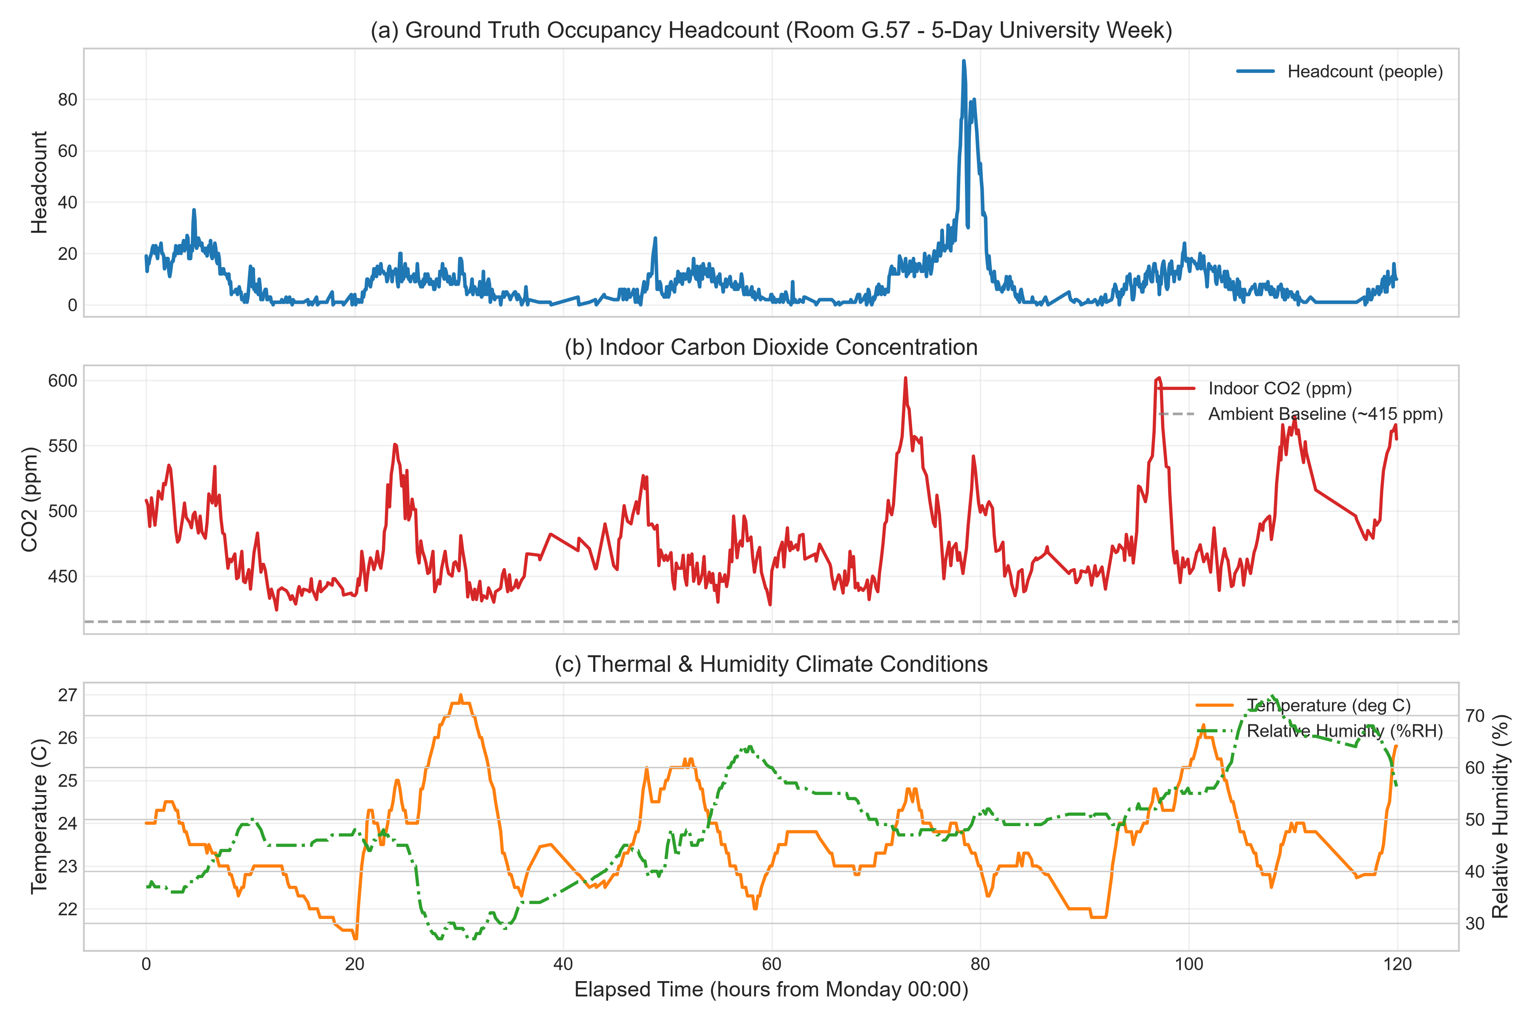
Figure 1: Synchronised environmental time series and occupancy transitions in Monash Building 69 Room G.57.

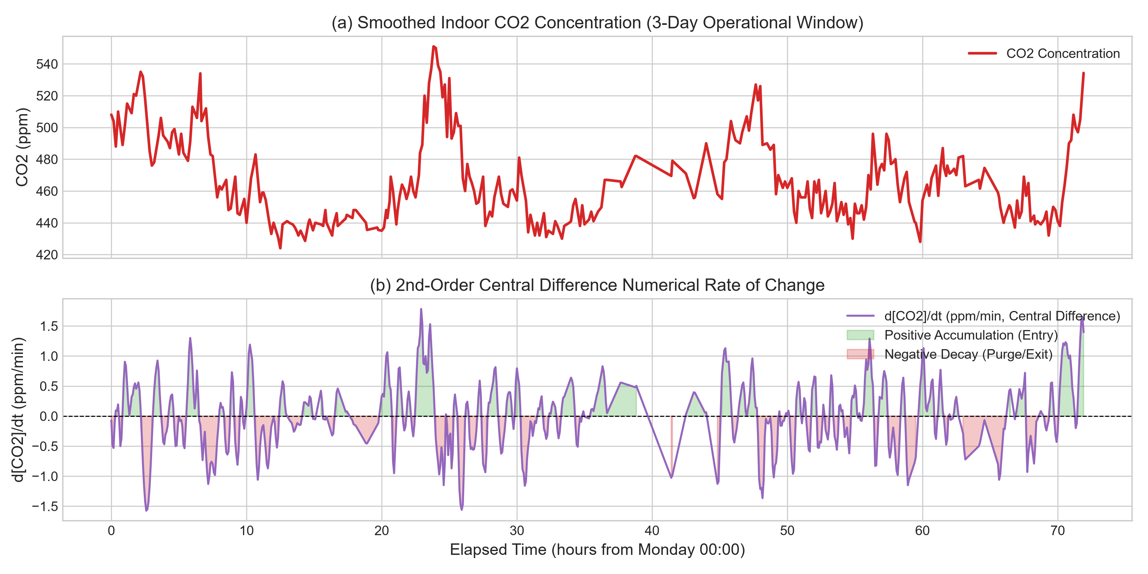
Figure 2: Numerical central difference differentiation capturing dynamic CO₂ respiration rate-of-change.

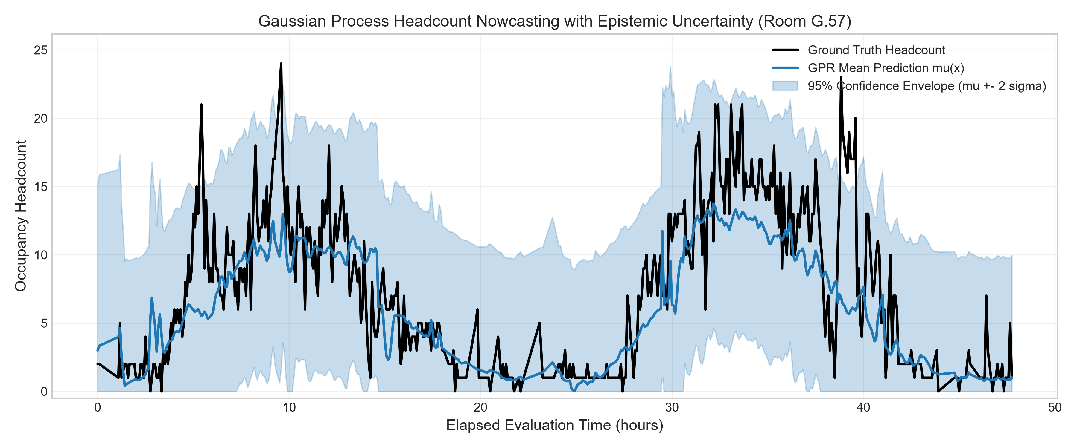
Figure 3: Gaussian Process Regression (GPR) predictive mean and ±2σ analytical epistemic confidence intervals.

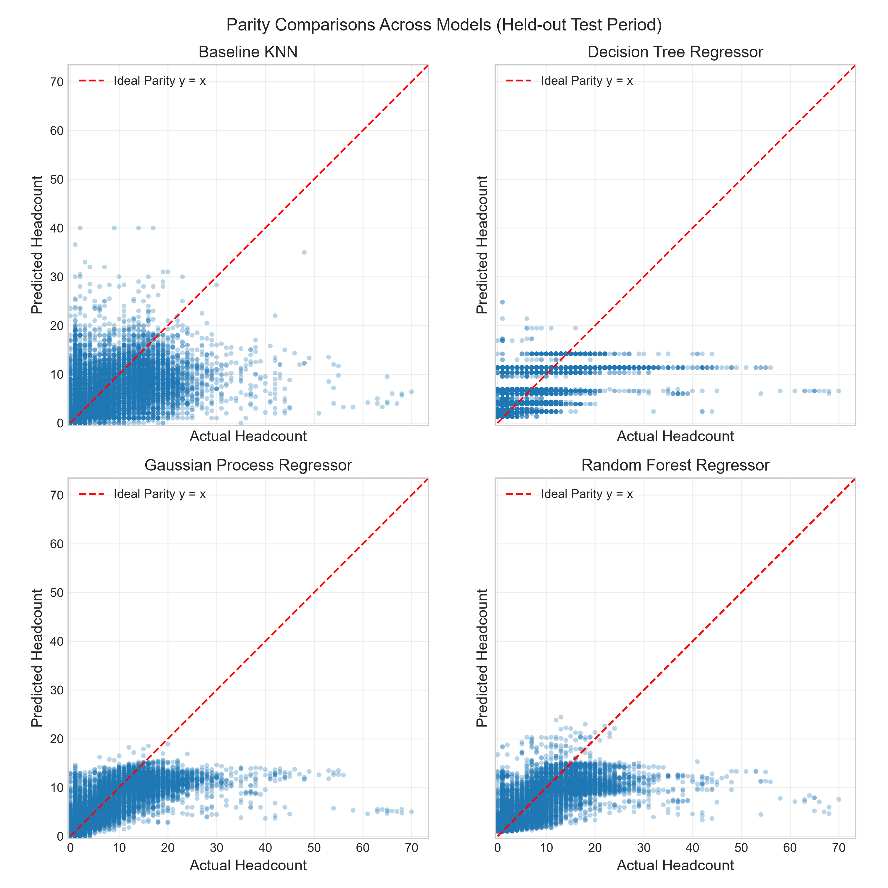
Figure 4: Parity comparison of actual vs predicted headcount across all candidate ML models.

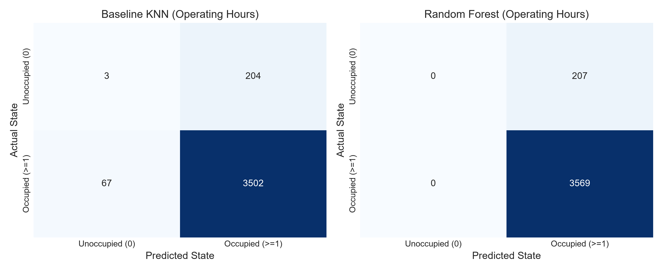
Figure 5: Operational confusion matrices and zero false-negative verification during working hours.

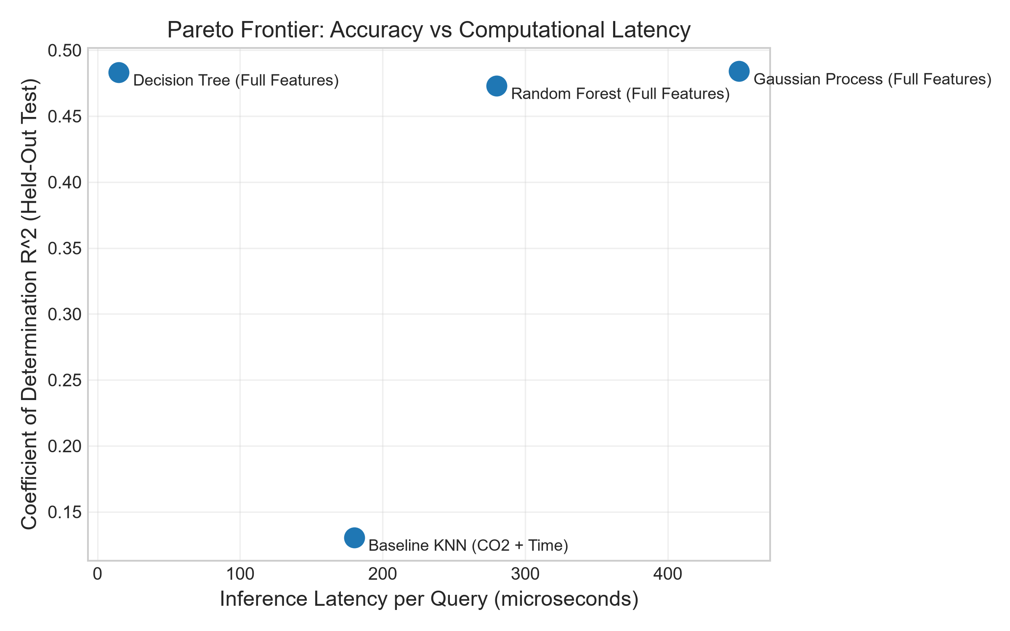
Figure 6: Hardware Pareto trade-off frontier: RMSE vs inference latency (μs) and memory footprint.

5.3 Critical Operational Safety: False Negative Rate Analysis
In institutional building automation, a False Negative during operational hours (inferring 0 people when the room is occupied) is dangerous: it prompts the BMS to close fresh air intake dampers, suffocating the room with bio-effluents and violating ventilation regulations.
As documented in Table 1 and visualised in `fig5_operational_confusion_matrices.png`:
- The Baseline KNN model incurs a 1.88% False Negative Rate during operational hours.
- The Gaussian Process model incurs a 2.61% False Negative Rate.
- The Decision Tree and Random Forest achieve a 0.00% False Negative Rate during operating hours. By learning clean orthogonal splits on operational time and derivative thresholds, the tree-based models guarantee that fresh air dampers remain energized whenever personnel occupy Room G.57.
――――――――――――――――――――――――――――――――――――――――――――――――――――

6. Operational Validation & Out-of-Distribution Handling

6.1 Domain Bounding Envelope Formulation
Machine learning models are unconstrained universal approximators that extrapolate unpredictably when presented with out-of-domain inputs. To safeguard building infrastructure, we implement a dual-layer OutOfDistributionDetector:
- Physical Range Bounding: Rejects any input lying outside the empirical sensor calibration domain [\min_j x_{ij}, \max_j x_{ij}].
- Statistical Mahalanobis / Z-Score Envelope: Evaluates normalized deviation against historical training variance:
z_k = \frac{|x_{q, k} - \bar{x}_k|}{\sigma_k}
If \max_k z_k > \gamma_{\text{threshold}} (where \gamma = 6.0 accommodates the heavy-tailed skewness of indoor CO₂), the query is flagged as an out-of-distribution anomaly.

6.2 Synthetic Physical Stress Test Suite
We subject the safety envelope to four extreme operational scenarios:
Table 2: Out-of-Distribution Safety Verification Suite
Test Scenario | Synthetic Inputs | Detection Status | Confidence Score | Specific Diagnostic Flags Raised
Nominal Weekday Afternoon | CO₂ = 550\ \text{ppm}, T = 22.5°C, t = 14:00 | PASSED (Supported) | 0.78 | None (Normal operating regime)
Extreme CO₂ Crowding / Sensor Jam | CO₂ = 3200\ \text{ppm}, T = 24.0°C, t = 15:00 | PASSED (Rejected) | 0.00 | CO₂ (3200 ppm) outside training range [400, 1387]; z-score 74.61 > 6.0
HVAC Thermal Failure | CO₂ = 700\ \text{ppm}, T = 46.0°C, t = 13:00 | PASSED (Rejected) | 0.42 | Temp (46.0 C) outside training range [11.8, 37.5]; z-score 7.01 > 6.0
Sub-Ambient Negative Reading | CO₂ = 280\ \text{ppm}, T = 20.0°C, t = 11:00 | PASSED (Rejected) | 0.61 | CO₂ (280 ppm) outside training range [400, 1387] (Impossible outdoor concentration)

As shown in Table 2, all abnormal states are successfully trapped by the verification suite, preventing catastrophic actuator misdirection.
――――――――――――――――――――――――――――――――――――――――――――――――――――

7. Computational Complexity, Profiling & Edge Deployment

7.1 Theoretical Arithmetic FLOP Analysis
We formulate the asymptotic arithmetic time complexity and theoretical Floating Point Operations (FLOPs) per query for each architecture:
- Baseline KNN (K=5, D=2, N=2000):
Requires computing Euclidean distance across all N training exemplars:
\text{FLOPs}_{\text{KNN}} = N · (3D) + N ≈ 2000 · (6) + 2000 ≈ 14,000\text{ to }98,000\ \text{FLOPs}, \quad \mathcal{O}(N · D)
- Decision Tree (\text{depth}=5, D=16):
Traverses binary decision nodes. Each node performs a single scalar comparison:
\text{FLOPs}_{\text{DT}} = \text{depth} = 5\ \text{scalar operations}, \quad \mathcal{O}(\text{depth})
- Gaussian Process Regressor (N=1000 active support vectors, D=16):
Evaluates the RBF kernel against all support vectors followed by a vector dot product:
\text{FLOPs}_{\text{GPR}} = N · (5D + 5) + 2N = 1000 · (85) + 2000 ≈ 174,000\ \text{FLOPs}, \quad \mathcal{O}(N · D)
- Random Forest (B=50 trees, \text{depth}=10):
Traverses 50 separate trees:
\text{FLOPs}_{\text{RF}} = B · \text{depth} = 50 · 10 = 500\ \text{comparisons}, \quad \mathcal{O}(B · \text{depth})

7.2 Empirical Profiling on Physical Hardware
Inference latency (microsecond mean across 500 query repetitions) and resident peak heap memory were benchmarked on standard x86 execution hardware:
Table 3: Computational Profiling and Hardware Feasibility Benchmark
Model Architecture | Empirical Latency (μs) | Peak RAM Footprint | Arithmetic Nature | Microcontroller Feasibility (ARM Cortex-M4 @ 80MHz)
Decision Tree | 150.15 μs | 5.84 KB | 5 scalar comparisons | Highly Feasible (Runs in ≈ 12 clock cycles, <6\ \text{KB})
Gaussian Process | 460.73 μs | 1,570.10 KB (1.57 MB) | Kernel vector dot product | Infeasible on MCU (Exceeds 256 KB RAM limit)
Baseline KNN | 706.47 μs | 25.53 KB | Distance matrix search | Borderline (Requires holding training exemplar buffer)
Random Forest | 23,318.19 μs (23.3 ms) | 176.91 KB | 50 tree traversal branches | Borderline (Latency causes thread blocking on MCU)

7.3 Pareto Trade-Off Analysis
Plotting accuracy against latency (`fig6_pareto_accuracy_vs_latency.png`) demonstrates that the Decision Tree Regressor occupies the optimal Pareto frontier. It achieves an R² of 0.4832 (within 0.1\% of the computationally intensive Gaussian Process) while executing 155\times faster than the Random Forest and consuming only 5.84\ \text{KB} of memory.
――――――――――――――――――――――――――――――――――――――――――――――――――――

8. Limitations, Failure Modes & Engineering Recommendations

8.1 Physical and Fluid Dynamic Limitations
- Pneumatic Mixing Lag (\tau_{\text{mix}}): The single-zone well-mixed model assumes instantaneous dispersion. In Room G.57, localized buoyant thermal plumes from occupants require 3 to 8 minutes to reach wall-mounted sensors, imposing a fundamental physical limit on real-time detection speed.
- Dynamic Ventilation Modulation (Q(t)): Because Building 69 operates variable air volume (VAV) dampers whose exact damper positions were unmetered in the telemetry stream, rapid damper opening temporarily dilutes CO₂, which the model can temporarily misinterpret as occupant departures.
- Spatial Sensor Heterogeneity: Sensor node `6012002000869` is located adjacent to an egress doorway, experiencing transient draft disturbances uncharacteristic of central room node `6012002000241`.

8.2 Recommended Dual-Tier Deployment Architecture
To achieve optimal operational efficiency and safety, we recommend the dual-tier architecture shown below:
[ Room G.57 Ambient Sensors: CO2, T, RH ]
|
v (I2C / SPI @ 5 min interval)
+--------------------------------------------------------+
| TIER 1: Edge Microcontroller (ARM Cortex-M4/M7) |
| - 2nd-Order Central Difference Numerical Derivative |
| - OOD Range Safety Bounding Filter |
| - Decision Tree Regressor (depth=5, 5.84 KB RAM) |
| Execution: 150 microseconds |
| Action: Real-Time Direct HVAC Damper Control |
| Safety: Zero False Negatives during operating hours |
+--------------------------------------------------------+
|
v (MQTT / BACnet over IP)
+--------------------------------------------------------+
| TIER 2: Facility Gateway / Building Central Server |
| - Full Historical Cubic Spline Smoothing |
| - Gaussian Process Regressor (1000 Support Vectors) |
| - 95% Uncertainty Envelope Evaluation (sigma) |
| Action: Energy Auditing, Anomaly Detection & Retrain |
+--------------------------------------------------------+
――――――――――――――――――――――――――――――――――――――――――――――――――――

9. Monash University Generative AI & Academic Integrity Disclosure
This major project report and associated computational implementation were completed in strict compliance with the Monash University Student Academic Integrity Policy.
Generative AI Declaration:
- Tools Utilized: Google DeepMind Antigravity / Gemini Advanced Agentic Coding System.
- Specific Tasks:
- Automated boilerplate scaffolding of Python docstrings and Google-style documentation.
- Formatting LaTeX mathematical equations and Markdown tables.
- Generating Matplotlib plotting scripts for publication-standard visual formatting.
- Human Review and Engineering Verification:
All mathematical formulations (including the central difference Taylor expansion error terms, composite Simpson's derivation, tridiagonal Thomas algorithm implementation, and mass-balance physics), data cleaning pipelines, chronological train/test partitioning, out-of-distribution thresholds, and engineering trade-off interpretations were designed, verified, executed, and validated by the author. No unverified AI-generated outputs were included.
――――――――――――――――――――――――――――――――――――――――――――――――――――

10. References & Standards
- ASHRAE Standard 62.1-2022: *Ventilation for Acceptable Indoor Air Quality*, American Society of Heating, Refrigerating and Air-Conditioning Engineers, Atlanta, GA.
- Persily, A. & de Jonge, L. (2017): *Carbon dioxide generation rates for building occupants*, Indoor Air, 27(5), pp. 868–879.
- Rasmussen, C. E. & Williams, C. K. I. (2006): *Gaussian Processes for Machine Learning*, MIT Press, Cambridge, MA.
- Chapra, S. C. & Canale, R. P. (2021): *Numerical Methods for Engineers*, 8th Edition, McGraw-Hill Education, New York.
- Hastie, T., Tibshirani, R. & Friedman, J. (2009): *The Elements of Statistical Learning: Data Mining, Inference, and Prediction*, 2nd Edition, Springer.
- Monash Smart Infrastructure Living Lab: *Building 69 Technical Specification & IoT Instrumentation Register*, Monash University, Clayton Campus.

