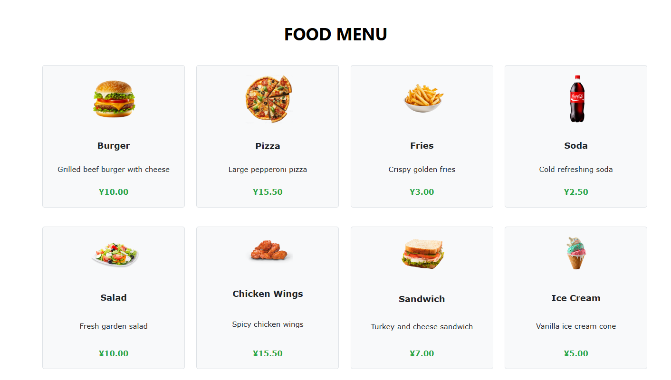

The page displays a grid of food items, each with an image, name, description, and price. Items include "Burger," "Pizza," "Fries," "Soda," and more. The prices are prominently displayed in green below each item. There is no error in this section.

Suggestions for Improvement:

Item Details: Could add more details or a quick view option where users can get additional information about ingredients or customization options before adding to the cart.

Filter/Sort Options: Consider adding filters (e.g., by category like drinks or meals) or sort options (e.g., by price, popularity) to help users navigate large menus more easily.

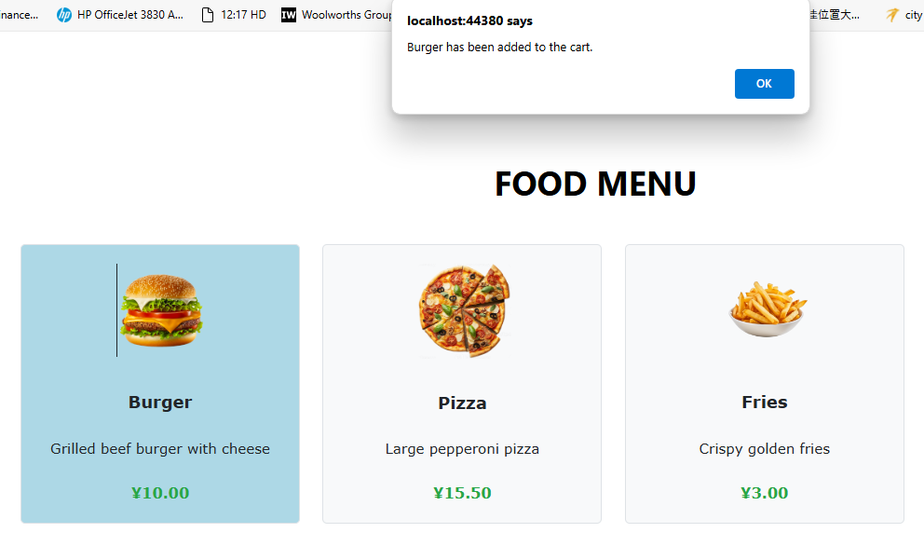

The user has clicked on the "Burger" item, which is highlighted in blue to show selection. A pop-up message confirms that the "Burger has been added to the cart." There is no error in this section.

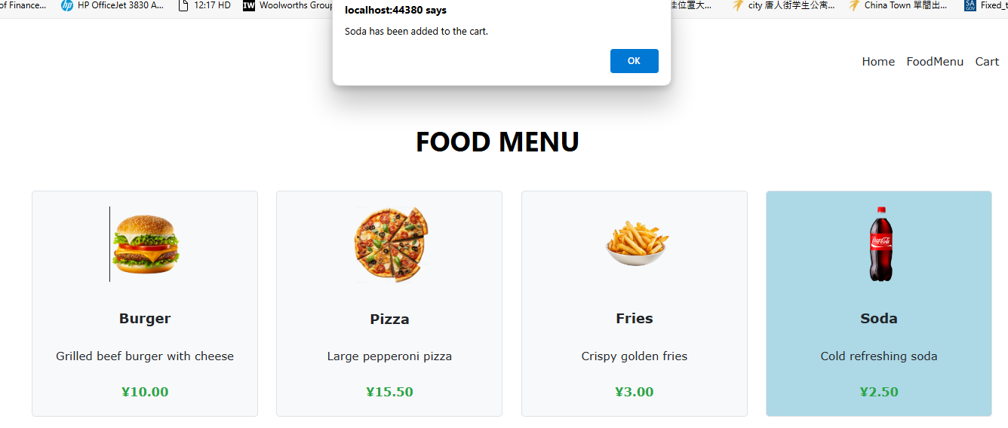

The user has clicked on the "Soda" item, which is now highlighted in blue. Another pop-up message appears, stating "Soda has been added to the cart." There is no error in this section.

Suggestions for Improvement:

Consistency in Feedback: Maintain consistency in user feedback mechanisms. If you're showing pop-up messages for adding to the cart, it would be better to use a single feedback system (e.g., updating the cart or using a small banner notification instead of pop-ups).