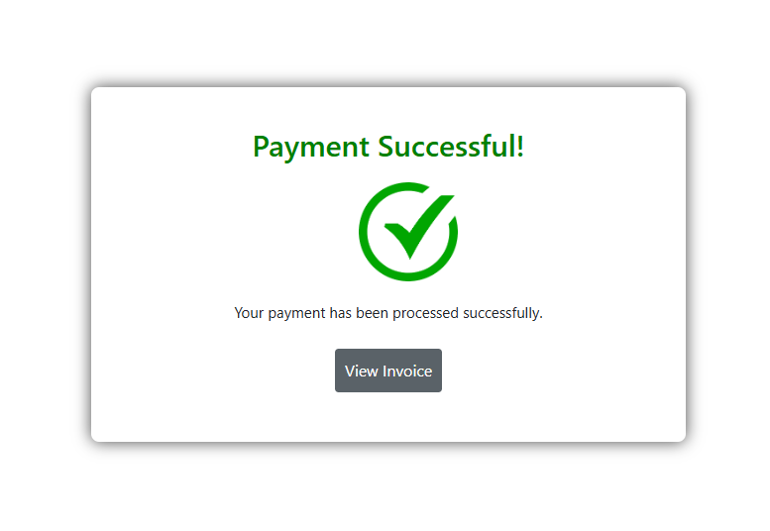

This screenshot shows a confirmation message that the payment was successfully processed. There is a clear "Payment Successful!" message along with a large checkmark symbol to indicate success. The user is prompted to "View Invoice" after the transaction has been completed. There are no bugs in this section.

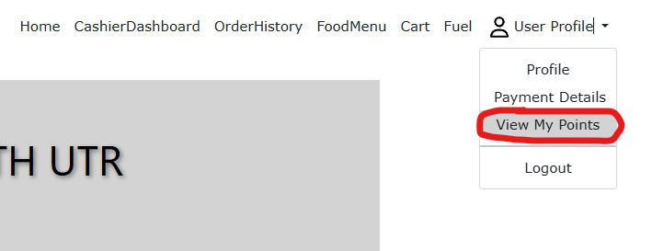

The screenshot shows a user profile dropdown menu, with an option to view points (labeled as "View My Points"). This functionality allows users to check their accumulated points from their completed orders. There are no bugs in this section.

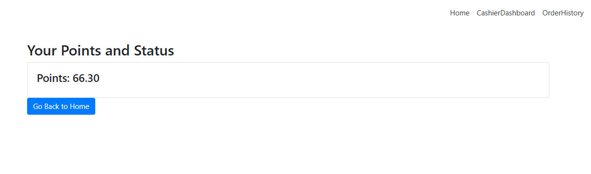

This screenshot shows the user’s total points, displayed prominently on the page. The user has earned 66.30 points, and there is a button labeled "Go Back to Home" for navigation. There are no bugs in this section.