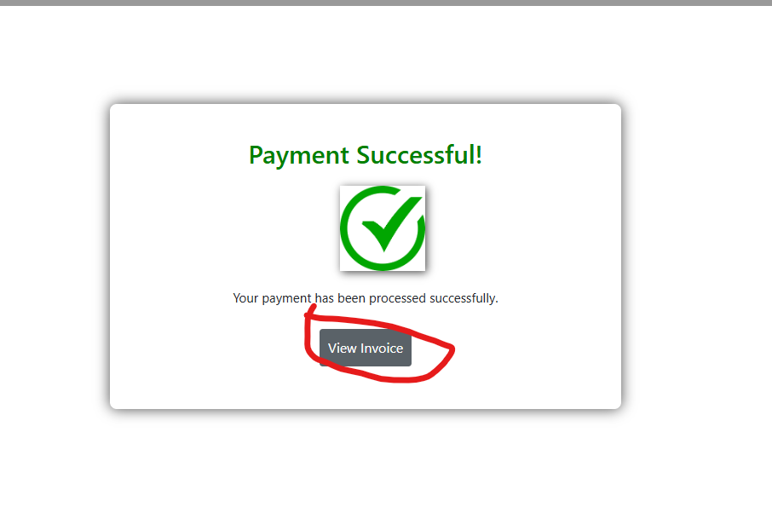

This screenshot shows the confirmation page that appears after a successful payment. It displays a message "Payment Successful!" and provides a "View Invoice" button for the customer to access their order details and invoice. There are no bugs in this section.

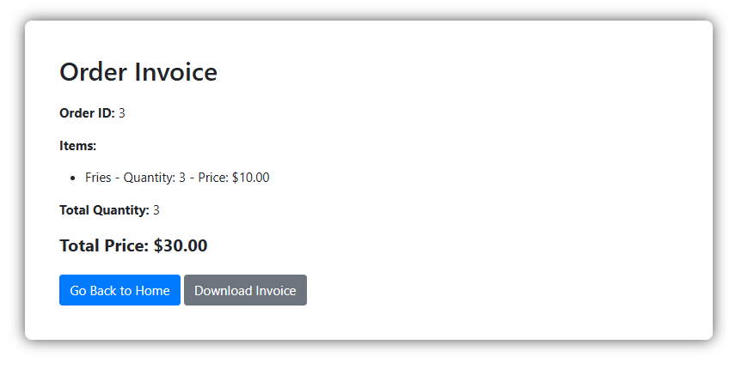

This page shows the order invoice after the user clicks on the "View Invoice" button. It displays the order ID, the items purchased, their quantities, and total price. The customer has the option to either go back to the home page or download the invoice as a PDF. There are no bugs in this section.