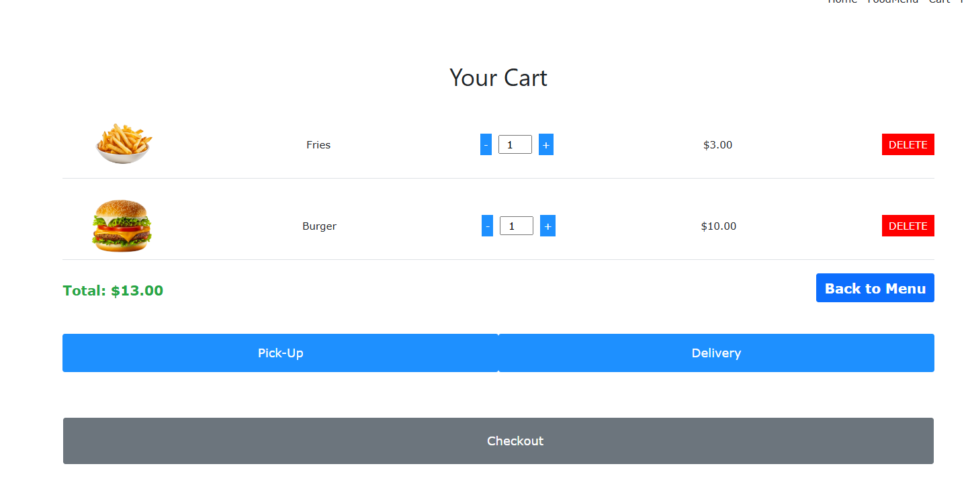

The cart shows two items: Fries and a Burger. Each item is accompanied by a quantity selector, price, and a red "DELETE" button. The total price of the items is calculated and displayed at the bottom: $13.00. Users can choose between Pick-Up or Delivery before proceeding to Checkout. No errors in this section.

Suggestions for Improvement:

Item Images: Adding larger or more detailed images of the items might enhance the user's visual experience and better reflect the item they selected.

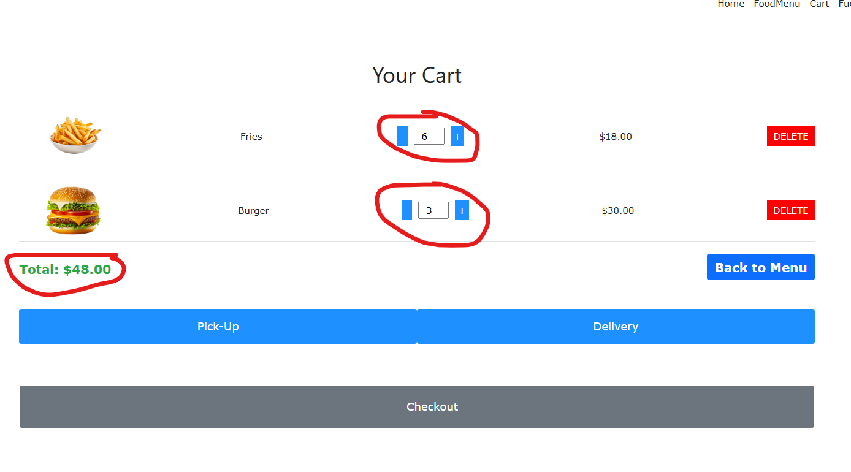

The user has increased the quantity of Fries to 6 and the Burger to 3, updating the total cost to $48.00. The quantity input has been modified with "+" and "−" buttons. No errors in this section.

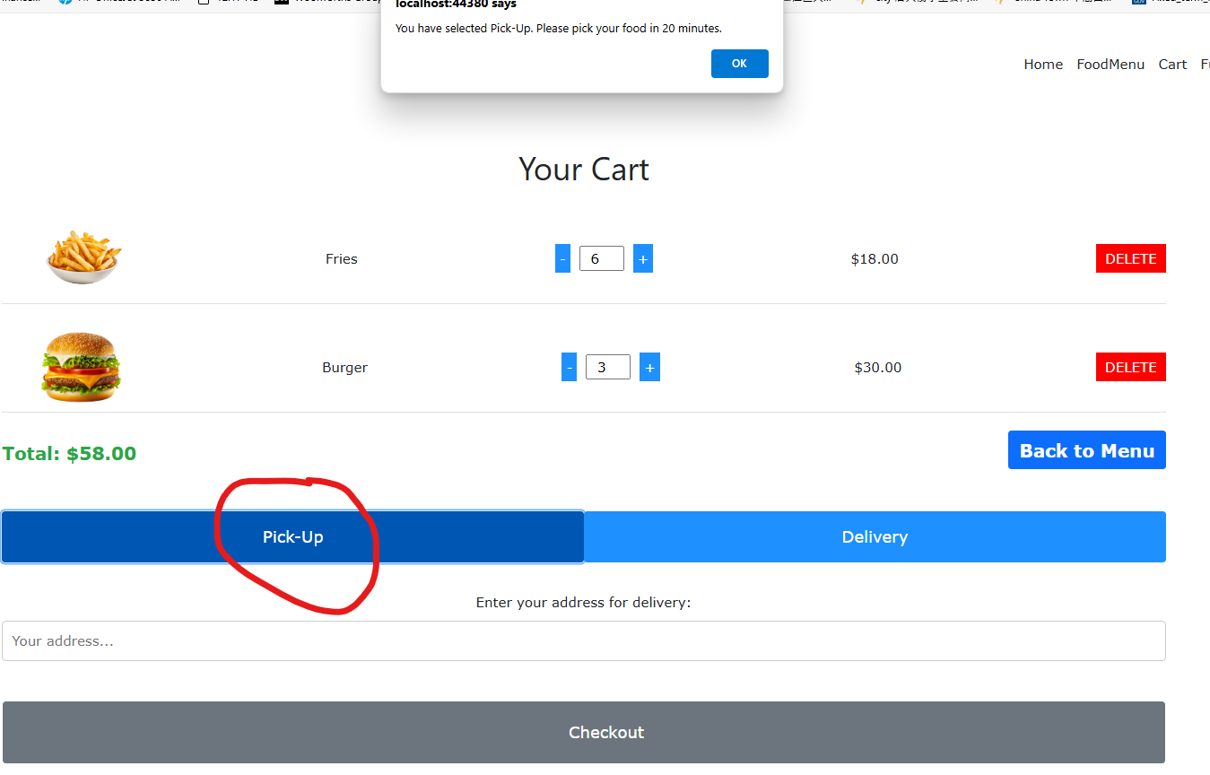

In this screenshot, Pick-Up has been selected as the delivery option. A confirmation message indicates that food will be ready for pick-up in 20 minutes. The total is now $58.00 after customer click “delivery”. ($10 charge for the delivery). The delivery address input field is hidden since Pick-Up is selected. No errors in this section.

Suggestions for Improvement:

Feedback on Change: When switching between Pick-Up and Delivery, offer real-time feedback, such as showing the delivery fee.