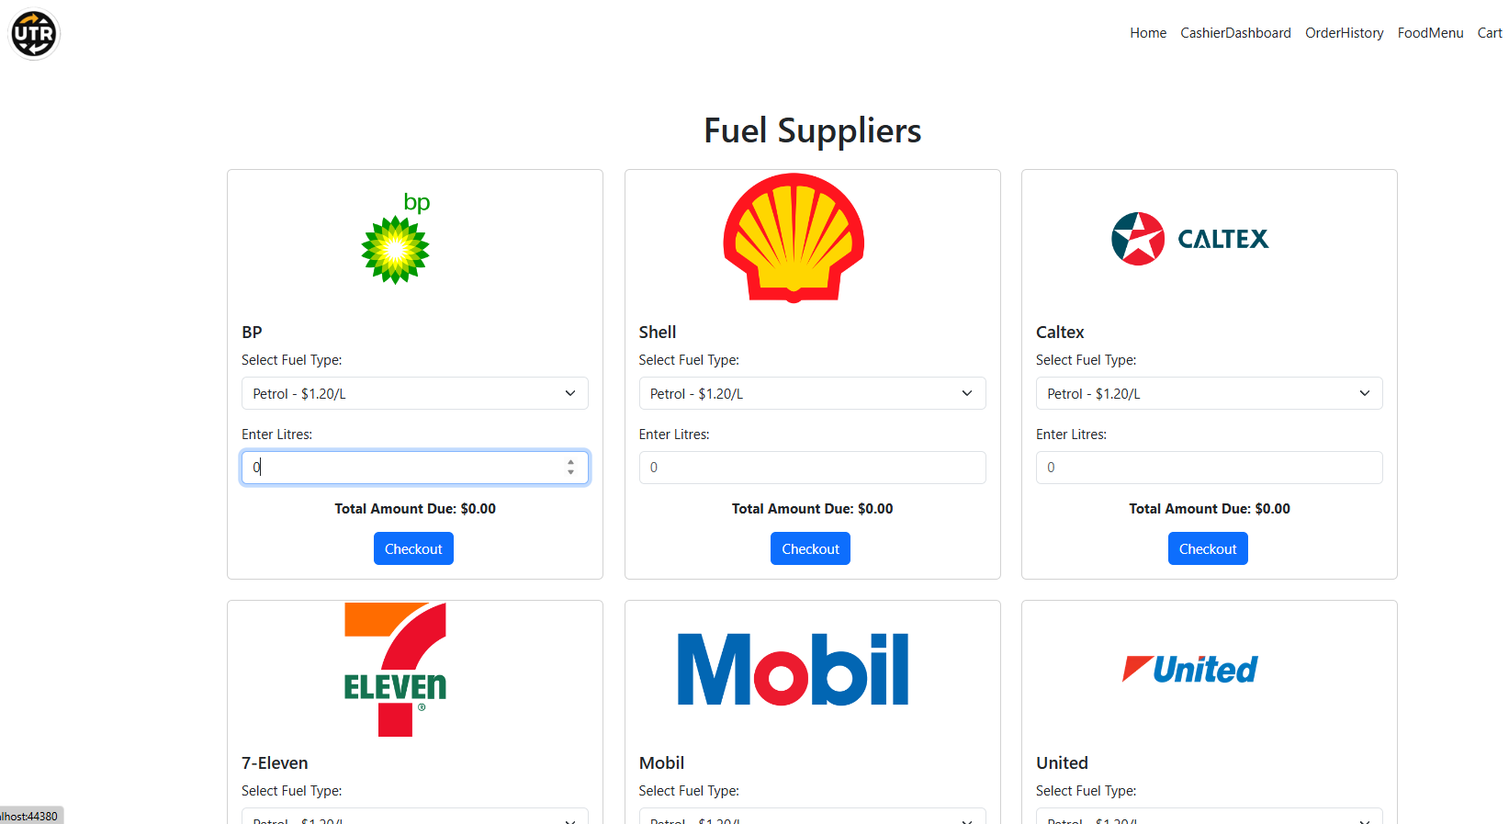

The user is presented with a list of fuel suppliers: BP, Shell, Caltex, 7-Eleven, Mobil, and United. Each supplier has a section where the user can select the fuel type (e.g., Petrol) and input the number of liters . The total amount due is calculated based on the selected fuel type and liters, and the Checkout button is available to proceed to the payment page. There are no bugs in this section.

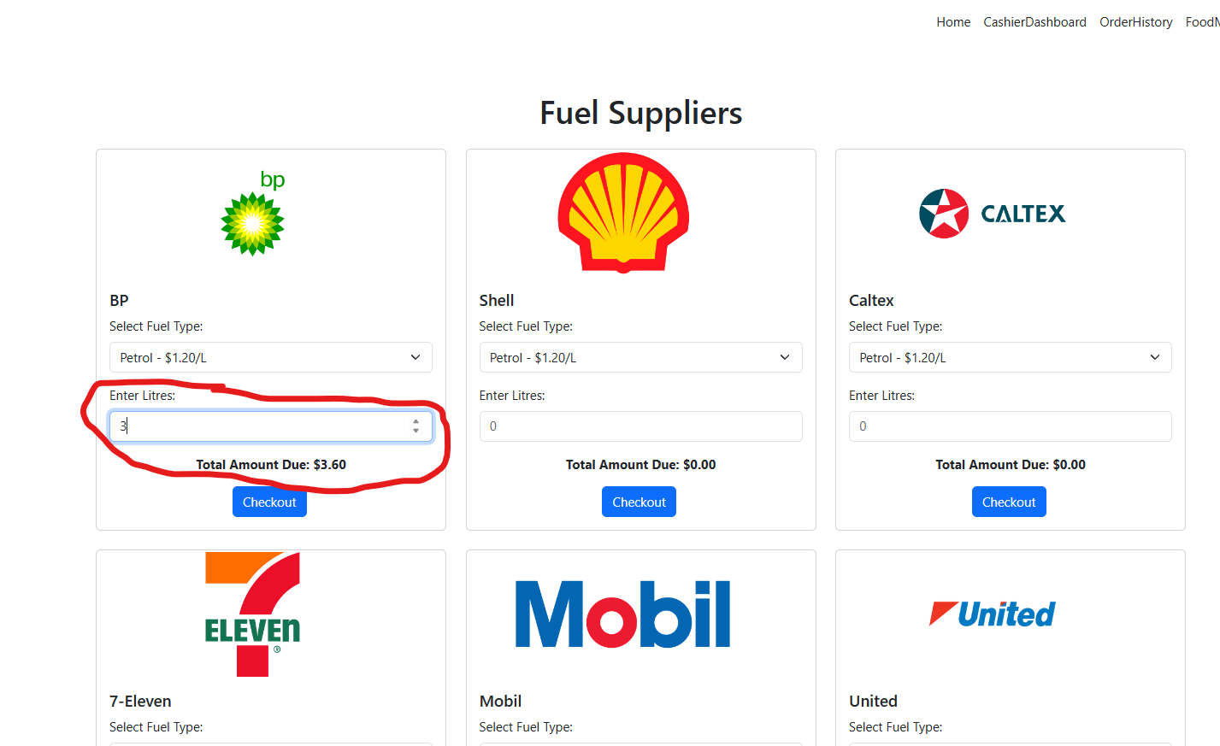

The user has entered 3 liters of petrol for BP at $1.20/L, with the total amount due calculated as $3.60. Other suppliers remain untouched with 0 liters and no total calculated. There are no bugs in this section.

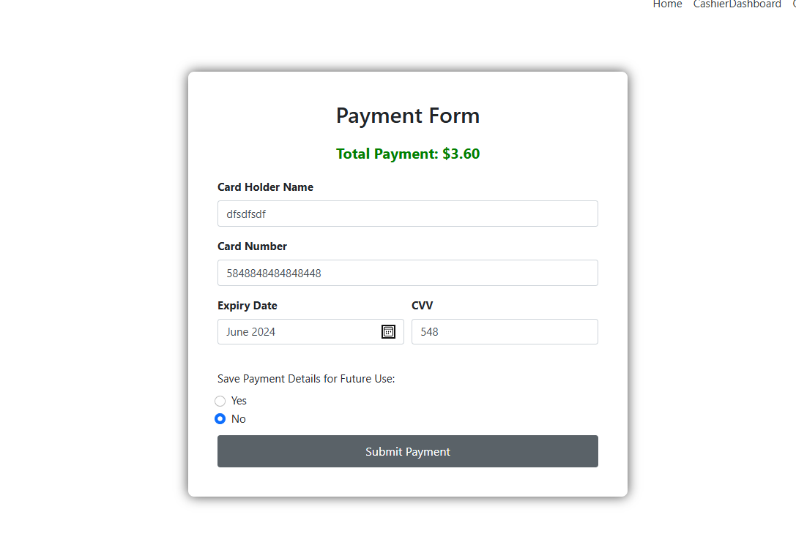

After selecting fuel and liters, the user is taken to the payment form. The total payment is displayed as $3.60, and the user needs to input their Card Holder Name, Card Number, Expiry Date, and CVV. The option to save payment details for future use is provided. The user can then submit their payment. There are no bugs in this section.

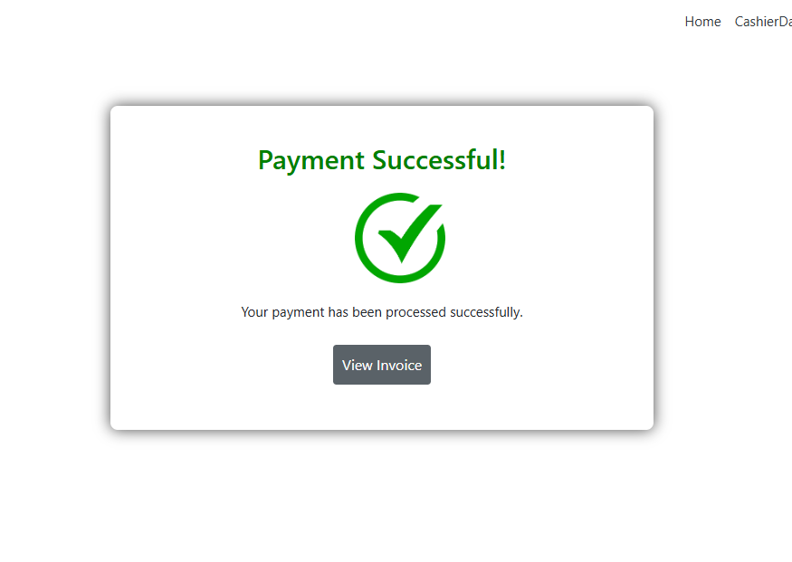

After submitting the payment, the user is shown a confirmation message: "Payment Successful!" with a green checkmark. The user is given the option to view and download the invoice for their purchase. There are no bugs in this section.