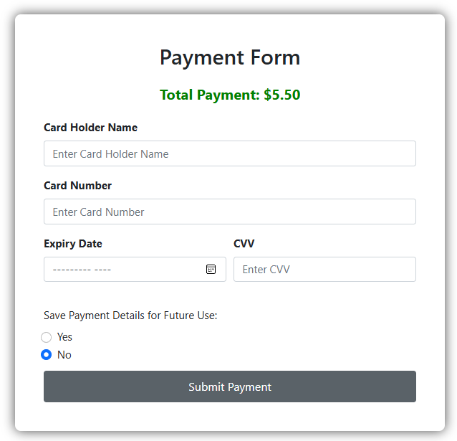

This is the initial payment form with fields for "Card Holder Name," "Card Number," "Expiry Date," and "CVV." The total payment amount is displayed at the top in bold. Users can choose to save payment details for future use, with "No" selected by default. A "Submit Payment" button is at the bottom. There is no error appear in this section.

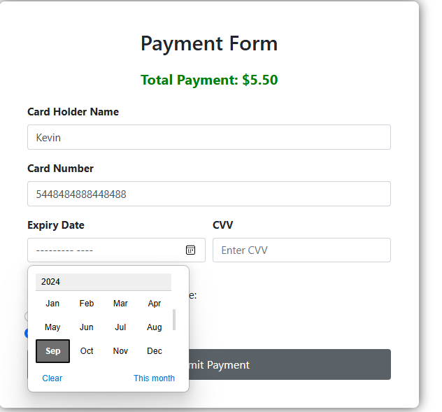

The same payment form, but some of the fields have been filled in: "Card Holder Name" is "Kevin," and the "Card Number" is partially entered. The user has started to interact with the expiry date input field, which displays a date picker. There is no error in this section.

Suggestions for Improvement:

Card Number Masking: Mask all but the last four digits of the card number after it has been fully entered, for added security.

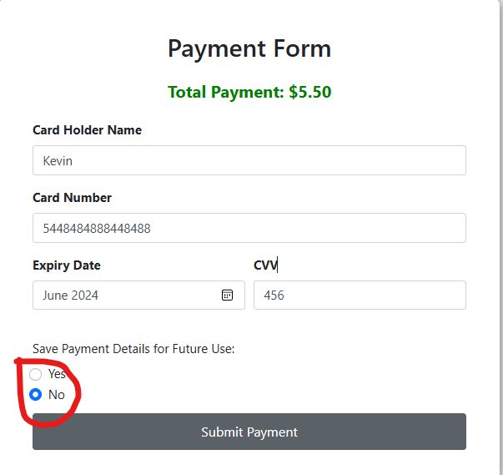

The form is now fully filled, with "Kevin" as the cardholder name, the card number completed, and the CVV field filled with a 3-digit number. The expiry date is set to "June 2024." The radio button option for saving payment details is visible, with "No" selected. There is no error in this section.

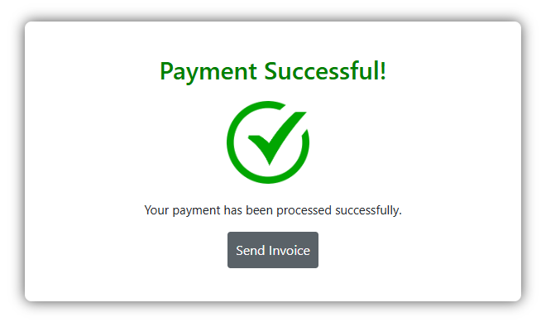

A confirmation page is displayed after successful payment. The page includes a large green checkmark with the message "Payment Successful!" followed by "Your payment has been processed successfully." There is a "Send Invoice" button for users to request an invoice. There is no error on this section.