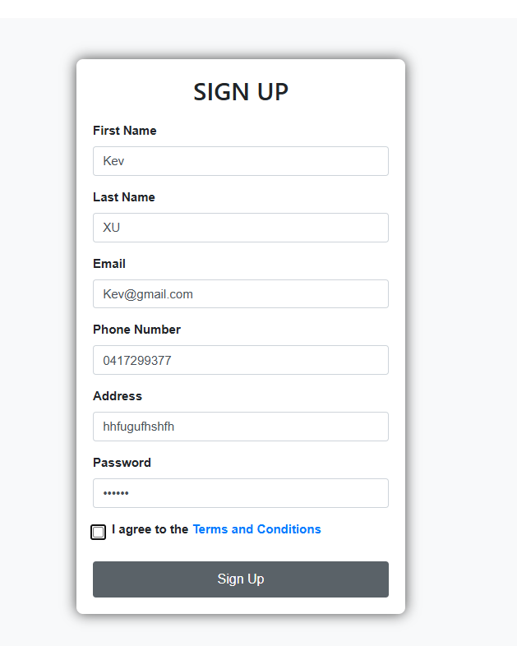

This page allows users to enter personal details such as First Name, Last Name, Email, Phone Number, Address, and Password.

There’s a checkbox to agree to the terms and conditions, with a link to the terms.

A "Sign Up" button is present at the bottom. There is no error appear in this section.

Suggestions for Improvement:

Input Validation: Ensure validation for each field. For instance, the phone number should be in a proper format, and the password should meet minimum security requirements (e.g., length, special characters).

Email Validation: Consider using real-time email validation to catch incorrectly formatted emails before submission.

UI Consistency: The password field could have a “show/hide” functionality, similar to the login page (as seen in later screenshots).

Password Strength Indicator: A password strength indicator would be helpful to guide users in creating secure passwords.

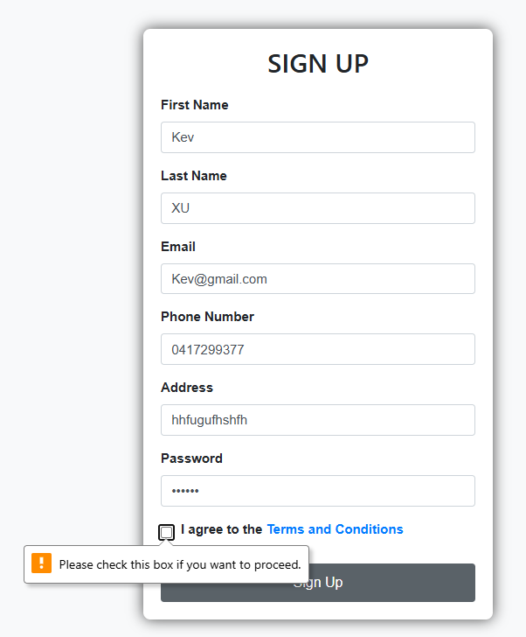

The same Sign-Up page as before, but an error message appears when the checkbox for agreeing to terms and conditions is left unchecked.

The validation alert highlights that the box needs to be checked to proceed. There is no error appear in this section.

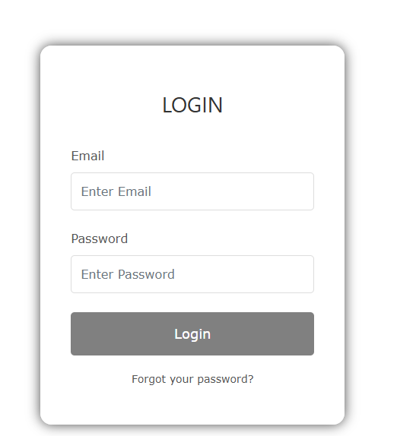

The login page has fields for "Email" and "Password."

A "Login" button is present along with an option for users to reset their password with a "Forgot your password?" link. There is no error appear in this section.

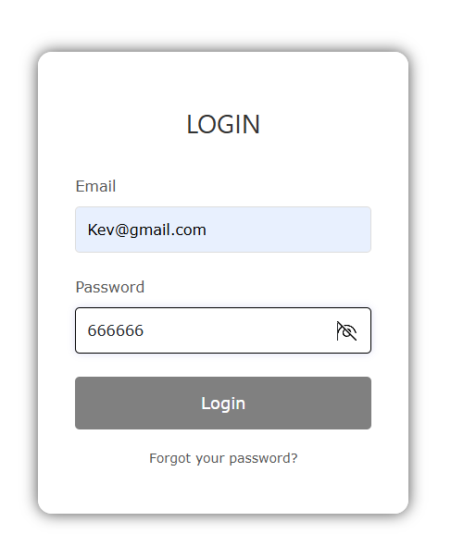

This is the same login page as before but with the password entered and a visible password toggle icon next to the password field.

The toggle icon allows users to hide or reveal the password during the login process. There is no error appear in this section.

Suggestions for Improvement:

UI Consistency: This feature is great for login, but it should also be added to the sign-up form (if it isn’t already), especially for the password confirmation field.

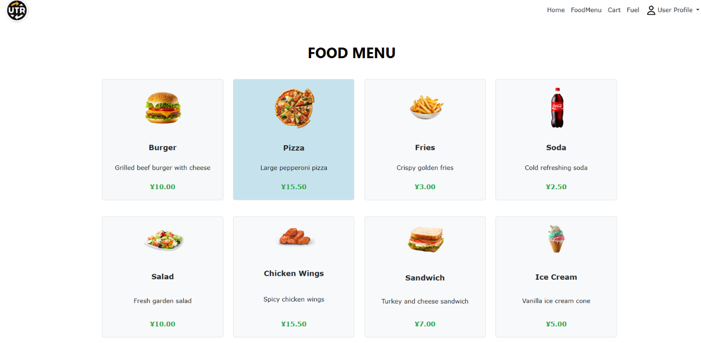

Once the customer successfully login, the food menu will display on the screen. There is no error appear in this section.

Suggestions for Improvement:

Login Feedback: Provide meaningful error feedback (e.g., “Invalid email or password”) on failed login attempts.