1.

function areEqualObjects(obj1, obj2) {

    const stringifyAndSort = (obj) => JSON.stringify(obj, Object.keys(obj).sort());

    return stringifyAndSort(obj1) === stringifyAndSort(obj2);

  }

  let obj1 = { name: "Person 1", age: 5 };

  let obj2 = { age: 5, name: "Person 1" };

  if (areEqualObjects(obj1, obj2)) {

    console.log("The objects have the same properties (ignoring order).");

  } else {

    console.log("The objects do not have the same properties (ignoring order).");

  }

**OUTPUT::**

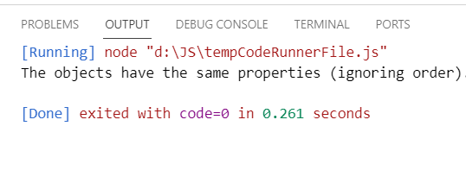

2.

var apiUrl = "https://restcountries.com/v3.1/all";

fetch(apiUrl)

  .then(response => {

    if (!response.ok) {

      throw new Error("Failed to fetch data. Status code: " + response.status);

    }

    return response.json();

  })

  .then(countries => {

    countries.forEach(country => {

      if (country.flags) {

        console.log(country.flags.png);

      }

    });

  })

  .catch(error => {

    console.error("Request failed:", error.message);

  });

**OUTPUT::**



3.

var apiUrl = "https://restcountries.com/v3.1/all";

fetch(apiUrl)

  .then(response => {

    if (!response.ok) {

      throw new Error("Failed to fetch data. Status code: " + response.status);

    }

    return response.json();

  })

  .then(countries => {

    countries.forEach(country => {

      console.log("Country: " + country.name.common);

      console.log("Region: " + country.region);

      console.log("Sub-Region: " + country.subregion);

      console.log("Population: " + country.population);

      console.log("--------");

    });

  })

  .catch(error => {

    console.error("Request failed:", error.message);

  });

**OUTPUT::**

