**2. a. Print odd numbers in an array using arrow function.**

const numbers = [1, 2, 3, 4, 5, 6, 7, 8, 9, 10];

const printOddNumbers = arr => {

console.log("Odd numbers in the array:");

arr.forEach(num => {

if (num % 2 !== 0) {

console.log(num);

}

});

};

printOddNumbers(numbers);

**Output::**

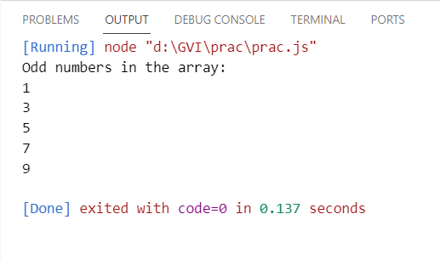

**2.b. Convert all the strings to title caps in a string array**

const stringArray = ["hello world", "goodbye universe", "javascript is awesome"];

const convertToTitleCaps = arr => {

return arr.map(str => {

return str.replace(/\b\w/g, char => char.toUpperCase());

});

};

const titleCapsArray = convertToTitleCaps(stringArray);

console.log(titleCapsArray);

**Output::**

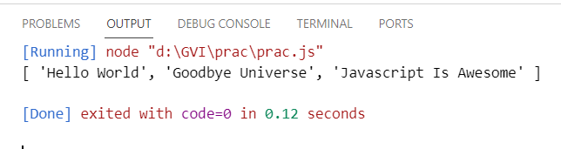

**c. Sum of all numbers in an array**

const numbers = [1, 2, 3, 4, 5];

const sumOfNumbers = arr => arr.reduce((acc, num) => acc + num, 0);

console.log("Sum of all numbers:", sumOfNumbers(numbers));

**Output::**

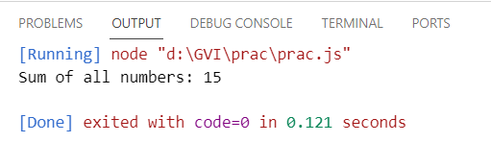

**d. Return all the prime numbers in an array**

const numbers = [1, 2, 3, 4, 5, 6, 7, 8, 9, 10];

const isPrime = num => {

if (num <= 1) {

return false;

}

for (let i = 2; i <= Math.sqrt(num); i++) {

if (num % i === 0) {

return false;

}

}

return true;

};

const primeNumbers = arr => arr.filter(num => isPrime(num));

console.log("Prime numbers in the array:", primeNumbers(numbers));

**Output::**

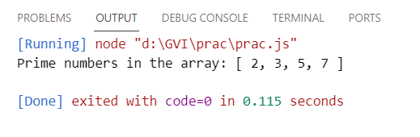

**e. Return all the palindromes in an array**

const words = ["level", "hello", "racecar", "world", "radar"];

const isPalindrome = str => {

const reversedStr = str.split("").reverse().join("");

return str === reversedStr;

};

const palindromes = arr => arr.filter(word => isPalindrome(word));

console.log("Palindromes in the array:", palindromes(words));

**Output::**

