**Game Design Document (GDD)**

**Executive Summary**:

Game Overview:

Cat get lost during sea trip. While owner looks the other way, cat get carried by the wave to a small island.

Cat must find its ways home with 3 lives:

Lvl1: Cross the sea

* Avoid Sharks’ attacks
* Step on float to cross to the other side and enter the cave
* **Lose condition(s):** fall to sea and ate by a shark
* **To go through this level**: Reach the cave at the other side

Lvl2: Go through the cave

* Avoid rocks’ roll
* Avoid bats
* **Lose condition(s)**: Touch rock and touch bats
* **To win this level**: reach the other entrance of the cave at the other side

***For the first 2 levels: Cat can collect coins to increase score (exchange 3 coins = 1 life)

Lvl3: Cross the street

* Collect all keys (3 or to be decided)) to make the house appeared.
* Game lose condition(s): fall into river, crushed by car, crushed by train.
* Final win: reach house

Assets: (**All are put in Assets folder on GitHub**)

Pics:

General: coins, heart, key, cat (walk, jump, died)

For level 1: sand blocks, float, shark, cave with entrance

For level 2: rolling rock, bats, cave entrance.

For level 3: river, track, road, car, train, house

Sounds: cat meowing, car, train, squish, dogs’ bark, game over (lose), kids’ yay(win)

**Green-foot Plan:**

World 1: Menu

1. Names, teacher, course’s name
2. Title of the game + cat => optional: animation (show after)

Press enter to start the game

Press C to get to Credit Page

Press I to go to the instruction page

World 2: instructions

1. Keyboards instruction
2. How to move and win

Press M to return to the main menu or press enter to start the game

World 3: lv1 press I for instruction or press M to return to the main menu

World 3 -2: board score

World 4: lvl2 press I for instruction or press M to return to the main menu

World 4-2: board score

World 5: lv3 press I for instruction or press M to return to the main menu

World 5-1: cat meets owner animation (option)

**User Interface Mock-up(s):**

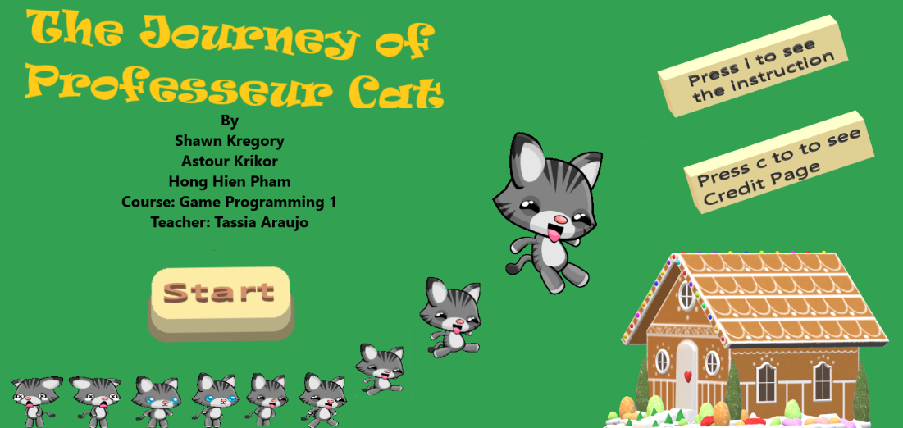

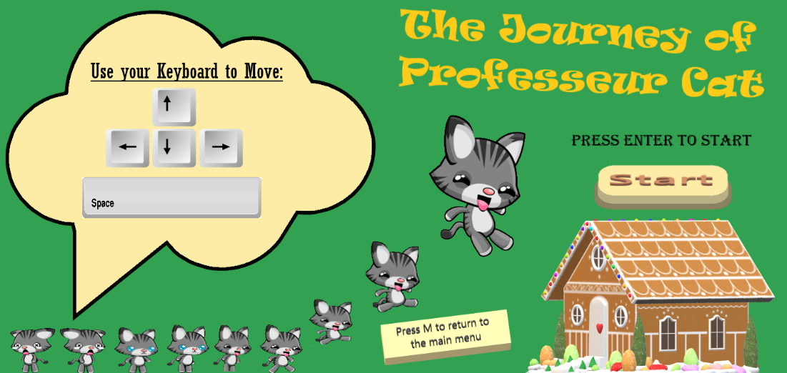

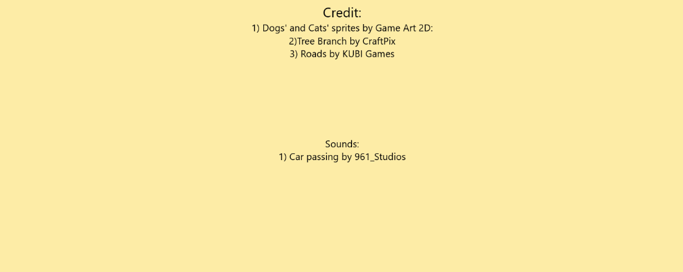

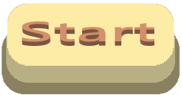 

Lvl1:

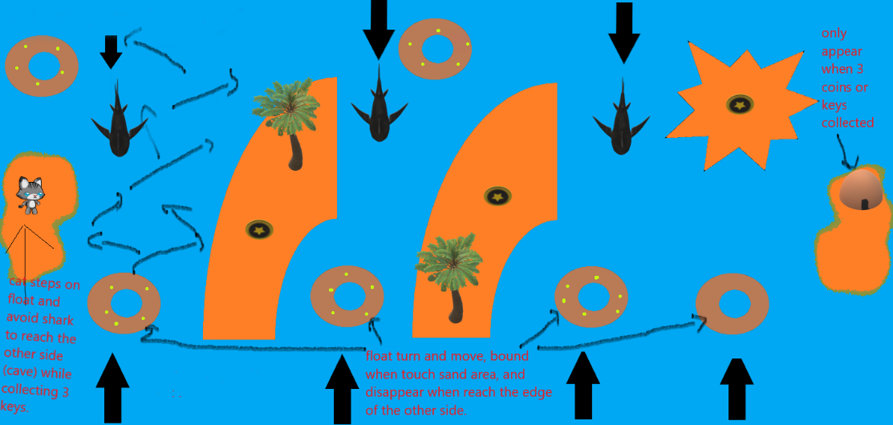

Lvl2:

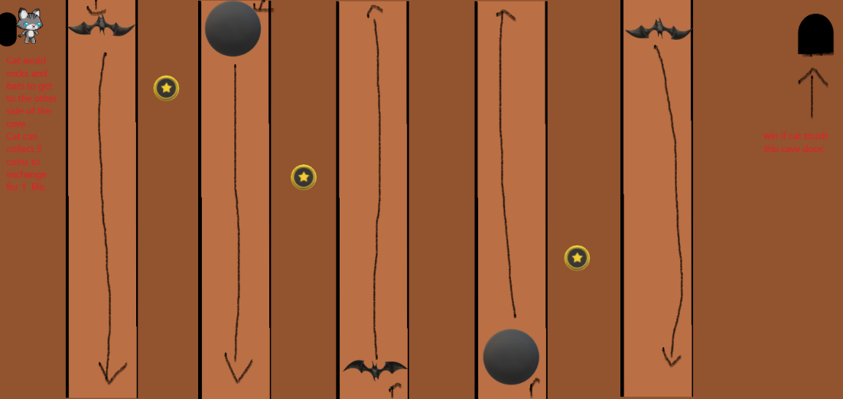

Lvl3:

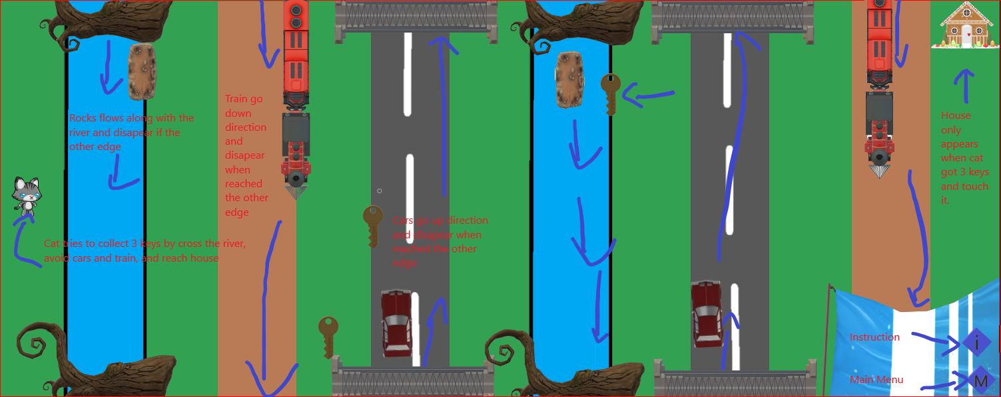

  

**Controls:**

Arrow up: go up

Arrow down: go down

Arrow left: go left

Arrow right: go right

Space: slide (optional)

**Developer Roles:**

Shawn’s role(s): programmer, level design

Krikor’s role(s): programmer, audio/sound engineer, level designer

Hien’s role(s): programmer, level designer, UI designer

|  |  |  |  |
| --- | --- | --- | --- |
|  | **Shawn Gregory’s Tasks** | **Krikor Astour’s**  **Tasks** | **Hong Hien Pham’s Tasks** |
| **Week 1:**   * **GitHub’s practice** * **Brainstorm idea** * **Find assets** | **Find the first half of pictures + 1 sounds:**  Cat meowing, river, railway, road, car | **Find all sounds tracks:**  cat meowing, car, train, squish, dogs’ bark, game over (lose), kids’  yay(win) | **Find the second half of the pictures:**  cat (walk, jump, died), train, debris, house |
| **Week 2: Prototype** | **- Give feed back’s on sample game**  **- Evaluate the performance of the game**  **- To be decided** | **- Test and give feedback’s on sample game**  **- Design one level of the game and code it**  **- Evaluate the performance of the game (fun?)** | **- Test game ideas by making a sample game and send to teammates for feedbacks and improvement**  **- Evaluate the performance of the game (fun?)**  **- Add new ideas to games and levels**  **- Making/Designing UI mocks up** |
| **Week 3:**  **First playable** |  |  |  |
| **Week 4:**  **Pre-Alpha** |  |  |  |
| **Week 5:**  **Alpha** |  |  |  |
| **Week 6:**  **Gold Master** |  |  |  |

**Schedule of Releases:**

* **11/15: Prototype**
* List all games ideas:

Task: Make 1 level (Test ideas)

* + Design level 1
  + Basic code: keys movement
  + Scrolling for train + interaction
  + Scrolling for car + interaction
  + Scrolling for debris/rock + interaction
  + Game transition (levels)
  + Evaluate games ideas: What does not work? What should be changed? Is it fun?
  + Add sounds
  + Front end making and applying
* **11/22: First playable**
  + Make 2 other levels with similar mechanics
  + Change for better assets
  + Artworks is added
  + Adjust sounds
  + Evaluate the performance of the game
* **11/29: Pre-Alpha**
  + Evaluate the game to decide if we need to add new feature
  + Add Smooth movers (optional)
* **12/06: Alpha**
  + Control and functionalities should be working properly
  + QA testers: make sure everything is running seamlessly
  + Some errors were detected and fixed
* **12/10: Gold Master**
  + Our game is ready to be released to the public.