VLSI System Design Track
STPVD-2025 Project
Design and Verification of a Parameterized Memory Controller
Target device: Xilinx Artix-7 (xc7a100tcsg324-1) — Digilent Nexys 4 DDR

1. Problem Statement
The project implements a single-port RAM together with a memory controller that presents a simplified, address-based interface to the outside world. The RAM has R rows, C columns, and N-bit words, operates at 100 MHz, and has a synchronous reset. A read is initiated by asserting req with rw high for at least one cycle, driving row address ar and column address ac; the RAM returns data on Qa together with a valid pulse. A write is initiated the same way with rw low, writing input data Qi to the addressed location. The controller sits in front of the RAM: it accepts a flat address addr from the outside world, generates the row/column addresses ar and ac for the RAM, forwards write data, and produces a ready signal once an operation completes.

2. Design Parameters and Assumptions
The RAM/controller parameters were chosen to keep the design small enough to verify and trace by hand, while remaining non-trivial:
Parameter | Value | Notes
R (rows) | 4 | 2-bit row address (ar)
C (columns) | 4 | 2-bit column address (ac)
N (word width) | 2 bits | Qi / Qa / Qa_out width
Flat address width | 4 bits | addr[3:2]=ar, addr[1:0]=ac
Clock frequency | 100 MHz | 10 ns period

Key design assumptions, made explicitly where the problem statement allowed “any other assumptions as required”:
- ready is defined as “the current operation just completed” (a one-cycle pulse), not “free to accept a new request.”
- The RAM has a registered (synchronous) read output: data appears on Qa exactly one clock cycle after a read request. Address decoding itself is purely combinational.
- The controller is implemented as an explicit 4-state FSM (rather than a minimal combinational passthrough) to deliberately exercise FSM design concepts.
- No abort/cancel input is included; a request, once issued, always runs to completion.
- Reads and writes are given uniform timing (both take the same 3-cycle latency through the FSM), even though a write logically completes as soon as the RAM samples it.
- Reset clears only the RAM's output-side registers (Qa, valid); memory contents are left undisturbed by reset, matching how real block RAM typically behaves.

3. Architecture
3.1 Block Diagram
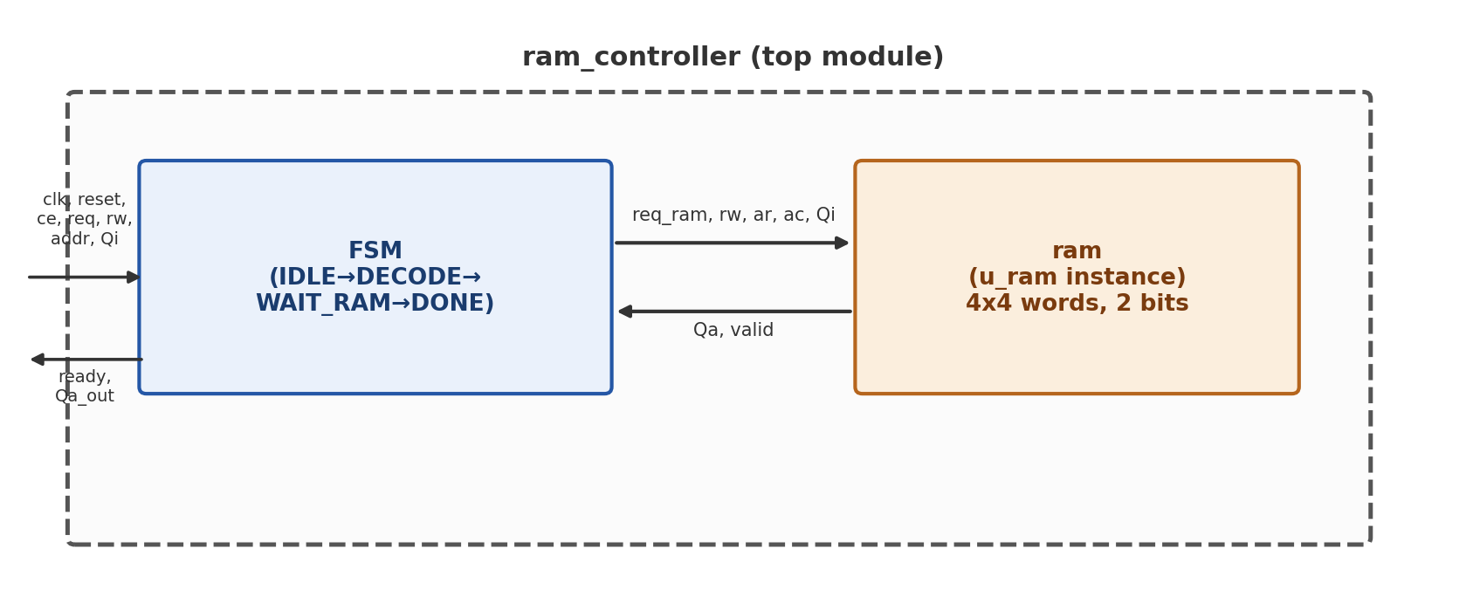
Figure 1: ram_controller instantiates ram internally; only the controller's ports are exposed to the outside world.
3.2 Finite State Machine
The controller is a 4-state Moore machine. Outputs (ready, Qa_out) depend only on the current state, so they change synchronously and glitch-free with the state register.
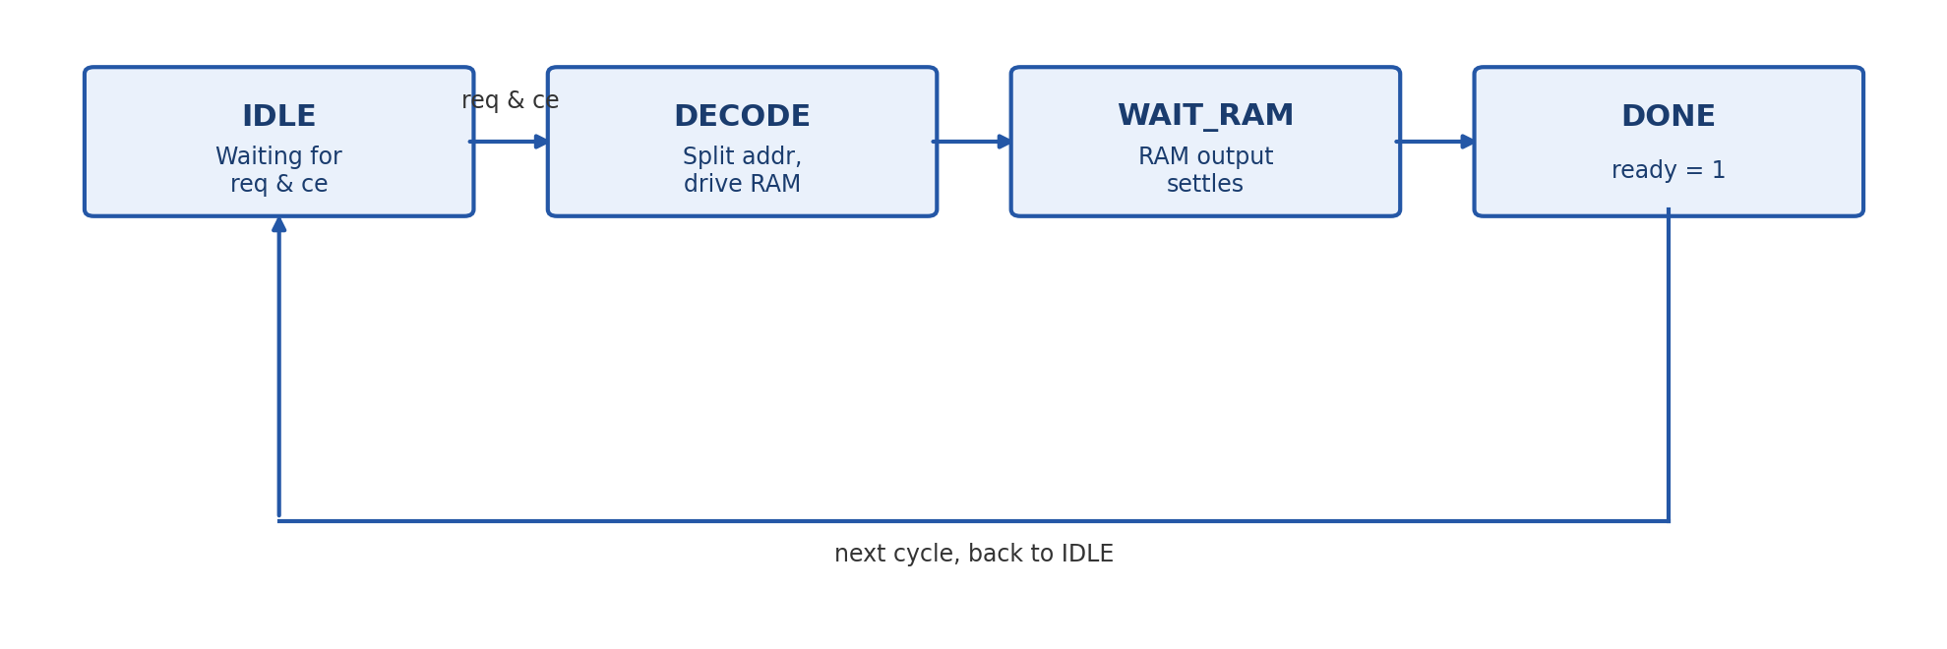
Figure 2: Controller FSM. A request is accepted only in IDLE (when req & ce); every other transition is unconditional.
State | req_ram | ready | Qa_out | Next state
IDLE | 0 | 0 | 0 | DECODE if (req && ce), else IDLE
DECODE | 1 (pulsed) | 0 | 0 | WAIT_RAM
WAIT_RAM | 0 | 0 | 0 | DONE
DONE | 0 | 1 | Qa (from RAM) | IDLE

Timing contract: a request presented in cycle N produces ready = 1 (and, for reads, valid data on Qa_out) in cycle N+3. req_ram is asserted to the RAM for exactly one cycle (DECODE only); the RAM's own internal registered output is what fixes the controller's WAIT_RAM state at one cycle.

4. Verilog Source Code
4.1 ram.v — Parameterized Single-Port RAM
R, C and N are module parameters (default 4, 4, 2). Row/column address widths (AR_W, AC_W) are derived automatically via $clog2(R) / $clog2(C) rather than hard-coded, so the address width always stays correct if R or C change. The memory is stored as a single flattened array of R×C words, indexed as (ar × C) + ac, which is the standard synthesizable pattern (true multi-dimensional memory arrays can behave inconsistently across synthesis tools).
// -----------------------------------------------------------------------------
// Module : ram
// Description : Parameterized single-port RAM.
// - R rows, C columns, N bits per word (default R=4, C=4, N=2).
// - Synchronous write.
// - Synchronous (registered) read: data appears on Qa exactly
// one clock cycle after a read request, with 'valid' pulsed
// high for that same cycle.
// - Address decoding (ar, ac -> flat index) is purely
// combinational; only the read DATA path is registered.
// -----------------------------------------------------------------------------

module ram #(
parameter R = 4, // number of rows
parameter C = 4, // number of columns
parameter N = 2, // bits per word
parameter AR_W = $clog2(R), // bits needed for row address, derived
parameter AC_W = $clog2(C) // bits needed for col address, derived
) (
input wire clk,
input wire reset,
input wire req, // request strobe (>=1 cycle)
input wire rw, // 1 = read, 0 = write
input wire [AR_W-1:0] ar, // row address
input wire [AC_W-1:0] ac, // column address
input wire [N-1:0] Qi, // write data
output reg [N-1:0] Qa, // read data (registered)
output reg valid // pulses 1 cycle when Qa is fresh
);

// Flattened memory array: R*C words, each N bits wide.
// Indexed as (ar * C) + ac.
reg [N-1:0] mem [0:(R*C)-1];

// Combinational flat index -- address decode has zero latency.
wire [$clog2(R*C)-1:0] flat_addr;
assign flat_addr = (ar * C) + ac;

always @(posedge clk) begin
if (reset) begin
Qa <= {N{1'b0}};
valid <= 1'b0;
// Memory contents are intentionally left undisturbed by reset --
// reset only clears the output-side registers (Qa, valid).
end else begin
// Default: no new valid data unless a read happens this cycle.
valid <= 1'b0;

if (req) begin
if (rw) begin
// ---- Read path: registered output ----
Qa <= mem[flat_addr];
valid <= 1'b1;
end else begin
// ---- Write path: synchronous write ----
mem[flat_addr] <= Qi;
end
end
end
end

endmodule

4.2 ram_controller.v — Top-Level FSM Controller
Instantiates ram internally. Address decoding (ar, ac) and the write-data path are driven combinationally from the external addr/Qi during DECODE, since that is the only cycle the RAM samples them. addr_reg and qi_reg additionally capture these inputs during DECODE; they are not required for the RAM's own correctness (req_ram is scoped to the DECODE cycle only) but were kept deliberately so WAIT_RAM/DONE do not rely on external signals remaining stable beyond the DECODE cycle — a conscious robustness/PPA trade-off discussed in Section 8.
// -----------------------------------------------------------------------------
// Module : ram_controller
// Description : Top-level memory controller. Presents a simple address-based
// interface to the outside world and internally sequences a
// 4-state FSM (IDLE -> DECODE -> WAIT_RAM -> DONE -> IDLE) to
// talk to the underlying `ram` module.
//
// External interface:
// clk, reset, ce, req, rw, addr, Qi (in)
// ready, Qa_out (out)
//
// Timing contract: a request presented in cycle N produces
// ready=1 (and valid Qa_out, for reads) in cycle N+3.
// -----------------------------------------------------------------------------

module ram_controller #(
parameter R = 4,
parameter C = 4,
parameter N = 2,
parameter AR_W = $clog2(R),
parameter AC_W = $clog2(C),
parameter ADDR_W = AR_W + AC_W // flat external address width
) (
input wire clk,
input wire reset,
input wire ce, // chip enable
input wire req, // request strobe from outside world
input wire rw, // 1 = read, 0 = write
input wire [ADDR_W-1:0] addr, // flat address from outside world
input wire [N-1:0] Qi, // write data from outside world

output wire ready, // pulses 1 cycle when op completes
output wire [N-1:0] Qa_out // read data, valid only when ready=1
);

// ---------------- FSM state encoding ----------------
localparam IDLE = 2'b00;
localparam DECODE = 2'b01;
localparam WAIT_RAM = 2'b10;
localparam DONE = 2'b11;

reg [1:0] state, next_state;

// ---------------- Internal registers (captured in DECODE) ----------------
// Not strictly required for RAM correctness (the RAM only samples its
// inputs during the one cycle req_ram is high, which is DECODE itself),
// but kept per design decision: decouples WAIT_RAM/DONE from having to
// rely on the external addr/Qi staying stable beyond the DECODE cycle.
reg [ADDR_W-1:0] addr_reg;
reg [N-1:0] qi_reg;

always @(posedge clk) begin
if (state == DECODE) begin
addr_reg <= addr;
qi_reg <= Qi;
end
end

// ---------------- Signals to/from the RAM sub-module ----------------
wire [AR_W-1:0] ar;
wire [AC_W-1:0] ac;
wire [N-1:0] Qi_ram;
wire req_ram;
wire [N-1:0] Qa;
wire valid;

// Address decode: purely combinational split of the flat address.
assign ar = addr[ADDR_W-1:AC_W];
assign ac = addr[AC_W-1:0];
assign Qi_ram = Qi;
assign req_ram = (state == DECODE); // 1-cycle pulse to the RAM

// ---------------- State register (sequential) ----------------
always @(posedge clk) begin
if (reset)
state <= IDLE;
else
state <= next_state;
end

// ---------------- Next-state logic (combinational) ----------------
always @(*) begin
case (state)
IDLE: next_state = (req && ce) ? DECODE : IDLE;
DECODE: next_state = WAIT_RAM;
WAIT_RAM: next_state = DONE;
DONE: next_state = IDLE;
default: next_state = IDLE;
endcase
end

// ---------------- Output logic (combinational function of state) ----------------
// Moore-style outputs: ready and Qa_out depend only on the current state.
assign ready = (state == DONE);
assign Qa_out = (state == DONE) ? Qa : {N{1'b0}};

// ---------------- RAM instantiation ----------------
ram #(
.R(R), .C(C), .N(N)
) u_ram (
.clk (clk),
.reset (reset),
.req (req_ram),
.rw (rw),
.ar (ar),
.ac (ac),
.Qi (Qi_ram),
.Qa (Qa),
.valid (valid)
);

endmodule

5. Verification
Verification followed a bottom-up methodology: the RAM was verified in isolation first (Section 5.1), before being verified again as part of the full controller (Section 5.2). This isolates bugs — if the combined system misbehaved, the RAM's correctness would already be independently established.
5.1 ram Testbench (ram_tb.v)
Drives req/rw/ar/ac/Qi directly, bypassing the controller, to check: reset behaviour, write-then-read-back at multiple locations (including all four corners of the 4×4 grid, to confirm the address-flattening formula indexes correctly with no collisions), and back-to-back read requests on consecutive cycles.
// -----------------------------------------------------------------------------
// Testbench : ram_tb
// Purpose : Standalone verification of the `ram` module ONLY.
// The controller/FSM is NOT involved here -- this testbench
// drives req/rw/ar/ac/Qi directly, exactly as the controller
// will eventually do, so any bugs found here are isolated to
// the RAM itself.
//
// Checks:
// 1. Reset behavior -> Qa=0, valid=0 after reset
// 2. Write then read-back -> correct data appears exactly 1 cycle after
// a read request, with valid pulsed that cycle
// 3. Multiple locations -> corners of the 4x4 grid, to confirm the
// flattening formula (ar*C + ac) indexes
// correctly and locations don't collide
// 4. Back-to-back requests -> a read immediately followed by another
// request on the very next cycle
// -----------------------------------------------------------------------------
`timescale 1ns / 1ps

module ram_tb;

// Parameters matching the locked design (R=4, C=4, N=2)
localparam R = 4;
localparam C = 4;
localparam N = 2;
localparam AR_W = 2; // $clog2(4)
localparam AC_W = 2; // $clog2(4)

reg clk;
reg reset;
reg req;
reg rw; // 1 = read, 0 = write
reg [AR_W-1:0] ar;
reg [AC_W-1:0] ac;
reg [N-1:0] Qi;
wire [N-1:0] Qa;
wire valid;

integer errors;

// ---------------- DUT instantiation ----------------
ram #(
.R(R), .C(C), .N(N)
) dut (
.clk (clk),
.reset (reset),
.req (req),
.rw (rw),
.ar (ar),
.ac (ac),
.Qi (Qi),
.Qa (Qa),
.valid (valid)
);

// ---------------- Clock generation: 100MHz -> 10ns period ----------------
initial clk = 0;
always #5 clk = ~clk;

// ---------------- Helper tasks ----------------

// Issue a single-cycle write request
task do_write(input [AR_W-1:0] a_row, input [AC_W-1:0] a_col, input [N-1:0] data);
begin
@(negedge clk);
req = 1; rw = 0; ar = a_row; ac = a_col; Qi = data;
@(negedge clk);
req = 0;
end
endtask

// Issue a single-cycle read request, then check Qa/valid one cycle later
task do_read_check(input [AR_W-1:0] a_row, input [AC_W-1:0] a_col, input [N-1:0] expected);
begin
@(negedge clk);
req = 1; rw = 1; ar = a_row; ac = a_col;
@(negedge clk);
req = 0;
// Qa/valid are now registered from last cycle's read request
if (valid !== 1'b1) begin
$display("ERROR: valid not asserted after read of ar=%0d ac=%0d at time %0t", a_row, a_col, $time);
errors = errors + 1;
end
if (Qa !== expected) begin
$display("ERROR: ar=%0d ac=%0d expected Qa=%0d, got Qa=%0d at time %0t", a_row, a_col, expected, Qa, $time);
errors = errors + 1;
end else begin
$display("PASS : ar=%0d ac=%0d Qa=%0d as expected at time %0t", a_row, a_col, Qa, $time);
end
end
endtask

// ---------------- Stimulus ----------------
initial begin
errors = 0;
req = 0; rw = 0; ar = 0; ac = 0; Qi = 0;
reset = 1;

// ---- 1. Reset check ----
@(negedge clk);
@(negedge clk);
if (Qa !== 0 || valid !== 0) begin
$display("ERROR: after reset expected Qa=0 valid=0, got Qa=%0d valid=%0d", Qa, valid);
errors = errors + 1;
end else begin
$display("PASS : reset correctly clears Qa/valid");
end
reset = 0;
@(negedge clk);

// ---- 2 & 3. Write then read-back, multiple locations (corners) ----
do_write(2'd0, 2'd0, 2'd1); // row0,col0 = 1
do_write(2'd3, 2'd3, 2'd2); // row3,col3 = 2
do_write(2'd0, 2'd3, 2'd3); // row0,col3 = 3
do_write(2'd3, 2'd0, 2'd0); // row3,col0 = 0
do_write(2'd2, 2'd1, 2'd1); // row2,col1 = 1 (used in earlier flat_addr example)

do_read_check(2'd0, 2'd0, 2'd1);
do_read_check(2'd3, 2'd3, 2'd2);
do_read_check(2'd0, 2'd3, 2'd3);
do_read_check(2'd3, 2'd0, 2'd0);
do_read_check(2'd2, 2'd1, 2'd1);

// ---- 4. Back-to-back requests: read immediately followed by another read ----
@(negedge clk);
req = 1; rw = 1; ar = 2'd0; ac = 2'd0; // read row0,col0 (expect 1)
@(negedge clk);
// Immediately issue the next read on the very next cycle, without
// de-asserting req in between.
req = 1; rw = 1; ar = 2'd3; ac = 2'd3; // read row3,col3 (expect 2)
// Check result of the FIRST read now (1 cycle after its request)
if (valid !== 1'b1 || Qa !== 2'd1) begin
$display("ERROR: back-to-back read #1 expected Qa=1 valid=1, got Qa=%0d valid=%0d", Qa, valid);
errors = errors + 1;
end else begin
$display("PASS : back-to-back read #1 Qa=%0d as expected", Qa);
end
@(negedge clk);
req = 0;
// Check result of the SECOND read now
if (valid !== 1'b1 || Qa !== 2'd2) begin
$display("ERROR: back-to-back read #2 expected Qa=2 valid=1, got Qa=%0d valid=%0d", Qa, valid);
errors = errors + 1;
end else begin
$display("PASS : back-to-back read #2 Qa=%0d as expected", Qa);
end

// ---- Summary ----
@(negedge clk);
if (errors == 0)
$display("\n=== ALL TESTS PASSED ===");
else
$display("\n=== %0d TEST(S) FAILED ===", errors);

$finish;
end

endmodule

Simulation result (Icarus Verilog, cross-checked against Vivado's simulator):
PASS : reset correctly clears Qa/valid
PASS : ar=0 ac=0 Qa=1 as expected at time 150000
PASS : ar=3 ac=3 Qa=2 as expected at time 170000
PASS : ar=0 ac=3 Qa=3 as expected at time 190000
PASS : ar=3 ac=0 Qa=0 as expected at time 210000
PASS : ar=2 ac=1 Qa=1 as expected at time 230000
PASS : back-to-back read #1 Qa=1 as expected
PASS : back-to-back read #2 Qa=2 as expected

=== ALL TESTS PASSED ===
Vivado simulation waveform:
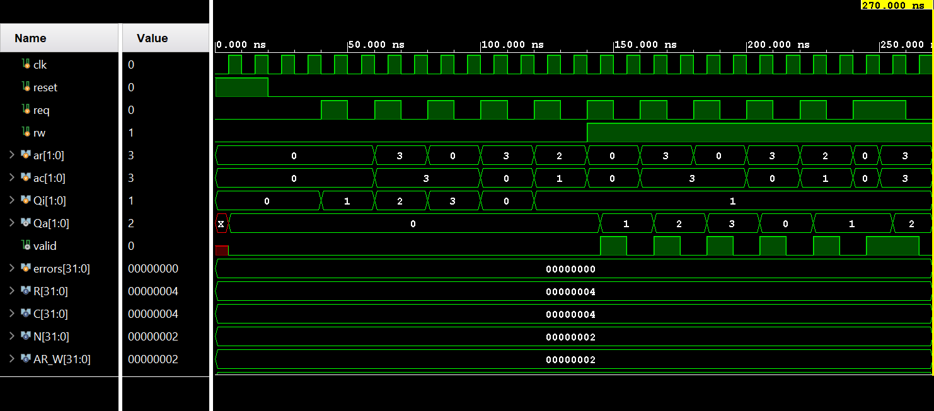
Figure 3: ram testbench waveform (XSIM). Writes to ar/ac=3,3 → Qi=1, then later 0,3 → Qi=2, etc., with Qa/valid updating one cycle after each read request — matching the registered-output behaviour by design.

5.2 ram_controller Testbench (ram_controller_tb.v)
Treats the controller as a black box, driving only req/rw/addr/Qi and observing ready/Qa_out. Checks idle behaviour, ce gating (a request held with ce=0 must never start), the 3-cycle request-to-ready latency across multiple different addresses, data correctness including an overwrite case, and correct re-arming after idle gaps between transactions.
// -----------------------------------------------------------------------------
// Testbench : ram_controller_tb
// Purpose : Black-box verification of ram_controller (RAM instantiated
// internally). Only touches the external interface:
// req, rw, addr, Qi (drive)
// ready, Qa_out (observe)
//
// Checks:
// 1. Idle behavior -> ready stays 0 with no request pending
// 2. Single write -> ready pulses exactly 3 cycles after request
// 3. Single read-back -> Qa_out correct exactly when ready=1
// 4. Multiple transactions -> several writes/reads to different addresses,
// with idle gaps, FSM re-arms correctly each time
// 5. ce gating -> req=1 with ce=0 must NOT start a transaction
// 6. Timing contract check -> 3-cycle latency held consistently, not just once
// -----------------------------------------------------------------------------
`timescale 1ns / 1ps

module ram_controller_tb;

localparam R = 4;
localparam C = 4;
localparam N = 2;
localparam AR_W = 2;
localparam AC_W = 2;
localparam ADDR_W = AR_W + AC_W;

reg clk;
reg reset;
reg ce;
reg req;
reg rw;
reg [ADDR_W-1:0] addr;
reg [N-1:0] Qi;
wire ready;
wire [N-1:0] Qa_out;

integer errors;

// ---------------- DUT instantiation ----------------
ram_controller #(
.R(R), .C(C), .N(N)
) dut (
.clk (clk),
.reset (reset),
.ce (ce),
.req (req),
.rw (rw),
.addr (addr),
.Qi (Qi),
.ready (ready),
.Qa_out (Qa_out)
);

// ---------------- Clock: 100MHz -> 10ns period ----------------
initial clk = 0;
always #5 clk = ~clk;

// ---------------- Helper task: issue one op, check 3-cycle latency + data ----------------
task automatic do_op(
input rw_val,
input [ADDR_W-1:0] a,
input [N-1:0] wdata,
input [N-1:0] expected_rdata,
input check_rdata,
input [8*24:1] label
);
integer cycles;
begin
@(negedge clk);
req = 1; rw = rw_val; addr = a; Qi = wdata;
cycles = 0;
@(negedge clk);
req = 0;
cycles = cycles + 1;
while (ready !== 1'b1) begin
@(negedge clk);
cycles = cycles + 1;
end

if (cycles !== 3) begin
$display("ERROR: %0s latency mismatch, expected 3 cycles, got %0d", label, cycles);
errors = errors + 1;
end else begin
$display("PASS : %0s latency = %0d cycles as expected", label, cycles);
end

if (check_rdata) begin
if (Qa_out !== expected_rdata) begin
$display("ERROR: %0s expected Qa_out=%0d, got %0d", label, expected_rdata, Qa_out);
errors = errors + 1;
end else begin
$display("PASS : %0s Qa_out=%0d as expected", label, Qa_out);
end
end
@(negedge clk); // let DONE->IDLE transition settle before next op
end
endtask

// ---------------- Stimulus ----------------
initial begin
errors = 0;
reset = 1; ce = 1; req = 0; rw = 0; addr = 0; Qi = 0;

@(negedge clk);
@(negedge clk);
reset = 0;

// ---- 1. Idle behavior ----
repeat (3) @(negedge clk);
if (ready !== 1'b0) begin
$display("ERROR: expected ready=0 while idle, got ready=%b", ready);
errors = errors + 1;
end else begin
$display("PASS : ready stays 0 while idle");
end

// ---- 5. ce gating: req=1 but ce=0 must NOT start a transaction ----
ce = 0;
@(negedge clk);
req = 1; rw = 0; addr = 4'd5; Qi = 2'd2;
repeat (5) @(negedge clk); // hold for 5 cycles, well beyond 3-cycle latency
if (ready !== 1'b0) begin
$display("ERROR: ce=0 should block the transaction, but ready went high");
errors = errors + 1;
end else begin
$display("PASS : ce=0 correctly blocks the transaction (ready stayed 0)");
end
req = 0;
@(negedge clk);
ce = 1;
@(negedge clk);

// ---- 2, 3, 6. Single write + read-back at several addresses, checking 3-cycle latency each time ----
do_op(1'b0, 4'd0, 2'd1, 2'd0, 1'b0, "write addr0=1 ");
do_op(1'b1, 4'd0, 2'd0, 2'd1, 1'b1, "read addr0 ");

do_op(1'b0, 4'd15, 2'd2, 2'd0, 1'b0, "write addr15=2");
do_op(1'b1, 4'd15, 2'd0, 2'd2, 1'b1, "read addr15 ");

do_op(1'b0, 4'd9, 2'd3, 2'd0, 1'b0, "write addr9=3 ");
do_op(1'b1, 4'd9, 2'd0, 2'd3, 1'b1, "read addr9 ");

// ---- 4. Multiple sequential transactions with idle gaps in between ----
repeat (4) @(negedge clk); // idle gap
do_op(1'b0, 4'd6, 2'd1, 2'd0, 1'b0, "write addr6=1 ");
repeat (2) @(negedge clk); // idle gap
do_op(1'b1, 4'd6, 2'd0, 2'd1, 1'b1, "read addr6 ");
repeat (3) @(negedge clk); // idle gap

// overwrite addr0 with a new value, confirm it updates correctly
do_op(1'b0, 4'd0, 2'd3, 2'd0, 1'b0, "overwrite addr0=3");
do_op(1'b1, 4'd0, 2'd0, 2'd3, 1'b1, "read addr0 again");

// ---- Summary ----
@(negedge clk);
if (errors == 0)
$display("\n=== ALL TESTS PASSED ===");
else
$display("\n=== %0d TEST(S) FAILED ===", errors);

$finish;
end

endmodule

Vivado simulation waveform:
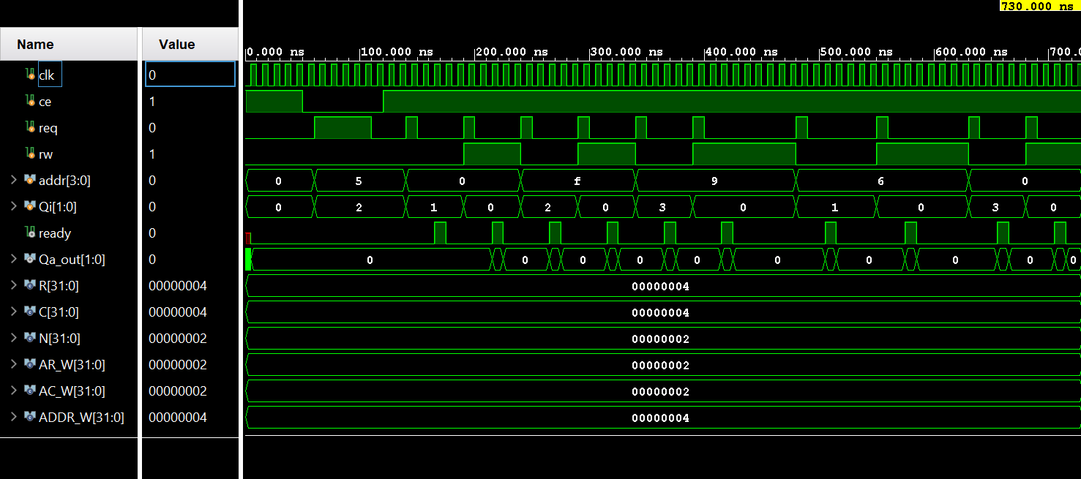
Figure 4: ram_controller testbench waveform (XSIM). req pulses at addr = 0, 5, 0, f, 9, 6, 0 drive write/read sequences; ready pulses exactly 3 cycles after each request, with Qa_out updating only on reads.
Vivado TCL console output:
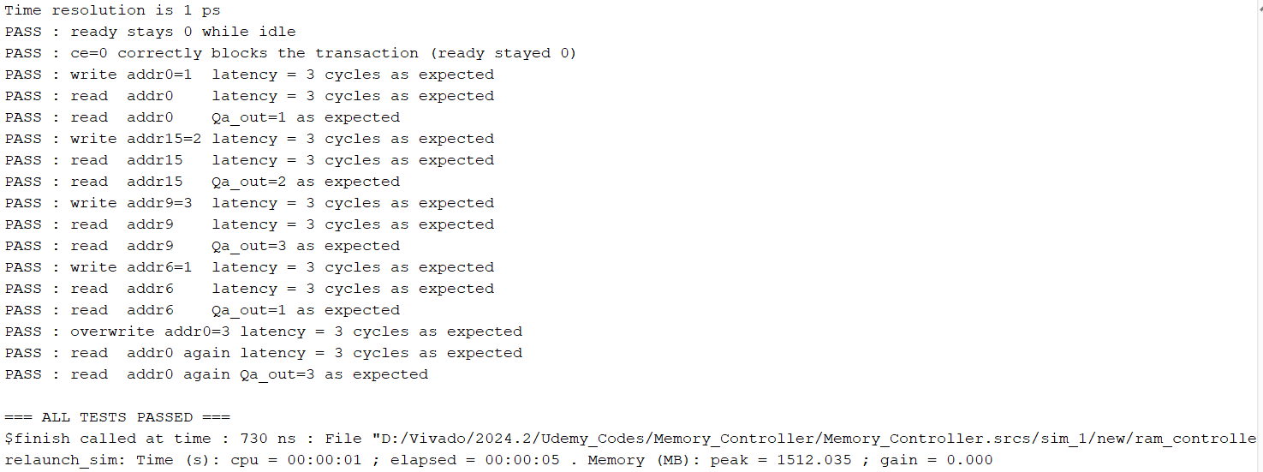
Figure 5: ram_controller testbench console log in Vivado — all checks pass (“=== ALL TESTS PASSED ===”).

Note: simulation is the only correctness evidence available without physical hardware — both testbenches above passed all checks with zero errors, on both Icarus Verilog and Vivado's XSIM simulator independently, before synthesis was attempted.

6. Synthesis and Implementation
6.1 Methodology
- Tool: Xilinx Vivado. Target part: xc7a100tcsg324-1 (Artix-7, as used on the Digilent Nexys 4 DDR).
- Top module: ram_controller (used directly, without the board-level I/O wrapper), since no physical FPGA board was available for this project and bitstream generation / hardware testing was therefore out of scope.
- Constraints: a single clock constraint, create_clock -name clk -period 10.000 [get_ports clk], defining the intended 100 MHz operating frequency. No pin locations or I/O standards were specified, since there is no physical board to map ports onto.
- Flow: Synthesis → Implementation (place and route) → Report Timing Summary / Report Power / Report Utilization.
6.2 Synthesized and Implemented Schematics
These are device-level (gate/primitive) schematics, generated automatically by Vivado from the netlist — not hand-drawn — shown here as the synthesis/implementation result snapshots required by the assignment.
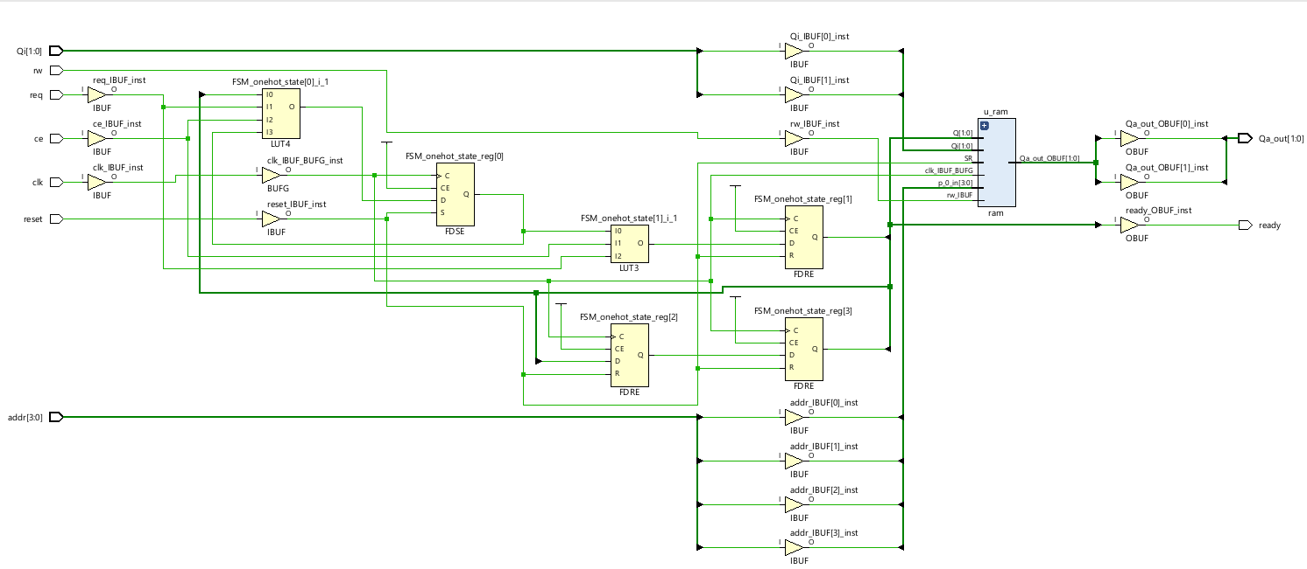
Figure 6: Post-synthesis schematic. The FSM is implemented in one-hot encoding (FSM_onehot_state_reg[0:3]), each state a separate FDRE/FDSE flip-flop; u_ram is still shown as a black-box primitive at this stage.
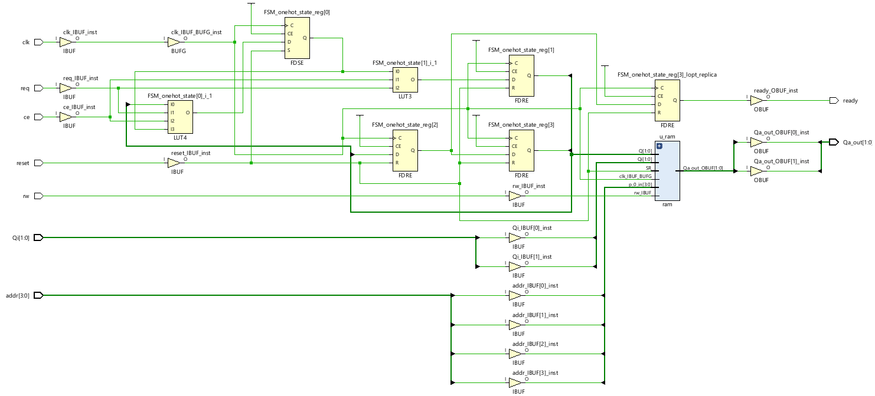
Figure 7: Post-implementation schematic, after place-and-route. Structurally the same netlist as Figure 6, now mapped to placed Artix-7 primitives (IBUF/OBUF/BUFG, FDRE/FDSE, LUT3/LUT4).

One detail worth noting: Vivado's synthesizer chose a one-hot state encoding for the 4-state FSM (one flip-flop per state, FSM_onehot_state_reg[0:3]) rather than the compact 2-bit binary encoding written in the RTL (IDLE=00, DECODE=01, WAIT_RAM=10, DONE=11). This is an automatic, tool-driven re-encoding — a common optimization on FPGAs, where flip-flops are abundant and one-hot encoding often yields simpler (faster, smaller) next-state logic per state than a dense binary encoding would. It does not change the FSM's behaviour, only its internal representation.
6.3 Timing Report
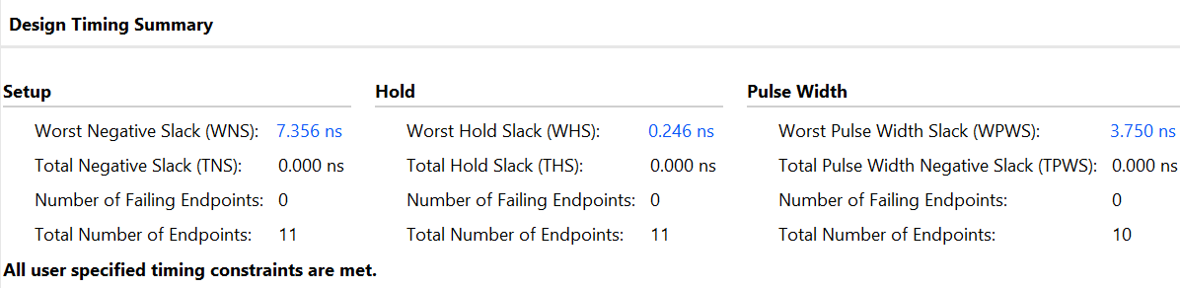
Figure 8: Design Timing Summary — all user-specified constraints are met.
Metric | Setup | Hold | Pulse Width
Worst slack | 7.356 ns (WNS) | 0.246 ns (WHS) | 3.750 ns (WPWS)
Total negative slack | 0.000 ns | 0.000 ns | 0.000 ns
Failing endpoints | 0 / 11 | 0 / 11 | 0 / 10

With a 10 ns clock period and 7.356 ns of positive setup slack, the design's actual critical path is only about 2.644 ns — comfortably inside budget, as expected for a small 4-state FSM driving a 4×4-word RAM. Zero failing endpoints across setup, hold and pulse-width checks confirms the 100 MHz target is met with margin to spare.
6.4 Power Report
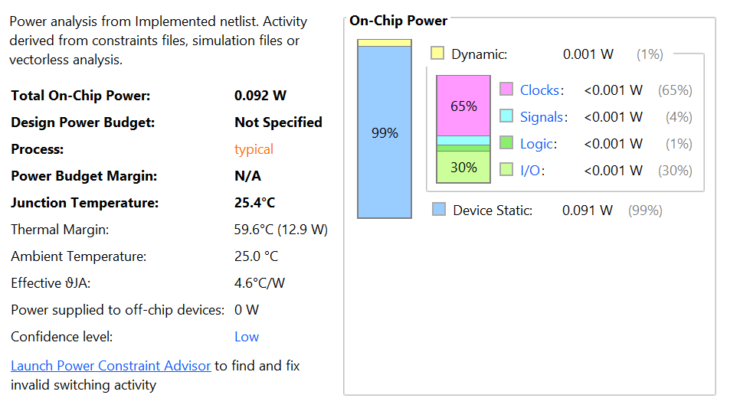
Figure 9: On-chip power estimate, post-implementation.
Total on-chip power is estimated at 0.092 W, of which 99% (0.091 W) is device static (leakage) power and only 1% (0.001 W) is dynamic — expected for a design this small, since static leakage from the FPGA fabric itself dominates regardless of what logic is mapped onto it. Of the dynamic component, clock distribution accounts for the largest share (65%), with I/O (30%), signals (4%) and logic (1%) making up the rest.
The report's confidence level is listed as “Low,” because Vivado estimated switching activity vectorlessly (generic assumptions) rather than from the project's own simulation. A SAIF file exported from the ram_controller_tb simulation could be imported to raise this to a simulation-backed estimate; this was considered but not pursued for this submission, since the relative power breakdown (dominated by static leakage, as expected for this design's size) would not be expected to change materially.
6.5 Utilization Report
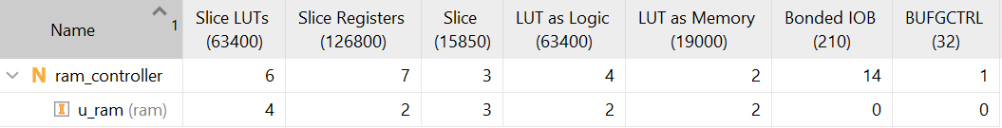
Figure 10: Post-implementation resource utilization, ram_controller top and the u_ram sub-instance.
Resource | ram_controller (top) | of which u_ram | Device capacity
Slice LUTs | 6 | 4 | 63,400
Slice Registers | 7 | 2 | 126,800
Slices | 3 | 3 | 15,850
LUT as Logic | 4 | 2 | 63,400
LUT as Memory | 2 | 2 | 19,000
Bonded IOB | 14 | 0 | 210
BUFGCTRL | 1 | 0 | 32

Resource usage is negligible relative to the xc7a100t's capacity (well under 0.1% of LUTs and registers), which is expected given the deliberately small R=4, C=4, N=2 parameters chosen for traceability during simulation. Of note: the 16-word memory array was implemented as distributed RAM using LUTs configured as small memories (“LUT as Memory”), rather than a dedicated Block RAM tile — a synthesis tool decision based purely on size, since consuming an entire 36 Kb BRAM block for 32 bits of storage would not be an efficient use of that resource. The design was not forced toward Block RAM inference, since the LUT-based implementation is already essentially free in context. Bonded IOB count (14) matches the design's 14 top-level ports exactly, and the single BUFGCTRL reflects the one global clock buffer automatically inserted for the clk input.
6.6 DRC and Methodology Notes
Running implementation without board-level pin constraints produces a small set of expected critical warnings and methodology notes, none of which affect the reports above:
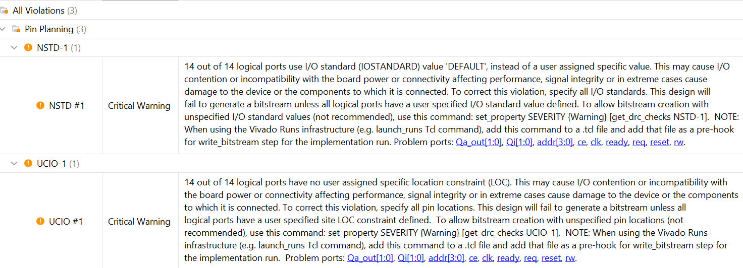
Figure 11: NSTD-1 and UCIO-1 — I/O standard and pin location not specified for all 14 ports.
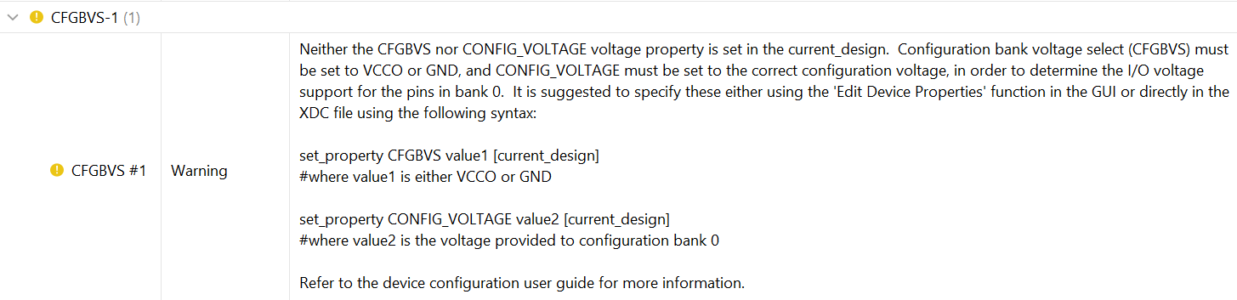
Figure 12: CFGBVS-1 — configuration bank voltage not specified.
All three (NSTD-1, UCIO-1, CFGBVS-1) are explicitly described by Vivado as blocking bitstream generation only — they do not affect synthesis, implementation, or the timing/power/utilization reports. Since no physical board or bitstream was targeted for this project, these were deliberately left unresolved rather than filled in with arbitrary pin assignments.
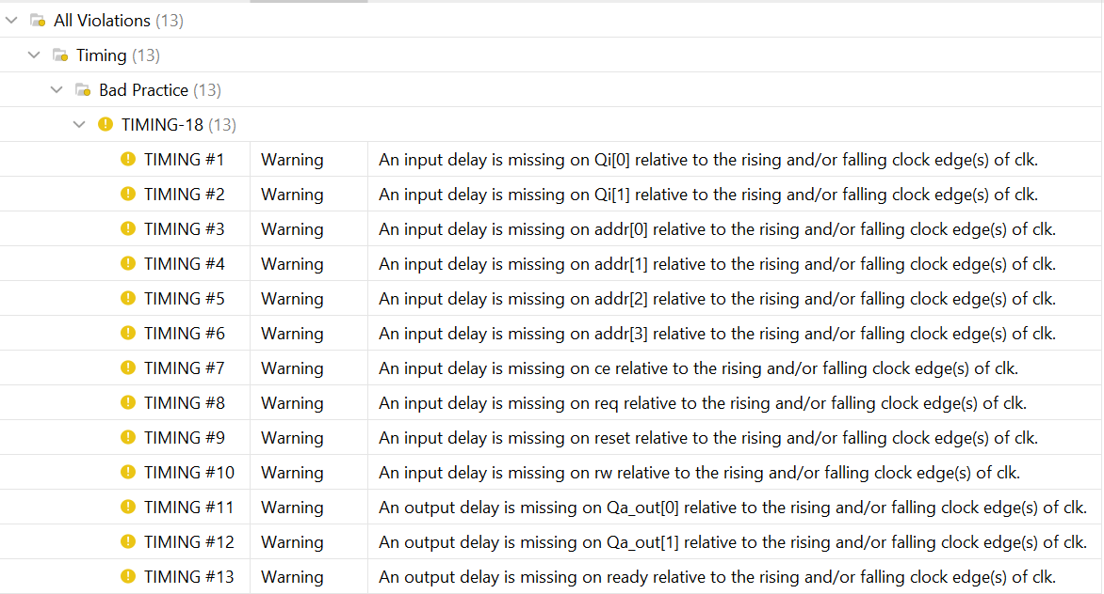
Figure 13: Report Methodology — TIMING-18, missing input/output delay relative to clk on all 14 ports.
This flags that no set_input_delay/set_output_delay constraints were added, so I/O-to-register and register-to-I/O paths are analyzed less rigorously than the internal register-to-register paths reported in Section 6.2. Realistic values for these constraints would normally be derived from a specific board's I/O timing characteristics; with no physical board targeted, no such values were available to assume, so this is noted here as a limitation of the analysis rather than resolved with arbitrary numbers.
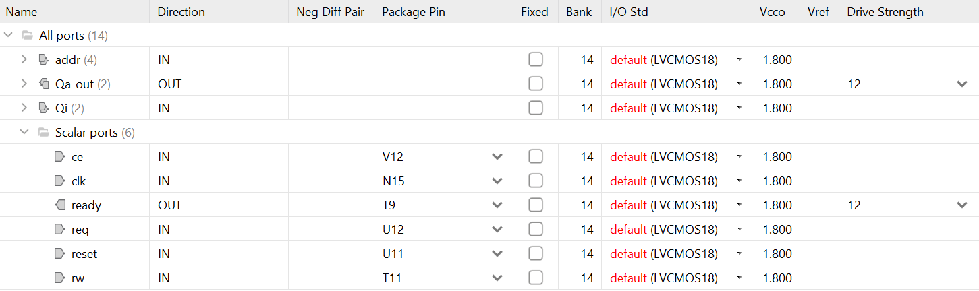
Figure 14: I/O Ports view, showing default IOSTANDARD and (where auto-assigned via the GUI) package pins — informational only, since no bitstream was generated.

7. Summary of Design Decisions
Decision point | Choice made | Rationale
ready semantics | Pulses when operation completes | Matches 'operation complete' intent more directly than a free/busy flag
Controller style | Explicit 4-state FSM | Deliberately chosen over a minimal combinational design, to build FSM design skills
Abort support | Not included | Not required by the spec; keeps the FSM and req timing simple
req_ram duration | 1 cycle (DECODE only) | Sufficient since there is no abort path requiring it to be held longer
Read/write timing | Uniform (3-cycle latency for both) | Simpler, symmetric FSM; avoids branching states for read vs. write
addr_reg / qi_reg | Captured in DECODE, kept even though not required for RAM correctness | Decouples WAIT_RAM/DONE from relying on external signal stability; negligible PPA cost
rw_reg | Dropped | Captured value was unused by any output logic
Qa_out idle value | Forced to 0 outside DONE | Cleaner waveforms, unambiguous 'no fresh data' state
Reset scope (RAM) | Clears Qa/valid only, not memory contents | Matches typical block RAM behaviour; avoids an unnecessary memory-clear loop
BRAM vs. distributed RAM | Left to synthesis tool (not forced) | Design is far too small to justify consuming a dedicated Block RAM tile
Power analysis method | Vectorless estimate (SAIF import not pursued) | Static leakage already dominates at this design's size; a more precise dynamic figure was not expected to change the conclusion

8. Conclusion
The memory controller and single-port RAM were designed, simulated, and synthesized successfully. Both modules were verified bottom-up: the RAM in isolation, then the full FSM-based controller, with all checks passing on two independent simulators. Post-implementation analysis shows the design comfortably meets its 100 MHz timing target (7.356 ns of positive setup slack, zero failing endpoints), consumes negligible chip resources (well under 0.1% of the target device), and draws 0.092 W of estimated on-chip power, dominated by static leakage as expected for a design of this size. All outstanding DRC and methodology warnings stem directly and exclusively from the deliberate choice to synthesize without a physical board or bitstream target, and do not reflect defects in the design itself.

