Design document

Sam Philipsen

Inhoud

C4 diagrams 3

C1 3

C2 4

C3 5

Design decisions 6

Test plan 7

# C4 diagrams

## C1

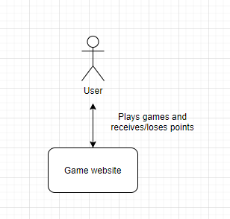

## C2

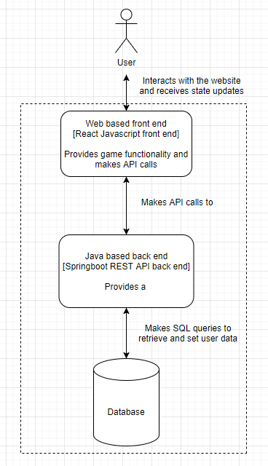

## C3

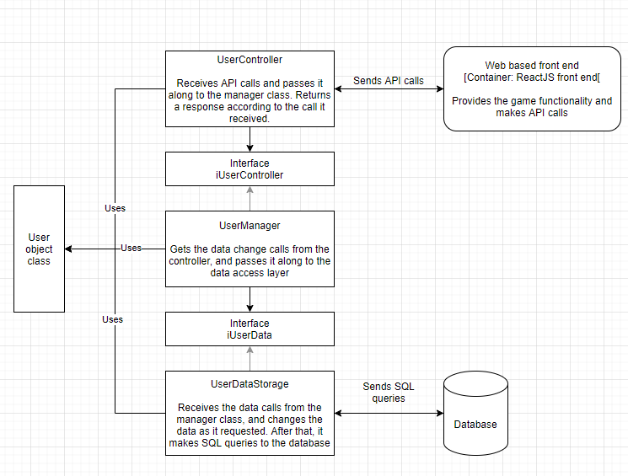

# Design decisions

As seen in the C4 diagrams above, the system is currently built up like the following:

The user can interact with the web based front end service. These interactions are planned to be logging in and playing games, though more might be added in the future. Once the user tries to log in to the system, a HTTP request with the filled in user details is created. This request is sent to the Spring boot API. The request is received by the controller class, which then tries to get the required information from the manager class. It does this through the IUserManager interface class, as to avoid every program in the system from depending on each other.

The manager class then tries to get the requested data from the data access layer, also going through an interface in the process. The data access class gets the requested data (the user’s information) and it all gets passed back to the API controller class, which sends the data to the web service. Once the web service has this information, it can now display it and store it for further HTTP requests.

**Why dependency inversion?**

The reason the manager and database access layer have interfaces is because of dependency inversion. If I’d want to test a single method in one of the classes, it would need to load every class just for testing a single method. To prevent this, these classes are connected to an interface. This means that I can put a fake data class instead of a real one so it does not have to load the real one each time.

**Why spring boot?**

Spring boot is used because it is an easy to use, but still very functional way to make the web API work. The required setup and learning curve is minimal compared to other popular web frameworks. It is also very easy to connect to the rest of my application.

# Test plan

For the testing of my classes I will be inserting unit tests for every major class, like the controller, manager, and repository classes. This is to ensure they all work according to what I designed, and it does not fail.

Integration testing is not necessary because the unit tests already provide enough coverage of my classes’ methods. I chose the unit tests above integration testing because I can check each method individually if they work or need changing.

In the future I might try TTD (Test driven development) if there need to be more classes, but for now this is it.

For a full list of the tests, I plan to complete at the end, see the project planning document.