**CURRICULUM VITAE**

Name : Nawshin Rashidi Oyshee 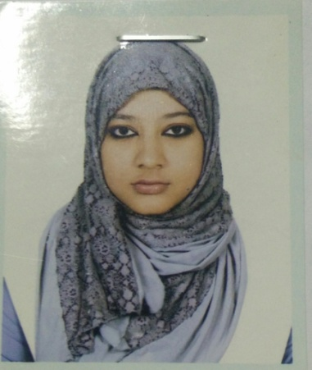  
Phone No: 01686519995  
Email: nawshinrashidioyshee@gmail.com

**Personal Information**  
  
Father’s Name : S. M. Harunar Rashid  
Mother’s Name: Shahnaz Mily  
Date of Birth : 15-07-1994  
Nationality : Bangladeshi  
Religion : Islam  
Permanent Address: D-124, Eastern Housing, Pallabi 2nd Phase, Mirpur, Dhaka.  
Present Address: H-1057, R-06, Avenue-07, D.O.H.S, Mirpur, Dhaka.

|  |  |  |  |  |
| --- | --- | --- | --- | --- |
| SSC | Name of Institute | Board | Year | GPA |
| ShaheedBirUttam Lt. Anwar Girls’ College | Dhaka | 2011 | 5.00 |
| HSC | RajukUttara Model College | Dhaka | 2013 | 5.00 |

**Educational Information**University Name: Military Institute of Science and Technology  
Currently Studying in Level-3

Department : Computer Science and Engineering(CSE)