**Military Institute of Science and Technology (MIST)**

**Department of Computer Science and Engineering**

**CSE-315 (DSD Sessional)**

**CSE-14, Level-3, Term-II**

**Lab-01(Group-A+B)**

1. **Implement 4:1 MUX in Circuit Maker software and simulate it.**

**Instructions:**

1. **Use basic gates (AND, OR and inverter)**
2. **Use Logic switch and logic display to give input and output.**

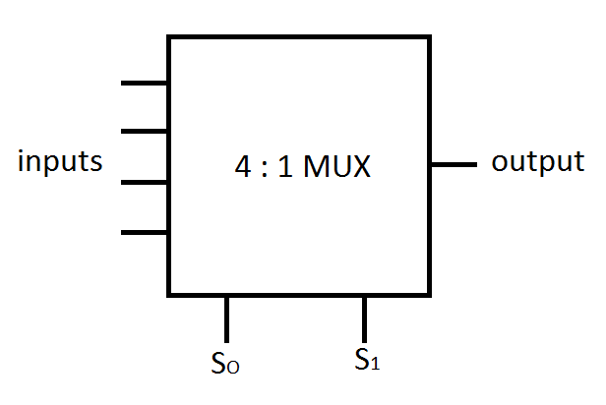

1. **Software implementation of 4-bit combinational logic shifter using basic gates and Shifter IC.**

|  |  |  |
| --- | --- | --- |
| S0  S1 S2 | Operation | Function |
| 0 0 0 | F A | Transfer A to F |
| 0 0 1 | F A’ | Complement of A |
| 0 1 0 | F shr A | Shift right A into F |
| 0 1 1 | F shl A | Shift left A into F |
| 1 0 0 | F cr A | Circular right A into F |
| 1 0 1 | F cl A | Circular left A into F |
| 1 1 0 | F All 0’s | Transfer 0’s into F |
| 1 1 1 | F All 1’s | Transfer 1’s into F |

**F: 4-bit outputs (F0, F1, F2, F3)**

**A: 4-bit inputs (A0,A1,A2,A3)**

**S: 3-bit Selection variables (S0, S1, S2)**