**Abstract**

**Time-division multiplexing** (**TDM**) is a method of transmitting and receiving independent signals over a common signal path by means of synchronized switches at each end of the transmission line so that each signal appears on the line only a fraction of time in an alternating pattern. It is used when the data rate of the transmission medium exceeds that of signal to be transmitted. This form of signal [multiplexing](https://en.wikipedia.org/wiki/Multiplexing) was developed in [telecommunications](https://en.wikipedia.org/wiki/Telecommunications) for [telegraphy](https://en.wikipedia.org/wiki/Telegraphy) systems in the late 19th century, but found its most common application in [digital](https://en.wikipedia.org/wiki/Digital_data) telephony in the second half of the 20th century.

(**S**ynchronous **O**ptical **Net**work) A fiber-optic transmission system for high-speed digital traffic. Employed by telephone companies and common carriers, speeds range from 51 Mbps to 40 Gbps.  
  
SONET is an intelligent system that provides advanced network management and a standard optical interface. Specified in the Broadband ISDN (B-ISDN) standard, SONET backbones are widely used to aggregate T1 and T3 lines. The European counterpart to SONET is the Synchronous Digital Hierarchy, and the term "SONET/SDH" is widely used when referring to SONET.

TDM-based networks of PDH (Plesiochronous Digital Hierarchy) and SDH/SONET have long served as standard transport platforms for cellular traffic. PDH and SDH/SONET are optimized to deal with bulk voice circuits with maximum uptime, minimal delay and guaranteed service continuity. SDH was created to replace PDH system for interoperability between equipment from various vendors. The signal hierarchy defined several line rates among which STM-1 (155 Mbps), STM-4 (622 Mbps), STM-16 (2.5 Gbps) and STM-64 (10 Gbps) and STM-256 (40 Gbps) happen to be widely adopted.

In these paper our team will try to…………………………

**SONET/SDH**

SONET that is used as a transport network to carry loads from other WANs. We first discuss SONET as a protocol, and we then show how SONET networks can be constructed from the standards defined in the protocol. The high bandwidths of fiber-optic cable are suitable for today's high-data-rate technologies (such as video conferencing) and for carrying large numbers of lower-rate technologies at the same time. For this reason, the importance of fiber optics grows in conjunction with the development of technologies requiring high data rates or wide bandwidths for transmission. With their prominence came a need for standardization. The United States (ANSI) and Europe (ITU-T) have responded by defining standards that, though independent, are fundamentally similar and ultimately compatible. The ANSI standard is called the Synchronous Optical Network (SONET). The ITU-T standard is called the Synchronous Digital Hierarchy (SDH).

**ARCHITECTURE**

Let us first introduce the architecture of a SONET system: signals, devices, and connections. Signals SONET defines a hierarchy of electrical signaling levels called synchronous transport signals (STSs). Each STS level (STS-1 to STS-192) supports a certain data rate, specified in megabits per second. The corresponding optical signals are called optical carriers (OCs). SDH specifies a similar system called a synchronous transport module (STM). STM is intended to be compatible with existing European hierarchies, such as E lines, and with STS levels. To this end, the lowest STM level, STM-1, is defined as 155.520 Mbps, which is exactly equal to STS-3.

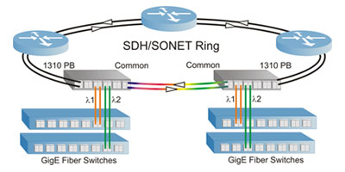

**SONET Devices**

SONET transmission relies on three basic devices: STS multiplexers/demultiplexers, regenerators, add/drop multiplexers and terminals.

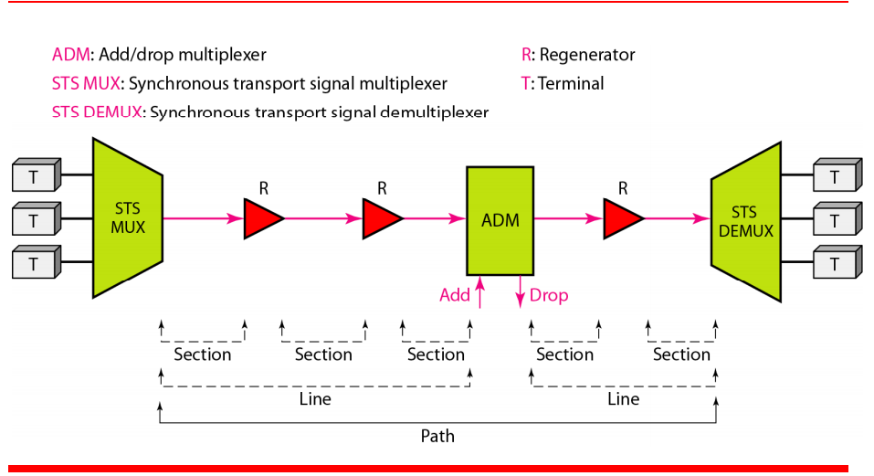

**STS Multiplexer/Detnultiplexer**

STS multiplexers/demultiplexers mark the beginning points and endpoints of a SONET link. They provide the interface between an electrical tributary network and the optical network. An STS multiplexer multiplexes signals from multiple electrical sources and creates the corresponding OC signal. An STS demultiplexerdemultiplexes an optical OC signal into corresponding electric signals.

**Regenerator**

Regenerators extend the length of the links. A regenerator is a repeater that takes a received optical signal (OC-n), demodulates it into the corresponding electric signal (STS-n), regenerates the electric signal, and finally modulates the electric signal into its correspondent OC-n signal. A SONET regenerator replaces some of the existing overhead information (header information) with new information.

**Add/drop Multiplexer**

Add/drop multiplexers allow insertion and extraction of signals. An add/drop multiplexer (ADM) can add STSs coming from different sources into a given path or can remove a desired signal from a path and redirect it without demultiplexing the entire signal. Instead of relying on timing and bit positions, add/drop multiplexers use header information such as addresses and pointers (described later in this section) to identify individual streams.

In the simple configuration, a number of incoming electronic signals are fed into an STS multiplexer, where they are combined into a single optical signal. The optical signal is transmitted to a regenerator, where it is recreated without the noise it has picked up in transit. The regenerated signals from a number of sources are then fed into an add/drop multiplexer. The add/drop multiplexer reorganizes these signals, if necessary, and sends them out as directed by information in the data frames. These remultiplexed signals are sent to another regenerator and from there to the receiving STS demultiplexer, where they are returned to a format usable by the receiving links.

**Terminals**

A terminal is a device that uses the services of a SONET network. For example, in the Internet, a terminal can be a router that needs to send packets to another router at the other side of a SONET network.

**Connections**

The devices defined in the previous section are connected using sections, lines, and paths.

**Sections**

A section is the optical link connecting two neighbor devices: multiplexer to multiplexer, multiplexer to regenerator, or regenerator to regenerator.

**Lines**

A line is the portion of the network between two multiplexers: STS multiplexer to add/ drop multiplexer, two add/drop multiplexers, or two STS multiplexers.

**Paths**

A path is the end-to-end portion of the network between two STS multiplexers. In a simple SONET of two STS multiplexers linked directly to each other, the section, line, and path are the same.

**SONET LAYERS**  
The SONET standard includes four functional layers: the photonic, the section, the line, and the path layer. They correspond to both the physical and the data link layers. The headers added to the frame at the various layers are discussed later in this chapter.

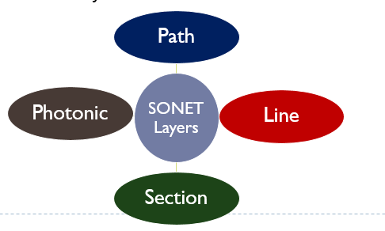  
  
**Path Layer**  
The path layer is responsible for the movement of a signal from its optical source to its optical destination. At the optical source, the signal is changed from an electronic form into an optical form, multiplexed with other signals, and encapsulated in a frame. At the optical destination, the received frame is demultiplexed, and the individual optical signals are changed back into their electronic forms. Path layer overhead is added at this layer. STS multiplexers provide path layer functions.  
  
**Line Layer**  
The line layer is responsible for the movement of a signal across a physical line. Line layer overhead is added to the frame at this layer. STS multiplexers and add/drop multiplexers provide line layer functions.  
  
**Section Layer**  
The section layer is responsible for the movement of a signal across a physical section. It handles framing, scrambling, and error control. Section layer overhead is added to the frame at this layer.  
  
**Photonic Layer**  
The photonic layer corresponds to the physical layer of the OSI model. It includes physical specifications for the optical fiber channel, the sensitivity of the receiver, multiplexing functions, and so on. SONET uses NRZ encoding with the presence of light representing 1 and the absence of light representing 0.  
  
**Device-Layer Relationships**  
an STS multiplexer is a four-layer device. A add /drop multiplexer is a three-layer device. A regenerator is a two-layer device.  
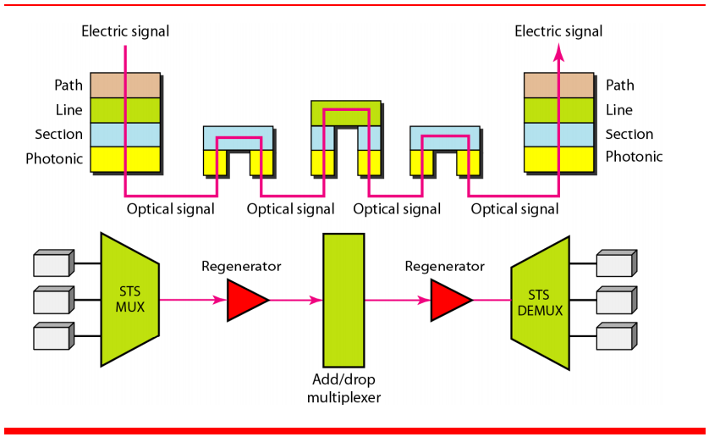  
**SONET FRAMES**  
Each synchronous transfer signal STS-n is composed of 8000 frames. Each frame is a two-dimensional matrix of bytes with 9 rows by 90 x n columns. For example, STS- 1 frame is 9 rows by 90 columns (810 bytes), and an STS-3 is 9 rows by 270 columns (2430 bytes).  
  
**Frame, Byte, and Bit Transmission**  
One of the interesting points about SONET is that each STS-n signal is transmitted at a fixed rate of 8000 frames per second. This is the rate at which voice is digitized. For each frame the bytes are transmitted from the left to the right, top to the bottom. For each byte, the bits are transmitted from the most significant to the least significant (left to right).  
  
If we sample a voice signal and use 8 bits (1 byte) for each sample, we can say that each byte in a SONET frame can carry information from a digitized voice channel. In other words, an STS-1 signal can carry 774 voice channels simultaneously (810 minus required bytes for overhead).  
  
**STS-1 Frame Format**  
SONET frame is a matrix of 9 rows of 90 bytes (octets) each, for a total of 810 bytes. The first three columns of the frame are used for section and line overhead. The upper three rows of the first three columns are used for section overhead (SOH). The lower six are line overhead (LOH). The rest of the frame is called the synchronous payload envelope (SPE). It contains user data and path overhead (POH) needed at the user data level. We will discuss the format of the SPE shortly.  
  
**Section Overhead**  
Alignment bytes (A1 and A2). Bytes A1 and A2 are used for framing and synchronization and are called alignment bytes. These bytes alert a receiver that a frame is arriving and give the receiver a predetermined bit pattern on which to synchronize. The bit patterns for these two bytes in hexadecimal are 0xF628. The bytes serve as a flag.  
  
Section parity byte (B1). Byte B1 is for bit interleaved parity (BIP-8). Its value is calculated over all bytes of the previous frame. In other words, the i-th bit of this byte is the parity bit calculated over all i-th bits of the previous STS-n frame. The value of this byte is filled only for the first STS-1 in an STS-n frame. In other words, although an STS-n frame has n B 1 bytes, as we will see later, only the first byte has this value; the rest are filled with ‘O’s.  
  
Identification byte (C1). Byte C1 carries the identity of the STS-1 frame. This byte is necessary when multiple STS-ls are multiplexed to create a higher-rate STS (STS-3, STS-9, STS-12, etc.). Information in this byte allows the various signals to be recognized easily upon demultiplexing. For example, in an STS-3 signal, the value of the C 1 byte is 1 for the first STS- 1; it is 2 for the second; and it is 3 for the third.  
  
Management bytes (D1, D2, and D3). Bytes D1, D2, and D3 together form a 192-kbps channel (3 x 8000 x 8) called the data communication channel. This channel is required for operation, administration, and maintenance (OA&M) signaling.  
  
Order wire byte (El). Byte E1 is the order wire byte. Order wire bytes in consecutive frames form a channel of 64 kbps (8000 frames per second times 8 bits per  
  
frame). This channel is used for communication between regenerators, or between terminals and regenerators.  
  
User's byte (F1). The F1 bytes in consecutive frames form a 64-kbps channel that is reserved for user needs at the section level.